SARE PARTNERSHIP GRANT: ONE08-092

FINAL REPORT

TITLE: Low input management practices for container ericaceous nursery crops

Image 3. Healthy roots of azalea DVW cultivar vs. P. cinnamomi-infected DVW roots.
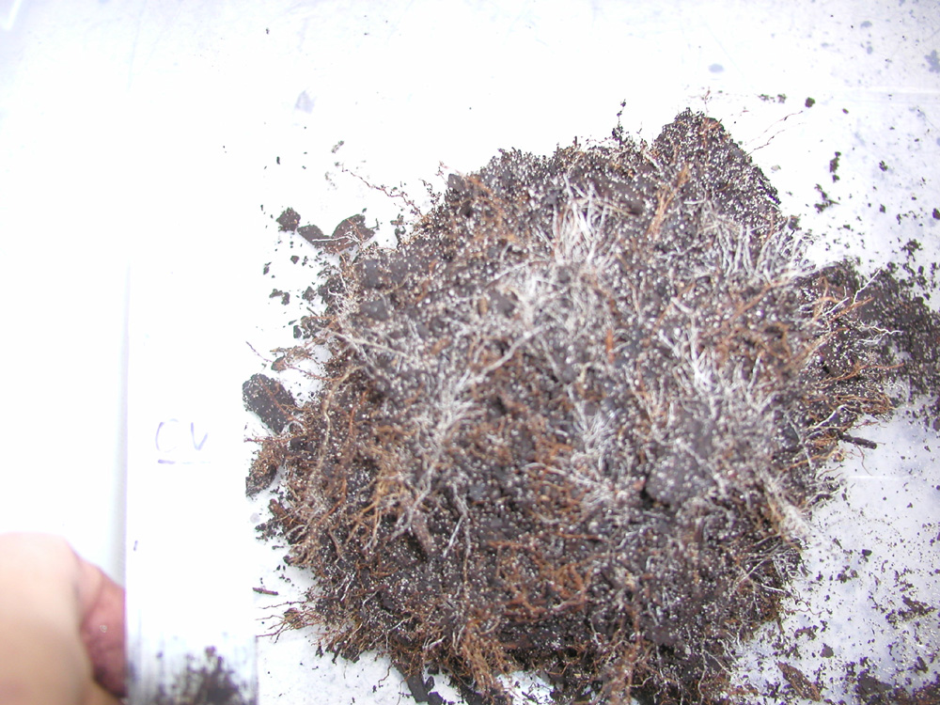
Infected roots are brownish in color
Healthy roots are white in color
Photo credits: Dr. Gladis Zinati

