Grassfed Beef Case Study
John Ovadal
Watertown, Wisconsin
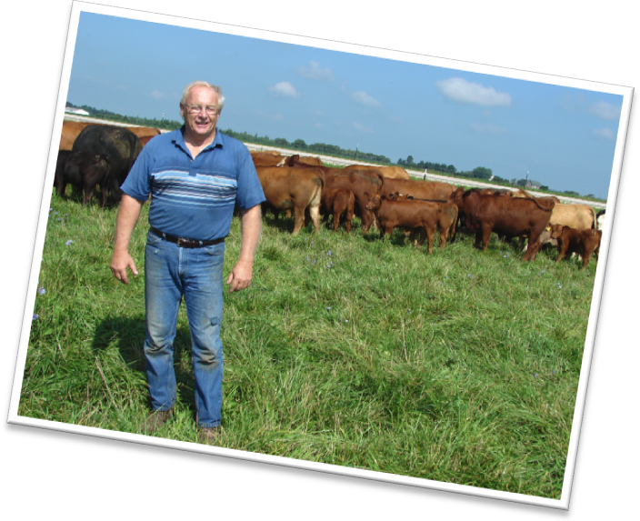

Who?
John Ovadal’s 250-acre farm is a retirement project. A beef producer early on in his life, he left farming for a successful career in industry. In 2000, John sold his acoustic ceiling business and he and his wife, Betsy, retired to Watertown, Wisconsin to raise beef cattle.

Production Model
The farm was conventional for a very short period, starting out with a pure-bred Simmental herd and a typical Wisconsin crop rotation of corn and alfalfa. John began transitioning to a pasture-based system in 2003.

The transition to pasture and forage came pretty easily; transitioning his herd to a more typical grass-fed frame size has been an on-going challenge.

Why?
John was motivated by an interest in taking better care of his land and his cattle, as well as reducing his costs and earning a premium. He believes grass-fed meat is a healthier product to offer consumers.

Farm, Soil, and Climate
John’s system includes about 110 acres of permanent pasture and 100 acres of hay ground, of which 50 acres is planted to annual forages each year. His farm includes a variety of soils, but the majority are silt loams. About 40 acres of low ground are enrolled in the wetland reserve program. Pasture mixes include soft-leaf fescues, orchard grass and ladino and red clover. In low areas, he plants low alkaloid reed canary grass. John quit fertilizing when fertilizer prices skyrocketed in 2008, but is considering starting again this year because he’s observed declines in his pasture carrying capacity.

Pastures/Grazing Management
For his cow herd, John has 17-5 acre paddocks and he moves the cows every 2 to 3 days to a new paddock. Recovery periods average about 30 days. The finishing animals are grazed on a separate group of 8 paddocks averaging 3 to 4 acres. These animals are moved every 2 to 3 days as well. At times during the season, the finishing herd may be moved onto the cow pastures and the cows are occasionally grazed on hay fields late in summer.

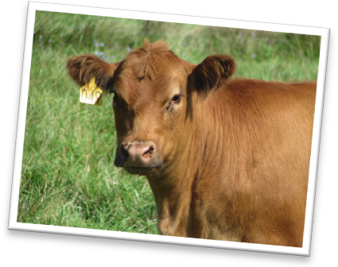
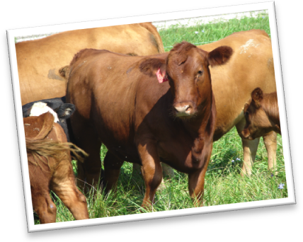
Hayfields are seeded to a mixture of soft-leaf fescue and alfalfa. John’s focus is on putting up high quality forage and he’s found that making baleage is a much more reliable way of being able to cut hay when it’s ready and avoiding having it rained on. The baleage is fed to both steers and cows from approximately November through April. The steers receive about 1/5 pounds of molasses per head per day poured over the baleage.

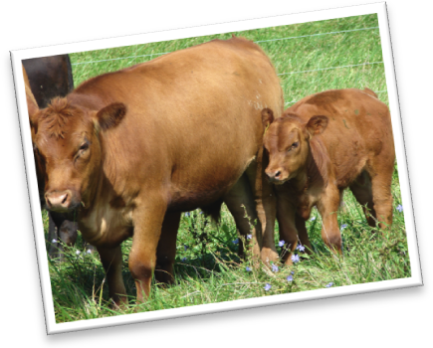
The hayfields are maintained for 4 to 5 years until the alfalfa starts to thin out. Then John plows down the hay and plants brown midrib sorghum sudangrass for late summer grazing or more baleage. “I’ve found that sorghum sudan helps me get through that late summer dry spell that we often have,” says John. The following year, the field goes back into alfalfa and grass for hay. John has experimented with other annuals, such as Italian ryegrass and winter rye, with the goal of extending the grazing season.

Winter Feeding
John feeds his herd baleage on pasture over the winter. To restore the paddock the next year, he puts sorghum sudan on and then seeds it back down the following year. Most years, John has enough baleage for the winter; however, last year he purchased one load of sweet corn sileage.

Beef Herd Management
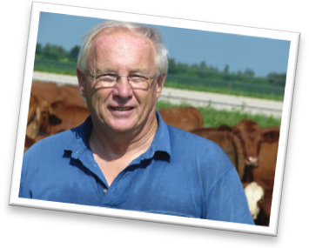
“One thing that I learned early on,” says John, “is that smaller framed cattle are more efficient in a grass-based system. It’s hard to put on weight and get the marbling you want in a reasonable amount of time, working with a steer that finishes at 1500 pounds.” To achieve his breeding goals, John isn’t focused on any specific breed, but instead looks for the frame size and performance he needs. He’s purchased several bulls from Kit Pharo, an Angus breeder who specializes in grass-fed genetics. He reduced his frame-size from a 6 to between 4 and 5.

And he’s not afraid to cull cows. In 2009, he culled about 30 head of his larger framed cows, reducing his herd to 43 head. He says he’ll probably increase back to his more typical 50 to 70 head depending on weather conditions. With a goal of producing all of his own feed, John manages his herd to match forage production. “2009 was a drought year and I didn’t put up as much feed as I needed for the herd,” he says. “This was a good opportunity to work on both improving the herd and reducing feeding costs over the winter.”

Herd Health
John has never had a problem with herd health. Last year, he dewormed and vaccinated his calves and he noticed better gain over the winter. However, he does not vaccinate or deworm his cow herd.

Marketing
As a member of the Wisconsin Grass-fed Beef Cooperative, John’s market animals are marketed through the coop as “Wisconsin Meadows” brand beef. The coop sells to white tablecloth restaurants, meat markets and food cooperatives throughout southern Wisconsin. The Coop’s protocol requires an entirely pasture and forage-based diet with no grain. Supplementation with vitamins, minerals, molasses, and flaxseed are allowed, but antibiotics, implants, ionophores, and hormones are not. The Coop’s production manager evaluates the animals for finish and schedules them for slaughter. John’s animals generally finish in the 18 to 24 month range at 1000 to 1300 pounds.

Summary – Challenges
Two areas John is currently working on include improving his pastures by frost seeding and fertilization, and improving his cattle genetics to produce a smaller framed cow that produces a calf that gains well on pasture. He’s also interested in getting into selling bred cows when he’s satisfied with his genetics.

Keys to the Operation
Just as he did in his ceiling business, John focuses on quality. Monitoring pasture quality allows him to routinely record weight gains of 2.5 to 3 lb/day on his finishing animals. His cattle are prized by Thousand Hills Cattle Company where he used to ship many of them. A founding member of the Wisconsin Grass-Fed Beef Cooperative, he now sells 30 to 40 market animals per year through the Coop.

John is happy with his system, but is always interested in improvements. He has set it up so that he can manage it by himself with little or no additional labor. He likes to keep things simple, keeping minimal records but monitoring key areas for financial performance and keeping a close watch on progress of his breeding program. He just started keeping grazing records when he joined the study.

Written by Kelliann Blazek and Laura Paine, WI DATCP. Photos by Kelliann Blazek. September 2010.

