SARE RESEARCH & EDUCATION GRANT: LNE07-265

FINAL REPORT

TITLE: An Integrated Approach to Developing Nutrient Management Schemes for Container-Grown Nursery Crops

Image 13: Engaging students in research and hands-on education.

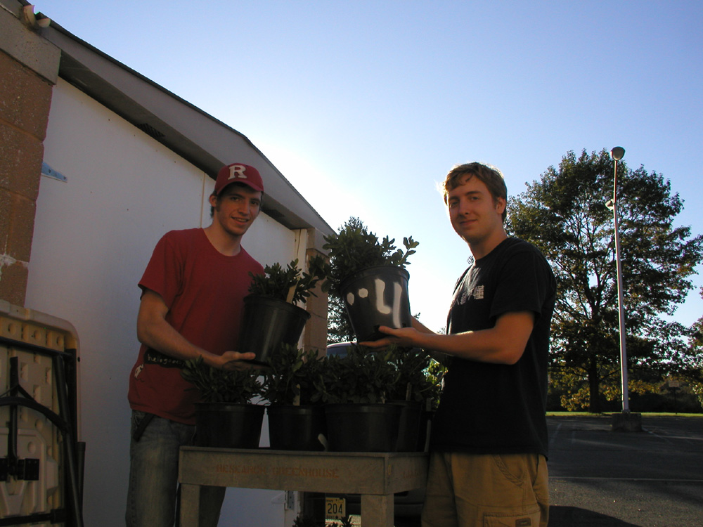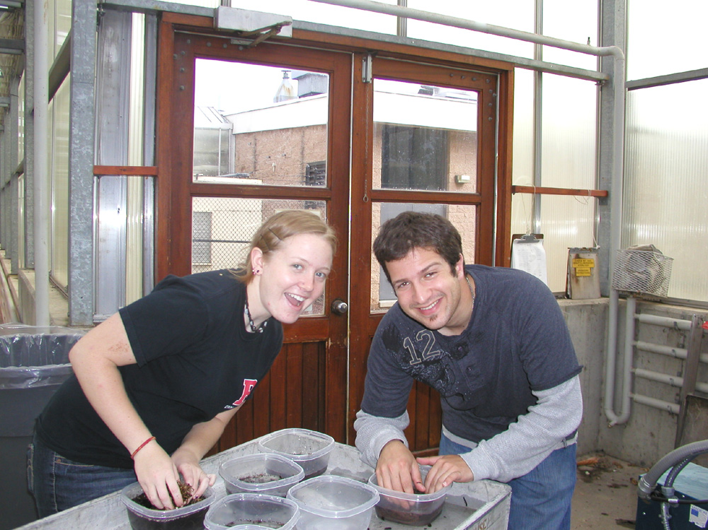
Photo Credits: Dr. Gladis Zinati

