SARE RESEARCH & EDUCATION GRANT: LNE07-265

FINAL REPORT

TITLE: An Integrated Approach to Developing Nutrient Management Schemes for Container-Grown Nursery Crops

Image 1: Participating nursery growers in growing their nursery crops using natural mycorrhizal fungi inoculum during 2008.

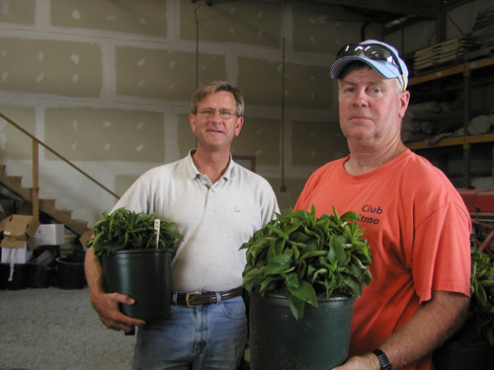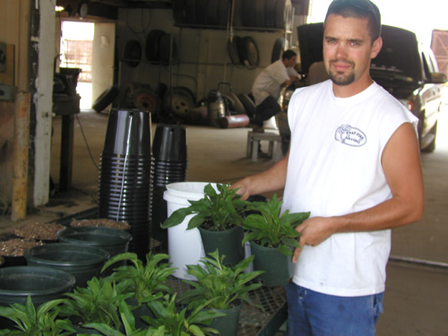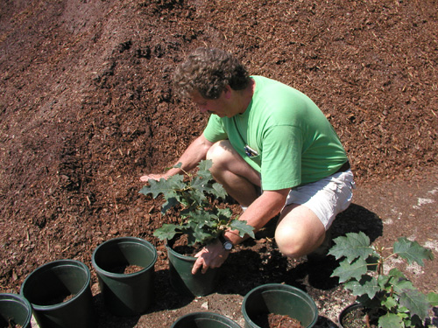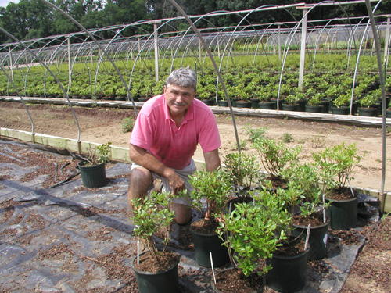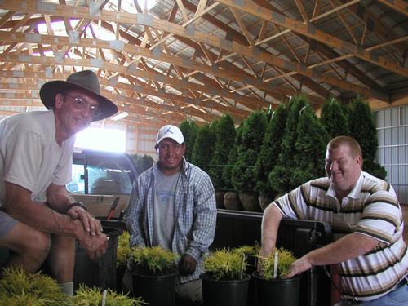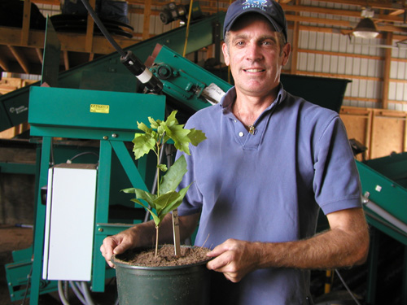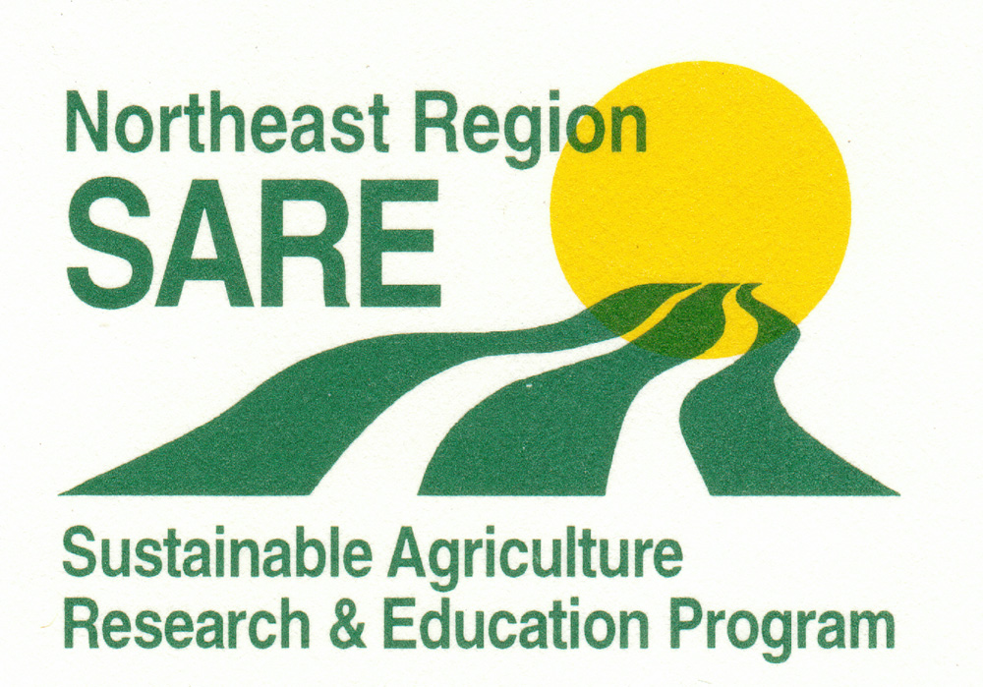
Six NJ nursery growers have participated in developing the protocols and implementing the schemes of using natural mycorrhizae

2008
Photo Credits: Dr. Gladis Zinati

