Table 1. Bees trapped at three Willamette Valley blueberry farms in 2009-2010.

Family | Species | Farm A |  | Farm B |  | Farm C
Family | Species | 2009 | 2010 | 2009 | 2010 | 2009 | 2010
Andrenidae | Andrena sp. |  |  | 1
Apidae | Anthophora bomboides stanfordiana Cockerell |  | 2
 | Apis mellifera L. | 4 | 4 | 41 | 25 | 41 | 9
 | Bombus appositus Cresson | 0 | 3 | 1 | 1 | 2 | 0
 | Bombus californicus Smith | 6 | 3 | 2 | 1 | 13 | 1
 | Bombus griseocollis (DeGeer) | 16 | 0 | 0 | 1 | 1 | 0
 | Bombus melanopygus Nylander | 0 | 7 | 0 | 0 | 1 | 0
 | Bombus mixtus Cresson | 3 | 1 | 6 | 2 | 4 | 0
 | Bombus nevadensis Cresson | 3 | 0 | 0 | 0 | 1 | 0
 | Bombus vosnesenskii Radozkowski | 90 | 3 | 21 | 0 | 16 | 3
 | Ceratina acanthi Provancher | 1 | 0 | 6 | 3 | 1 | 1
 | Ceratina michneri Daly | 0 | 0 | 3 | 0 | 0 | 0
 | Melissodes metenua Cockerell | 1 | 1 | 0 | 1 | 1 | 1
 | Melissodes pallidisignata Cockerell | 0 | 2 | 0 | 0 | 0 | 0
 | Melissodes rivalis Cresson | 1 | 0 | 2 | 3 | 0 | 1
 | Melissodes robustior Cockerell | 1 | 2 | 6 | 0 | 1 | 0
 | Synhalonia edwardsii (Cresson) | 2 | 1 | 4 | 3 | 0 | 0
Colletidae | Hylaeus sp. | 0 | 0 | 1 | 0 | 0 | 0
Halictidae | Agapostemon texanus Cresson | 4 | 5 | 3 | 2 | 1 | 0
 | Agapostemon virescens (Fabricius) | 9 | 11 | 5 | 0 | 12 | 0
 | Halictus farinosus Smith | 18 | 3 | 5 | 2 | 4 | 0
 | Halictus rubicundus (Christ) | 2 | 0 | 1 | 5 | 2 | 1
 | Halictus tripartitus Cockerell | 6 | 14 | 5 | 2 | 44 | 0
 | Lasioglossum mellipes (Crawford) | 3 | 1 | 1 | 3 | 2 | 0
 | Lasioglossum olympiae (Cockerell) | 0 | 0 | 1 | 0 | 1 | 0
 | Lasioglossum pacificum (Cockerell) | 3 | 1 | 1 | 1 | 9 | 2
 | Lasioglossum pavonotatum (Cockerell) | 3 | 1 | 0 | 1 | 4 | 0
 | Lasioglossum sisymbrii (Cockerell) | 3 | 1 | 0 | 1 | 0 | 0
 | Lasioglossum titusi ( Crawford) | 0 | 0 | 0 | 0 | 0 | 1
 | Lasioglossum trizonatum (Cresson) | 3 | 4 | 0 | 1 | 17 | 0
 | Lasioglossum spp. (12) | 6 | 27 | 4 | 8 | 66 | 4
 | Specodes spp. (2) | 1 | 1 | 0 | 0 | 0 | 0
Megachilidae | Heriades cressoni Michener | 0 | 0 | 2 | 0 | 0 | 0
 | Meghachile perihirta Cockerell | 2 | 0 | 0 | 0 | 0 | 0
 | Osmia spp. (6) | 1 | 2 | 14 | 0 | 2 | 0

Table 2. Bees trapped in southwestern Oregon cranberry agroecosystems in 2008 and 2009.
Family | Species | Number Collected^{z} | Sites where present
 |  |  | 1 | 2 | 3 | 4
Andrenidae | Andrena sp. | 10 | √ | √ | √ | √
Apidae | Apis mellifera L. | 235 | √ | √ | √ | √
 | Bombus californicus Smith | 4 | √ |  | √ | √
 | Bombus caliginosus (Frison) | 40 | √ | √ |  | √
 | Bombus melanopygus Nylander^{y} | 60 | √ | √ |  | √
 | Bombus mixtus Cresson | 101 | √ | √ |  | √
 | Bombus vosnesenskii Radozkowski | 151 | √ | √ | √ | √
 | Ceratina sp. | 1 |  |  | √
 | Melissodes spp. | 57 (2) | √ | √ | √ | √
 | Nomada sp. | 1 | √
 | Synhalonia sp. | 4 | √ | √ |  | √
Colletidae | Colletes sp. | 3 | √ |  |  | √
Halictidae | Agapostemon texanus Cresson | 329 | √ | √ | √ | √
 | Agapostemon virescens (Fabricius) | 5 | √ |  | √ | √
 | Halictus rubicundus Christ | 28 | √ | √ | √ | √
 | Halictus tripartitus Cockerell | 3 | √ | √
 | Lasioglossum mellipes (Crawford) | 1 |  |  |  | √
 | Lasioglossum olympiae (Cockerell) | 5 | √ | √ |  | √
 | Lasioglossum pacificum (Cockerell) | 39 | √ | √ | √ | √
 | Lasioglossum sisymbrii (Cockerell) | 1 | √
 | Lasioglossum spp. | 239 (6) | √ | √ | √ | √
Megachilidae | Megachile spp. | 16 (2) | √ | √ | √ | √
 | Osmia sp. | 2 | √ |  |  | √

^{y} Including individuals with the black phenotype earlier referred to as B. edwardsii
^{z} Numbers in parentheses indicate approximate number of species
Table 3. Multivariate logistic model associating honeybee and bumble bee foraging to abiotic factors. Residual deviance is 301.07 on 297 degrees of freedom. AIC is 307.07.

 | Estimate | Std. Error | z value | Pr (>|z|)
(Intercept) | 13.95380 | 2.09046 | 6.675 | 2.47 ×10⁻¹¹ ***
Temperature (C) | -0.19385 | 0.02830 | -6.849 | 7.46 ×10⁻¹² ***
Wind speed (m/s) | -0.41137 | 0.09917 | -4.148 | 3.35 ×10⁻⁵ ***
*** P > 0.001
Table 4. Mean (%) mortality of queen Bombus vosnesenskii after exposure to pesticide-treated blueberry plant material.

Pesticide /  Time of exposure | Mean % mortality (± SEM) |  |  |  | Analysis  F, P*
Pesticide /  Time of exposure | Pesticide concentrationª |  |  |  | Analysis  F, P*
Pesticide /  Time of exposure | untreated control | minimum | maximum | 2X maximum | Analysis  F, P*
imidacloprid  24 hrs | 0.00 ± 0.00a | 8.33 ± 8.33a | 16.67 ± 10.54a | 16.67 ± 10.54a | 0.82, 0.50
48 hrs | 25.00 ± 11.18a | 66.67 ± 16.67a | 66.67 ± 16.67a | 58.33 ± 15.37a | 1.33, 0.30
72 hrs | 25.00 ± 11.18a | 75.00 ± 11.18ab | 75.00 ± 17.08ab | 83.33 ± 10.54b | 3.59, 0.04
spinosad  24 hrs | 0.00 ± 0.00a | 8.33 ± 8.33a | 8.33 ± 8.33a | 8.33 ± 8.33a | 0.38, 0.77
48 hrs | 8.33 ± 8.33a | 50.00 ± 18.26a | 25.00 ± 17.08a | 16.67 ± 10.54a | 1.89, 0.17
72 hrs | 16.67 ± 10.54a | 75.00 ± 17.08b | 41.67 ± 15.37ab | 16.67 ± 10.54a | 7.86, <0.01
pyraclostrobin/boscalid  24 hrs | 8.33 ± 8.33ab | 0.00 ± 0.00a | 0.00 ± 0.00a | 50.00 ± 18.26b | 5.00, 0.01
48 hrs | 8.33 ± 8.33a | 8.33 ± 8.33a | 8.33 ± 8.33a | 50.00 ± 18.26a | 2.55, 0.09
72 hrs | 33.33 ± 16.67a | 16.67 ± 10.54a | 16.67 ± 10.54a | 58.33 ± 20.07a | 1.48, 0.26
Table 5. Plant species providing favored resources for bees as evidenced by heavy foraging; [I] introduced, [C] cultivated, [N] native

Family | Species | Common Name | Bloom
Asteraceae | Centaurea nigrescens^{[I]} | Tyrol knapweed | Jun – July
 | Cichorium intybus^{[I]} | Chicory | Jun – Aug
 | Cirsium arvense^{[I]} | Canada thistle | Jun – July
 | Cirsium vulgare^{[I]} | Bull thistle | Jun – Aug
 | Hypochaeris radicata^{[I]} | Hairy cat’s ear | May – Sept
 | Tagetes cvs. ^{[C]} | Marigold | Jun – Aug
Dipsacaceae | Dipsacus fullonum^{[I]} | Teasel | Jun – Aug
Ericaceae | Vaccinium corymbosum^{[C]} | Highbush blueberry | April – May
Fabaceae | Trifolium pratense^{[I/C]} | Red clover | May – Sept
 | Trifolium repens^{[I/C]} | White clover | Jun – Aug
Lamiaceae | Lavandula angustifolia^{[C]} | Lavender | Jun – Aug
 | Mentha pulegium^{[I]} | Pennyroyal | Jun – Aug
 | Prunella vulgaris^{[N]} | Common selfheal | Jun – Aug
Rhamnaceae | Ceanothus thyrisiflorus^{[N/C]} | Ceanothus | May – Jun
Rosaceae | Rubus armeniacus^{[I]} | Himalayan blackberry | Jun – July
 | Rubus spp. &cvs. ^{[C]} | Blackberry & Raspberry | Jun – July

% of all pollen loads

Fig. 1. Composition of pollen in loads collected from pollen traps placed in honey bee hives in blueberry orchards. In 2009, no blueberry pollen was detected in any of the 350 pollen loads examined; in 2010, 0.38% blueberry pollen was recorded from 500 pollen loads examined.
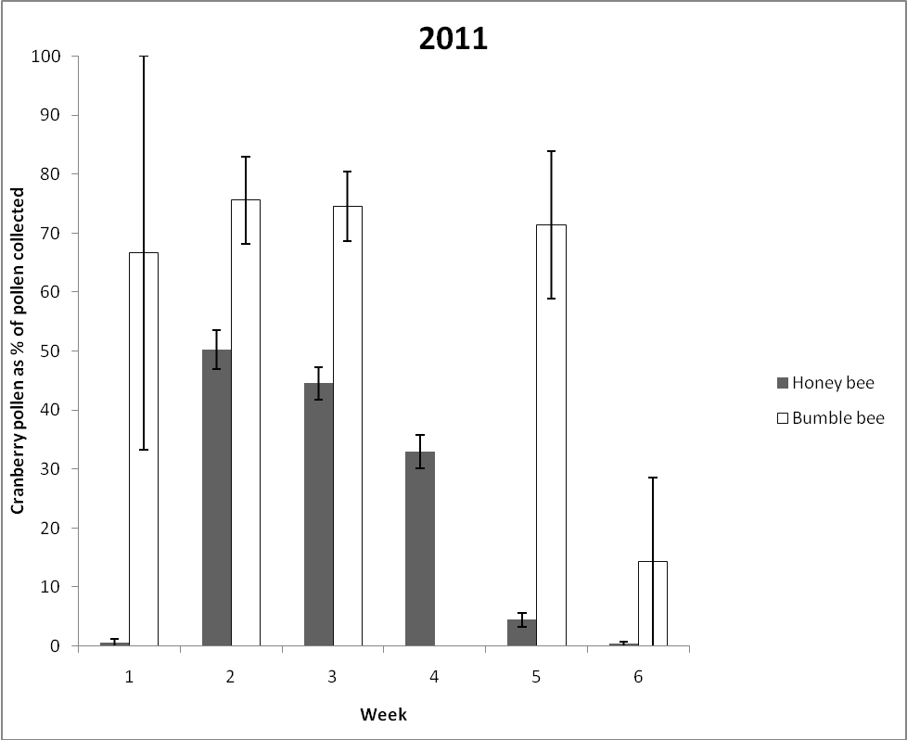

Fig. 2. Comparison of percentage of cranberry pollen in pollen loads collected from honey bee hives and from bumble bees returning to bumble bee nests, both placed near cranberry beds. No pollen loads were collected from bumble bees in week four due to fungicide spray in the field.

- Honey bees

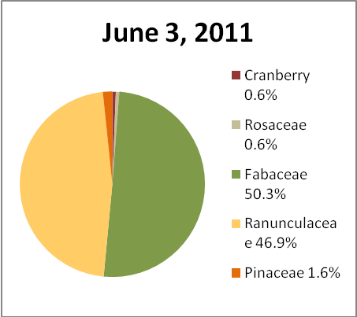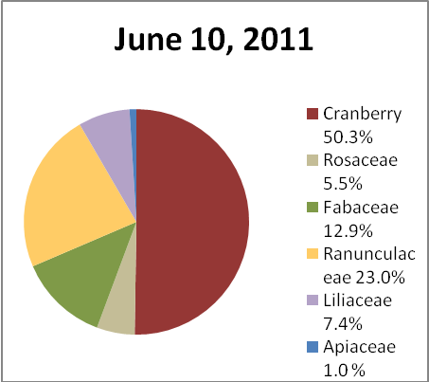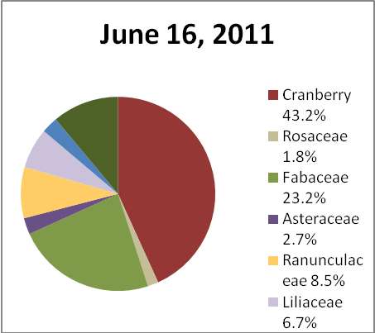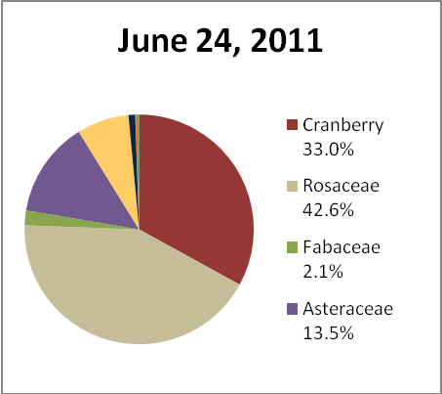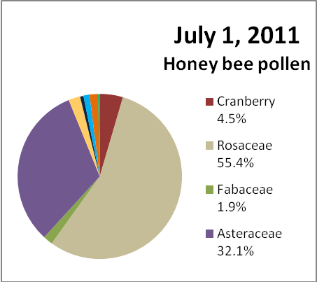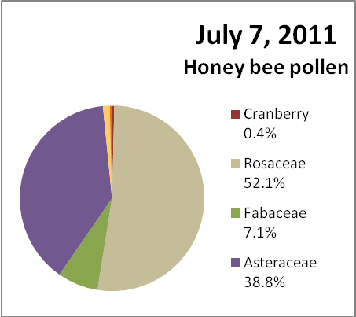

- Bumble bees

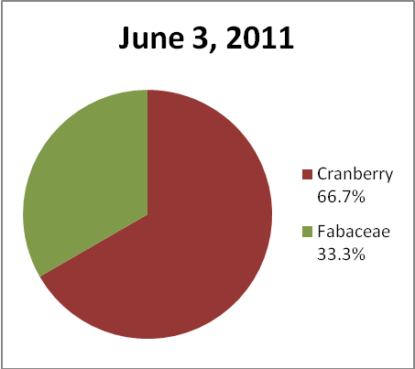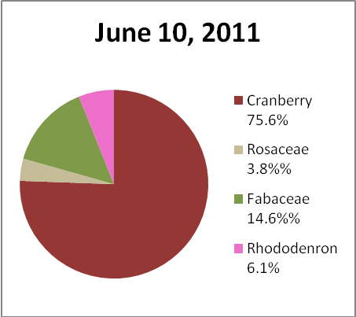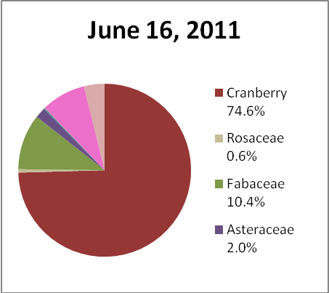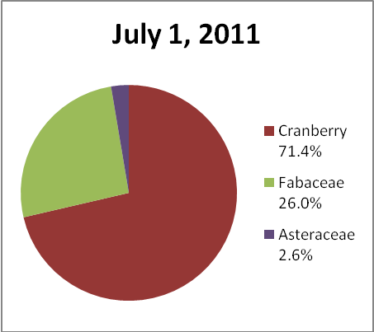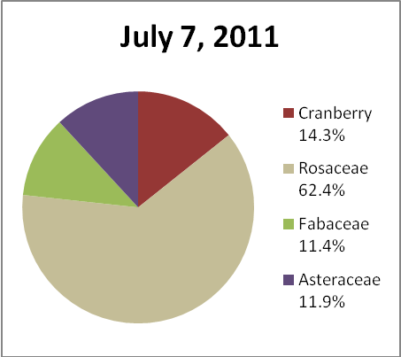

Fig. 3. Comparison of pollen profiles of pollen loads collected through cranberry bloom from honey bee hives (A) and bumble bees returning to bumble bee nests (B), both placed near cranberry beds. No pollen loads were collected from bumble bees on June 24 due to fungicide spray in the field.
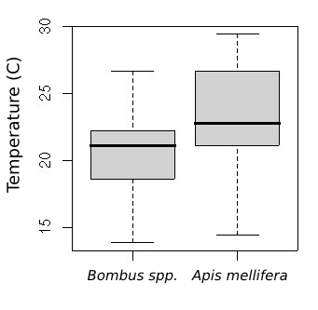

Fig. 4. Temperatures at which bumble bees (n=96), and honeybees (n=207) were observed foraging on cranberry bloom.

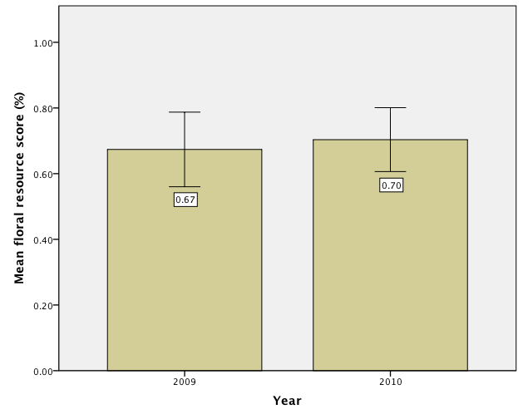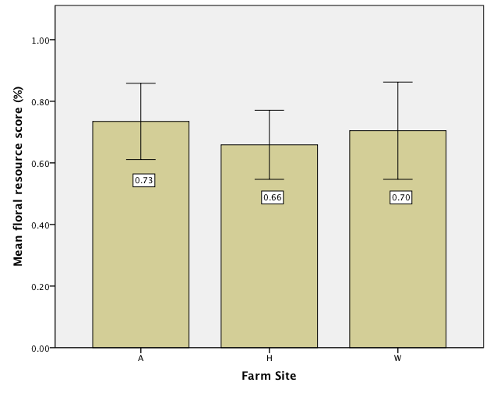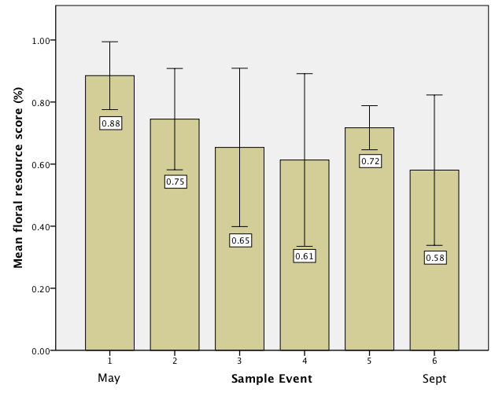
Fig. 5. Mean floral resource site score by (a) years (n=36, P=0.901); (b) farm sites (n=36, P=0.673); and (c) sample events (n=36, P=0.114)

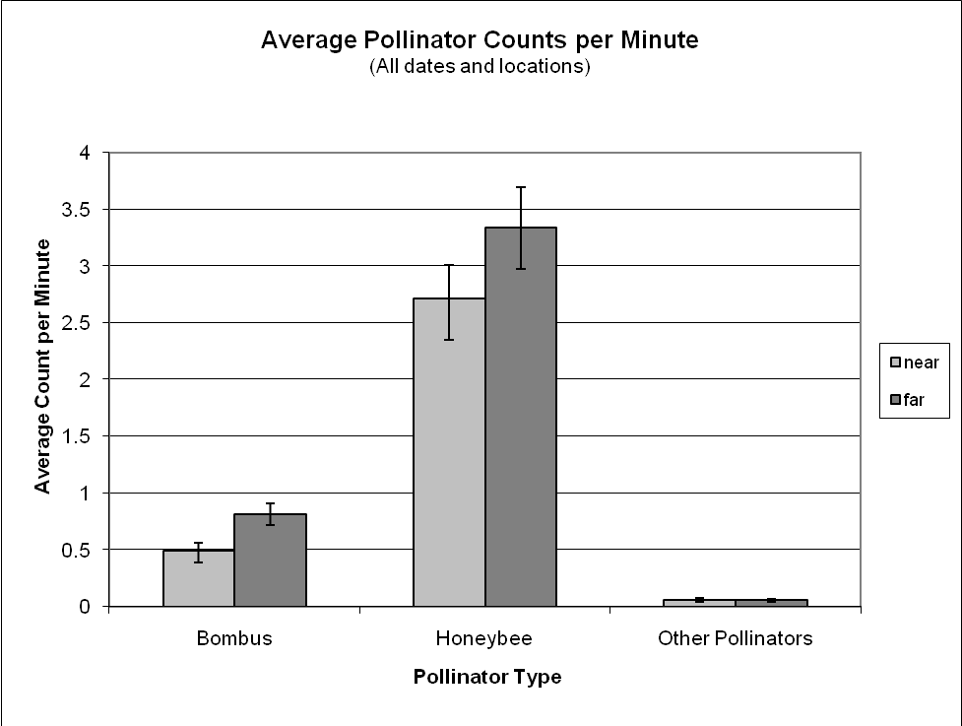

Fig. 6. Comparison of honey bees, bumble bees and other pollinators close to and away from the string of blue vanes set up in cranberry fields.

