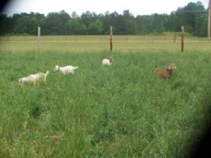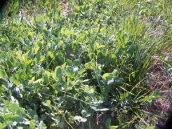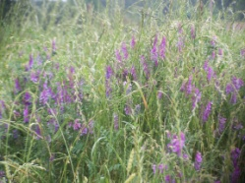
- Top (2) Middle (3) Bottom
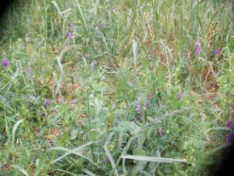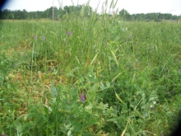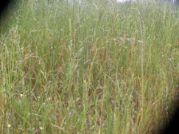
(4) Top (5) Middle (6) Bottom
Figure 1. Multi-cultural forage system during winter and spring, Tuskegee, AL
- Annual rye grass/wheat (RW) + Berseem clover (BC), (2) RW + Australian pea (AP), (3)
RW + Hairy vetch (HV), (4) RW + AP + HV, and (5) RW + HV + AP + BC, and (6) annual rye grass/wheat (RW),

