Penn State Horse Newsletter

Newsletter
DAS 2011-173
Content

Farrier Clinic - Limb Length Disparity

Health Alert
How to Analyze Feed & Hay
Feeding Horses

PSU Horse Sale

Toxic Weed
PSU Equine Events
The Newsletter publishes articles on horse health, management, Penn State events. More about the Penn State Horse Newsletter...


We have experts from Universities around the country ready to answer your questions click on
http://www.extension.org/ask

Farrier Clinic: Limb Length Disparity at Penn State
On Saturday May 28, Penn State Equine Extension and the Pennsylvania Professional Farriers Association will be hosting an event to educate farriers, veterinarians and horse owners. Dr. Esco Buff of Webster, New York will be the featured clinician. Throughout the day, Dr. Buff will speak on equine limb length disparity and mechanical treatment. The clinic will run from 10 am until 4pm and consist of lectures and shoeing demonstrations. The clinic will be held at the Penn State University Snider Agricultural Arena located on the University Park campus.
Dr Esco Buff is well known for his work with shoeing and work with foundered horses. Dr. Buff is the owner of Esco Buff’s Equine Educational Enterprises located in Webster, New York. He is a leader in the field of foundered and limb length disparity horseshoeing. He also is an American Farriers Association Dr Buff has also had articles published in farrier magazines and papers submitted to the AAEP, American Assoc. of Equine Practitioners. In recognition of distinguished accomplishments in advancing the farrier industry, Dr. Esco Buff was inducted into the International Horseshoeing Hall of Fame this February (2011). Dr Buff’s lecture is sponsored by PurdyBuilt by UPSCO, Moravia, N.Y., designers of truck and trailer accessories. Limb Length Disparity (LLD) is an observable body imbalance and physical deviation that manifests itself in a structurally and/or functionally different limb length, and more than likely has been created due to congenital, hereditary, injuries, environmental, muscular and/or spinal problems. Identifying LLD includes a thorough evaluation of the conformation, muscles, skeletal structures, movement and attitude of the horse. There are two types of LLD, structural or anatomic limb length disparity and functional or apparent limb length disparity. In horses, we are mainly dealing with functional LLD. The disorder of unequal limbs or lack of similarity goes by several names such as: High-Low Syndrome, Limb Length Inequality, Bilateral Asymmetry, Club Foot (not to be confused with Club Feet).
Clinic costs will be $15/day for those that pre-register and $20 at the door. Checks can be made out to the Pennsylvania Professional Farriers Association. For more information or to register for the clinic contact Ann Swinker at 814-865-7810, email: aswinker@gmail.com or Randy Rider at 814-574-3196, email: ridershorseshoeing@gmail.com

Health Alert: Cornell Equine Hospital Quarantined with Confirmed EHV-1

Cornell University College of Veterinary Medicine's equine hospital is under a voluntary quarantine after confirming a case of the neurologic form of equine herpesvirus (EHV-1). The quarantine began March 20. EHV-1 is a highly contagious virus that can cause a variety of ailments in horses including rhinopneumonitis (a respiratory disease mostly of young horses), abortion in broodmares, and myeloencephalopathy (the neurologic form). Contact Cornell Vet Hospital for more information and the end of the quarantine and more information http://www.vet.cornell.edu/.

How Green is Your Farm?

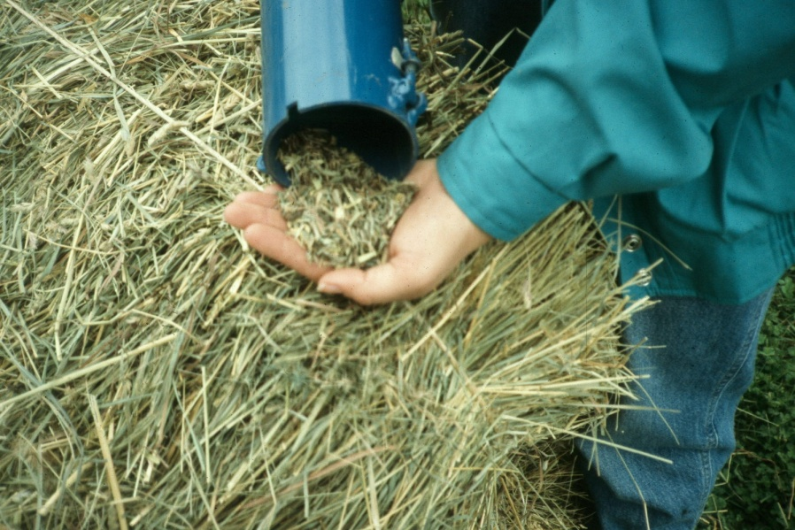
How to Analyze Feed and Forage
Sampling for Horses
Ann Swinker, PhD, Associate Professor Equine Science
It has been said that art and science are combined to determine the best feeding program for your horse. The first half, the laboratory analytical results requires a lot of science. Remember, the lab analysis of your feed is only as good as the sample you submit. Collecting a representative sample is the first step of the analytical process. Following recommended sampling procedures will help insure that your results truly reflect the nutrient composition of your sample.

Hay – Hays of different types, cuttings or lots should be sampled separately. Using a Penn State Forage Sampler (or other suitable hay probe), bore 12 – 20 bales selected at random. Combine all core samples and submit for analysis. For more information: http://www.extension.org/pages/13009/hay-analysis:-its-importance-and-interpretation
http://www.equi-analytical.com/TakingASample/TakingAHaySample.pdf

Pasture – randomly select 12 to 20 sites where the animals have been grazing and clip the forage at grazing height. All subsamples should be combined and thoroughly mixed in a clean plastic bucket to form a composite sample. Take a one pound (0.5 kg) composite sample, pack tightly in a plastic bag and freeze for 12 hours prior to submitting for analysis. Freezing will help prevent marked chemical changes due to respiration or fermentation.

Grains and Ingredients – Bin storage: randomly collect 12 to 20 samples as the grain is discharged and combine in a clean plastic bucket. Thoroughly blend and submit about one pound (0.5 kg) sample for analysis.
Generally, analysis can be as little as $10 for an individual nutrient and as much as $80 for analysis of 30 nutrients. The most common nutrients analyzed include crude protein, fat, soluble carbohydrates, fiber, and the minerals calcium, phosphorus, potassium, magnesium, sulfur, copper, zinc, and selenium. The crude protein content measurement gives an estimate of a feed's protein content, but it doesn't give much information on the quality of the protein. Fat is a nutrient that provides energy, as do soluble carbohydrates. Soluble carbohydrates can be analyzed as water-soluble carbohydrates, ethanol-soluble carbohydrates, fructan, and starch, and this analysis is important for horses with a variety of disorders (such as equine metabolic syndrome, laminitis, or equine polysaccharide storage myopathy). The two most common fiber analyses are for acid detergent fiber (ADF) and neutral detergent fiber (NDF), which can be used to estimate forage quality.
The Analytical results are reported on both an as sampled and dry matter basis. Either can be used for ration balancing and it is important to understand the difference between them and how each can be used most effectively. The important point is to be consistent. When developing a ration or comparing different feeds, the results need to be compared on the same basis. Failure to do this will result in improper formulation.
For a laboratory near you contact your county Extension office. Companies such as Equi-Analytical (www.equi-analytical.com), Holmes Laboratory Inc. (www.holmeslab.com), or Dairy One (www.DairyOne.com) for grain and forage analysis. These companies provide information on their websites about how to collect samples, and they can provide prepaid packaging for sending samples to their laboratory for analysis.
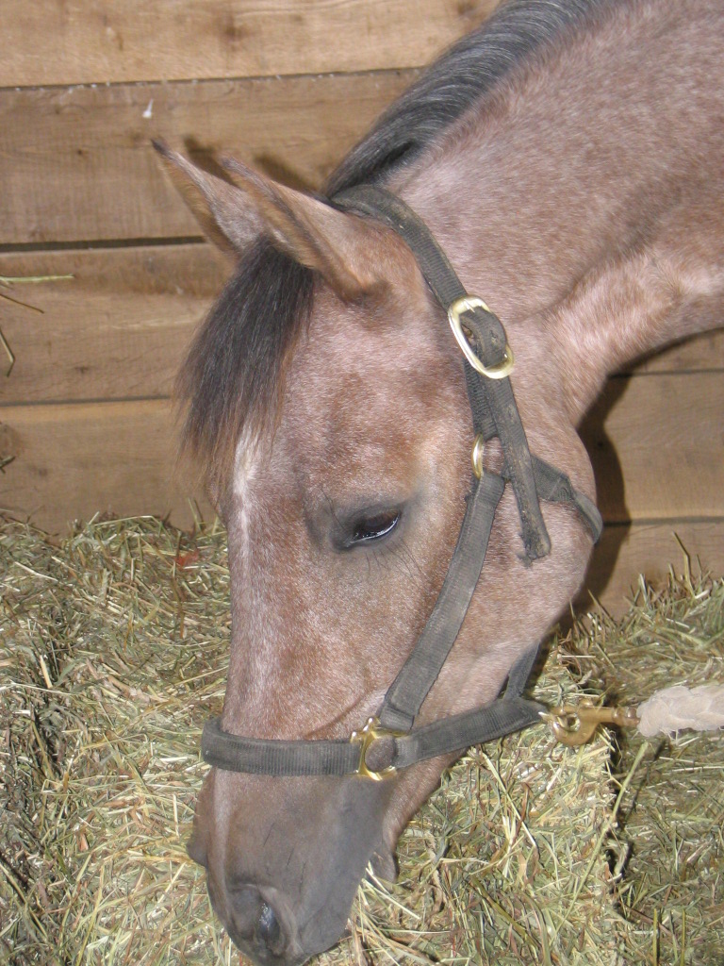
Reference
National Research Council (NRC). 2007. Nutrient Requirements of Horses, 6th Revised Edition. The National Academies Press, 500 Fifth Street N.W., Washington, D.C. 20001.
http://www.nap.edu/catalog.php?record_id=1213
Equi-analytical laboratories, Ithaca, NY http://www.equi-analytical.com/default.htm
Janice Holland, Analyzing Feed and forage for Horses, TheHorse.com, 2010, http://www.thehorse.com/ViewArticle.aspx?ID=17666&src=bio

Feeding Horses
Ann Swinker, Ph.D.
Penn State University
Extension Horse Specialist
When you feed your horse, take into account its age, weight, work and growth to determine its diet. Some horses are easier to feed and require fewer nutrients than others. Other horses are very difficult to feed and require special attention. It is important to know how to feed your horse and to make sure it gets all the nutrients it needs.
Five types of nutrients
A horse requires five types of nutrients. Each nutrient has an important role in the horse’s body and is needed to keep the horse healthy. Those nutrients are:
• Energy nutrients (such as carbohydrates and fats),
• Proteins
• Vitamins
• Minerals
• Water
Water is the greatest single part of nearly all-living things. Water performs many tasks in the body. It makes up most of the blood that carries nutrients to cells and takes waste products away. In addition, water is the body’s built-in cooling system; it regulates body heat and acts as a lubricant. A horse drinks about 10 to 12 gallons of water daily depending on the work it is doing. In hot weather, a horse may drink up to 15 to 20 gallons of water. In very cold weather, water heaters may be needed to prevent the water from freezing.
Energy in feeds is measured in Mega calories (Mcal) of digestible energy (DE). Energy nutrients are the body’s fuel and make up the bulk of the diet. After food is digested, blood carries its energy to the body. Energy nutrients power muscle movement to walk, breathe and blink eyes. (At the same time, this energy maintains body temperature). Carbohydrates are the main energy source for all animals. Carbohydrates are complex compounds made up of carbon, hydrogen and oxygen. Cellulose (carbohydrates found in hay and grass) is one of the more complex carbohydrates. Horses can digest cellulose (grass and hay) because they have small microbes in their large intestine (cecum) that can break it down. Fats or oils are another source of energy. Like carbohydrates, fat is made up of carbon, hydrogen and oxygen and also provide energy for movement and heat. Energy in fat is more concentrated than energy in carbohydrates. Fat has 2.25 times more energy per gram than carbohydrates. Never feed more than 10% of the diet in fats/oils.
Protein supplies material for body tissue. During digestion, proteins break down into amino acids. Amino acids build bodies; they enter the blood stream from the intestine, and blood carries amino acids to all parts of the body. They form body tissue. Proteins eventually become muscle, internal organs, bone and blood. Skin, hair, hooves and many other parts of a horse also are made of protein. Protein not needed to maintain or build a horse’s body is either converted into energy or passed through the digestive system. Total protein in feeds is measured by crude protein (CP).
Vitamins are needed in much smaller amounts than other nutrients, but they are just as vital. Each vitamin has a different job in the body. Some vitamins are in the food a horse eats while others are produced inside the horse. Depending on its diet, a horse may need vitamin supplements. Supplements usually are not necessary if a horse is allowed to graze on grass.
Minerals Small amounts of minerals usually are needed. Iron, copper, phosphorous, calcium and magnesium are examples of minerals that are important for a horse’s body. Without iron, blood cannot carry oxygen to the body’s cells. Without calcium and phosphorous, bones and teeth will not form properly. Calcium and phosphorous should be fed in a ratio that ranges from 3:1 (three parts calcium for each part of phosphorous) to 1:1. An imbalance of these minerals can cause developmental bone disease in young, growing horses.
Types of feeds
Your horse can get its essential nutrients from many types of feed.
Roughage/Forage Roughage, found in hay or grass, is the bulk of the horse’s food. Grass or alfalfa hay, or a combination of the two, are good sources of roughage. Grass hay is generally higher in fiber and dry matter than alfalfa, but alfalfa may be higher in protein, energy, vitamins and calcium. Hay can be long-stemmed in hay bales, or come bagged in cubes, or pellets. Many horse owners feed grass hay or straight alfalfa or a combination of grass and alfalfa to their horses. Grasses commonly used as hay are brome, orchard, and timothy.
- Long stem hay is the traditional baled hay. It is cut, cured, and baled. It can be bundled in 50- to 80-pound square bales or large, round or long square bales that can weigh tons.
- Hay cubes are about an inch wide and 1- to 3-inches long.
- Hay pellets are ground hay compressed into 2 inch by ½ inch pellets.
Horses need good quality hay. It should be bright green, leafy and fine textured, with a fresh, pleasant aroma. Musty hay or other indications of mold or heating, and dust, weeds and other foreign material in hay can be unhealthy for an animal. Color is an indicator of quality and nutrient content; good hay is a bright green. Most nutrients in hay are in the leaves, and leafy hay is a valuable source of food. Leafiness is influenced by the kind of hay, its maturity when cut, the weather conditions while growing and curing the hay, and curing procedures of the hay. Dust is objectionable in any feed for horses. It not only reduces the taste of the hay, it also aggravates respiratory problems. Sprinkling or dunking dusty hay in water can reduce dust. Avoid feeding moldy or dusty hay. In the field, heavy rain can break off drying hay leaves and leaches energy and protein from the hay. Hay baled before it is dry enough will lose nutrients through fermentation, or heating in the bale. This sometimes starts fires through spontaneous combustion in barnyard stacks of stored, baled hay. This type of hay is unacceptable for horses.
Good pasture or grass that an animal can graze can be an economical food for horses, but pasture must be maintained. If animals are allowed to graze on a pasture too long, the grass may be killed. Some of the basic requirements for a good pasture are:
- a supply of appetizing plants such as grasses or legumes;
- a paddock or stall to house your horse for part of the day.
- only use pastures for daily exercise and grazing;
- a year-round supply of fresh, clean water;
- shelter from wind, cold and sun;
- safe, durable fencing;
- no poisonous plants
- no equipment, holes or other dangerous materials in the pasture
- grain for highly active horses or if the quality of the grass is poor.
Well-managed pastures reduce feed costs and provide energy, protein, vitamins and minerals to animals. An exercise lot with a few blades of grass is not a pasture; such a lot, or overgrazed pasture, is not a source of nutrients and can be a serious source of internal parasites. When a grass stand becomes too thin, overgrown, coarse or unappetizing to a horse, it should be clipped or mowed. Lush pasture forages can act as a laxative in early spring and may cause founder. Introduce horses gradually to pastures by slowly increasing their daily grazing time.
Concentrates. Small grains, such as corn, oats and barley, are known as concentrates. Concentrates are lower in fiber and higher in energy than roughages. The grain should be clean, mold- and insect-free, with a bright color. Grain quality is just as important as hay quality. Grains may be cracked, steamed or rolled, but, if ground too finely, may cause respiratory problems or colic. Oats are the safest and easiest grain to feed with hay because it is high in fiber and low in energy, and higher in protein than corn. Corn has the highest energy content of any grain and can put weight on a horse quickly. It can be fed on the ear, cracked, rolled or shelled. Barley is an intermediate source of energy and protein content. All grains are low in calcium, but high in phosphorus.
Supplements. Protein and vitamin-mineral supplements are added to the diet to increase the diet’s concentration. Grains are energy supplements to a high forage diet. Only add supplements to the diet if something is missing. Some protein supplements are oilseed meals, soybeans, cottonseed, linseed (flaxseed) meal, peanut meal, sunflower seed meal and rapeseed (canola). Vitamin and mineral supplements should only be added to the diet if the horse is deficient. Generally, the only minerals of concern in feeding horses are calcium, phosphorus and salt. In some geographical areas, lack of selenium and, in growing horses, copper and zinc, is a concern. Other minerals are likely to be present in adequate amounts in a normal diet.
Commercial grain mixes or complete feeds. Concentrated mixes are cereal grains with supplements added to increase the specific nutrient content of the mix. A complete feed is a grain mix that is high in fiber because it contains a forage or high-fiber byproducts feed such as hulls. Complete feeds are held together, usually by extrusion (puffed up like dog food) or by forming into pellets. If you are feeding a commercial complete feed, you will not need to feed hay (follow the label for feeding recommendations). There are also feeds for specific classes of horses. Some feeds are specially formulated for young, growing horses (weanlings and yearlings); and for geriatric (aged) horses that are old and have specific nutritional needs. Some commercial feed companies make pre-mixed, convenient, easy-to-use formulated feeds for horses that are on different hay diets such as grass or alfalfa. You should not need to add any other supplements to the diet. These feeds may be more expensive than developing your own ration, but they are good for the owner who does not want to spend time to research their horse’s diet. Feeds from commercial companies have an analysis attached either as a separate tag or printed directly on the container, or that gives guaranteed minimum and/or maximum amounts of certain nutrients.
Nutrient requirements for different horse. The nutrient requirements of a horse vary with its age, weight and the amount of work it performs. Good quality hay is sufficient feed for a mature horse that is ridden very little. With an increase in work, grain should be added to its diet.
Table 1. General daily feed required for the average adult 1,000-pound horse in good body condition & health:
Approximate Amounts (1,000 -pound horse) Hay (good quality) Grain
No work 20-25 lbs. none
Light (1-2 hrs./day) 15-20 lbs. 1-3 lbs.
(1-1.5 lbs. grain/hr. of work)
Medium (2-4 hrs. /day) 15-20 lbs. 3-8 lbs.
(1.5-2 lbs. grain/hr. of work)
Heavy (4 or more hrs/day) 15-20 lbs. 5-10 lbs.
(1.5-2.5 lbs. grain/hr. of work)
Only a horse that is worked extremely hard would ever receive half of its ration in grain. A racehorse in heavy training is an example of a horse requiring half of its ration in grain. So never feed your pleasure horse more than it needs. Younger horses require special rations, talk to your veterinarian.
The above chart can be used as a rule of thumb, or you can be more exact and balance your horse’s ration. There are many books available to show you how to balance a horses’ ration or contact your local Penn State Cooperative Extension Educator for help. When balancing or evaluating a ration, use the National Research Council tables as a guideline to determine available nutrients to meet your horse’s requirements. When you balance a ration: Determine the age, weight and level of activity or work of the horse, and determine the actual nutrient content of the available feed by sending your feed to a commercial feed-testing laboratory (follow the direction in the article above). Contact your local Penn State Cooperative Extension Educator for the name of the laboratory nearest you.
The horse's daily nutrient ration needs will vary due to age, activity or performance level, health status, and, in broodmares, stage of pregnancy or lactation. Estimates of dietary requirements can be found in a variety of publications, such as the National Research Council's Nutrient Requirements of Horses, 6th Edition (NRC, 2007), in extension web sites: http://www.extension.org/pages/20224/evaluating-rations-for-horses
http://www.extension.org/pages/10409/feeding-horses-by-weight-not-
http://ohioline.osu.edu/anr-fact/0006.html
http://extension.missouri.edu/publications/DisplayPub.aspx?P=G2807
Once you determine a horse's requirements, then analyze your hay and feeds for what nutrients they provide. This determines if you're feeding program meets or exceeds the horse's needs.
There are a variety of websites that allow you to make the calculations automatically or provide step-by-step instructions: National Research Council, http://nrc88.nas.edu/nrh, Equi-Analytical, www.equi-analytical.com/PuttingResultsToWork/Nutrient_Requirements/default.asp.
Always be careful not to create an excess of other nutrients when increasing feed ingredient levels. Excesses of some nutrients can inter-act with other nutrients. For example, excess calcium can prevent complete utilization of phosphorus. Check National Research Council tables for calcium to phosphorus ratios; however, a good rule of thumb is a 2:1 ratio. Metabolic disorders, such as laminitis, osteochondrosis and epiphysitis, stem from an imbalance in nutrients. Many disorders can be avoided by giving your horse a balanced ration. Remember, each horse has to be fed as an individual. Feed an amount that is adequate to maintain a body condition similar to that of an athlete. The National Research Council requirements are suggested values; individual horses may require adjustments to these nutrients. Constantly assess the body condition of your horse. A properly conditioned horse will have enough fat so its ribs don’t show, but you should still be able to feel the ribs when you run your fingers over them. Some horses require more and some less feed than others.
Other factors such as body condition, health history and environmental factors should be taken into account to best design a sound ration for your horse. Consult with your nutrition professional, county extension agent or veterinarian to help you formulate a ration designed to insure the health and longevity of your horse.
Feeding tips: These helpful hints will help you care for your horse nutritionally.
• Provide high quality alfalfa or grass roughage with a complementing grain to balance the horse’s diet. Feed by weight, not by volume.
• Always maintain at least half of the ration as roughage, such as hay or grass.
• Never feed moldy or dusty hay, grass or grain.
• Never feed lawn grass clippings.
• Have fresh, clean water available at all times-except to a hot horse. A hot horse needs to be given water slowly.
• Keep feed and water containers clean. Check and clean water buckets and tanks regularly.
• Watch your horse while it eats and inspect feed containers daily to detect abnormal eating or drinking behaviors.
• Check horse’s teeth annually for sharp points that interfere with chewing. Floating sharp edges of teeth will increase feed efficacy. If a horse dips mouth in water while eating, it may have a sharp tooth. Tilting head to one side while eating grain may indicate a tooth problem.
• Ration changes should be gradual — over a minimum of five days to prevent digestive disturbances.
• Proper exercise improves appetite, digestion, muscle tone and mental health for horses. • Because a horse’s stomach is very small and cannot hold a large amount of feed at one time, it should be fed at least twice a day on a regular schedule. Some horses benefit from three or more feedings per day. But don’t overfeed your horse; too much feed at one time can cause founder.
Estimate your horse’s body weight. Multiply the girth (in inches) times itself (heart girth 2) times the body length (in inches) and divide by 330. Example: Heart Girth = 74.8 inches Body length = 63 inches 74.8 x 74.8 x 63 330 Equals 1,068 pounds
Reference
National Research Council (NRC). 2007. Nutrient Requirements of Horses, 6th Revised Edition. The National Academies Press, 500 Fifth Street N.W., Washington, D.C. 20001.
Equine Environmental Short Courses
“Pennsylvania Equine Stewardship Programs,” will focus on three areas: horse and pasture interaction; nutrient and manure management; and water, soil, and air quality in a horse operation. The Equine Environmental Stewardship Course consists of individual lessons geared to horse owners. It covers the crucial issues of maintaining a healthy pasture for their horse(s) and the environment.

A series of Environmental Short Courses have been developed for delivery through county extension programs for this year. The Equine Environmental Stewardship Short Course will provide information and “hands on” learning experiences designed to provide you with the knowledge and skills necessary to develop sustainable and environmentally sound farm management practices. The short course will include instruction with activities and will be offered at several locations throughout the state. The curriculum focuses on pasture management for the horse and includes the following topics: Pasture Grazing Basics, Pasture Plants & Pasture Renovation, Soil Fertility Management, Weed Management and Composting, nutrition and the state regulation. Contact: Donna Foulk at dlf5@psu.edu or 610-746-1970.
Penn State Equine Science Showcase and Registered Quarter Horse Sale
On April 30, 2011 this event opens at 8:30 am at the Ag Arena, near Beaver Stadium in University Park, PA. Demonstration of sale horses at 10:00 am farm tour of Horse Barns at 12:00 noon. The Sale of Horses begins at 2:00 pm. For information and the online list of horses click here: http://dasweb.psu.edu/sales/horse/catalog.cfm Contact: Brian Egan at began13@gmail.com or 814-863-0569. Events includes: Demonstration of Sale Horses, Training Demonstrations, Educational Exhibits, See Sires & Dams of Sale Horses, Penn State Horse Farm Tour and complimentary lunch.
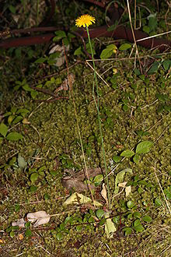

Toxic Weed
Catsear (Hypochaeris radicata or Hypochoeris radicata),
also known as flatweed, cat's ear or false dandelion, is
a perennial, low-lying herb often found in lawn. The plant
is native to Europe, but has also been introduced to the
Americas, Japan, Australia and New Zealand. The plant is also known as false dandelion, as it is commonly mistaken for true dandelions. Both plants carry similar flowers which form windborne seeds. However, catsear flowering stems are forked and solid, whereas dandelions possess unforked stems that are hollow. Both plants have a rosette of leaves and a central taproot. The leaves of dandelions are jagged in appearance, whereas those of catsear are more lobe-shaped and hairy. Both plants have similar uses.
Catsear is considered a noxious weed in pastures and lawn. Currently it is only classified as noxious - not toxic or harmful for livestock. However, Hypochaeris (presumably this species) is suspected of causing stringhalt in horses if consumed in excess. Stringhalt Is a sudden flexion of one or both hind legs in the horse. It is most easily seen while horse is walking, or trotting. Best while backing up slowly, turning on affected leg, or suddenly frightened. It involves one or both hind limbs. It is a spasmatic contraction of the lateral extensor tendons of the hind legs.

Edited by Extension Horse Specialist Ann Swinker, The Horse Newsletter publishes articles on the many facets of horse health, management, Penn State equine events related to the horse industry in Pennsylvania. More about the Penn State Horse Newsletter...
http://www.das.psu.edu/research-extension/equine/penn-state-horse-newsletter
PSU Equine Events:
FREE webcasts, “My Horse University” visit the site for live webcasts. www.myhorseuniversity.com
Equine Environmental Short Courses:
West Chester, PA, March 8, 15 and 29th,
Montgomery County, Kulpsville, Pa March 10, 17 and 31st,
Berks County, April 15 th
Northampton County March 24 ^{th}
Contact: Donna Foulk at dlf5@psu.edu or 610-746-1970 or Cheryl Fairbairn at 610-696-3500

Penn State Equine Science Showcase and Registered Quarter Horse Sale, April 30, 2011.
Penn State Ag Arena, University Park, PA.
http://www.das.psu.edu/research-extension/equine/quarterhorses/sale/sale

Farrier Clinic: Limb Length Disparity at Penn State Ag Arena Park Ave., May 28, 2011
Ann Swinker at 814-865-7810, email: aswinker@gmail.com or Randy Rider at 814-574-3196, email: ridershorseshoeing@gmail.com

Welcome to the 2011 e-Tips brought to you by My Horse University and eXtension/horses. Everyone is outside riding and training their equine companions, getting ready for the fall season of trail rides, horse show and more. Visit this website:
This publication is available in alternative media on request. The Pennsylvania State University is committed to the policy that all persons shall have equal access to programs, facilities, admission, and employment without regard to personal characteristics not related to ability, performance, or qualifications as determined by University policy or by state or federal authorities. It is the policy of the University to maintain an academic and work environment free of discrimination, including harassment. The Pennsylvania State University prohibits discrimination and harassment against any person because of age, ancestry, color, disability or handicap, national origin, race, religious creed, sex, sexual orientation, gender identity, or veteran status. Discrimination or harassment against faculty, staff, or students will not be tolerated at The Pennsylvania State University. Direct all inquiries regarding the nondiscrimination policy to the Affirmative Action Director, The Pennsylvania State University, 328 Boucke Building, University Park, PA 16802-5901; Tel 814-865-4700/V, 814-863-1150/TTY.Produced by Department of Dairy and Animal Science

