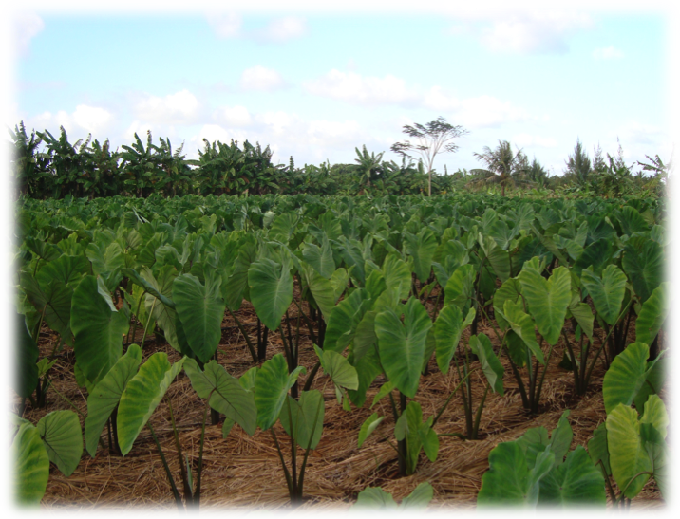

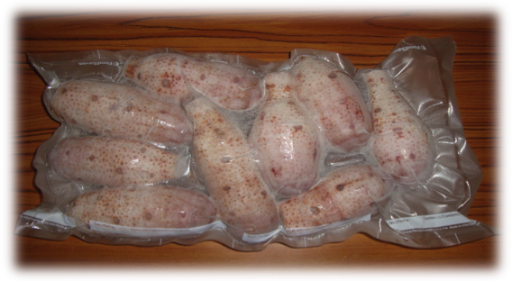
⇨
⇨
THE DEVELOPMENT OF THE
“READY TO COOK FROZEN TARO”
PRODUCER: ASAP OGUMORO
Technical Advisor: Dr. Jang Kim

Time: 9:00am – 12:00am
Place: As Paris Restaurant
Date: 3/15/11

