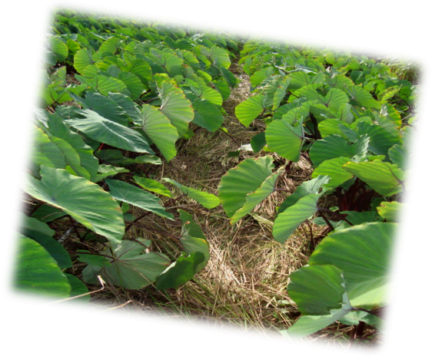

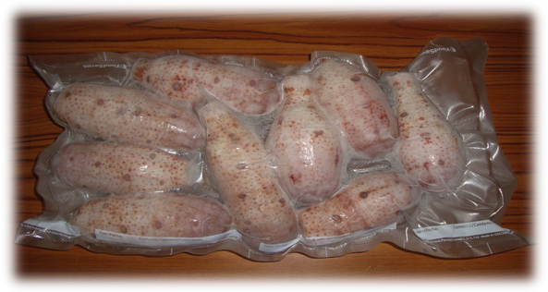
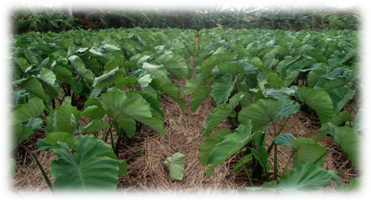
Sponsored by NMC CREES &
WSARE
Producer: Asap Ogumoro, Marianas Farmer
Technical Advisor: Dr. Jang Kim, NMC CRESS

Vacuum Machine, Stainless steal manual peelers 2”-3” blade width, vacuum sealer sanit bags
Select healthy taro plants to harvest. Wash and clean
off roots and soil.
Peel exterior (skin) off the corm using stainless steel
manual peelers.
Preserving our Local Crops, 2011
“Ready to Cook Frozen Taro”
2011

Nutritional Information

Packaging Tips
Tools:
Step 1
Step 2
Step 3
Place peeled corm in vacuum sealer bag. Insert open portion of the bag into the vacuum machine’s sealer section. Make sure bags are sealed properly. Place sealed bags into freezer units.
Nutritional Value per 100grams | 1 Month Frozen Taro  (Dry Season) | 6 Month Frozen Taro  (Rainy Season)
Calories | 141 | 157
Carbohydrates | 33.07 | 36.03
Protein | 1.13 | 2.26
Fat | .50 | .44
Sodium | 30.2114 | 27.4412
Trans Fat | 0 | 0
Saturated Fat | .1893 | .1639

