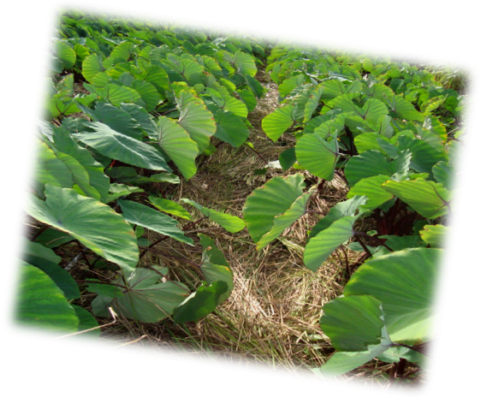
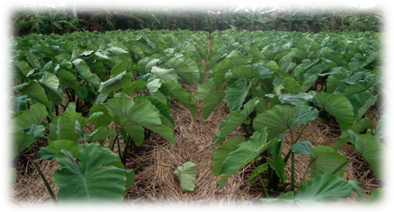

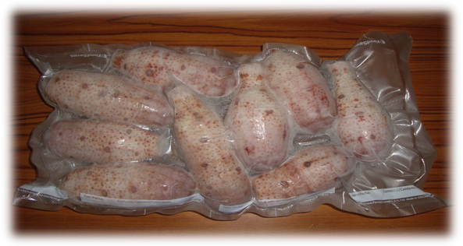
Sponsored by NMC CREES &
WSARE
Producer: Asap Ogumoro, Marianas Farmer
Technical Advisor: Dr. Jang Kim, NMC CRESS

Objective:
Preserve and extend the shelf life on fresh taro
Design a post harvest method
Quality:
Has a package shelf life of at least 6 months of more
Appearance: Natural color is has been maintained
Taste:
- Has an acceptable taste as fresh harvested taro
Nutritional Value:
- Is pending
Bed your taro rows 8-12 inches high, fertilize at the same time, mulch between
rows 3-5 inch thick.
Preserving our Local Crops, 2011
“Ready to Cook Frozen Taro”
2011

Packaging Taro

Helpful Growing Tips
Month
1st Month
2nd Month
Harvest
Choosing one or two months prior to rainy season to plant taro.
Cultivate your cropland, plant your seedlings 1foot apart
Observe the changes in leaf coloration and shrinkage, good signs for maturity and harvest.

