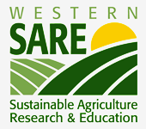
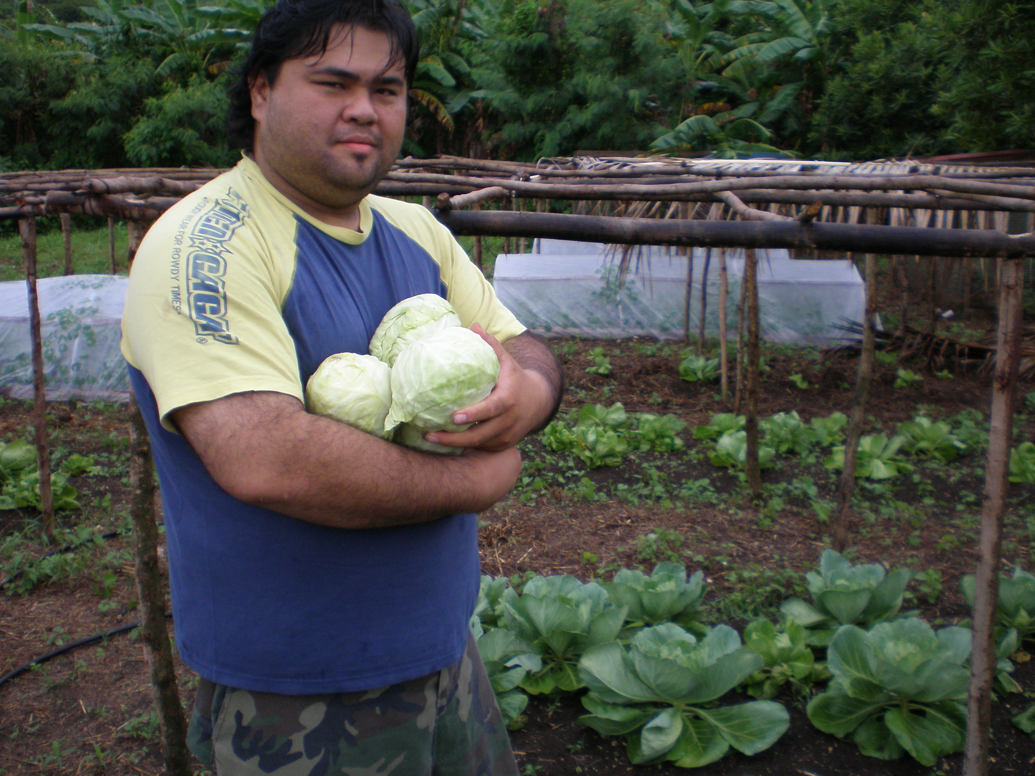

Growing Head Cabbage Using an Integrated Farming System
Field Day @
NMC-Rota Campus, Tatachog Area
(July 14, 2011).

Date: July 14, 2011

To: All Interested Participants
From: Mr. Joshua Calvo – Farmer Rancher

Re: Invitation

July 14, 2011 Time: 9:00 AM to 12:00 NOON

Welcoming of Participants: By: Mr. Joshua Calvo & his staff.
Plantation Field Tour: By Joshua Calvo/Felix Calvo - Producer/Technical Advisor
Refreshment will be provided!!!

