NE-SARE Final Report
Maximizing natural enemy-provided control in no-till, field crop systems
Tooker-Penn State

Figures

Fig. 1. Slug-damage rating on corn planted at A) Criswell Acres or B) LARC. See text for details.

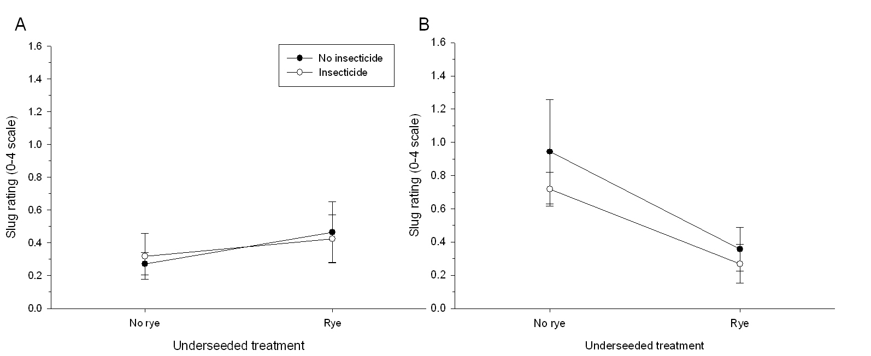

Fig. 2. Total number of beetles trapped at A) Criswell Acres and B) LARC. See text for details.
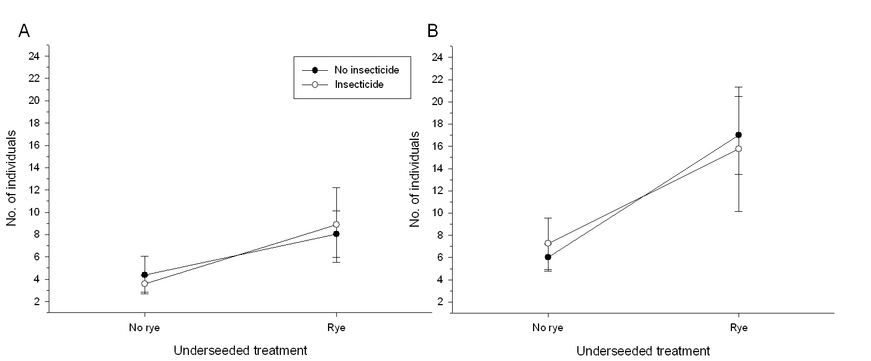

Fig. 3. Number of representative beetle species trapped. A) Harpalus pensylvanicus at Criswell Acres; B) Bembidion quadrimaculation oppositum at LARC. See text for details.
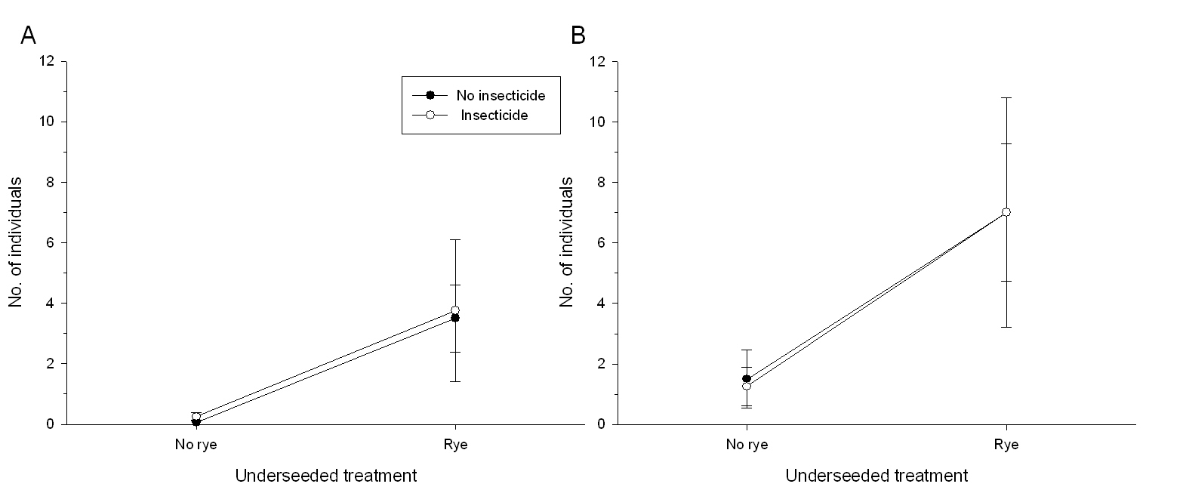

Fig. 4. Influence of the underseeded crop and insecticides on yield at the two sites: A) Criswell Acres, B) LARC.
