Reading the Farm Workshop 1-year Follow-up Survey

Sent electronically to 32 workshop participants and facilitators in December 2011. Eighteen individuals responded to the survey.

1. Which of the following agencies or organizations do you work for?

Agency/Organization | # of respondents
Cooperative Extension / University | 8
Natural Resource Conservation Service | 8
Conservation District | 0
Private Consultant | 0
Other (please specify) | 2
‘Other’ responses included Chesapeake Bay Program Advisory Committee and Penn State Public Broadcasting

2. Within the last year, did you deliver any educational programs to farmers that included knowledge or experience you gained at the Reading the Farm program? If yes, please estimate the number of farmers that attended these programs.

Affiliation of Respondent | # Yes | # No | # Not Applicable | # Not Sure | # of farmers who attended the programs
Cooperative Extension / University | 3 | 2 | 2 | - | 450
NRCS | 2 | 5 | - | 1 | 5
Other | 1 | 1 | - | - | 299
Total | 6 | 8 | 2 | 1 | 754

3. Within the last year, did you deliver any educational programs to other ag service providers that included knowledge or experience you gained at the Reading the Farm program? (Ag service providers include individuals that work for Extension, NRCS, Conservation Districts, ag consultants, ag industry, etc.) If yes, please estimate the number of ag service providers that attended these programs.

Affiliation of Respondent | # Yes | # No | # Not Applicable | # Not Sure | # of farmers who attended the programs
Cooperative Extension / University | 4 | 2 | 2 | - | 718
NRCS | 2 | 5 | 1 | - | 14
Other | - | 2 | - | - | -
Total | 6 | 9 | 3 | - | 732

4. A major emphasis of the Reading the Farm workshop was understanding how components of whole-farm systems interact. If you delivered educational programs within the last year using knowledge about whole-farm system interactions gained at the Reading the Farm workshop, which components of whole-farm systems were included in your educational programs? Check all components that were included in your programs.

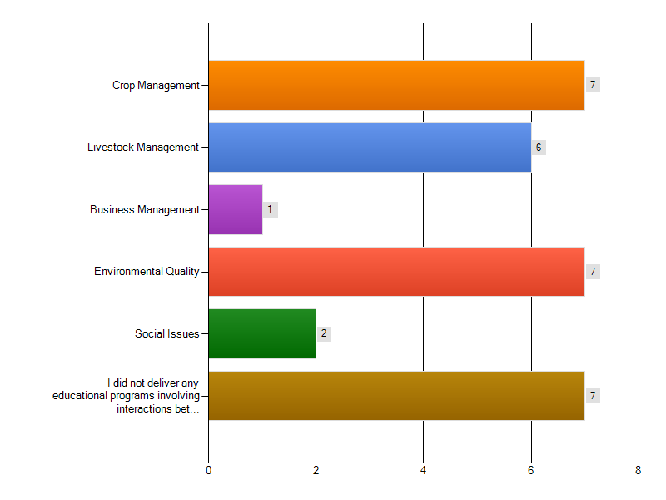
# including each component

5. Briefly list the specific topics of the educational programs you delivered to farmers or ag service providers that included knowledge or experience you gained at the Reading the Farm workshop.

- Using cover crops for forage
- Organic Farming systems, using one of the RTF farms as a case study
- Ag 101 NRCS training program
- Benefits of inclusion of cover crops into Northeast cropping systems (multiple field days, spring and fall 2011)
- Performance of cover crops grown during past year (Keystone Crops Conference)
- Potential for rolling vertical tillage in Mid-Atlantic cropping systems (Crops Diagnostic Clinic).
- Subsurfer Solution is a video on manure management. The subsurfer equipment injects dry poultry manure and environmental sustainability.
- BMP, Livestock Health and Management, Water/Soil quality benifits, Ecconomics and social interaction with farmers.
- This has been something I have continually kept in mind and talked about with my colleagues especially in regards to working with new farmers but also advanced growers, primarily for organic vegetable growers. I have used this in my introduction to organic vegetable classes and farm planner classes to help new farmers think about how their goals fit the environment and markets they are in. Just today in a group discussion of service providers we talked about using this type of swot analysis. I have not specifically presented on whole farm planning but have integrated it into the way I present and think about my work with new farmers.
- Integrating animal feeding systems with land use and matching animals to land opportunities.

6. Have you developed any educational materials (newsletter articles, fact sheets, power points, etc.) that included knowledge or experience you gained at the Reading the Farm workshop? If yes, please briefly describe the materials that you created.

- Powerpoint about organic farming systems, using one of the RTF farms as a case study
- Handouts about forage quality of cover crops
- Powerpoint about cover crop management in forage based cropping systems
- Three or four Field Crop News articles completed during 2011; these were focused on cover cropping on-farm field trials and practices. These are catalogued in the Field Crop News archives on the Crop Mgt Team's website.
- The videos produced are educational materials. The two videos are the Subsurfer Solution and the Conewago Creek Visioning Video that is targeted at a watershed community, including all community members. URL links follow:
Subsufer Solution: http://www.youtube.com/watch?v=V6IHAS4Ng6o
Conewago Creek: http://www.youtube.com/watch?v=N__fbWH4-go
- I have developed powerpoints in which I have shared knowledge gained from this workshop with high school students in agriculture classes. I have also shared powerpoints with College Classes for students in the natural resources fields.

7. To what extent did the Reading the Farm training improve your ability to help farmers implement aspects of sustainable agriculture during the last year?

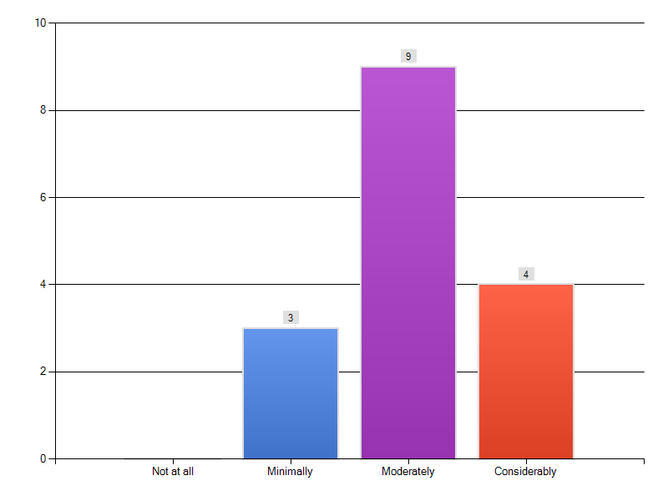

8. Do you have any significant success stories of using knowledge and experience you gained at the Reading the Farm workshop to help farmers implement aspects of sustainable agriculture within the last year? If yes, please describe below.

- In my role as Chair of the Chesapeake Bay Program Science and Technical Advisory Committee, the knowledge was instrumental in assisting me to fund appropriate workshops and reviews on agricultural issues. During this phase of TMDL planning, this knowledge was critical to the committee.
- Getting a better understanding of Organic Farm Systems has given me a better understanding of challenges that Organic Farmers face and considerations that I previously had not contemplated
- I had a much better understanding about looking at the farm as a whole after the training. I use the knowledge learned, everyday, but no specific stories.

9. Have you had any significant challenges integrating knowledge and experience gained at the Reading the Farm workshop into your work with farmers and other ag service providers? If yes, please describe below.

- The main challenges are the intensity of the process with limited resources and other commitments. We have made a plan to use this process more with a farm visit approach but it has not happened really yet.

10. Are there any resources or follow-up activities related to the Reading the Farm workshop that could be planned that would be beneficial to you? If yes, please describe below.

- Short farm visits to other locations, to continually supplement and refresh that knowledge, would be wonderful.
- It would be great to receive more schooling on how our ag economists use future contracting and other marketing tools to lock-in prices for grain and other farm products being sold through the farm gate.
- It would be fun to do this again on a much different type of farm - ie vegetable CSA?
- I feel that this training is a really good introduction, and that the rest is picked up in the field over time.

11. Are there other comments you have regarding the impact of the Reading the Farm workshop?

- One of the best parts of the workshop was the informal discussions and exchanges among the farmer hosts and other participants. I gleaned numerous tips about forage based cropping systems which I now regularly include in my extension programs related to cover crop use on small dairy farms.
- I thought the workshop was very good compared to other trainings I have attended in the last year. I enjoyed comparing each of the farms and seeing what could work for each. I think adding an additional day would be beneficial because topics were crammed in at times. Very good training overall
- It was an exceptional experience. It was well-organized, focussed, and almost overwhelming in the amount of substantive content. Excellent job.
- For many who have spent years working with farmers, many of the concepts that were shared during the RTF workshop were not "new". However, it was great to have the opportunity to spend time with colleagues from other disciplines to learn some of the new ideas within that discipline, to improve our understanding of concepts that we know at least something about, or to receive some reinforcement that the many concepts/ideas that we've known and shared with our farmer and ag professional clientele remain current.
- Great program. Thanks to all the folks that put it together.
- The Reading the Farm workshop has positively impacted my understanding of all of the variables that farmers need to consider and contend with on a daily basis. The experience plays a role in how I approach and interact with farmers and the questions I pose to them to understand their experiences.
- The course was extremely helpful and changed my understanding of how to work well with my farmer colleagues. I think it has changed my approach more than the content of my work.
- Really good training to learn about inventory and evaluation of resources and concerns.

