Making Your Compost Product Work for You!

FREE Compost Marketing Workshop/Field Day
Concord, New Hampshire • Saturday, March 26

Whether selling compost is your primary business or a side business, this workshop is for you! The workshop will provide marketing insights and sales techniques, including technical information on compost applications and benefits, feedstocks, quality standards, and marketing principles. Learn tips on developing a marketing plan for your compost operation, how to position your product, the ins-and-outs of compost market segments, bulk sales vs. bagged, distribution strategies, and making money on tipping fees. Sales strategies will also be covered, including sales points, using social media and new media techniques, branding, and customer education tips.

The workshop is free, but all attendees must register by March 23. Capacity is limited to 25. Please bring brown bag lunch; refreshments/dessert provided. To register or find out more information, contact Athena Lee Bradley at 802.254.3636 or by email at athena@nerc.org.

When: Saturday, March 26, 9:30 am – 4 pm
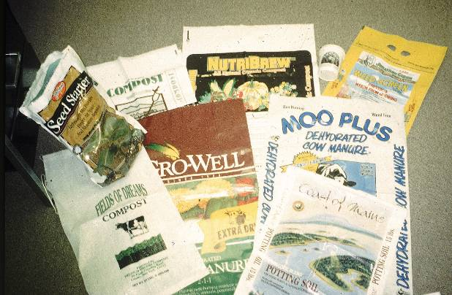
Where: Unitarian Universalist Church of Concord
274 Pleasant Street
Concord, NH 03301-2551
Presenters:
Bob Kelly
Seacoast Farms Compost Products, Inc.
www.seacoastcompost.com.

Peter Schmidt
Compostwerks LLC
www.compostwerks.com
Athena Lee Bradley
Northeast Recycling Council, Inc.
www.nerc.org

Harry Lewis
Lewis Farm
www.lewisfarmnh.org

Sponsors

- Northeast Recycling Council, Inc.,
- Northeast Organic Farming Association New Hampshire (NOFA NH)

Funding for the workshop is from the Northeast SARE (Sustainable Agriculture, Research, and Education).

