New York Workshop Provides Compost Marketing Training
Marketing is an essential component of any business and business plan. Financial lenders want accurate information about potential markets, sales potential, etc. A well-done marketing plan demonstrates a clear understanding of production, capital requirements, costs, market segments, alternative markets, customer needs and purchasing habits, and the competition. Successful marketing of compost requires a foundation of knowledge about compost—benefits to potential customers, uses for compost, the composting process, and compost characteristics, as well as marketing principles.

In a recent workshop offered by the Northeast Recycling Council, Inc., a wide range of compost marketing principles were presented. The workshop was held on January 12 in Ithaca, New York at Cornell Waste Management Institute. Despite an unexpectedly powerful snow storm, 36 people from around the state of New York, Vermont, and Pennsylvania braved the weather to attend. Presenters included Jean Bonhotal, Associate Director, Cornell Waste Management Institute; Dr. Robert Rynk, SUNY Cobleskill, Agricultural Engineering Department; and Mark Wittig, Cayuga Compost. Sponsors for the workshop included NERC; Cornell Waste Management Institute; SUNY Cobleskill; and the New York State Department of Environmental Conservation
A previous compost marketing workshop was held in Millerton, New York in March 2010, hosted by McEnroe Organics. Speakers included: Sally Rowland, Ph.D., P.E., NYSDEC, Division of Solid & Hazardous Materials; Jean Bonhotal, Cornell Waste Management Institute; Charles Duprey, WeCare Organics, LLC and Athena Lee Bradley, NERC. More than 50 people attended the event, representing public and private compost operators, consultants, and others from New York, Vermont, Pennsylvania, and Connecticut.
Both events featured a lively roundtable discussion involving all participants which provided valuable insight into the many issues affecting compost operations. A free CD resource toolkit was distributed to workshop participants. Resources include:
- Making Your Compost Product Work for You
- Model Marketing Plan Template, an MS Word document
- Compost Marketing Resources
The workshops provide marketing insights and sales techniques, including technical information on compost applications and benefits, feedstocks, quality standards, and marketing principles. Developing a marketing plan, product positioning, compost market segments, distribution and sales strategies, and making money on tipping fees are also presented.

NERC is offering eight compost marketing workshops in New Jersey, New York, Massachusetts, and New Hampshire. Funding for the workshops and NERC’s Compost Marketing project is from the Northeast SARE (Sustainable Agriculture, Research, and Education). NERC is also providing free technical assistance to farm-based compost operators in marketing. Resources developed by NERC for the project, as well as presentations from the workshops, are posted on NERC’s Compost Marketing Webpage. For additional information, contact Athena Lee Bradley, NERC Projects Manager.

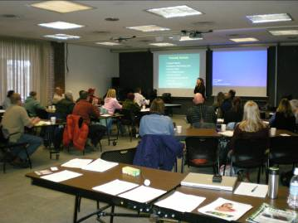
Compost Marketing Workshop
Cornell Waste Management Institute

