NERC’s First Compost Marketing Workshop in New Jersey
The workshop—Making Your Compost Product Work for You!—will provide an overview of best management practices in composting designed to make a quality marketable product. Marketing insights and sales techniques, including technical information on compost applications and benefits, feedstocks, quality standards, market segments, marketing principles, and distribution strategies will be covered. Participants in the workshop receive a Resource Toolkit on a CD containing hundreds of compost marketing and general compost operation management articles and technical papers.

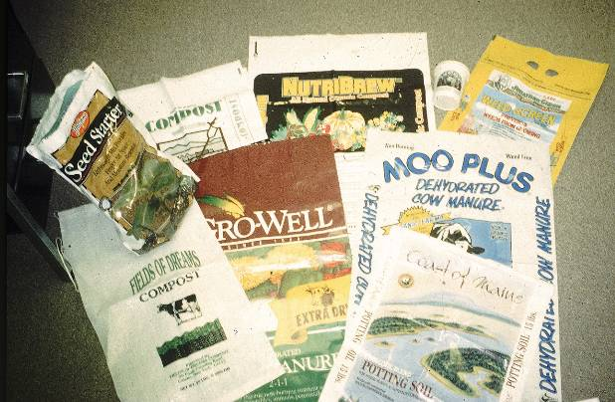
The workshop is being held on Friday, January 28, 2011 from 9:30 am – 4:00 pm at Duke Farms in Hillsborough, NJ. Presenters include:
Michael L. Westendorf, Ph.D., PAS
Extension Specialist in Animal Sciences, Rutgers University; Loren S. Muldowney, M.S.
Staff Scientist Rutgers/NJAES Soil Testing Lab; Erich V. Bremer, Supervisor, Organic Certification Program, New Jersey Department of Agriculture
Division of Marketing and Development; and Athena Lee Bradley, NERC staff.

Sponsors for the workshop are NERC; the Northeast Organic Farming Association of NJ; and the New Jersey Department of Environmental Protection.

The workshop is one of eight that NERC is offering in New Jersey, New York, Massachusetts, and New Hampshire. All workshops are free. Funding for the workshops and NERC’s Compost Marketing project is from the Northeast SARE (Sustainable Agriculture, Research, and Education). Resources developed by NERC for the project, as well as presentations from the workshops, are posted on NERC’s Compost Marketing Webpage.

To register or for more information, contact Athena Lee Bradley by email or at 802.254.3636.
Ebulletin and NERC Home page March 2011
Free Compost Marketing Workshops Offered in New Hampshire & Massachusetts
Whether selling compost is your primary business or a side business, these workshops are for you! The workshops will provide marketing insights and sales techniques, including technical information on compost applications and benefits, feedstocks, quality standards, and marketing principles.
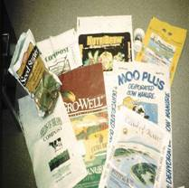
Learn how to develop a marketing plan for your compost operation, how to position your product, the ins-and-outs of compost market segments, bulk sales vs. bagged, distribution strategies, and making money on tipping fees. Sales strategies will also be covered, including sales points, using social media and new media techniques, branding, and customer education tips.
This workshop is being offered twice in March — Concord, NH, on March 26, and Wrentham, MA, on March 28. Funding for the workshops is from the Northeast SARE (Sustainable Agriculture, Research, and Education) program.
Concord, NH — Saturday, March 26 from 9:30 to 4:30
Unitarian Universalist Church of Concord
274 Pleasant Street, Concord, NH
Presenters: Bob Kelly, Seacoast Farms Compost Products, Inc.; Peter Schmidt, Compostwerks LLC; Harry Lewis, Lewis Farm; and Athena Lee Bradley, NERC. The workshop will include a tour of the Lewis Farm Compost Operation.
Sponsors: USDA SARE, NERC, and the Northeast Organic Farming Association New Hampshire
The workshop is free, but all attendees must register by March 23. Capacity is strictly limited to 25. Please bring your own brown bag lunch; beverages and dessert provided. To register or for more information, contact Athena Lee Bradley at 802.254.3636, or by email.
Wrentham, MA — Monday, March 28 from 9:00 to 4:00
Wrentham Developmental Center
7 Littlefield Road, Graves Hall, Wrentham, MA
Presenters: Geoffrey Kuter, Agresource, Inc.; John Engwer, Groundscapes Express, Inc.; and Athena Lee Bradley, NERC. The workshop will include a tour of Wrentham Farm (Groundscapes Express, Inc.).
Sponsors: USDA SARE, NERC, and the Massachusetts Department of Environmental Protection
The workshop is free, but all attendees must register by March 23. To register or for more information, contact Athena Lee Bradley at 802.254.3636, or by email. Lunch can be purchased for $10, but must be ordered at the time of registering. Otherwise please bring your own bagged lunch. Beverages provided.
For more composting marketing information and presentations from previous workshops visit NERC’s Compost Marketing Webpage. For more information, contact Athena Lee Bradley, NERC Projects Manager.
Two Previous NERC Workshops on Compost Marketing Training Well Attended
The two workshops mentioned above are part of a series of eight that NERC is offering in New Jersey, New York, Massachusetts, and New Hampshire through the SARE funding. Two others — held in New York and New Jersey in January — were very well attended. In fact, so many registrations were received that a waiting list was required.
A wide range of compost marketing principles were presented at the workshops. Topics included: the importance of compost quality; compost as a commodity; market sectors; product positioning; volume vs. value markets; distribution and delivery options; making money from tipping fees; establishing a fair market return; finding a niche; meeting customer needs; branding; social marketing; customer education tips; and sales principles and strategies.
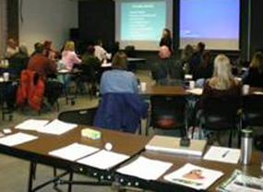
Compost Marketing Workshop
Cornell Waste Management Institute
The first workshop was held in Ithaca, New York, at the Cornell Waste Management Institute. Despite an unexpectedly powerful snow storm, 36 people from New York, Vermont, and Pennsylvania braved the weather to attend. Presenters included Jean Bonhotal, Associate Director, Cornell Waste Management Institute; Dr. Robert Rynk, SUNY Cobleskill, Agricultural Engineering Department; and Mark Wittig, Cayuga Compost. Sponsors for the workshop included NERC, the Cornell Waste Management Institute, SUNY Cobleskill, and the New York State Department of Environmental Conservation
The second workshop, attended by 33 people, was held at Duke Farms in Hillsborough, New Jersey. Presenters included Dr. Michael L. Westendorf, Rutgers University, Department of Animal Sciences; Loren S. Muldowney, Staff Scientist Rutgers/NJAES Soil Testing Lab; Erich V. Bremer, Supervisor, Organic Certification Program, New Jersey Department of Agriculture, Division of Marketing and Development; and Athena Lee Bradley, NERC. Sponsors for the workshop were NERC, the Northeast Organic Farming Association of NJ, and the New Jersey Department of Environmental Protection.
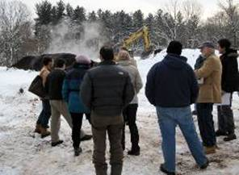
Tour of Mulch Facility at Duke Farms
A free CD resource toolkit is provided to workshop participants. Resources include:
- Making Your Compost Product Work for You
- Model Marketing Plan Template
- Compost Marketing Resources
Resources developed by NERC for the project, as well as presentations from the workshops, are posted on NERC’s Compost Marketing Webpage.
Compost Marketing Workshops a Success with Participants
Effective marketing can influence whether a company survives in today’s economy or not. This is true in any business, including compost. Compost operations must compete with other compost operations, as well as gardening supply centers and retail stores selling multiple brands of compost, peat moss, and fertilizers. NERC’s compost marketing workshops offer participants marketing insights and sales techniques, technical information on compost applications and benefits, quality standards, marketing principles, and customer education. Developing a marketing plan, product positioning, compost market segments, distribution and sales strategies, and making money on tipping fees are also discussed.
NERC organized two recent compost marketing workshops. The first was held in Concord, New Hampshire in March. The workshop was co-sponsored by the Northeast Organic Farming Association New Hampshire (NOFA NH). Twenty-three people participated.
Presenters included:
- Athena Lee Bradley, NERC staff
- Bob Kelly, Seacoast Farms Compost Products, Inc.
- Peter Schmidt, Compostworks, LLC
The workshop was followed by a tour of Lewis Farm Composting and a talk given by Harry Lewis about his operation and marketing.
A second workshop, in Wrentham, Massachusetts, was also held in March, in conjunction with the annual Massachusetts Organic Summit. Sponsors for the workshop were NERC and the Massachusetts Department of Environmental Protection. Forty-two people participated.
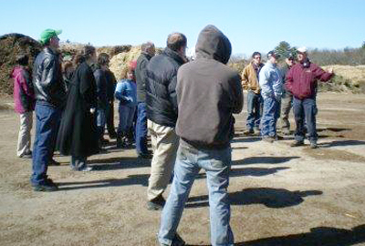
Above: Compost marketing workshop participants tour the Groundscapes Express Inc. compost facility. Below: Wrentham, Massachusetts workshop.
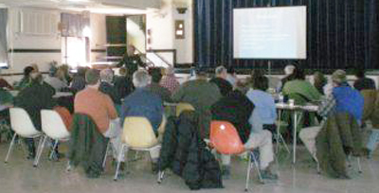
Presenters included:
- Athena Lee Bradley, NERC staff
- Geoffrey Kuter, Agresource, Inc.
- Gary Mottau, Groundscapes Express, Inc. (Wrentham Farm)
The workshop was followed by a tour of Groundscapes Express and an overview of the operation presented by Butch Goodwin, Operations Manager.
To date, NERC has held six compost marketing workshops in Massachusetts, New Hampshire, New Jersey, and New York, with 231 participants from states around the Northeast. Funding for the workshops and NERC’s Compost Marketing project is from the Northeast SARE (Sustainable Agriculture, Research, and Education). One final workshop will be held in August in Massachusetts. The date is yet to be determined.
Networking opportunities, interaction with presenters, Q&A, and a roundtable with all participants are features of each of the workshops. Additionally, workshop participants receive a “CD toolkit” of resources on composting, marketing principles, and compost marketing specifics. Participants are asked to complete a questionnaire at the end of each workshop. The questionnaire inquires about current operation and marketing, marketing needs, and how the workshop may have helped them. Reviews of the workshops have been overwhelmingly favorable and successful in meeting the marketing skills training goals of participants in the workshops.
Toolkit resources and workshop presentations can be found on NERC’s Compost Marketing Web page.
For more information, contact Athena Lee Bradley, Projects Manager.

