1. General Information:

Project Title: Triple-cropping dairy forage production systems through conservation tillage in California’s San Joaquin Valley

Participants:

Jeff Mitchell Department of Plant Sciences, University of California, Davis, Kearney Agricultural Center, 9240 S. Riverbend Avenue, Parlier, CA 93648 Telephone (559) 646-6565, Fax (559) 646-6593, mitchell@uckac.edu
Marsha Campbell-Mathews Cooperative Extension Stanislaus County, University of California, 3800 Cornucopia Way, Suite A, Modesto, CA 95358 (209) 525-6800 mcmathews@ucdavis.edu
David Crohn Department of Environmental Sciences, University of California, Riverside, 92521 (951) 827-3333, David.Crohn@ucr.edu
Carol Frate Cooperative Extension Tulare County, University of California, 4437 S. Laspina Street, #B, Tulare, CA 93274, (559) 685-3303, cafrate@ucdavis.edu
William Horwath Department of Land, Air, and Water Resources, 3226 Plant and Environmental Science Building, One Shields Avenue, Davis, cA 95616 (530) 754-6029, wrhorwath@ucdavis.edu
Anil Shrestha Department of Plant Science and Mechanized Agriculture, California State University, Fresno,
Danny Petersen Aldon Petersen and Sons, N. Central and Fulkerth Avenues, Turlock, CA 95380 (209) 664-0749
Frank Gwerder Gwerder Dairy, 825 S. Hart Road, Modesto, CA 95358, (209) 579-5723
Dino Giacomazzi Giacomazzi Dairy, 9530 6th Avenue, Hanford, CA (559) 381-8125 dino

Funding Amount: $118,100 (But roughly half of this amount was returned to WRSARE)

2. Project Summary:

Excess nitrate in groundwater under California dairies is common and recent regulations prohibit applications of nitrogen in excess of 140% of crop removal. This standard will force many dairies out of business if they cannot acquire additional land. Triple-cropping, - growing three forage crops annually, - theoretically utilizes more manure nutrients on the same ground and provides more feed, but is dependent on timely harvests and crop turnover. We evaluated triple-cropping as a means to address both economic and environmental stewardship goals in field studies in important dairy counties in California’s San Joaquin Valley.

3. Introduction:

The problems of the dairy industry in California are currently quite complicated and difficult. Despite its being ranked first among US states in milk production and the longstanding and major contributions it makes to the State’s agricultural productivity (CDFA, 2006), California’s dairy industry currently faces monumental challenges that reach ultimately to its very survivability. The industry as a whole experienced a net loss of 68 dairies in 2006, compared to 2005 (CDFA, 2006). Fuel costs and environmental concerns that have recently led to significant air and water quality regulations aimed at the industry have been identified as major issues of sustainability (CDFA, 2006), however, more recent losses of forage corn that is being diverted as biofuel feedstocks, are also exerting additional pressures on this very vulnerable sector within California’s agricultural landscape. In addition, recent large-scale exporting of US forages to Asia and the Middle East has resulted in high feed costs for California dairy producers (Mooney, 2010).
New water quality regulations recently introduced by California’s Regional Water Quality Control Boards in March 2007,also impose strict requirements for nutrient management at dairies and demand increased production and resource use efficiencies as well as evidence of reduced negative off-farm impacts. Using conservation tillage practices to “triple-crop” forage production may be a potentially useful management tool to help sustain the California dairy industry and to improve dairy forage production efficiencies. While the use of CT is developed and established to some extent in many other regions of the US, CT is not at all widely used in California at this time. Surveys conducted by the University of California’s Conservation Tillage and Cropping Systems Workgroup, which includes farmer, private sector, NRCS and University members, indicate that less than 2% of annual crop acreage in California’s Central Valley was farmed using CT approaches in 2004, and yet more than 20% of dairy silage acreage used either strip-till or no-till practices in 2010, largely as a means to cut costs (Warnert, 2011). Such systems, - if they are shown to be profitable and productive within the dairy forage sector may in essence, provide completely new management systems for California’s dairy industry. (Personal communication, Dino Giacomazzi, Hanford, CA).

Although the Regional Water Quality Control Board (RWQCB) now projects triple-cropping of forages to be a higher risk factor for nitrate leaching than traditional double-cropping systems, this management option has not yet been tested as a means for reducing N contamination risk in California’s San Joaquin Valley. The RWQCB allows dairies to fertilize at 40% above annual crop uptake without restriction. Because triple cropped systems are likely to assimilate more nitrogen than double-cropped systems, triple-cropped systems are eligible to receive more dairy nutrients. RWQCB staff are concerned that elevated application rates associated with triple cropped systems may be associated with greater nitrate pollution potential. RWQCB staff therefore intend to pay special attention to triple-crop systems, and this scrutiny is expected to discourage triple-cropping by farmers.

The disincentive to triple-crop is ironic, because prudent triple-cropping is likely in theory to protect both ground and surface water. Triple-cropping reduces erosion by providing soils with additional vegetative cover. Although triple-cropping increases expected annual nitrogen uptake and therefore allows more nitrogen because the total N loading in the triple-crop system is thought to be higher, it is likely that that triple-cropping may actually be less of a risk for leaching losses because greater amounts of N may conceivably be captured, removed and recycled through the additional crop. The organic fraction of dairy manure mineralizes nitrogen continuously. Most of the nitrogen mineralized in between conventionally managed crops will be leached to groundwater during preirrigation. A third crop theoretically reduces this threat by providing a sink for mineralized nitrogen.

There is no information available on the relative benefits or risks of triple-cropping in SJV dairy forage production fields on N balance, storage and loss. Additionally, the scheduling of lagoon water and dry manure applications should account for expected mineralization rates from the soil organic nitrogen pool. Mineralization rates are known to be highly temperature-dependent. It is also likely that the organic nitrogen associated with lagoon water will decompose more rapidly than that in dry manure. Application rates and schedules should take organic nitrogen mineralization rates into account in order to closely meet the needs of developing crops. In this WRSARE project, we therefore collected field data on silage crop growth and development and N uptake to evaluate the potential of triple-cropping as an N management strategy for SJV dairies.

4. Objectives/Performance Targets:

The objectives of this project were:

- to increase the reliability of triple-cropping dairy forage production with the use of CT practices as a means of increasing forage biomass and nutrient uptake by determining production rates and N removal in triple-cropped forage fields compared to standard double-cropped fields,
- to evaluate triple-cropping compared to standard double-cropping forage production in terms of whole dairy nitrogen budgets and profitability,
- to extend widely information developed by the project to dairy farmers, consultants and industry groups via a variety of extension education means including four field days annually at farms of partner farmers, distribution of an electronic CT forage production newsletter via the California Conservation Tillage Workgroup’s website http://groups.ucanr.org/ucct/, production of a DVD video on CT and forage triple-cropping that will be provided to 500 SJV dairy farmers during the course of this proposed work, distribution of four “popular press” summary articles on this work annually to dairy industry publications such as Western United Dairymen, California Dairy Coalition, Hoard’s Dairy, and Dairy Business Journal, development of training materials on CT forage production that will be produced by UC’s Agriculture and Natural Resources Communication Services in their peer-reviewed 8000 Series and that will be used as part of the twice-annual educational events of the California Dairy Quality Assurance Program, publication of a peer-reviewed article on the work in an appropriate scientific journal such as the Agronomy Journal, the Journal of Environmental Quality, or California Agriculture, and presentation of results as part of our CT Workgroup’s involvement in the World Ag Expo held every second week in February in Tulare, CA with an expected “draw” of over 10,000 visitors, and
- to track changes in the adoption of CT forage production practices in the SJV as evidenced by CT acreage surveys conducted by California’s CT Workgroup and CT equipment sales records

5. Materials and Methods:

A. Dairy Silage Farm Experience with Conservation Tillage (Objective 1)

While one farmer partner working with us on this study was already using triple-cropping that was accomplished by quick intercrop disking, the use of strip-tillage and no-tillage practices was new for both farmers. Throughout the course of the study, we thus recorded assessments of the performance of the new conservation tillage systems at both farms and through the eyes of both farmer partners. Our study team was also generally present and provided strip-tillage implements and no-till seeding equipment for each crop.

B. Dairy Silage Field Crop Biomass and N Content Sampling (Objective 2)

From April 2008 through August 2010, we sampled silage crop biomass and determined total crop N content at two dairies in Stanislaus County in California’s San Joaquin Valley. The owners of these dairies, Frank Gwerder and Danny Peterson, agreed to work with us in implementing comparisons of standard tillage versus conservation tillage / triple-cropping practices throughout this time. As the study progressed, it turned out that triple-cropping was attempted in both the conventional tillage fields and the conservation tillage fields at both sites in one case because the farmer was already comfortable doing this and in the other case because it made management sense to perform field operations in both fields at about the same time. The Peterson dairy (Turlock, CA) used strip-tillage for the 2008 corn crop, however for each other crop, a shallow one-pass disking preceded each crop in both the conventional and conservation tillage fields. In 2008, sorghum sudan was the late-summer triple-crop at this site, while in 2009 and 2010, the third crop was corn. The Gwerder dairy (Modesto, CA) used strip-till for each corn crop and no-tillage for each late-summer sorghum sudan and winter wheat silage crop in the conservation tillage field and traditional intercrop disking in the conventional field (Table 1).

Table 1. Crops produced at triple-crop study dairies in Stanislaus County, CA 2008 – 2010
 |  | 2008 |  | 2009 |  |  | 2010
Modesto
 | Conventional tillage | corn | sorghum sudan | wheat | corn | sorghum sudan | wheat | corn | sorghum sudan
 | Conservation tillage | corn | sorghum sudan | wheat | corn | sorghum sudan | wheat | corn | sorghum sudan
Turlock
 | Conventional tillage | corn | sorghum sudan | wheat | corn | corn | wheat | corn | corn
 | Conservation tillage | corn | sorghum sudan | wheat | corn | corn | wheat | corn | corn
Throughout each season, aboveground crop biomass was sampled, dried and weighed at about two-week intervals. For each corn crop, the total biomass in three separate 1 m crop row distances was sampled (generally about 7 – 9 plants within each 1 m row length) and for each sorghum sudan and wheat crops, three 1m² quadrats were sampled. Data for each sampling date are thus the means of these three subsamples from each field and are presented as lbs biomass per acre. After biomass weighing, the material was ground into a powder and the total N content of the entire aboveground sample was determined at the UC Davis Analytical Laboratory using the combustion method (AOAC Official Method 972.43).

C. Extension Education (Objective 3)

Our efforts and activities related to Objective 3, extension education, are described under “Publications/Outreach” below.

D. Conservation Tillage Acreage Survey (Objective 4)
Surveys of tillage management practices comparing annual row and field crop acreage farmed under different tillage systems throughout the 8-county Central Valley region of California were conducted as part of this WRSARE project in 2008 and 2010. Over 35 local NRCS, University of California and private sector experts were surveyed and results were compared with County Agricultural Commissioner cropland acreage for each year. Previous surveys have been conducted in 2004 and 2006.

Data in this survey were compiled for two general types of conservation tillage. Tillage practices such as no-till, strip-till, ridge-till and mulch-till, that leave at least 30% of the residue from previous crops in place on the soil surface are the typical forms of conservation tillage that are recognized throughout the world. In addition to these practices, “minimum tillage” practices that reduce the overall number of tillage passes by at least 40% relative to what was done in the year 2000, are also included in our tally of conservation tillage acreage.

6. Results and Discussion/Milestones:

Triple-crop biomass data for the period from spring 2008 – fall 2010 are shown in figures 1 and 2. Total dry biomass during this time under triple-cropping at the Modesto dairy was 60,412 lbs/ac (Figure 1) and 58,363 lbs/ac for the Turlock dairy (Figure 2). If we assume that the late-summer triple-crop is not produced, as would be the custom at the majority of dairies currently, then about 8,601 lbs/ac less biomass would have been generated at the Modesto dairy and 12,919 fewer lbs/ac at the Turlock dairy over the course of this study (Photo 1).

Again, if we assume that triple-cropping is not done, this would mean that at the Modesto dairy there would be roughly 164 fewer days in 2008 and 84 fewer days in 2009 when a crop would not be growing in a silage field. For the Turlock dairy, there would be 107 fewer days of cropping in 2008 and 141 fewer days in 2009.
Our biomass tissue N content data are not complete at this time and thus determinations for some key sampling dates are missing. However, if we use N content values from the most prior available monitoring date for missing values, preliminary projections indicate that under the simulated triple- versus double-cropping scenarios of this investigation, 329 lbs of N more would be taken up in a triple-cropped scenario during the 2008 – 2010 monitoring period at the Modesto dairy and 239 lbs of N more would be removed by triple-cropping at the Turlock dairy.

A number of significant learning experiences occurred during the course of this study with respect to the adoption of conservation tillage management systems for silage production in San Joaquin Valley dairies. As stated above, these were the first efforts by either of our farmer partners with either strip-till corn or no-till sorghum sudan and wheat planting techniques, and as a result, several ‘learning curve’ issues were confronted . In the 2008 corn crop at the Turlock dairy, strip-tilling and seeding were conducted to produce commercially adequate crop stands (Data not shown) (Photo 2), however, very prominent yellow veining of leaves and crop stunting occurred which were traced to a Mn deficiency in the strip-till crop (Photo 3). We are not though convinced of the actual reason for this deficiency and whether or not it was linked to the strip-till system or some other cause. A foliar Mn solution was applied by ground rig and the crop recovered to some extent, however, the partner farmer subsequently preferred his single-pass intercrop disking practice to strip-tillage and did not resume strip-tillage during the remainder of the project.

Another difficulty related to the use of conservation tillage occurred at the Modesto dairy concerning corn planting directly along the strip-tilled row. At this dairy, we relied on a custom operator who had GPS and large-enough horsepower tractors to pull the strip-tiller. Though there were never any noticeable or detectable crop stand losses due to strip-tilling at either farm, Frank Gwerder believed that alignment problems between the strip-till and seeding passes may have been a partial contributor to the generally lower strip-till yields that he has had (Photo 4). In addition, in the video we are now producing for release by June 2012 on conservation tillage dairy silage production systems, in a videotaped interview with Frank Gwerder, he suggests that subsoil compaction may also be a negative outcome of using conservation tillage in his evaluation field. We have no recent bulk density or soil penetrometer data to test this possibility, but we do intend to use a multi-probe tractor-mounted penetrometer this spring in his side-by-side study fields to determine the possible extent to which compaction has built up (Photo 5).

In our 2010 survey of tillage management, conservation tillage systems accounted for about 14% of the acreage for the crops that were surveyed including silage and grain corn, small grains for hay, silage and grain, tomatoes, cotton, dry beans, and melons throughout the nine-county Central Valley region (Table 2). This was an increase from about 10% in 2008. Minimum tillage practices were used on about 33% of crop acreage in 2010, also up from about 21% in 2008.

The largest change in conservation tillage acreage over the 2004 – 2010 period is found in the amount of corn silage acreage that uses strip-tillage. In 2004, there were only about 490 acres of summer silage corn using strip-till, while in 2010 over 103,000 acres throughout the San Joaquin Valley dairy region had adopted the use of this form of conservation tillage. The overall use of minimum tillage practices has also greatly increased during this time from about 64,000 acres under reduced pass tillage in 2004 and just over 700,000 acres under minimum tillage in 2010. A full and detailed report of the tillage acreage survey is available at our website http://ucanr.org/sites/ct/

Table 2. California conservation tillage acreage survey (2010) for tomatoes, cotton, edible dry beans, silage corn, grain corn, and small grains for grain, hay and silage, December 15, 2011

 | > 30% Residue Cover after Planting |  |  |  | >40% reduction in total passes | < 30% Residue Cover after Planting | Total Acreage | CT %
Total | No Till | RT/ST | Mulch Till | CT Total | Minimum Tillage | Conventional Tillage | Total Acreage | CT %
Fresno County | - | 1,280 | 3,331 | 4,611 | 148,800 | 389,688 | 394,299 | 1%
Kern County | - | - | 711 | 711 | - | 220,504 | 221,215 | 0%
Kings County | 3,037 | 54,498 | 32,154 | 89,689 | 44,156 | 228,157 | 317,846 | 28%
Madera County | 100 | 14,909 | - | 15,009 | - | 46,511 | 61,520 | 24%
Merced County | 3,000 | 18,100 | 19,866 | 40,966 | - | 227,928 | 268,894 | 15%
Sacramento | 620 | 559 | 1,866 | 3,045 | 3,568 | 46,913 | 49,958 | 6%
San Joaquin | 2,100 | - | - | 2,100 | 150,260 | 276,440 | 278,540 | 1%
Tulare County | - | 68,478 | 12,270 | 80,748 | 305,184 | 340,382 | 421,130 | 19%
Yolo County | 23,530 | - | 26,069 | 49,599 | 49,792 | 47,295 | 96,894 | 51%
Total | 32,387 | 157,824 | 96,267 | 286,478 | 701,760 | 1,823,818 | 2,110,296

7. Impacts of Results/Outcomes:

There are several impacts that stem directly from this WRSARE-supported project that should help inform future dairy silage production and manure N management practices in San Joaquin Valley dairies in California. The most immediately useful and direct impact this study will soon have is that it has provided data sets for silage biomass and N content under the alternative triple-crop management strategy versus traditional double-cropping that our team is now using in simulation runs of the fate of N in dairy fields using the APTRAKER and NBOT models that project partners David Crohn and Marsha Campbell-Mathews have been developing over a number of years. This will be a significant outcome that our data will serve and contribute to. In this project, we have provided important data for N uptake by intensified production of silage materials that we believe can be used by APTRAKER and NBOT to lead to better manure management strategies in San Joaquin Valley dairy silage fields in the very near future. Answering whether or not conservation tillage enabled triple-cropping makes good sense as a strategy for reducing the risk of NO₃⁻ leaching to groundwater in silage fields should, we suggest, be now based on better data that this study has generated.

Another important outcome from this project is the finding of Mn deficiency in the 2008 strip-till corn crop at one of our conservation tillage silage evaluation sites. While this occurrence proved to be quite devastating to the productivity of the strip-till system, it was the first and so far only situation in California in which this outcome has been documented. This finding now becomes part of the growing set of issues needing further investigation and elucidation as to its actual cause and whether or not other related practices such as proposed nutrient acquisition disruptions in plants by herbicides may be somehow responsible.

This study must, however, be seen as important step, - yet only one step, - in the overall process of designing improved silage production systems in California’s Central Valley dairy corridor. Other factors such as the actual finessing in terms of rates and timing of manure and lagoon water applications in silage fields based on simulation model runs that our team will now conduct to optimize crop management so as to reduce the risk of nitrogen losses to groundwater and also the actual feed quality characteristics that may be associated with different double or triple-cropping systems will need to be evaluated in more detail to better help dairy producers manage nitrogen in their systems. There will also be a clear need to further refine and optimize triple-crop strategies in terms of the timing of seeding, selection of crop varieties and the deliberate use of harvesting equipment and strategies to reduce soil compaction.

8. Economic Analysis:

Our current analyses indicate that the expected annual cost savings that may be expected from using strip-till or no-tillage relative to conventional tillage practices in California dairy silage production systems are about $70/ac (T. Barcellos, Personal communication). The savings associated with this estimate result largely from fewer tractor passes across a field, less labor required, and less diesel fuel being used. We will be consolidating the economic data related to conservation tillage silage production for the video we are now producing on this subject and also in a follow-up peer-reviewed publication that will summarize findings from this study and some of our other related work on conservation tillage systems for silage production. We have an agricultural economist from the University of California, Davis working on this dimension of our work with us.

With the savings from reductions in tillage though, would come additional expenses associated with seeding and producing a third crop within an annual silage production scenario. Detailed economic comparisons of alternative tillage management systems that consider the entire cost/benefit tradeoffs will be part of the video and peer-reviewed output from this basic WRSARE-supported work.
It is important to recognize that considerable recent work on the adoption process and on farmer decision-making and change strongly suggests that complex innovations such as conservation tillage and triple-cropping do not exclusively occur for solely economic reasons (Vanclay and Lawrence, 1998; Vanclay, 2004). There tend to be various amalgamated drivers for change that of course include economic motivators, but that are not limited to these factors exclusively. Once ‘combinations of perceived benefits’ of using conservation tillage for dairy silage production come together sufficiently for producers to motivate them to change their production practices and behaviors, then we will expect an even greater increase in the use of these systems in the historically tillage-intensive San Joaquin Valley. We are in the process of conducting an analysis of a survey that has been completed by over 500 Central Valley producers, including many dairy farmers to better understand what both the perceived benefits and the constraints to adoption of conservation tillage cropping systems are. This WRSARE-funded work has allowed us to directly partner and work with two leading dairy farmers in the San Joaquin Valley and there have been several benefits that have been realized in this work related to the adoption process of alternative production systems. We intend to bring these together as part of the video series project we are now working on.

9. Publications/Outreach:

Two major products that will result from this work that are now being prepared are a video on ‘CT silage production’ that we are working with the company North By Northwest out of Spokane, WA and one and possibly two peer-reviewed papers that we are now preparing based on the general findings and modeled outcomes from the work developed in this WRSARE project. We hope to complete these two large outcomes by June 2012. Our current plan is to produce either an extension article on conservation tillage silage production systems or a suitable summary research article for our University’s California Agriculture quarterly journal based on the findings of this study and other recent work in dairy silage systems, and to also produce additional peer-reviewed outcomes from the modeling work. Other extension education activities conducted in conjunction with this project are listed below.

December 19, 2011. 174-word summary of our triple-crop work for a ‘Nitrogen Fact Sheet’ that is being developed by University of California Communication Services as part of a soon-to-be-released press release on UC work on dairy stewardship issues.

April 19, 2011. Invited presentation. Strip-till field day. Poldevardt Dairy, Artois, CA. 20 participants.

February 8, 9, and 10, 2011. Conservation tillage and cropping systems Workgroup M-52 extension education site at the 2011 World Ag Expo in Tulare, CA. Provided extension education display.

December 29, 2010. Provided telephone and email content information for Alison Andrews. Progressive Forage Magazine on conservation tillage silage production in California.

October 26, 2011. Strip-tillage provides farmers with money-saving option. FW06-308. SARE Grant Report article in AG ALERT. California Federation of Farm Bureaus.

October 2, 2010. Strip-till grows among farmers in California. No-till Farmer Magazine.

June 28, 2010. Dairy silage conservation tillage farm tour to Bar-Vee Dairy, Turlock, CA and Correia Family Dairy, Santa Nella, CA. 15 participants.

June 29, 2010. Dairy silage conservation tillage farm tour to Barcellos Dairy, Tipton, CA and Giacomazzi Dairy, Hanford, CA.

July 12, 2010. Conservation tillage silage production expanding in California’s San Joaquin Valley. Web publication for Progressive Forage.

March 23, 2010. CT silage production in California. Heritage Center. World Ag Expo. Tulare, CA

January 28, 2010. Conservation tillage silage production systems. Invited presentation. Wilbur Ellis/Monsanto Grower Meeting. Willows, CA. 30 participants.
February 3, 2010. California Plant and Soil Conference. Conservation tillage dairy production. Tulare, CA. 30 participants.
February 17, 2009. Recent work on conservation tillage dairy forage production. CSU Chico. Chico, CA.

February 10, 11, and 12, 2009. Recent activities of the Conservation Tillage Workgroup. 2009 World Ag Expo, Tulare, CA.

10. Farmer Adoption:

Based on the experience and information developed in this project, intensified and expanded work on triple-cropping silage systems is warranted in the San Joaquin Valley. This work, we propose, should take on two directions or applications. First, the simulation modeling work that we have already initiated that will make use of the silage production and N uptake date we present here, is very much needed to further elucidate the complete ‘risk/benefit’ assessment of attempting triple-cropping or intensified silage production rotations based on tighter turnovers between crops. This work is needed and in fact is critical to validate or further evaluate the insertion of an additional crop within an annual cycle in terms of N loading and loss potential. Second, in order for additional San Joaquin Valley dairy farmers to take up conservation tillage with triple-cropping, the growing list of potential benefits of such practices needs to be more broadly ‘made acceptable’ as a legitimate production and business model or option to producers. With an increase in the adoption of strip-tillage in the San Joaquin Valley from 2004 to 2010 of about 100,000 acres, there is clearly a growing experience base of successful adopters that now exists. Nonetheless, there is still a relatively large sector of producers who remain quite skeptical of the applicability of conservation tillage practices to their production systems. If the N management benefits of triple-cropping are borne out in our upcoming modeling work, and if it makes sense to intensify silage cropping as a means to remove greater quantities of N from dairy corrals, then this outcome, in and of itself, may well serve as a very large incentive to broader adoption. We also note that there has been progress during the course of this project at Gwerder Dairy in Modesto with respect to securing yields in the no-till winter small grain silage wheat crop relative to the conventionally seeded wheat crop. We have continued to monitor the progress at both dairies and the 2010 – 2011 no-till wheat actually performed slightly better than the dairy’s conventional wheat. Improvements occurred, according to Frank Gwerder, due to improved weed management early season as well as better timed fertilization.

11. Areas Needing Additional Study:

As noted above, we believe that the basic data collected in this study can now be quite readily used to model actual costs or benefits of triple-cropping as a potential means for mitigating N loss risk from dairy silage fields. We also believe that additional attention is needed to address the corn Mn deficiency issue that surfaced in a conservation tillage field in this project.

Accomplishments/Milestones: What work has been accomplished to date and what work is left to do?

With this report, we have made good on the original objectives of our project: learning and experience with conservation tillage dairy silage production systems has increased and has been expanded throughout new areas in the San Joaquin Valley, critically-important data on silage biomass productivity and N uptake using triple-cropping have been compiled, surveys of conservation tillage management in the region have been completed, and outreach based on the findings of this work has been conducted. What remains to be done is use these data in simulation model runs to further evaluate both economic and environmental tradeoffs of triple-crop silage production systems.
Impact and Contributions/Outcomes: How does this research, demonstration, training or activity benefit producers or consumers in the Western region?

This WRSARE project adds greatly to the experience and knowledge base for conservation tillage in the historically tillage intensive San Joaquin Valley. It provides key crop growth and N content data that are now being used in simulation model runs to evaluate the impacts of intensified silage production in the region on N loss to the groundwater. It has identified issues such as Mn deficiency in corn silage that had previously not been documented in San Joaquin Valley conservation tillage fields and that now warrant further study. Finally, this work has provided a key focus and significant learning related to successful conservation tillage systems for silage production throughout the region.

References:

AOAC Official Method 972.43. Microchemical Determination of Carbon, Hydrogen and Nitrogen. Automated Method. In. Official Methods of Analysis of AOAC International, 18th edition. Revision 1. 2006. Chapter 12. Pp. 5-6. AOAC International. Gaithersburg, MD.

CDFA. 2006. California Dairy 2006: Statistics and Trends.

Mooney, R. 2010. Hay export outlook brightens. Asia, Middle East and China may buy more U.S. hay. Hay and Forage Grower. http://hayandforage.com/marketing/archive/0201-hay-export-outlook/

Vanclay, F. 2004. Social principles for agricultural extension to assist in the promotion of natural resource management. Australian Journal of Experimental Agriculture. 44:213-222.

Vanclay, F. and G. Lawrence. 1998. European Journal of Agricultural Education and Extension. Farmer rationality and the adoption of environmentally sound practices: A critique of the assumptions of traditional agricultural extension. 1:(1):59-90.

Warnert, J. 2011. 2011. California conservation tillage acreage increasing. Green Blog. UC work in natural resources, pest management, climate change and sustainable agriculture. December 21, 2011. (http://ucanr.org/blogs/Green/, http://ucanr.org/sites/ct/?blogpost=6429&blogasset=14128 )

Figure 1. Total silage crop biomass at Modesto, CA dairy 2008 – 2010

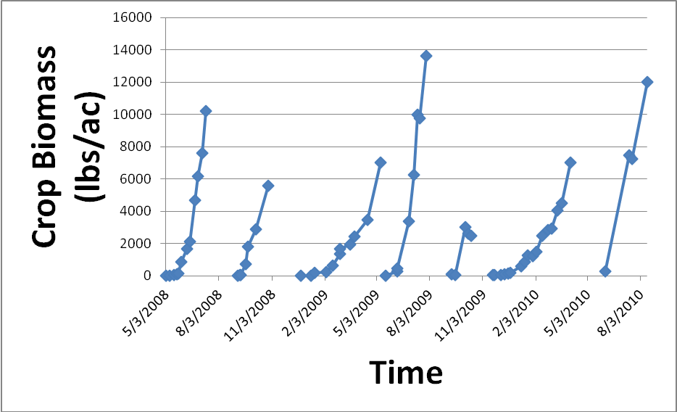

Figure 2. Total silage crop biomass at Turlock, CA dairy 2008 - 2010

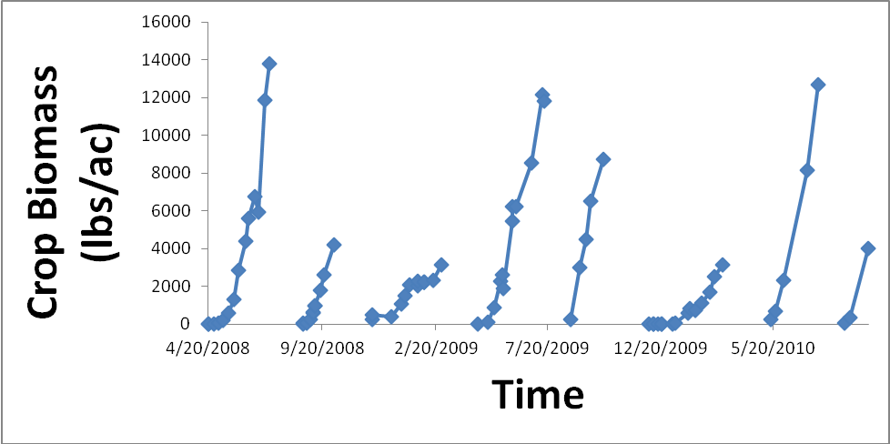

Photos accompanying Final Report text

(Note that additional support photos are being provided to the WRSARE office that can be used in conjunction with this project as well.)

Photo 1
DSC_3230
No-till seeding sorghum sudan triple-crop at Gwerder Dairy, Modesto, CA, August 2008. Conventional corn is in background along left side.

Photo 2

DSC_2808
Stunting of 2008 strip-tillage corn at Peterson Dairy, Turlock, CA

Photo 3
DSC_2814
Yellow leaf veins in 2008 strip-tillage corn at Peterson Dairy, Turlock, CA

Photo 4
DSC_2817
2008 strip-till corn stand at Gwerder Dairy, Modesto, CA

Photo 5
DSC_0393
WRSARE dairy silage triple-crop project partners, Marsha Campbell-Mathews, UC Cooperative Extension Stanislaus County, farmer partner, Frank Gwerder and son, and custom corn planter, David Wheeler, at Gwerder Dairy strip-till evaluation field, Modesto, CA April 2008

