Growing Beets and Carrots Within High Tunnels

Lewis W. Jett¹

Carrots (Daucus carota) and beets (Beta vulgaris) are two popular cool season, root crops for production and marketing in West Virginia. Beets are closely related to spinach and Swiss chard vegetables while carrots are botanically related to celeriac, celery, dill, fennel and parsnips. Beets are a great source of folate while carrots are high in vitamin A.
Like most root crops, beets and carrots do best in a light textured, deep soil without stones. Raised beds, which permit the soil to be relatively deep and loose, are well suited for root vegetables.
Beets and carrots should be seeded early or late enough in the year to grow under cool weather conditions which favors both yield and quality.
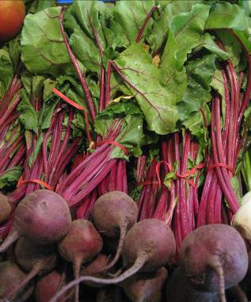
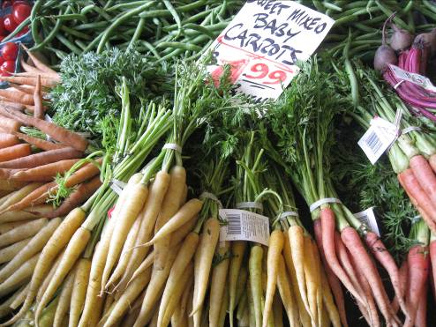
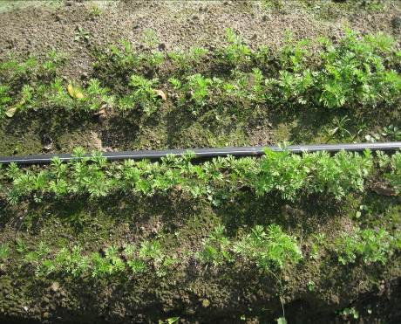

Figure 1. Carrots and beets are a popular cool season crop which can be grown year-round in West Virginia.
.
Choosing a Carrot and Beet:
There are several types of carrots based mainly on shape and intended market use such as fresh market, processing or storage.
Nantes: Carrots which have a long cylindrical shape and blunt tip.
Imperator: Carrots which have long tapered roots and grow best in deep soils.
Chantenay: Carrots which have a thicker, cone-shaped appearance and do well in heavy soils

Beet roots are actually enlarged portions of the stem called the hypocotyl with most modern varieties having a round shape. However, there are some beet cultivars which have a cylindrical shaped root (Table 1). Some beets also have edible foliage and are eaten as greens. Both beets and carrots can be harvested as small vegetables often referred to as “baby vegetables”.

Planting Beets and Carrots:
Beets and carrots grow best in a soil with a pH of 6.0-6.8. Beet “seeds” are actually fruits containing several seeds (Figure 2). Thus, when seeded, beets are typically thinned to one plant. Each seed is planted 1-2 inches apart and thinned to one plant every 3 inches. Beets can be either direct-seeded or transplanted. Beets should be sown beginning 6 weeks before the last spring frost and in August for fall beets in West Virginia. When transplanted, beets are sown in small cell containers and transplanted 4-6 weeks later. Beets are spaced approximately 2-3 inches apart with rows 12-18 inches apart. If the objective is to harvest beet greens for a salad mix, the beets can be broadcast- seeded over a raised bed. When the leaves are approximately 2 inches long, they can be harvested.
Carrot seeds are very small, but pelleted seeds are available which make it easier to sow and reduces thinning labor (Figure 2). The pellet is an inert clay material which dissolves in the soil moisture. In the open field, carrots can be seeded 4-6 weeks before the last frost in spring or 6-8 weeks before the first frost in fall. Seeding rate is approximately 30 seeds per linear foot when using non-pelleted (raw) seed. The seed is sown approximately 0.25 inches deep either in rows or broadcast-seeded. When seeding in rows, the rows are spaced 12-18 inches apart for spring and summer carrots and 6-8 inches apart when growing winter carrots. After emergence, the carrots can be thinned to approximately 1-2 inches apart.

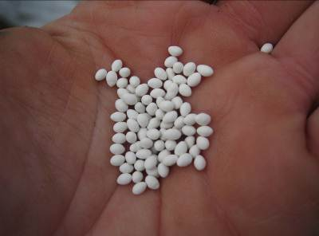
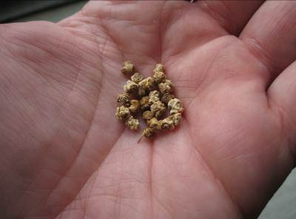
A
B

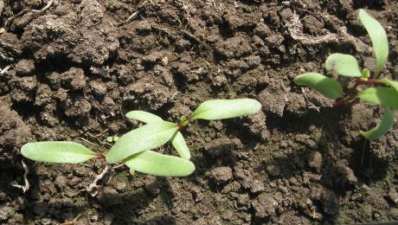
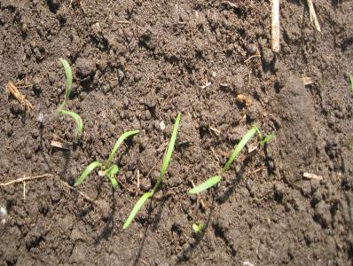
C
D

Figure 2. Pelleted carrot seed (A) and raw beet ‘seed” (B). Carrot (C) and beet (D) seedlings can be thinned soon after emergence.

Planting beets and carrots in low tunnels or high tunnels can significantly lengthen the growing season for both crops (Figure 3). Low tunnels are essentially cold frames which are fabricated from plastic or metal pipe into bows covered with row cover material. High tunnels are walk-in cold frames and can be used to grow and harvest winter beets and carrots. Using high tunnels, beets and carrots can be seeded in September for early winter harvest. The following spring, the beets and carrots can be seeded as early as February 15 for harvest in April. For a continuous supply of beets and carrots, a new seeding is made after the first true leaf appears on the current planting.
After thinning, the carrots and beets should be evenly watered. Drip irrigation is the preferred method of watering beets and carrots since this form of irrigation wets only the soil without wetting the foliage. Approximately 60 lbs/acre of actual nitrogen can be applied before planting with an additional 30 lbs. applied as a sidedress 4-6 weeks after planting. Do not apply nitrogen through the drip lines when growing beets or carrots. Too much nitrogen can reduce quality of both beets and roots. Carrots will fork when the soil is compacted. Uneven soil moisture will cause carrots to be misshapen and have poor color, and beets exhibit a condition called “zoning” which is uneven internal color. Both beets and carrots can be grown on either organic or plastic mulches. Since both crops do not compete well with weeds, the mulches reduce weed competition and soil moisture loss.
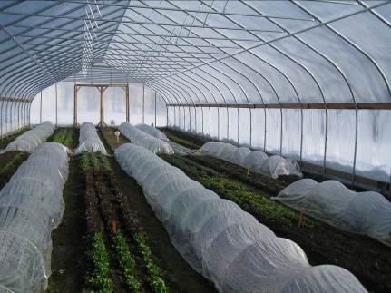
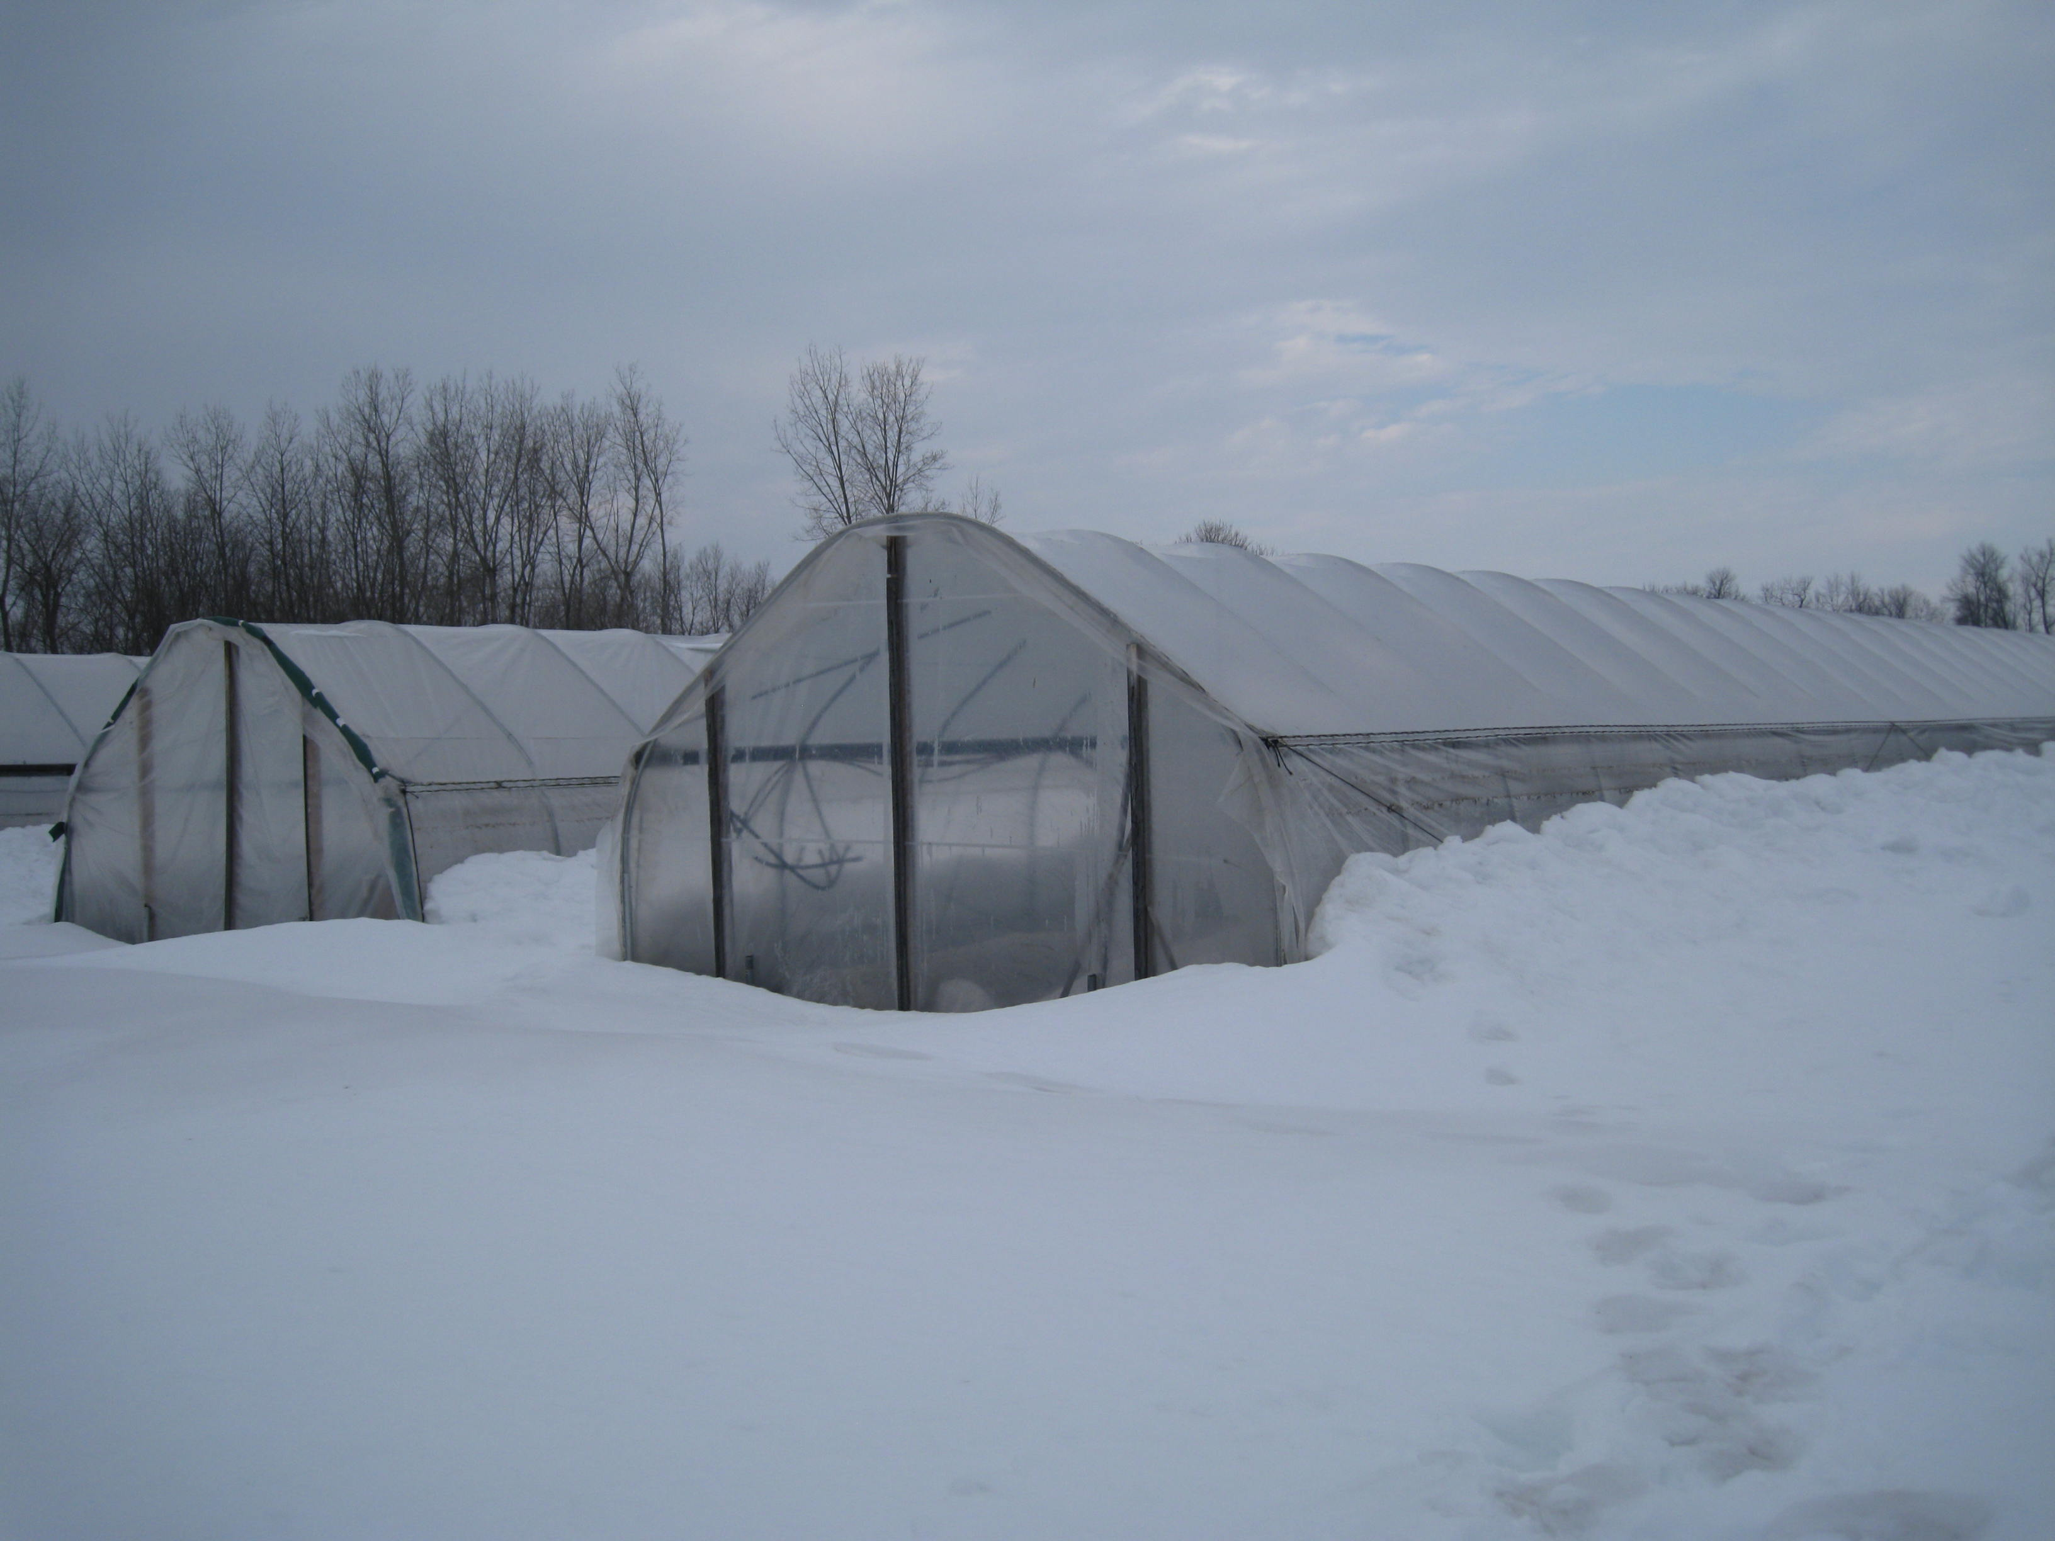

Figure 3. High and low tunnels can be used to grow winter beets and carrots.

Beet and Carrot Variety Selection:
Selecting suitable varieties is a critical decision for any grower. Table 1 lists recommended beet and carrot varieties for West Virginia.

Table 1. Recommended cultivars of beets and carrots in West Virginia.
Cultivar | Relative Maturity  (days) | Comments
Beets:
Early Wonder Tall Top | 45 | Very early beet; edible leaves; good for salads
Bull’s Blood | 60 | Dark red foliage; excellent for beet greens
Chioggia Guardsmark | 60 | Candy-cane striping of beet; very sweet
Kestrel | 53 | Excellent beet for baby beet production.
Red Ace | 53 | Early, high-sugar beet
Pacemaker III | 53 | High-sugar, uniform beet with dark red color
Touchstone Gold | 54 | Uniform golden color beet.
Cylindra | 60 | Long, cylindrical beet
Carrots:
Sugarsnax 54 | 68 | Imperator type with dark orange color
Hercules | 65 | Chantenay type with excellent yield and quality.
Bolero | 75 | Very good winter storage carrot. Nantes type
Napoli | 58 | Early variety. Nantes type.
Yaya | 56 | Early variety. Good flavor. Nantes type.
Rainbow | 67 | Multi-colored mix with good quality.

Winter carrots have a very unique flavor. The slow growth and cool temperatures concentrates sugars in the roots. If carrots cannot be harvested before December in the high tunnel, they can be left in the soil as “in-ground” storage for harvest the following March-April in West Virginia.

Figure 4. Marketable yields of carrot trials in West Virginia-2010.

Harvest and Postharvest Handling:
Carrots and beets can be harvested at any stage in which color or size is optimum. Baby carrots are usually harvested 36-40 days after sowing. Baby beet leaves are often harvested as cut greens for salads. For mature harvest, beets should be approximately the size of a golf ball. The beets and carrots can be gently dug from the soil with a fork or simply pulled. Fall/winter beets and carrots should be dug before the ground freezes. If they are being placed in storage, the tops can be trimmed and the beets or carrots can be lightly washed of soil and placed in boxes or bins until use or market. Optimal storage conditions are 32°F with high (95%) relative humidity.
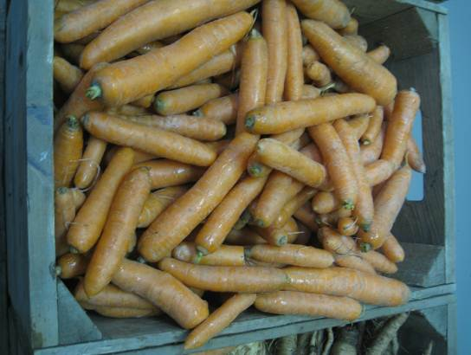
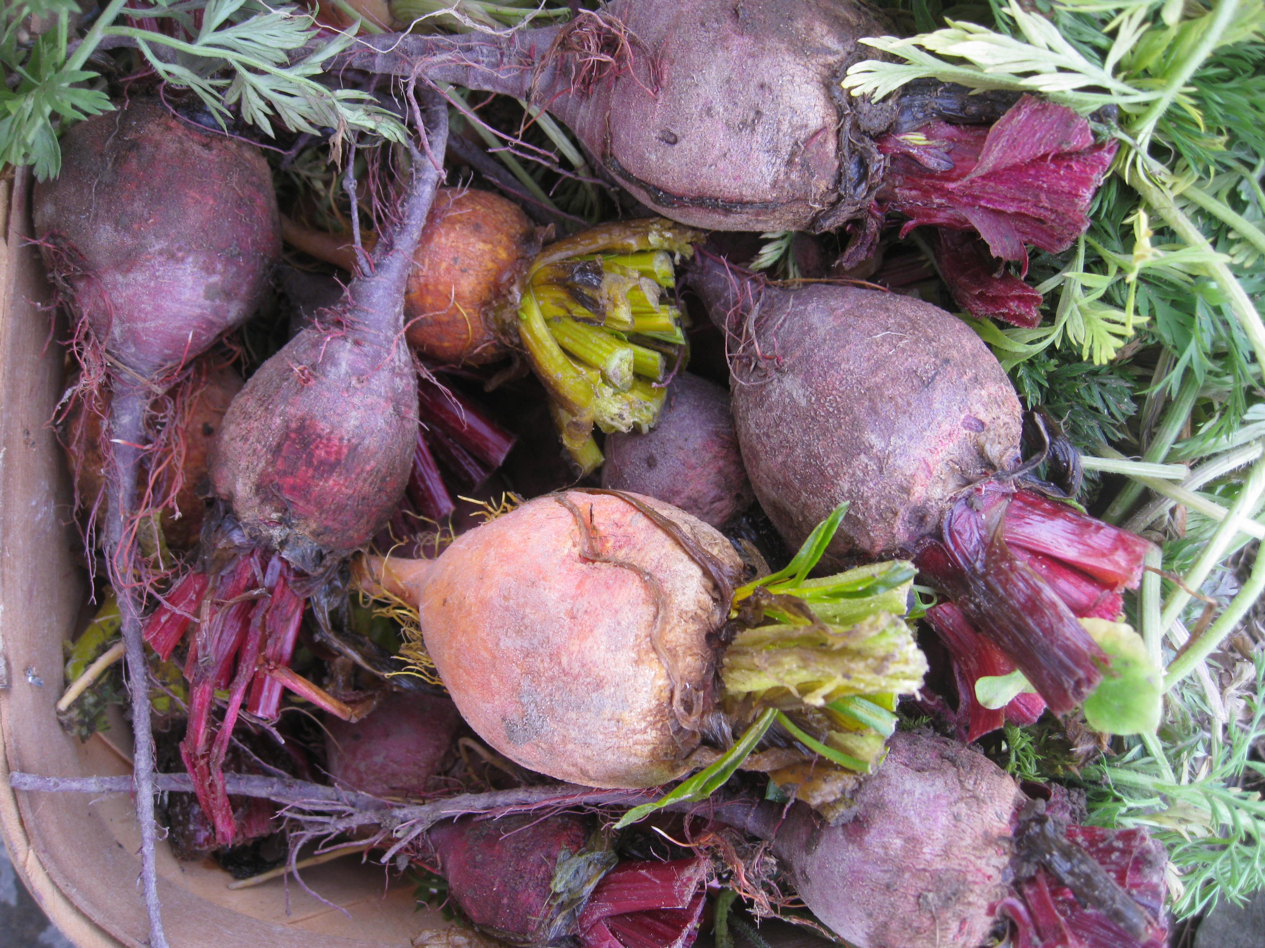

Figure 4. Beets and carrots can be placed in winter storage at 32°F and high relative humidity for extended marketing.
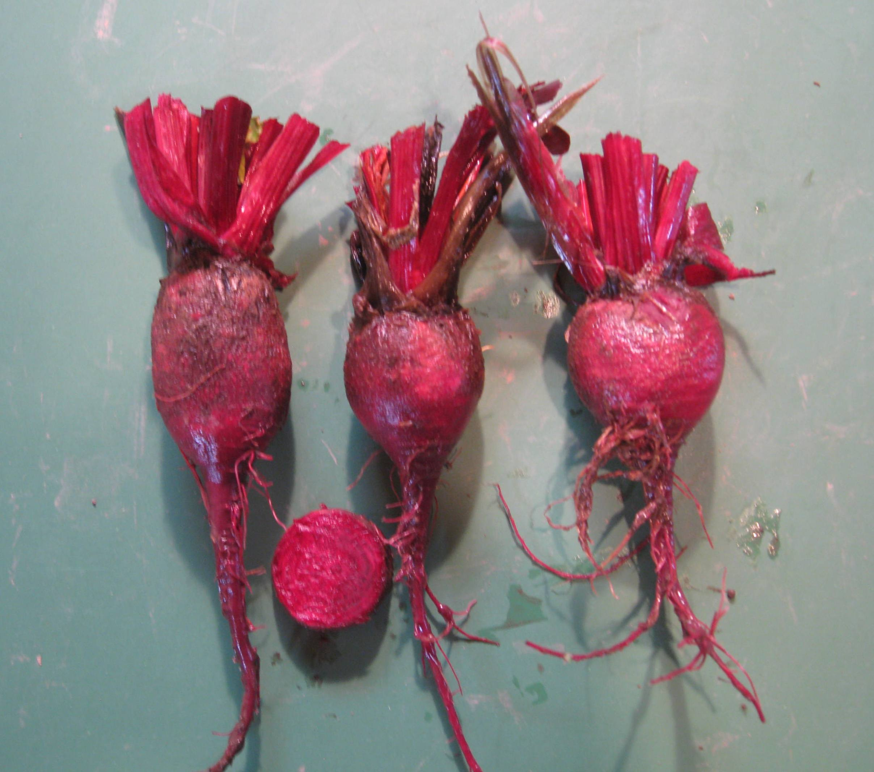
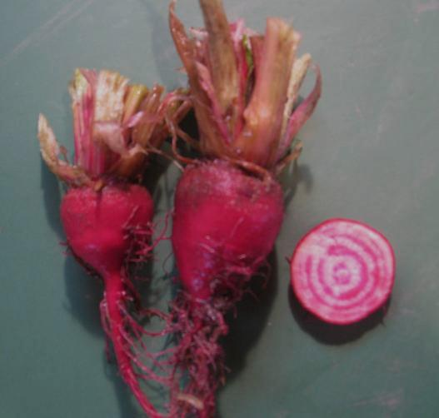
‘Red Ace’
‘Chioggia Guardsmark’

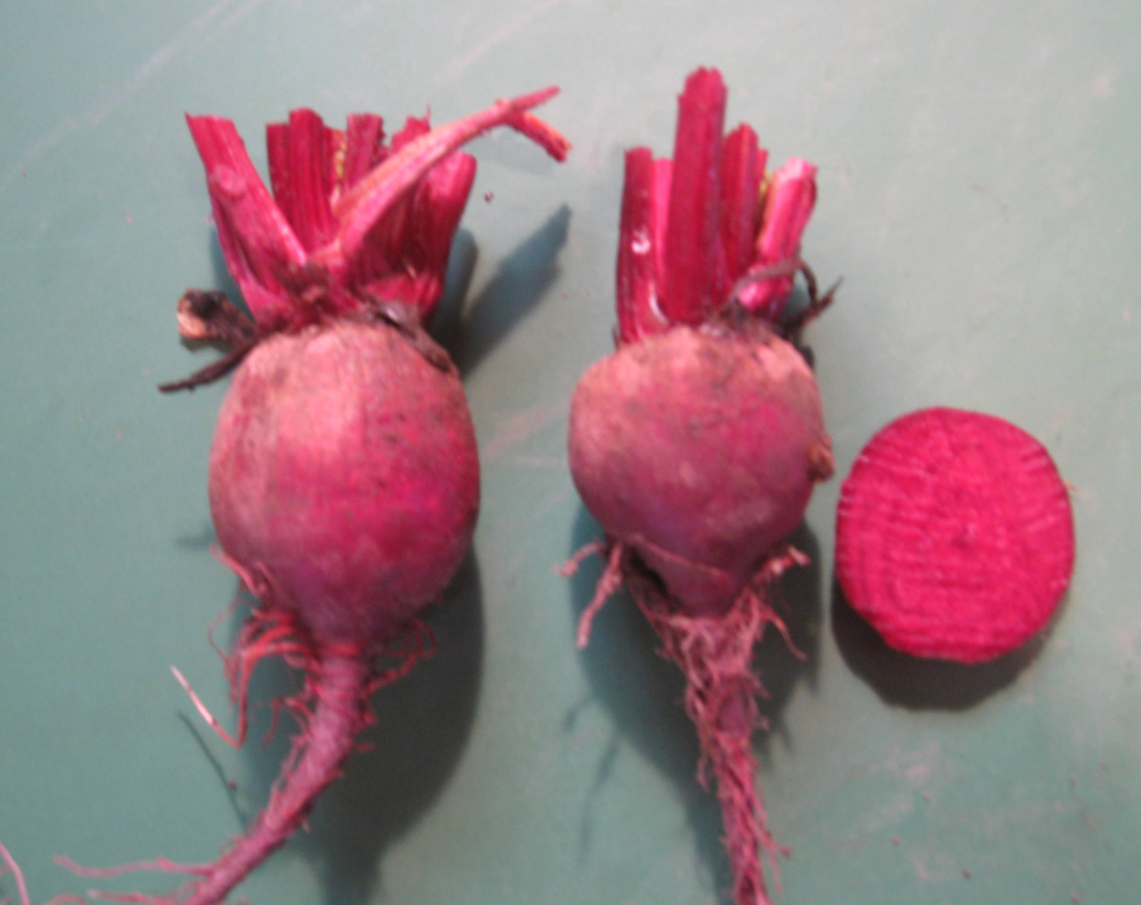
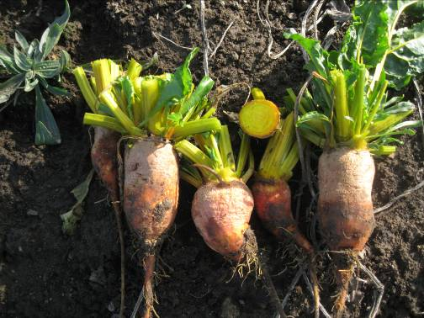
‘Kestrel’
‘Touchstone Gold’

Figure 5. Selecting recommended cultivars improves marketable yield and quality.
¹Lewis W. Jett
West Virginia University
Commercial Horticulture Specialist
2102 Agriculture Building
Morgantown, WV 26506



