SARE Farmer grant FNE09-655‏

Project Title: Sustainable cropping systems for processing baby lima bean production.

Project Leader: Wm. Donald (Don) Clifton II, President Clifton Farms, Inc.

Address: 306 Warner Road Milford, DE 19963

Telephone: (302) 424-8340

E-mail address: wdclifton@hotmail.com

Clifton Farms, Inc. Profile

The Clifton family has farmed in Sussex County since the 1920s. The Clifton operation has evolved over time. The family has been involved in dairy farming, beef production, vegetable farming, and grain farming. In addition, from 1948 to 1994, the family operated Clifton Canning Company, a vegetable processing facility. From 1995 through 2003, Clifton Farms concentrated primarily on grain and soybean crops. In 2004, a fresh pack lima bean processing line was constructed, placing renewed focus on a family staple crop. The processing line has been used from 2006-present to provide primary product cleaning for a major frozen vegetable processor. Enhanced productivity for Mid-Atlantic baby lima beans is a major objective for Clifton Farms, Inc.
Project purpose and goal

Baby lima beans are the most important processing vegetable crop of the $60 million vegetable industry in the Delmarva area of the mid-Atlantic region. However, there has been little yield improvement over recent decades. Competition from alternative land use for field crops due to high grain commodity prices threatens the economic viability of processing vegetables, and lima bean production in particular. This reduces rotational options and the diversity of agriculture on farms in the area. Obtaining higher yields through improved production practices is critical to remaining competitive. The focus of this project was to explore whether lima beans can be successfully double cropped, thereby increasing total tonnage produced on available Delaware acres.

Project activities

The project was revised to be a commercial sized trial. Two fields (A & B) were planted for 2011. In order to obtain two harvests, the crop had to be planted much earlier than lima beans are normally planted. Early maturing varieties were used. Non-inversion tillage was employed.

Both fields contain sandy loam soil, well drained to the point of being drought prone. Neither was irrigated for this project, non-irrigated lima beans being representative of roughly fifty percent of lima beans grown in Delaware.

Both fields were planted seeking about 65,000 final populations. Resistant pigweed has been a problem in Delaware for the past several seasons. For this reason, a pre-emergence treatment including a new herbicide tool named Spartan Charge (3.75 oz./a) was added to a combination of Dual (1 pt./a.) and Pursuit (1.3 oz./a.), two herbicides used for lima beans for many years. Both fields had reduced final populations diagnosed as the probable effects of Spartan Charge. The cooler conditions at planting and light soils are considered factors contributing to the Spartan Charge damage. Later plantings on somewhat heavier soils on which the same herbicide treatment was used did not show adverse effects to the same extent as these early fields. An observation recorded May 25, 2011, “Spartan charge damage seems to vary dramatically with just a slight change in organic matter. Where there is little damage, the beans are quite vigorous with large twin leaves.”

Project activities, continued

An IPM program is employed on all Clifton Farms, Inc. crops, including these trials. Fungicide and insecticide treatments are made when scouting reports indicate pest numbers or disease meeting economic damage thresholds. During the period prior to the first harvest, conditions were very dry and hot, not conducive to disease. Insect threats during this period were minimal as well. This may indicate that a very early cropping window for lima beans will require minimal chemical crop protection measures. However, during the second cropping cycle, conditions were much wetter. Fifteen inches of rain were dumped on the area in two weeks from late August through early September from two major storms. Pest and disease issues were addressed as stated below.

The fields were harvested with mechanical harvesters with pod stripping heads. The machines each weigh about 62,000 pounds. The machines are self propelled with flotation track front drives and wide tire rear drives. The machines harvest five 30 inch rows. The distance between the tracks and track width result in two of the five rows being heavily compressed during harvest. Field A was harvested July 23-24, 2011, Field B on July 25, 2011.

Field A was re-tilled after the first harvest with a light disking and replanted. Field B was allowed to re-grow. The damaged rows provided minimal regrowth, but the rows unaffected by harvester tracking made significant regrowth and podded nicely.

Field B recovered, matured, and was harvested on October 19, 2011. Field A, being replanted so late, never fully matured, but was harvested November 2, 2011. Many plants in Field A had no mature pods at harvest.

Concurrent with this commercial sized trial, the University of Delaware Cooperative Extension conducted a plot sized irrigated trial. The results are displayed below.

Results

The combined yields for Field A were 1316 lbs. per acre. The early crop was severely impacted by drought and heat, while the late crop was simply too late. The plants podded well, but lacked sunlight and heat to fully mature. The combined yields for Field B were 1663 lbs, per acre. As in Field A, the early crop was very low due to drought and heat. The late crop performed relatively well, considering the surviving plants represented about half of a normal stand.

.

Conditions - restated

During the period prior to the first harvest, conditions were very dry and hot, not conducive to disease. Insect threats during this period were minimal as well. This may indicate that a very early cropping window for lima beans will require minimal chemical crop protection measures. However, during the second cropping cycle, conditions were much wetter. Fifteen inches of rain were dumped on the area in two weeks from late August through early September from two major storms.

Employing irrigation will mitigate the early dry, hot conditions, which are to be expected in Delaware. The trial was performed on very well drained soil, which helps offset drenching storms, which are prevalent in the Mid-Atlantic.

Economics

Field B yielded 26% more beans than Field A. Field A incurred more cost due to one additional tillage pass prior to the second planting and the cost in labor, fuel, seed, and pre-emergence herbicide for the second planting. Field A incurred about $100 more per acre than Field B, while yielding less.

Assessment

Double cropping baby lima beans in Delaware seems to have some potential. Ultra-early plantings definitely require irrigation. For a second planted crop to have a chance to mature, the first crop must be harvested around July 14-18, with replanting by July 20. This may not always be possible. Allowing the plants to regrow after first harvest may be a better option, however the issue of harvester traffic damage must be addressed. Stripper harvesters with tracks or tires spaced to fit between the rows will likely cause less permanent damage to the plants resulting in better second crop potential. In addition, in a regrowth scenario, cultivation is problematic due to crop residues left from first harvest. A rotary cultivator may be an option. An additional benefit to this approach would be the incorporation of residues, which may then break down quickly enough to feed the later crop.

Adoption

While it is too early to draw definitive conclusions on the viability of double cropped (twice-harvested) baby lima beans in Delaware, Clifton Farms, Inc. plans to take lessons learned in this project and plant another commercial sized trial in 2012. It will be sixty irrigated acres, employing the regrowth strategy.

Field A 36 acres
First Planting date | May 4, 2011
Variety | Cypress
Final population | 50.800 viable plants per acre (20% reduction likely due to Spartan Charge herbicide effects)
Herbicide-first crop | Dual (1 pt.) plus Pursuit (1.3 oz.) plus Spartan Charge (3.75 oz.) – pre-emergence
Mechanical cultivation | Three times total - Twice (once in each direction) May 25-26, final time June 23
Fungicide | None on first crop
Insecticide | None on first crop
Harvest date | July 23-24, 2011
1st Yield per acre | 693 lbs.

Field A 36 acres
Second Planting date | July 26, 2011
Variety | M-15
Final population | 62.000 viable plants per acre
Herbicide-second crop | Sandea (2/3 oz.) pre-emergence
Mechanical cultivation | Once
Fungicide | Ridomil Gold Copper
Insecticide | Brigade for stinkbug followed later by Lannate as a cleanup for worms
Harvest date | November 2, 2011
2nd Yield per acre | 623 lbs.
Combined Yield | 1316 lbs.

Field B 18 acres
Planting date | May 6, 2011
Variety | M-15
Final population | 46,150 viable plants per acre (29% reduction likely due to Spartan Charge herbicide effects)
Regrowth population | +/- 30,000 due to harvest traffic damage
Herbicide-first crop | Dual (1 pt.) plus Pursuit (1.3 oz.) plus Spartan Charge (3.75 oz.) – pre-emergence
Herbicide-regrowth crop | none
Mechanical cultivation – first crop | Three times total - Twice (once in each direction) May 25-26, final time June 23
Mechanical cultivation – second crop | Once – considerable difficulty due to harvested crop residues dragging
Fungicide – 1st crop | None
Fungicide – 2nd crop | Ridomil Gold Copper
Insecticide – 1st crop | None
Insecticide – 2nd crop | Brigade for stinkbug followed later by Lannate as a cleanup for worms
1st Harvest date | July 23-24, 2011
2nd Harvest date | October 19, 2011
1st Yield per acre | 705 lbs.
2nd Yield per acre | 958 lbs
Combined Yield | 1663 lbs.

Figure 1: Clifton Farms, Inc. - Lima Bean Regrowth Project
Lima bean plants showing regrowth eight days after first harvest
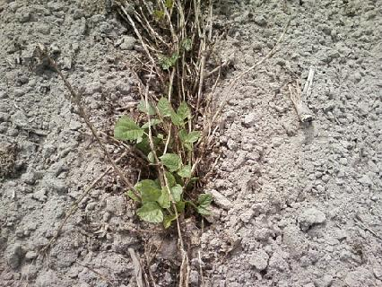

Figure 2: Clifton Farms, Inc. Lima Bean Regrowth Project
Three weeks after first harvest - Effects of harvester traffic clearly evident
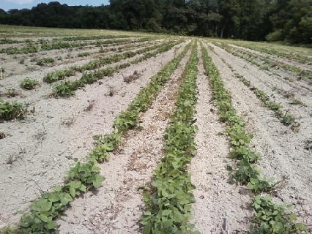

Figure 3: Lima Bean Regrowth Plot – irrigated trial
University of Delaware Carvel Research and Education Center
Plants are exhibiting vigorous regrowth
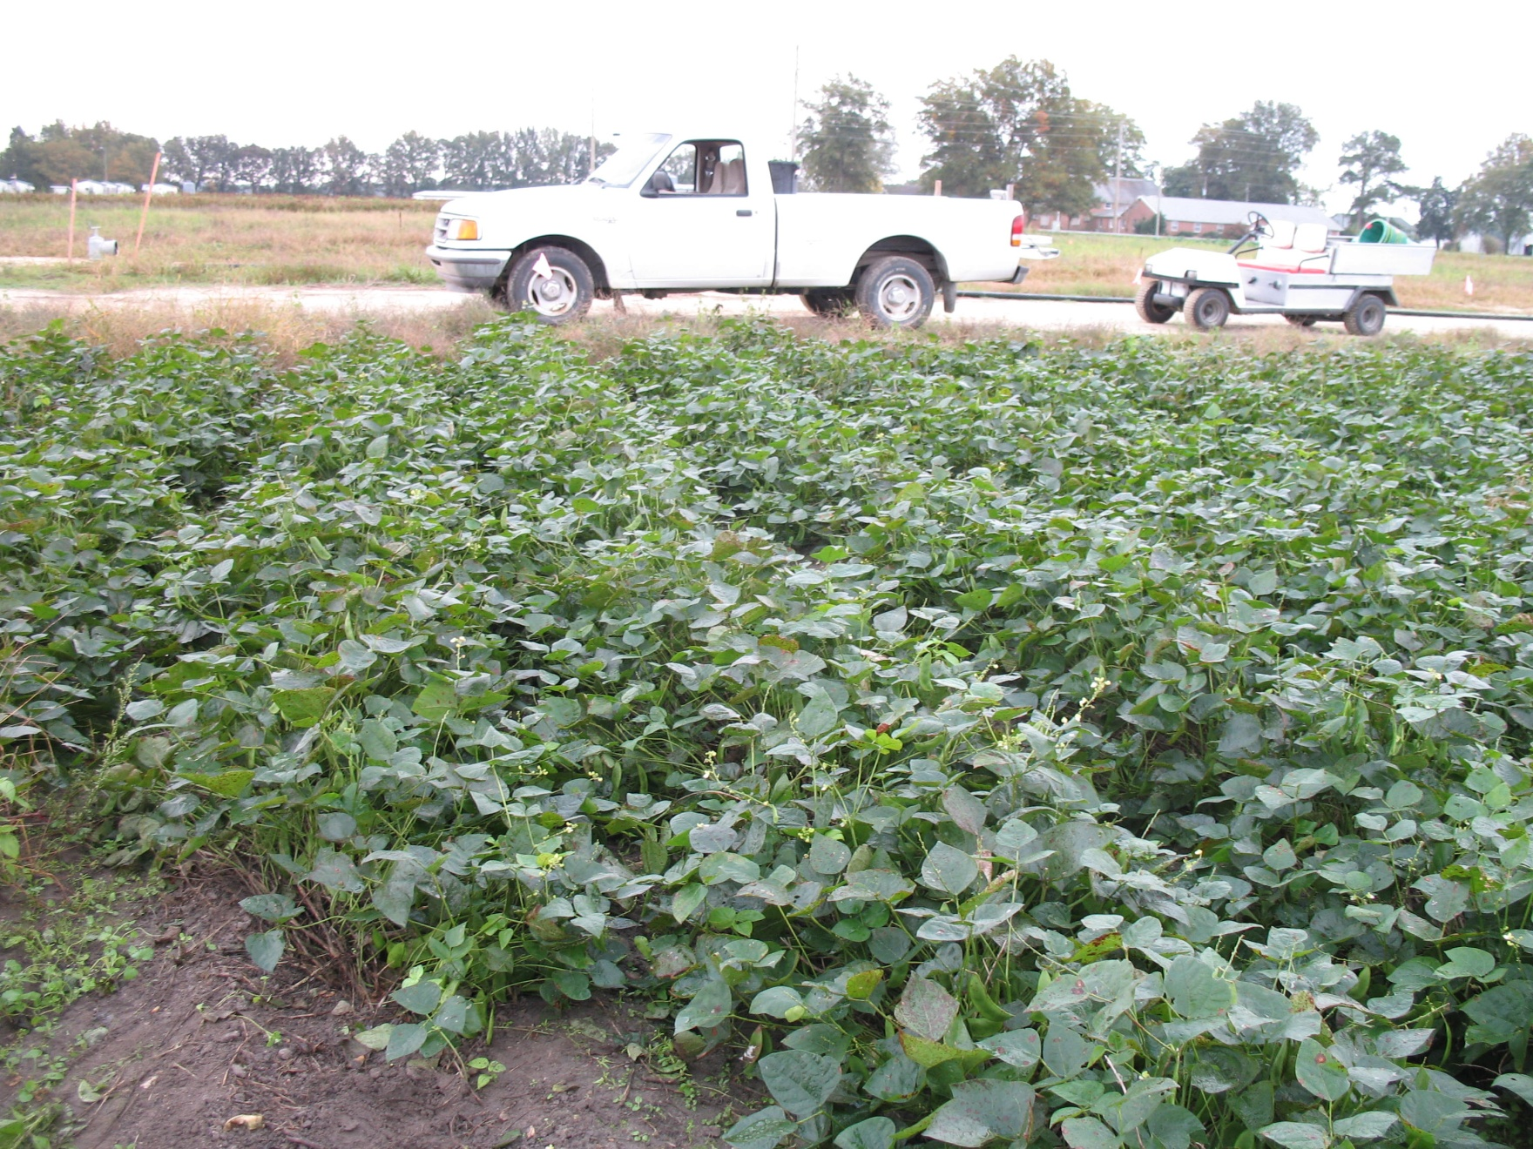

Figure 4: Lima Bean Regrowth Plot – irrigated trial
University of Delaware Carvel Research and Education Center
Close-up of second crop podding
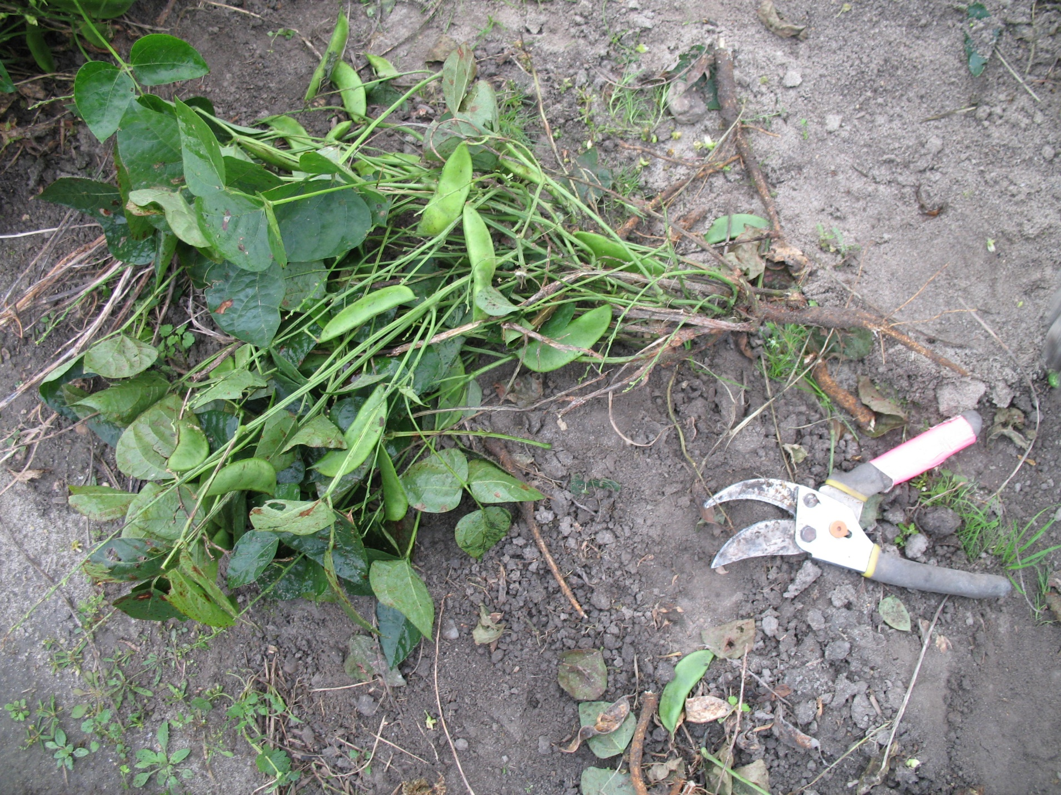

UD Cooperative Extension trial results – Regrowth lima beans - average of four samples
Plant lbs. | Seed lbs. | Dry % | Flat % | Full %
18,769 | 2,029 | 3.3 | 48.5 | 48.2

Outreach

UD Cooperative Extension presented results-to-date of its regrowth lima bean trial at a grower field day, September 15, 2011. Final results of the project with observations will be presented at the Vegetable and Fruit Growers Association of Delaware meetings, January 17-18, 2012.

