Figure 2. Some of the on-farm plots established near Hays and Garden City, KS in summer 2011. All fields were under long-term no-till management. Wheat straw after harvest was cut with a forage harvester at different heights to remove 0, 25, 50, 75, and 100% of straw.

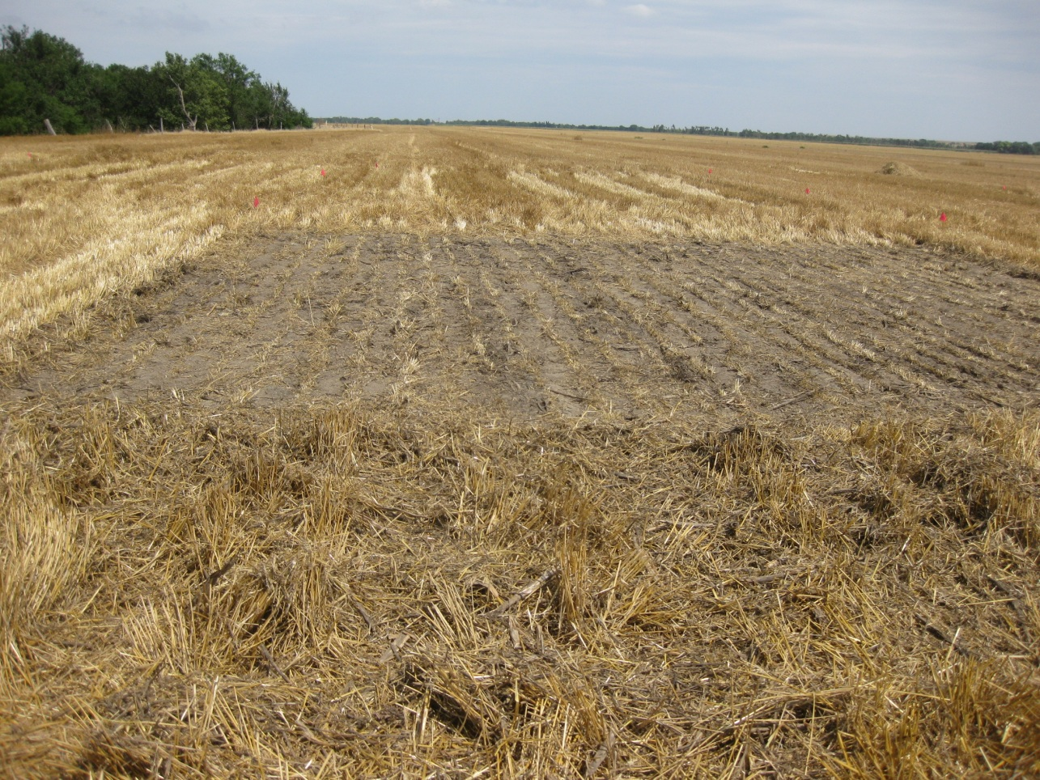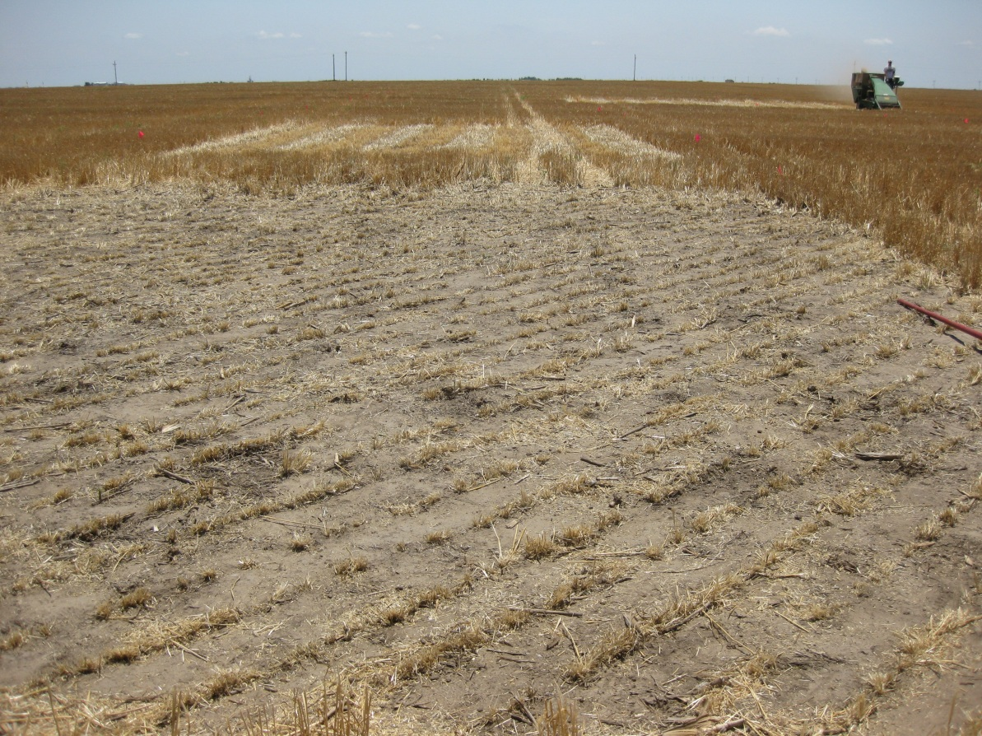
A site near Hays, KS
A site near Garden City, KS

