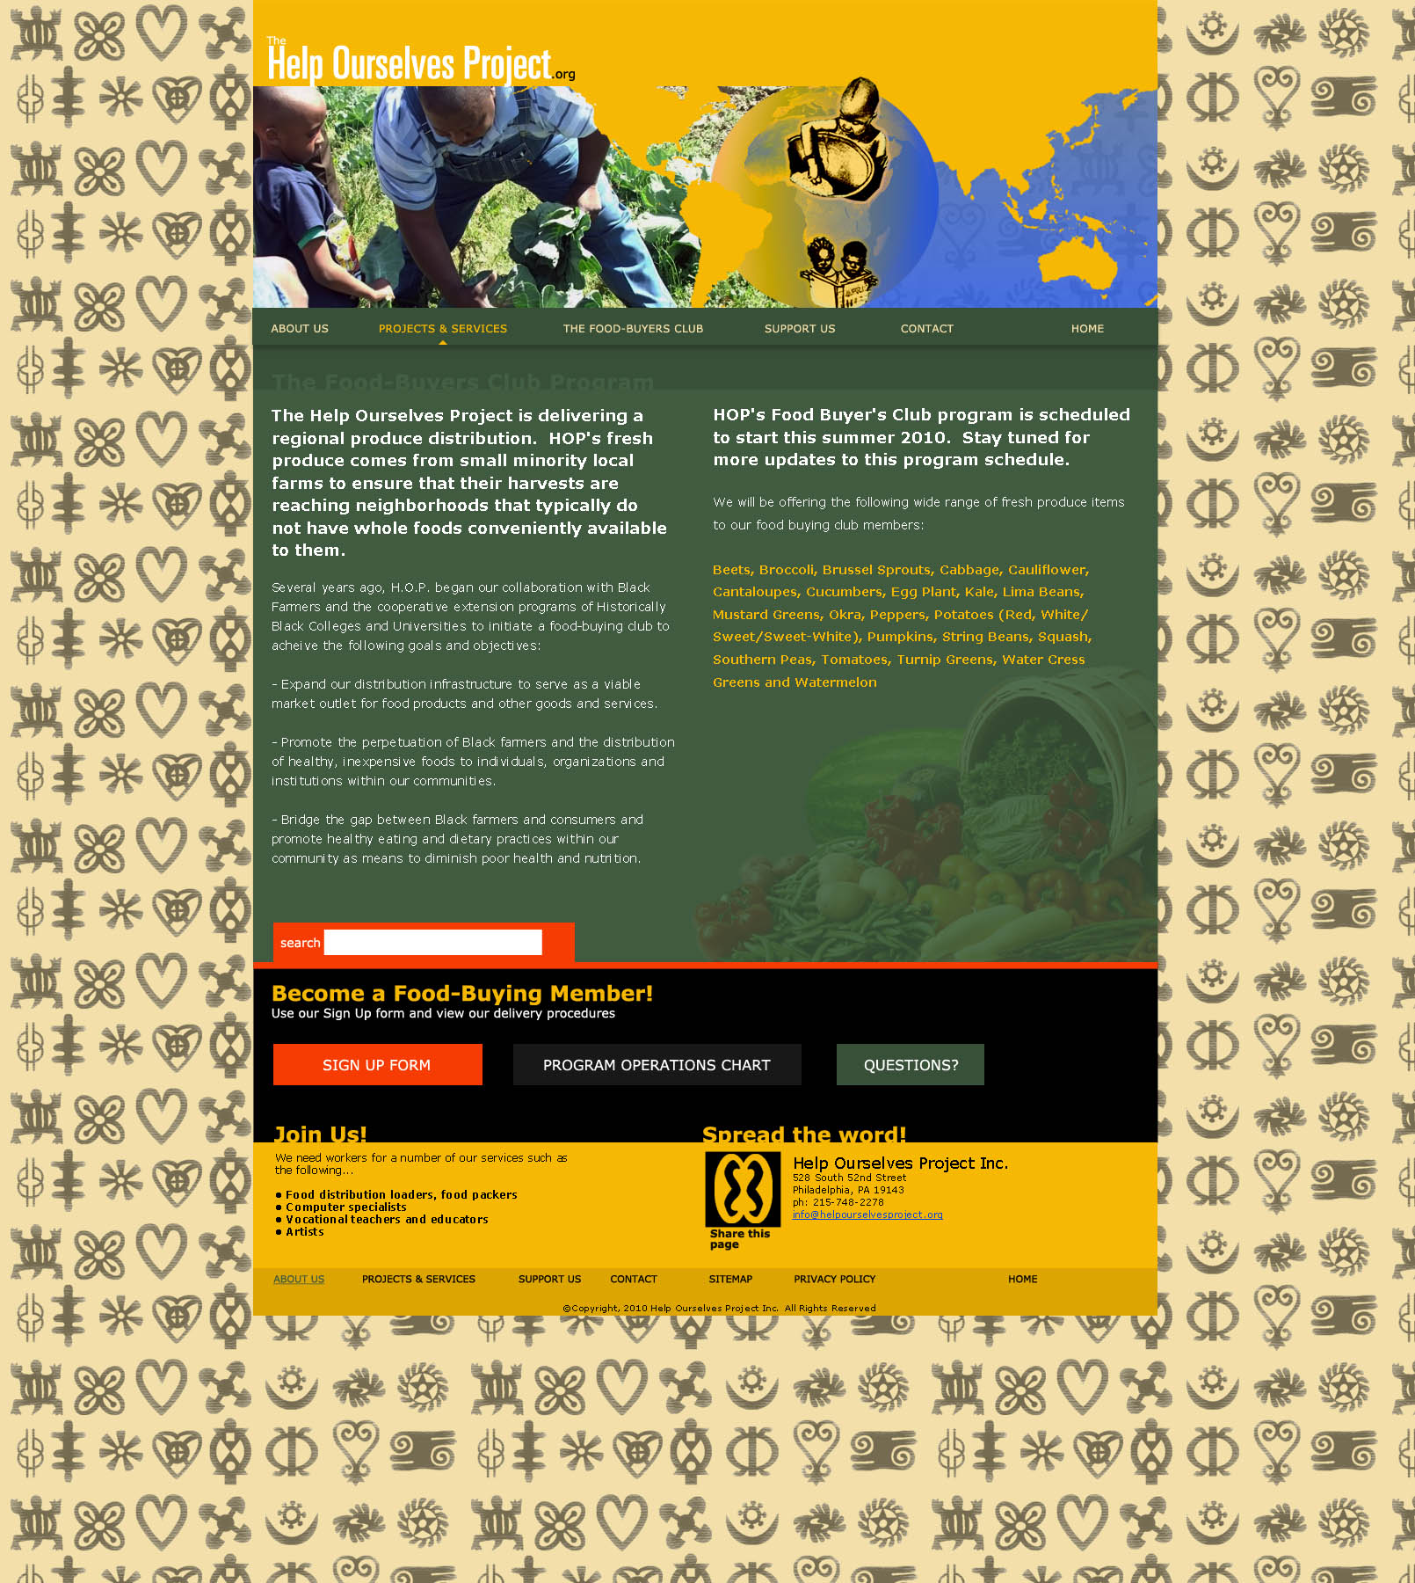

Mid- Atlantic Black Farmers Food Distribution Project

Several years ago, H.O.P. began our collaboration with Black farmers and the cooperative extension programs of Historically Black Colleges and Universities to initiate a much needed black farmers’ “People Play with Dirt” program focusing particularly on the black youth to learn the rudimentary lessons of agricultural science in order to teach the following goals and objectives:

- Provide an opportunity for black farmers to introduce to young people to agricultural science and basic farming techniques.

- Stimulate community awareness on the existence of black farmers in nearby regions, the importance of promoting black farmers’ products and the unique challenges that black farmers face from certain sectors of the food industry that have proven to be indifferent to their role as food producers.

- Bridge the education gap between black farmers and the inner city minority poor with regards to promoting self-reliance, promoting the critical interdependent relationship that exists between the food provider and the food consumer; and placing the black food grower in the unique position of teaching our people the importance of healthy eating.

We ask that you take time to help us partner with you, our potential farm educational partner, better by completing this survey and mailing it back to Help Ourselves Project with the self-addressed stamped envelope. For any questions you can email us at helpourselvesproject@yahoo.com or contact us at (215) 472 – 3571:

The Help Ourselves Project
Mid- Atlantic Black Farmers Food Distribution Project Farmer Survey

Please take a minute to complete this survey to help us better serve our community!

- Print first name and last name

- Print name and location of farm

- How did you like working with H.O.P. and People Play with Dirt Program?

- How did you like working with the children that HOP brought to your farm?

- Would you like to work with H.O.P.'s "People Play with Dirt" Program through teaching children basic farming concepts?

- What would you require in order for you to be a consistent farm education partner for children?

- Are there other considerations that were not listed? Please Explain:

Sign name here
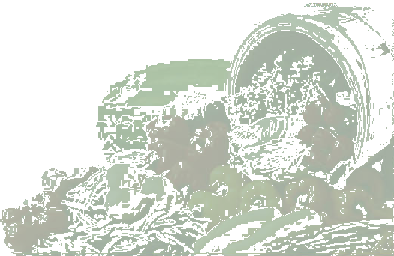
Thank you!

The Help Ourselves Project
c/o Know Thyself Bookstore
528 S. 52nd Street
Philadelphia, PA 19143
215-472-3571
info@helpourselvesproject.org
www.helpourselvesproject.org

