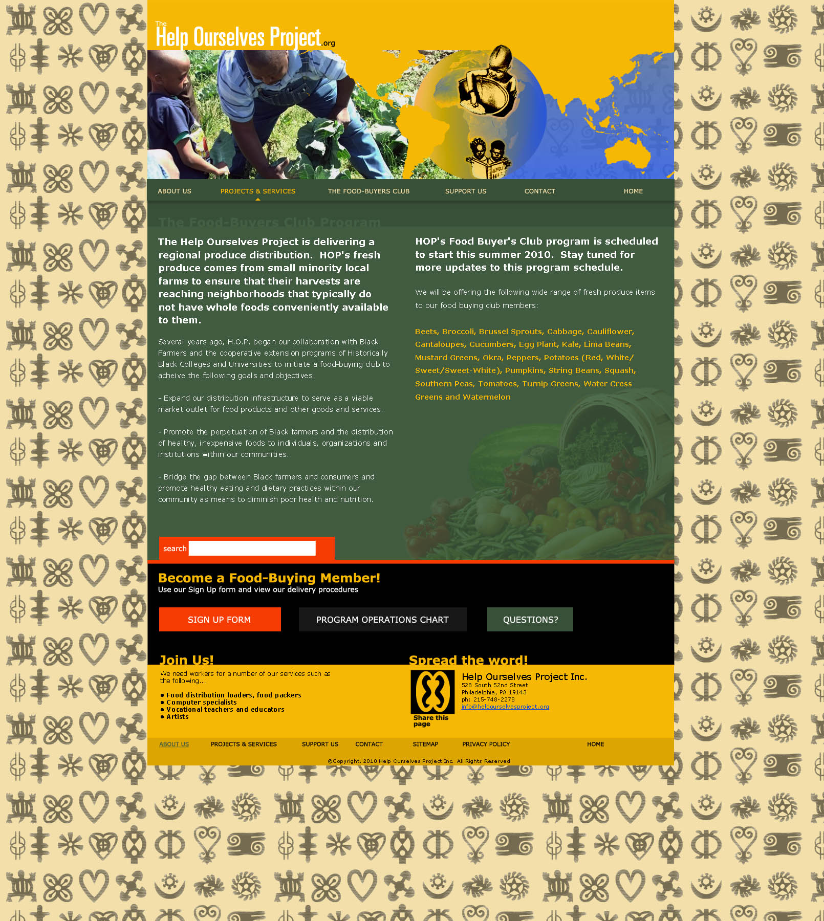

Mid- Atlantic Black Farmers Food Distribution Project

Several years ago, H.O.P. began our collaboration with Black farmers and the cooperative extension programs of Historically Black Colleges and Universities to initiate a much needed black farmers food distribution network to achieve the following goals and objectives:

- Open up a viable produce market for black farmers who grow exceptional produce and other goods and services produced by black farmers.

- Promote the perpetuation of black farmers and the distribution of healthy, fair-priced foods to individuals, organizations and institutions within our communities.

- Bridge the gap between black farmers and the inner city poor to promote healthy eating and improve dietary practices within these communitie as a means to diminish poor health and nutrition.

We ask that you take time to help us partner with you, our farm partner, better by completing this survey and mailing it back to Help Ourselves Project with the self-addressed stamped envelope. For any questions you can email us at helpourselvesproject@yahoo.com or contact us at (215) 472 – 3571:

The Help Ourselves Project
Mid- Atlantic Black Farmers Food Distribution Project Farmer Survey

Please take a minute to complete this survey to help us better serve our community!

- Print first name and last name

- Print name and location of farm

- How did you like working with H.O.P.?

- Were the meetings with H.O.P. informative and fruitful?

- Yes

- No

- How reliable was H.O.P. regarding purchasing produce from your farm?

- Do you believe H.O.P. can help your farm business grow as a produce distribution partner? In other words, what would we need to convince you of in order to be considered as a major distribution partner of your fruit and produce needs?

- Are there other considerations that were not listed? Please Explain:

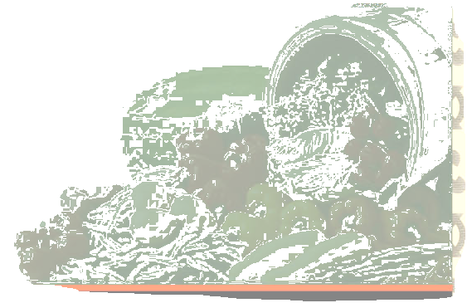

Sign name here

Thank you!
The Help Ourselves Project
c/o Know Thyself Bookstore
528 S. 52nd Street
Philadelphia, PA 19143
215-472-3571
info@helpourselvesproject.org
www.helpourselvesproject.org

