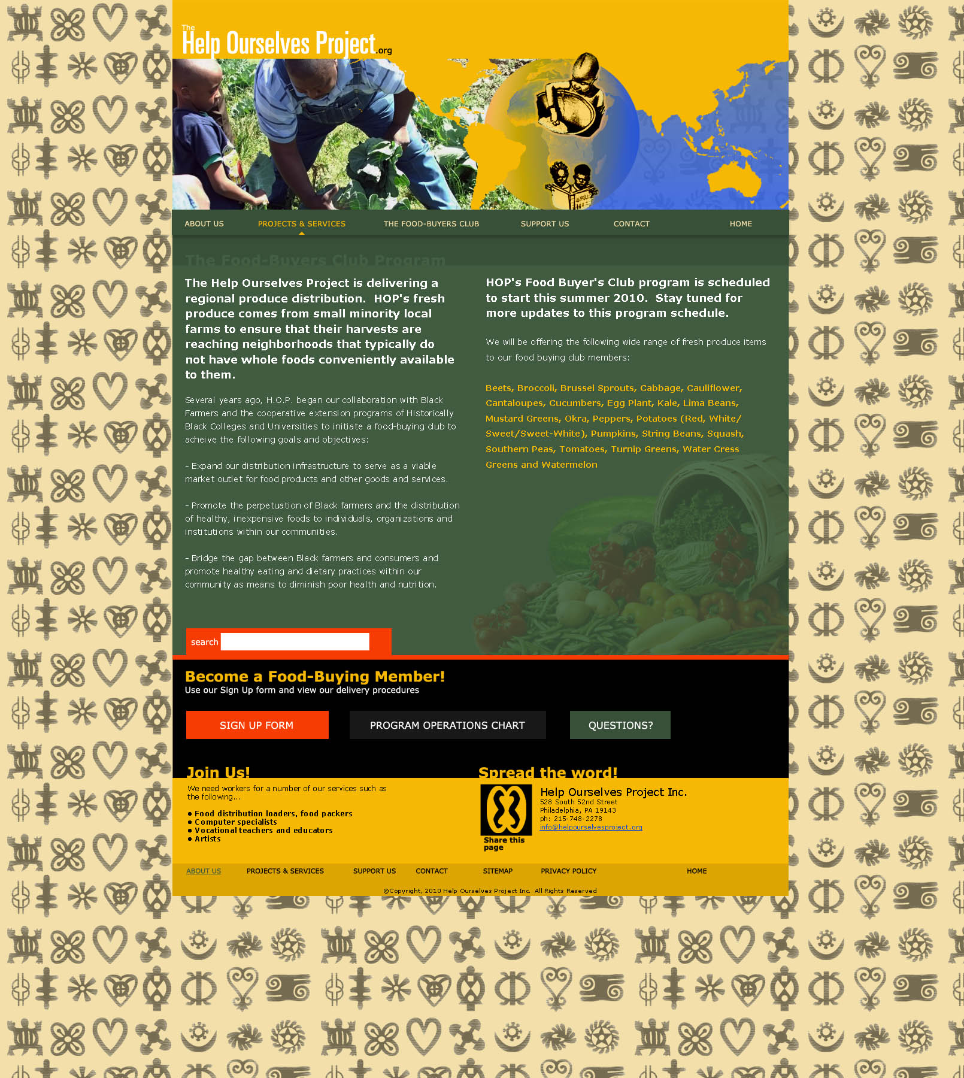

Mid- Atlantic Black Farmers Food Distribution Project

Several years ago, H.O.P. began our collaboration with Black farmers and the cooperative extension programs of Historically Black Colleges and Universities to initiate a food-buying club to achieve the following goals and objectives:

- Expand our distribution infrastructure to serve as a viable market outlet for food products and other goods and services produced by Black farmers and business persons.

- Promote the perpetuation of Black farmers and the distribution of healthy, fair-priced foods to individuals, organizations and institutions within our communities.

- Bridge the gap between Black farmers and consumers and promote healthy eating and dietary practices within our community as means to diminish poor health and nutrition.

The H.O.P. Food Buying Club provides our community with the opportunity to purchase nutritious food directly from Black farmers. Through our food-buying program, our people learn the importance of creating economic opportunities for themselves with the vision of this project moving worldwide.

We ask that you take time to help us serve you and our farmers better by completing this survey. Additionally, if you may be interested in becoming a member of our food buying club or finding other ways you can support our efforts, please complete the contact information below. You can visit our website at www.helpourselvesproject.org or contact us at (215) 472 – 3571:

Contact Information
Individual or Organizational Name
Address
City, State, Zip Code
Phone Number
E-Mail

The Help Ourselves Project
Mid- Atlantic Black Farmers Food Distribution Project Community Survey

Please take a minute to complete this survey to help us better serve our community!

- What types of fruits and produce do you regularly purchase
and at what quantities and prices:

Fruits/Produce Regularly Purchased or Needed | Quantities Regularly Needed/Purchased  (pounds, cases, bushels, etc.) | Price Range of Normal Purchases

- From where do you normally acquire these items?

- Home Grown
- Direct from Farmers/Producers
- Supermarket
- Neighborhood Store
- Produce Vendor
- Food Distribution Center
- Wholesaler
- Delivery Person
- Other

- In general, how regularly do you need/purchase these items?

- Daily
- 2–3 times/week
- Weekly
- Bi-weekly
- Monthly

Please rank the following factors in the order of importance to you when making a buying
decision for fruits and produce (1 being most important, 6 being lease important):

- Price
- Convenience
- Location
- Service
- Quality
- Support Local Businesses

Are there other considerations that were not listed? Please Explain:

- What factors would make you consider switching from your current supply method? In other words, what would we need to convince you of in order to be considered as major suppliers of your fruit and produce needs:

- What additional products could we provide you that would help with your current/future operations?

- Baked Goods
- Canned/Jarred Items
- Dried Fruits/Nut Snacks
- Fresh Squeezed Juices
- Dried Herbs/Seasonings

- Jams and Preserves
- Natural Soaps, Scrubs, Lotions and Other Items

Additional Comments/Feedback:

The Help Ourselves Project
c/o Know Thyself Bookstore
528 S. 52nd Street
Philadelphia, PA 19143
info@helpourselvesproject.org
www.helpourselvesproject.org

