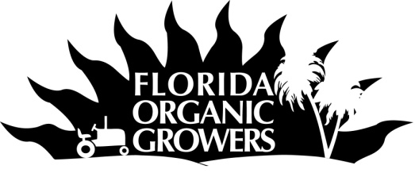
Florida Certified Organic Growers & Consumers, Inc.
P.O. Box 12311 Gainesville, FL 32604
352-377-6345 phone, 352-377-8363 fax
fog@foginfo.org
www.foginfo.org

SSARE Project Annual Report
April 20, 2012

Summary

Activities in 2011 focused more on working one-on-one with individual farmers and food businesses to adjust and develop fair labor and trade practices. One farm in particular committed to seeking certification and spent 2011 adjusting his labor practices and policies to align with the standards. FOG did collaborate to offer a training for farmworkers on business structure and payroll. While some preliminary data crunching had been done for the organic farmer survey the bulk of the data analysis was put on hold in 2011 due to the withdrawal from the project of the Agricultural Economist who was slated to do the data analysis. The public survey to explore knowledge and support for fairness in the food system that was developed and finalized in 2010 was administered to a variety of groups in 2011. The last few surveys are being completed in early 2012, after which data analysis will be done in tandum with the farmer survey data analysis. FOG and the other project collaborators spent the majority of the project time in 2011 on public education activities, developing new and innovative materials for distribution, information portfolios for display at events, participating in relevant speaking engagements to raise awareness, supporting and working with other groups that promote fairness in the food system, and organizing project specific events. Part of this effort has included shooting video footage for a public education video clip.

Objectives/Performance Targets

Objective 1: Indentify best practices and support for socially, economically and environmentally sustainable agriculture through research on perceptions, priorities, and practices on organic farms in the South.

Objective 2: Assist farmers and others essential to our food system to benefit from a socially, economically, and environmentally sustainable farming and food system model by providing education and outreach tools, certification and by assessing the impact of the system and tools.

Objective 3: Research public knowledge of and support for social, economic, and environmental sustainability in agriculture and the full food chain and explore commitment to pay for AJP certified products.

Objective 4: Develop and implement a public outreach and education model to raise public awareness of quality of life issues in agriculture and the food system.

Accomplishments/Milestones

Objective 1:

The main avenue through which the project anticipated gaining input on best practices and support for socially, economically and environmentally sustainable agriculture on farms in the South was through a mail-out survey to certified organic farms across the South. As previously reported, FOG used a comprehensive list of 633 non-exempt certified organic farms in the South. The farmer survey was mailed out 400 farms total. The data entry was mostly complete in 2010. Some preliminary data analysis was done in 2011. The bulk of the analysis was put on hold when the Agricultural Economist slated to do the analysis on the project was no longer able to do so. FOG has hired staff to complete the data analysis and write up in 2012. The preliminary data analysis on the demographic data provided some insight into the types of certified organic farmers that responded to the survey. It is difficult to compare the sample for this survey to data on US organic farms as many of the demographic questions reported on below for our survey were not asked in the USDA Organic Production Survey (such as age, gender, and ethnicity of main farm owner).

Table 1. Distribution of Age of Certified Organic Farmer Respondents for SSARE-funded FOG Survey
Age of Main Farm Owner | Number | % of Respondents
18-25 | 0 | 0%
26-35 | 0 | 0%
36-45 | 4 | 8.7%
46-55 | 14 | 30.4%
56-65 | 20 | 43.5%
66-75 | 4 | 8.7%
76-85 | 4 | 8.7%
86+ | 0 | 0%
Total | 46 | 100%

Table 2. Distribution of Gender of Certified Organic Farmer Respondents for SSARE-funded FOG Survey
Gender of Farm Owner | Number | % of Respondents
Male | 32 | 73%
Female | 9 | 20%
Both | 3 | 7%
Total | 44 | 100%

Table 3. Distribution of Ethnicity of Certified Organic Farmer Respondents for SSARE-Funded FOG Survey
Ethnicity of Farm Owner | Number | % of Respondents
White | 44 | 92%
Hispanic | 4 | 8%
African American | 0 | 0%
Asian | 0 | 0%
Other | 0 | 0%
Total | 48 | 100%

The 2008 USDA Organic Production Survey did collect data on years farming of principle farm owners. The data categories do not match exactly. However there is a general trend that certified organic farmers nationwide from 2008 tended to have more farming experience than certified organic farmers in the south in 2011.

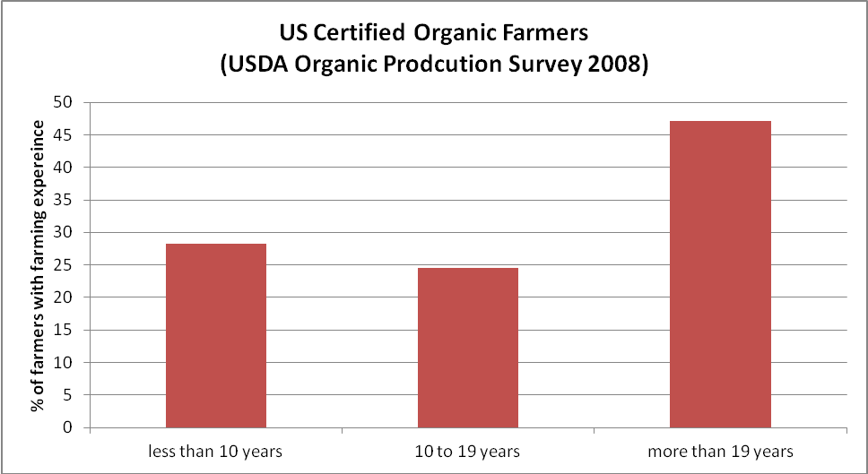
Figure 1. Distribution of Years of Farming Experience for National Survey of Organic Producers (USDA)

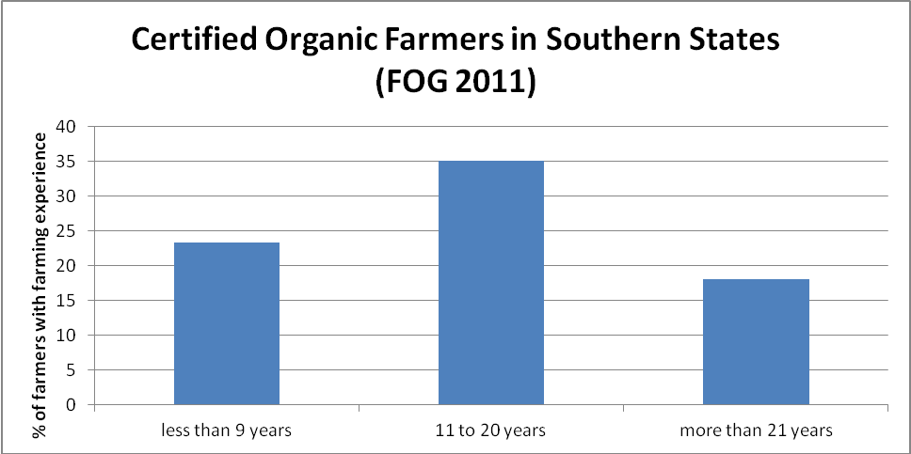
Figure 2. Distribution of Years of Farming Experience for SSARE-Funded FOG Survey

The data from the USDA Organic Production Survey on income are not comparable to our income data as the FOG survey collected data on gross household income for all sales (organic and conventional) and the USDA collected data only on net household income from organic sales.

Table 4. Distribution of Gross Annual Certified Organic Farm Income for SSARE-Funded FOG Survey
Total Farm Gross Annual Income 2010  (organic & conventional) | Number | % of Respondents
$0 | 0 | 0%
$1-$999 | 1 | 2%
$1000-$2499 | 3 | 7%
$2500-$4999 | 1 | 2%
$5000-$9999 | 2 | 5%
$10,000-$24,999 | 5 | 12%
$25,000-$49,999 | 8 | 20%
$50,000-$99,999 | 4 | 10%
$100,000-$249,999 | 9 | 22%
$250,000-$499,999 | 5 | 12%
$500,000-$999,999 | 0 | 0%
$1,000,000-$4,999,999 | 2 | 5%
$5,000,000 or more | 1 | 2%
Total | 41 | 100%

Of those certified organic farmers who responded (n=45) to the question, 76% reported being 100% organic, with an average 91% of respondents’ sales being certified organic.

The preliminary data analysis (which is to be considered draft until statistical assumptions and tests are done) on the farmer survey seems to indicate that the certified organic farmers that responded to our survey may be very supportive of agriculture including good working conditions for farmworkers (Figure 3). In addition, the preliminary data also may indicate that average worker wage is not necessarily correlated with farm income (Figure 4). However, sample sizes in each category may not be sufficient to conduct statistical analysis.

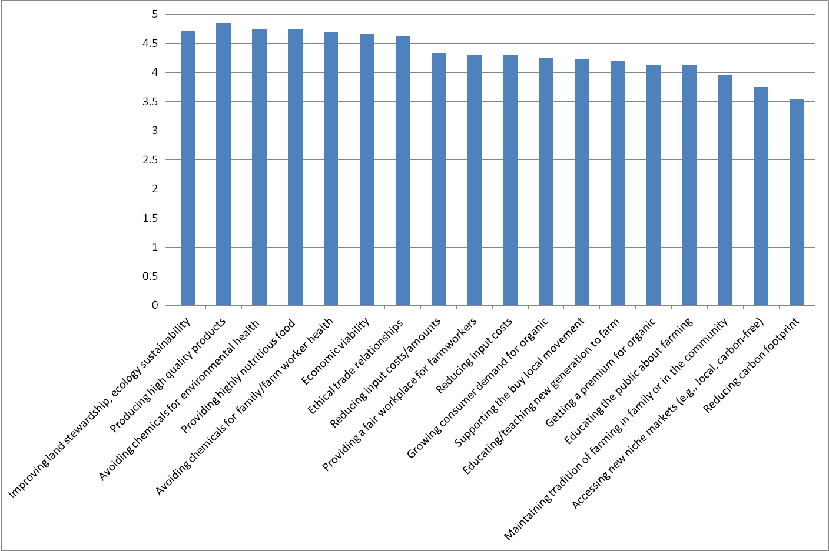
Figure 3: Responses for Certified Organic Farmers to “What is important to you in farming/ranching? (Using a scale of 1 to 5)” for SSARE-Funded FOG Survey

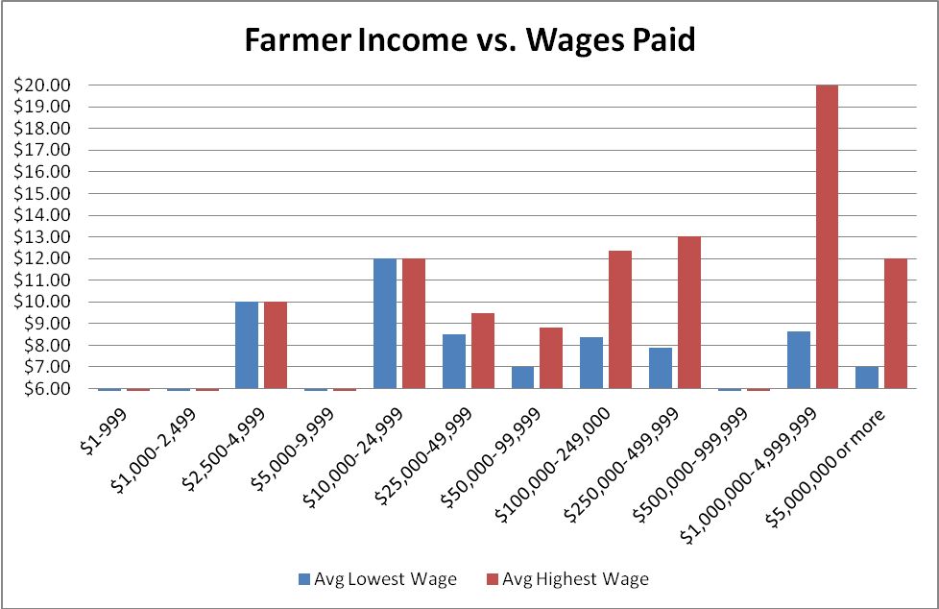
Figure 4: Certified Organic Farmer Income Compared to Lowest and Highest Hourly Wages Paid by Respondent in 2010 for SSARE-Funded FOG Survey

In addition to the survey, FOG has received anecdotal reports on farmer perspectives on participating in Food Justice Certification and on injustices in the food system. Comments received from farmers have addressed labor difficulties due in part of immigration laws and access to skilled labor and inadequacies of local/domestic inexperienced workers. Notably, that local, inexperienced workers contribute to safety concerns on the farms, unwillingness to do the hard work of farmers, and low productivity. All of which are big concerns for farms that already have a difficult time making ends meet. Starting up small business infrastructure and unfair contracts/agreements with buyers were some of the other issues brought up by Southern organic farmers as obstacles. The further analysis of the survey data will illuminate the extent to which these constraints are experienced by certified organic farmers in the South.

Objective 2:

Trainings and Technical Assistance to Farmers and Food Businesses to Improve Practices:
In 2011 FOG continued to provide assistance to help improve the quality of life of organic farmworkers and farmers in the South. This included working individually with farms and food businesses interested in Food Justice Certification, developing resources and tools for farmers and businesses and presenting a workshop for farmers. Given the anecdotal feedback FOG has received from the smaller organic operation in the South regarding lack of written policies, procedures, or written contracts, as well as a need to formalize and organize their farm businesses, FOG sought opportunities to province trainings to farmers. On Aug 1, 2011 FOG collaborated with Blue Oven Kitchens to develop and present a workshop on helping farmers establish their business structures for their farms and setting up payroll. This area of assistance has been noted by farmers as a needed piece in their farm businesses.
Business Planning & Accounting: This workshop is designed as a splash session in the following topics, with additional resources provided for further study and progress: business planning and structure, SWOT analysis, costs and budgets, payroll, spreadsheets, and sales and farm taxes. We anticipate it will be of interest primarily to farmers, but general business topics and cost sheets may be of interest to restaurants wishing to expand into local food in a planned way. Whenever possible the general business topics are focused on farm-to-restaurant relationships. Taught by Leah Cohen and Patrick Jean-Francois of FOG; Bill Dorman, Consultant at SFC CIED; and Beth Davies, CPA.
In working with a handful of individual food businesses and farmers the project has found that the small scale operations that are interested in supporting Food Justice Certification and are dedicated to providing fair practices for their workers and in trade are totally overwhelmed with just staying in business. The challenge they face is in finding the time to spend on paperwork and improvement in practices necessary for certification when their businesses are tittering on the edge of failure. They have dedicated more financial resources to paying workers and farmers well than their businesses can afford. The missing link in supporting sustainable agriculture that includes decent treatment of the people who provide food for all of us is educating the public to support fair businesses with their purchases. Farmers have anecdotally reported that their clients do not know about the Food Justice Certification and therefore they are not sure they will be able to reap the increased profits that would allow them to invest more money and time into improving the conditions of farmworkers and farmers. The project therefore recognized the need arose to concentrate more on public awareness. Many of the farmers that FOG talked to in 2010 and 2011 reported that they don’t support the type of agriculture that they see in their neighbors that takes advantage of people (worker or farmers) in order to make more money. However, they felt trapped financially since most of the public have no idea about the abuses in the food system in labor and trade practices and therefore the public is not empowered to vote with their dollar to improve the food system’s treatment of people.
Training to Increase Capacity of Worker Organizations & Certifier Staff in the South to Support Increased Social Justice for Farmers and Farmworkers: FOG and other project collaborators (CATA, RAFI, and NOFA) worked together to conduct a training course for certification staff and worker representatives participating in Food Justice certification. The project trained two staff members from Quality Certification Services in Florida, QCS is one of the collaborators on the grant and certifiers a number of farmers to the organic standards in the South. The project was also able to send two additional staff members to the Food Justice certification training held in Oregon in May 2011 in order to increase capacity for offering Food Justice Certification in the South. One of the staff members trained is based in Virginia therefore widening the regional capacity in the South and lowering the cost of certification for farmers and businesses. FOG and the project collaborators were also able to train two staff members from the Farmworker Association of Florida to participate in the Food Justice Certification process in the South. This ensures farmworker rights and conditions are considered and improved through the certification process and contributes to the truth in labeling in the marketplace. In the end the project trained 2 additional certification staff than originally anticipated in the grant proposal. This lead the project to focus more intensely on objective #4 in 2011 (reported on below).

Objective 3:

One of the main tools the project anticipated using to assess public knowledge of and support for social, economic, and environmental sustainability in agriculture and pubic willingness to pay for AJP Food Justice certified products is a public survey. The survey distribution plan was revised in 2010 and then again in 2011. In 2010 the change was made due to the fact that no retail stores were certified and therefore the project could not distribute surveys in Food Justice Certified stores. The plan was to survey the public at a variety of retail locations (rather than just those that were certified). However, in 2011 after contact numerous grocery stores and not receiving permission to survey at their businesses, the survey distribution plan was revised again.

FOG has distributed a total of 247 public surveys to-date at a variety of public events. FOG has divided the surveys collected into two categories to compare results (events that are likely to draw a food justice supportive crowd and events that are less focused on food justice issues) (Figure 5). FOG was able to collected completed surveys at all of the events except the Wash King Laundromat.

Events likely to draw a food justice supportive crowds:
- Agricultural Justice Project Meeting
- Fair Trade Fair
- Fair Food Panel Discussion
- Screening of the film “Fresh” organized by Florida Organic Growers
- The Jones Restaurant (supports Buy Local campaign and Food Justice Certification)
- Chattham Marketplace (food coop)

Events that are less focused on food justice issues:
- Pet Smart pet adoption day
- Senior center presentation on organic production
- Gainesville city annual arts festival
- Pride festival
- Kanapaha Garden Festival
- Harn Museum of Art event
- Where the Sidewalk Ends kids’ art festival
- Wash King Laundromat

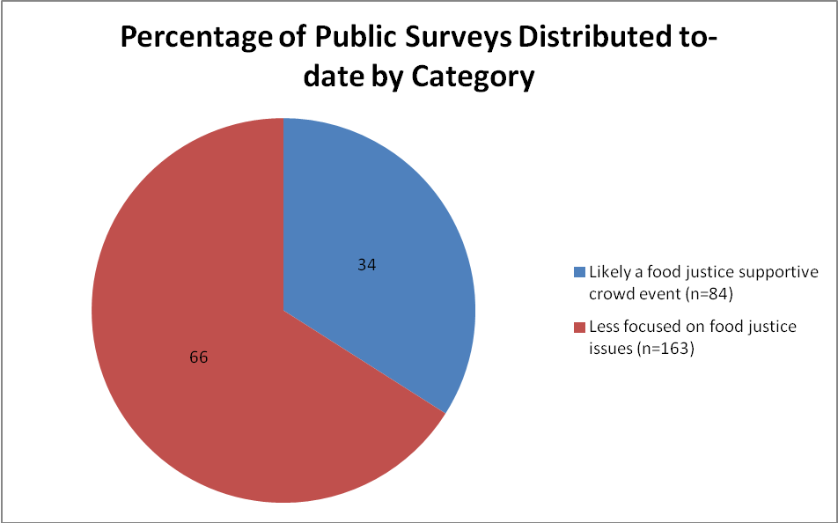
Figure 5. Distribution of Surveys Collected Based on Categorization of the Type of Event for SSARE-Funded FOG Public Survey

We intend to collect just a few more surveys and would like to focus on surveying the Latino community. In anticipation of this FOG had the survey translated into Spanish and has reached out to Latino community groups to see if they are willing to distribute the survey. Data coding, analysis and write up is anticipated to be done by the same FOG staff member hired to work on the farmer survey data.

Objective 4:

It was anticipated that having socially just certified products in retail settings would be the most effective base from which to reach out to the public about fairness in the food system. As certified products have not hit the retail shelves and given the feedback received from farmers and food businesses that improvements to the fairness in the food system cannot occur without increased awareness on the part of the public, the project increased its efforts on public education and awareness raising in 2011. In fact the disconnect of the public with knowledge of how their food is grown and processed and how this affects those who labor in the food system may indeed be the reason injustice occurs. Many of us as adults still remember a time when family farms were a substantial part of our communities and it is all too easy to assume the more transparent, hard-working, wholesome farm is providing our food then idealic pictures of happy animals and people on happy farms are what remains on the packages and in the marketing materials of food companies. It prevents us from asking the difficult questions about where our food really comes from. In 2011 FOG continued to focus its public education campaign on presentations, tabling events, social media, and developing print material with messages about national and regional conditions and challenges for farmers and farmworkers.

Social Media:
The Facebook for the Agricultural Justice Project that was created at the end of 2010 has continued to receive increased attention and has highlight the important work of famrworker and famrer advocacy groups as well as reported data on the conditions for farmers and workers in the food system (it now is liked by 333 individuals). FOG has received good feedback on this method of outreach and important connections have been made with other groups working on improving the lives of farmers and farmworkers.

Print Outreach Materials:
A print publication was finalized in early 2011 and distributed to local businesses and project collaborators to distribute at tabling events (Figure 6).

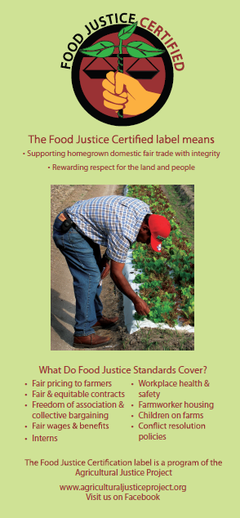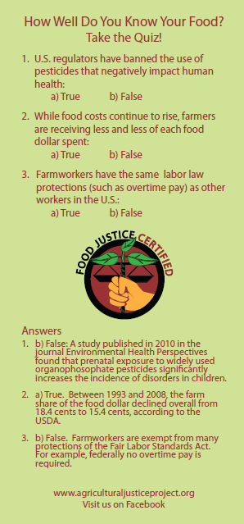
Figure 6. Public Education Rack Card Developed as Part of Public Awareness Campaign for SSARE-Funded FOG Project

In addition, table topper signs were created to demonstrate to the public how choosing a label in a retail setting can indicate better working conditions for farmers and farmworkers.

FOG designed an “early adopters” publication to feature the farms and businesses that are on the cutting edge of good working and trade practices. As has been the case with recruiting farms and businesses for certification, it has been a challenge to get farms and businesses (who have already done all the work associated with getting certified) to take the time away from the busy schedules to write up their experiences in working on improving conditions in the food system. We hope to be able to publish the early adopters stories soon and feel that putting faces to the concept of social justice in the food system will help make it real for the public.

FOG also collaborated with QCS to write an article for the Fair World Project magazine published in fall of 2011. This publication and the article in particular is designed in increase public awareness of the issues of injustice in the food system and how to make ethical purchases in the marketplace. See the full article at: http://fairworldproject.org/voices/single/398.

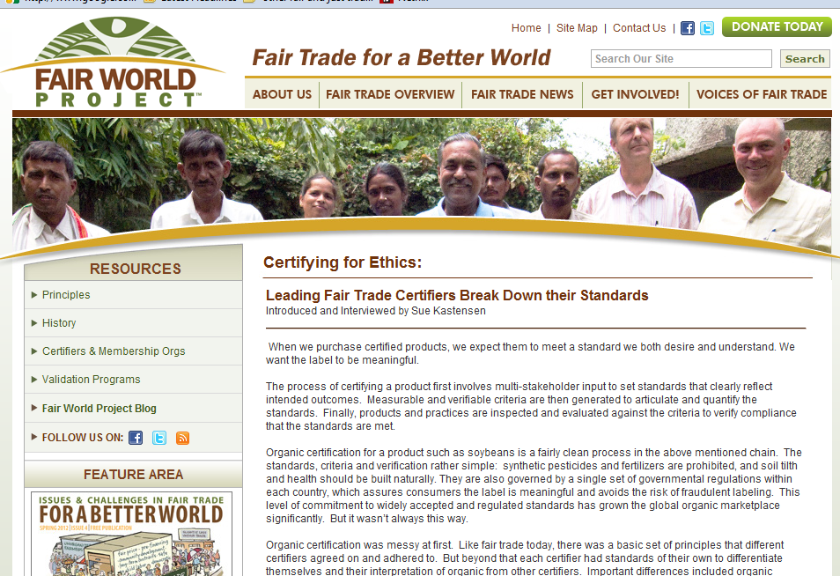

Events: Considerable effort was made to expand FOG’s participation in public education events and to improve the public education display used at events to increase awareness of social justice issues in the food system and the challenges farmers and farmworkers face. SSARE-funded events included:

- Tabling and Film Screening at the Virginia Agricultural Biological Farming Conference (Feb 2011) (estimated reach: tabling – 40 people, signage – 150 people, film – 10 people)
- Food Day Fair Food Film and Panel Discussion: Panel with representatives of different parts in the food system (restaurant owner, farmer, farmworker representative, and Agricultural Justice Project representative) (October 2011) (Figure 8) (estimated reach of presentation – 60 people)
- Tabling at Farmers Market Promotion at the City of Gainesville/Alachua County Senior Recreation Center event (Dec 2011) (estimated reach – 25 people)
- Tabling and participatory workshop at Fair Trade Fair Food Fair organized by Gainesville Interfaith Alliance for Immigrant Justice (November 2011) (estimated reach: tabling – 30 people, workshop: 15 people)
- Presentation on panel at Recurso-organized Fair Trade Panel (October 2011) (estimated reach: 75)
- Display at FOG-organized Harvest Hoe-Down (September 2011) (estimated reach: 100 people)
- Weekly display at Wednesday and Saturday farmer’s markets in Gainesville, FL (estimated reach: hundreds)
- Tabling at Farm to Restaurant Workshop and Culinary Fair (August 2011) (estimated reach: 50 people)

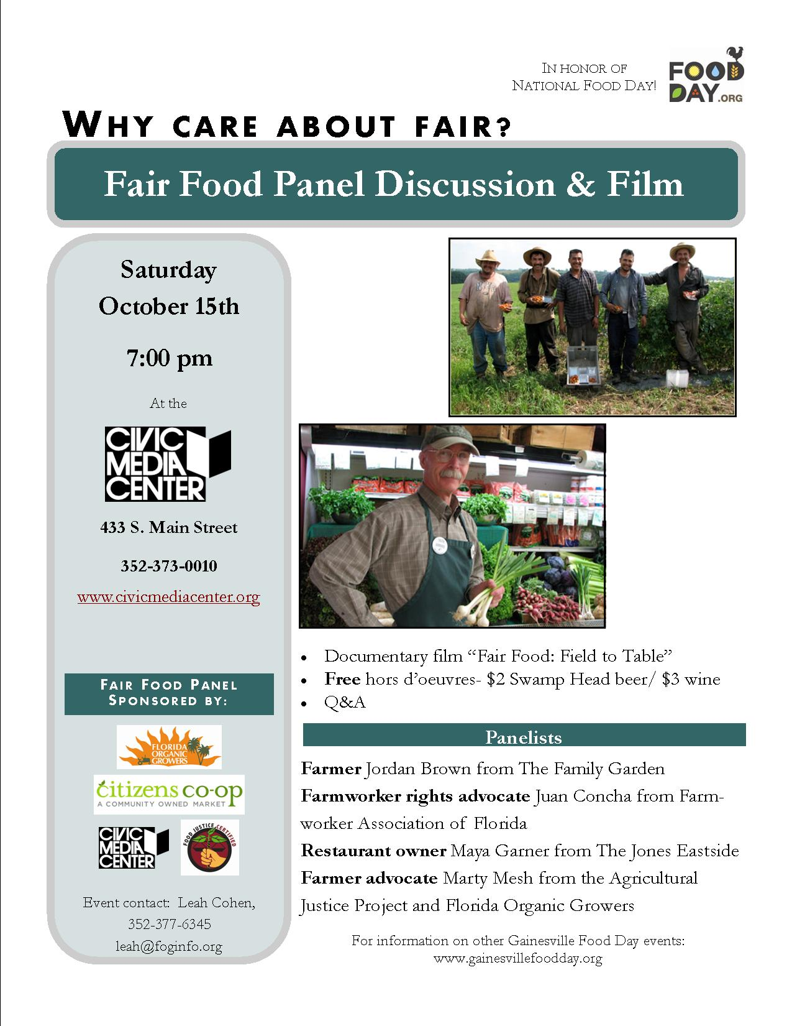

Figure 8: Flier Created for Fair Food Film and Panel Discussion to Raise Awareness of Challenge Farmworkers and Farmers Face

Film: With a late start on the public education video clip that the project planned to develop, design and planning had just begun in 2010. In 2011, the project developed interview questions for farmers, restaurant owners and farmworkers. The questions were translated into Spanish for farmworkers. Fifteen hours of video footage was shot on location at a small certified organic farm seeking Food Justice Certification with the farmer and the workers, of a restaurant owners also considering Food Justice Certification, and of a farmworker representative. Plans have been made to conduct additional interviews with the director of the Domestic Fair Trade Association. In addition, video footage was taken at the Fair Food Film and Panel Discussion and a presentation by Agricultural Justice Project representative and voice recordings were made at the training for farmworker representatives.

Impact and Contributions/Outcomes

The project continues to shine a spotlight on the challenges and injustices in the food system. This has been particularly evident in feedback from the public with the projects more substantial focus on public education materials and events in 2011. Anecdotally the support for making purchases that ensure fairness is there amongst the public; the public survey will highlight the extent to which this is shared. There was a thread of hope expressed by the farmworker representative who said that the system does have an opportunity to change with Food Justice Certification and the work of the Agricultural Justice Project and the Domestic Fair Trade Association. It is recognized that a system as opaque and abusive as the one we currently have will take time but that the work is worth the effort. This is balanced against the overwhelming feeling coming from farmers who are asked and attempt to complete the heavy documentation burden of meeting the certification requirements.

