Specialty Beef Case Study
Draft Copy
-------Grassfed Beef
Gordon and Tannon Dvorak
Atkinson, Nebraska
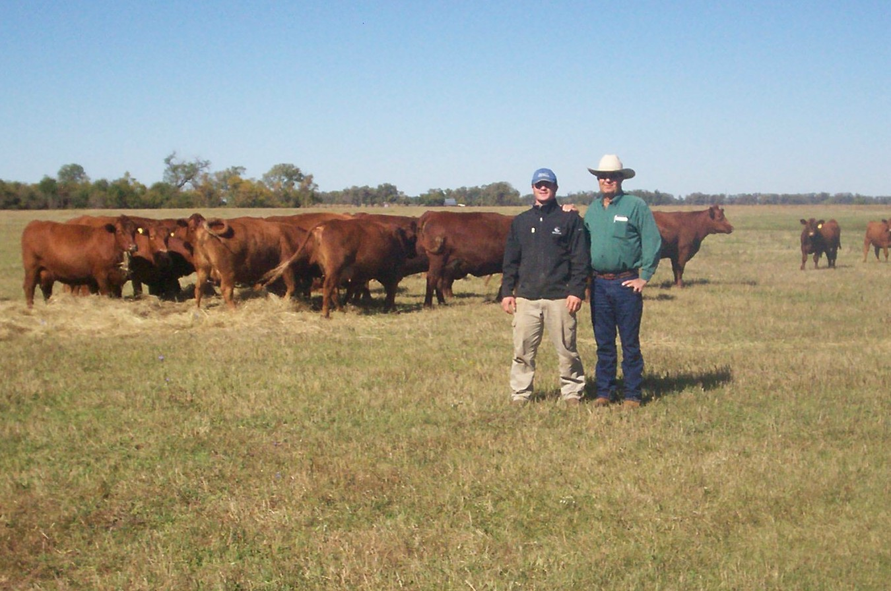Gordon and Tannon Dvorak


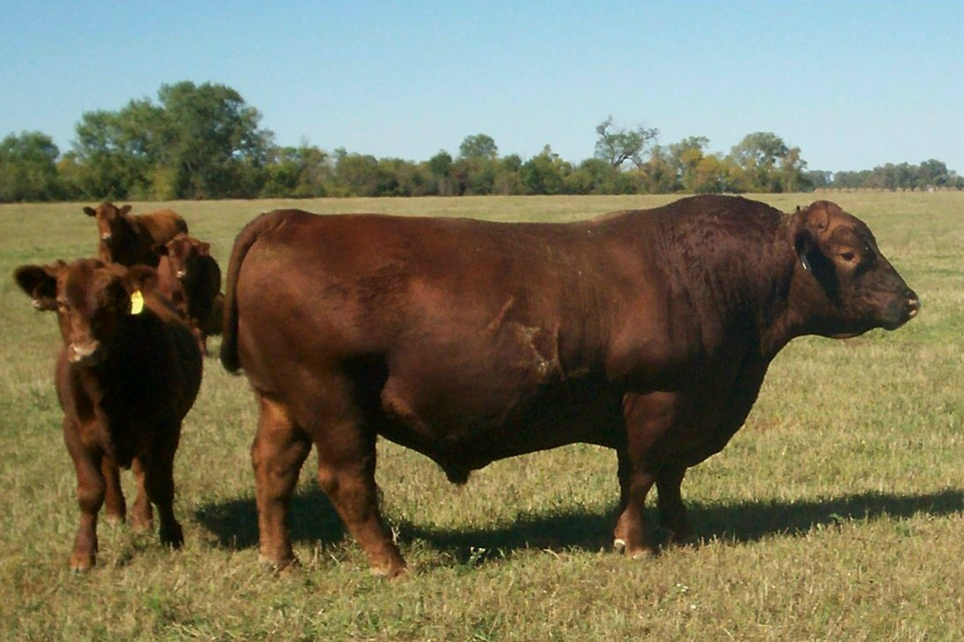
Dvorak’s Grassfed Herd Bull

The Dvorak Brothers Ranch, west of Atkinson Nebraska, was homesteaded in 1880 by Jan Dvorak, the great grandfather of Gordon Dvorak. The original 160 acre ranch and Hereford cattle herd has grown and diversified with grassfed beef production, row crops, and custom grazing beef cows under the ownership and management of Gordon. The land, which once was grazed by large roaming herds of buffalo, now produces high quality grass fed beef.

The ranch's management and labor team consists of Gordon, his wife Shannon, son Tannon, and Dan Malmberg the ranch foreman for 28 years.

Gordon grew up working on the family ranch with his parents and sister. He attended the University of Nebraska-Lincoln and studied agriculture for two years. Returning to the ranch in 1969, he provides the leadership and direction for the operation. Gordon's vision for the ranch emphasizes ranch management practices which will maintain and improve the water, grass, and soil resources.

Shannon, as with most ranch wives, is always on call to provide support and assistance with ranch and business operations.

In 2008, Tannon returned to the ranch after graduating from St. John's University in Collegeville Minnesota with degrees in Economics and Environmental Studies. He brings lots of energy and new ideas to the ranch and has been placed in charge of the management of the row crops, hay, growing calves, and grass finishing cattle.

Dan's many years of experience on the ranch are utilized in all production areas and he is responsible for the management of the custom grazed cattle.

Production Model
In 2002 the Dvorak Ranch began producing natural grass fed beef and currently market 92% of their calf crop to Thousand Hills Cattle Company. The 357-head cow herd produces all replacement heifers, with the remaining calves entering the grassfed growing and finishing program. Approximately 2,125 acres of native grassland and the crop residues from 950 acres of cropland are utilized to provide feed resources for the grassfed operations.

Because the cattle are marketed to Thousand Hills Cattle Company, Gordon and Tannon have implemented the company’s Grass-Fed Beef Program Protocol. The cattle must be British breeds, fed a 100% forage diet, and be naturally raised. The use of antibiotics, growth hormones, and ionophores are prohibited for program animals.

Gordon has utilized the ranch's forage resources and Red Angus genetics to successfully implement this production model. This systems approach is designed to market the finished cattle at 18 to 20 months of age during October and November to avoid feeding the animals through a second winter.

Why
Since the majority of the ranch's land is in native grasslands which are unsuitable for row crops, marketing that grass is their business. The Sandhills of Nebraska has traditionally been cow calf country, with late winter or early spring calving and the calves sold at weaning in the fall. This production model places the rancher in the position of a price taker in the conventional cattle commodity market.

Gordon began attending meetings and reading about grass fed beef production in 2000. He was searching for an alternative to producing cattle for the commodity beef business which could provide increased profits while utilizing ranch resources. His personal goals and values could be attained by implementing the grass fed production system, the product's positive health aspects, and the opportunity to satisfy the growing market demand. The grass fed production system based upon grazing high quality forages and feeding ranch produced hay were a natural fit for the ranch's resources and environment.

Six area ranchers formed a group to learn about grass finishing in 2003. Monthly meetings were rotated among members and each tried finishing their cattle on their ranch resources. The animals were processed and the group held a steak fry to evaluate the results. Gordon sold some of this beef through a health food store in Kansas City.

Farm, Soil, and Climate
The ranch is located near the northeastern edge of the Sandhills. The topography includes sub-irrigated wet meadows and upland pastures. Since most of the 2,125 acres of pasture land has never been farmed, the pastures are primarily composed of the native plant species which are adapted to the sandy loam soil, climate, and past grazing practices. The cools season forages present in the meadows are Timothy, frost seeded Red and Alsike Clover, plus invading Bromegrass and Wheat Grass. The native warm season grasses include Big Bluestem, Indian Grass, and Switchgrass. These mixed forage pastures in the meadows and uplands provide the ranch with a high-quality forage resource which is adapted to the local growing season and average precipitation of 23 inches of rain and 25 inches of snow.
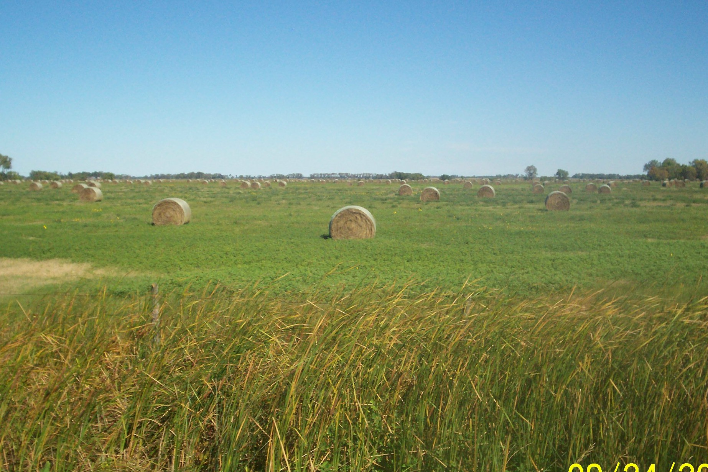Hay Meadow

Land resources also include 555 acres of irrigated corn and 170 acres of dry-land cropland farmed in a soybean/wheat rotation. All crop farming operations are custom hired. Since grains cannot be used for the grassfed animals they are sold, however the dry cows utilize the crop residue after the calves are weaned.
Pasture/Grazing Management
The grassfed beef production system depends upon the grazed forages, hay, and crop residue which are produced on the ranch. Optimum forage quality and yields are produced through grazing management, legume frost seeding, selective haying, stockpiling, and nutrient recycling. Cattle are provided a custom blended range mineral formulated to complement forage minerals measured by analysis of grass samples from the ranch.

Gordon began to implement a rotational grazing system in the late 1990's after attending Stockman Grass Farmer seminars and numerous grazing meetings conducted by Terry Gompert, Knox County Nebraska Extension Educator. He has noticed thicker, healthier grass stands and the ranch's grazing capacity has increased 25-30%.

The calving pastures have excellent shelter belts to provide protection during the March and April calving period. Since these pastures were grazed in the fall, there is no regrowth and prairie grass hay is fed with a hydra-bed feeder. The machine drops the hay in a windrow, allowing for the feeding areas to be moved and providing plenty of feed access for all cows.

Soon after calving, the pairs are moved to another pasture to be fed and kept until May 10th when they will be moved to the native upland pastures. The rotational grazing strategy provides for three to seven day grazing periods, allows the pastures to rest for four to five weeks, and only grazes the pasture four times per year.

At the end of October, the cow herd is moved from the upland pasture to a meadow near the working corrals in order to prepare the calves for weaning. After weaning the cows will be moved to harvested corn fields to begin the winter grazing program.
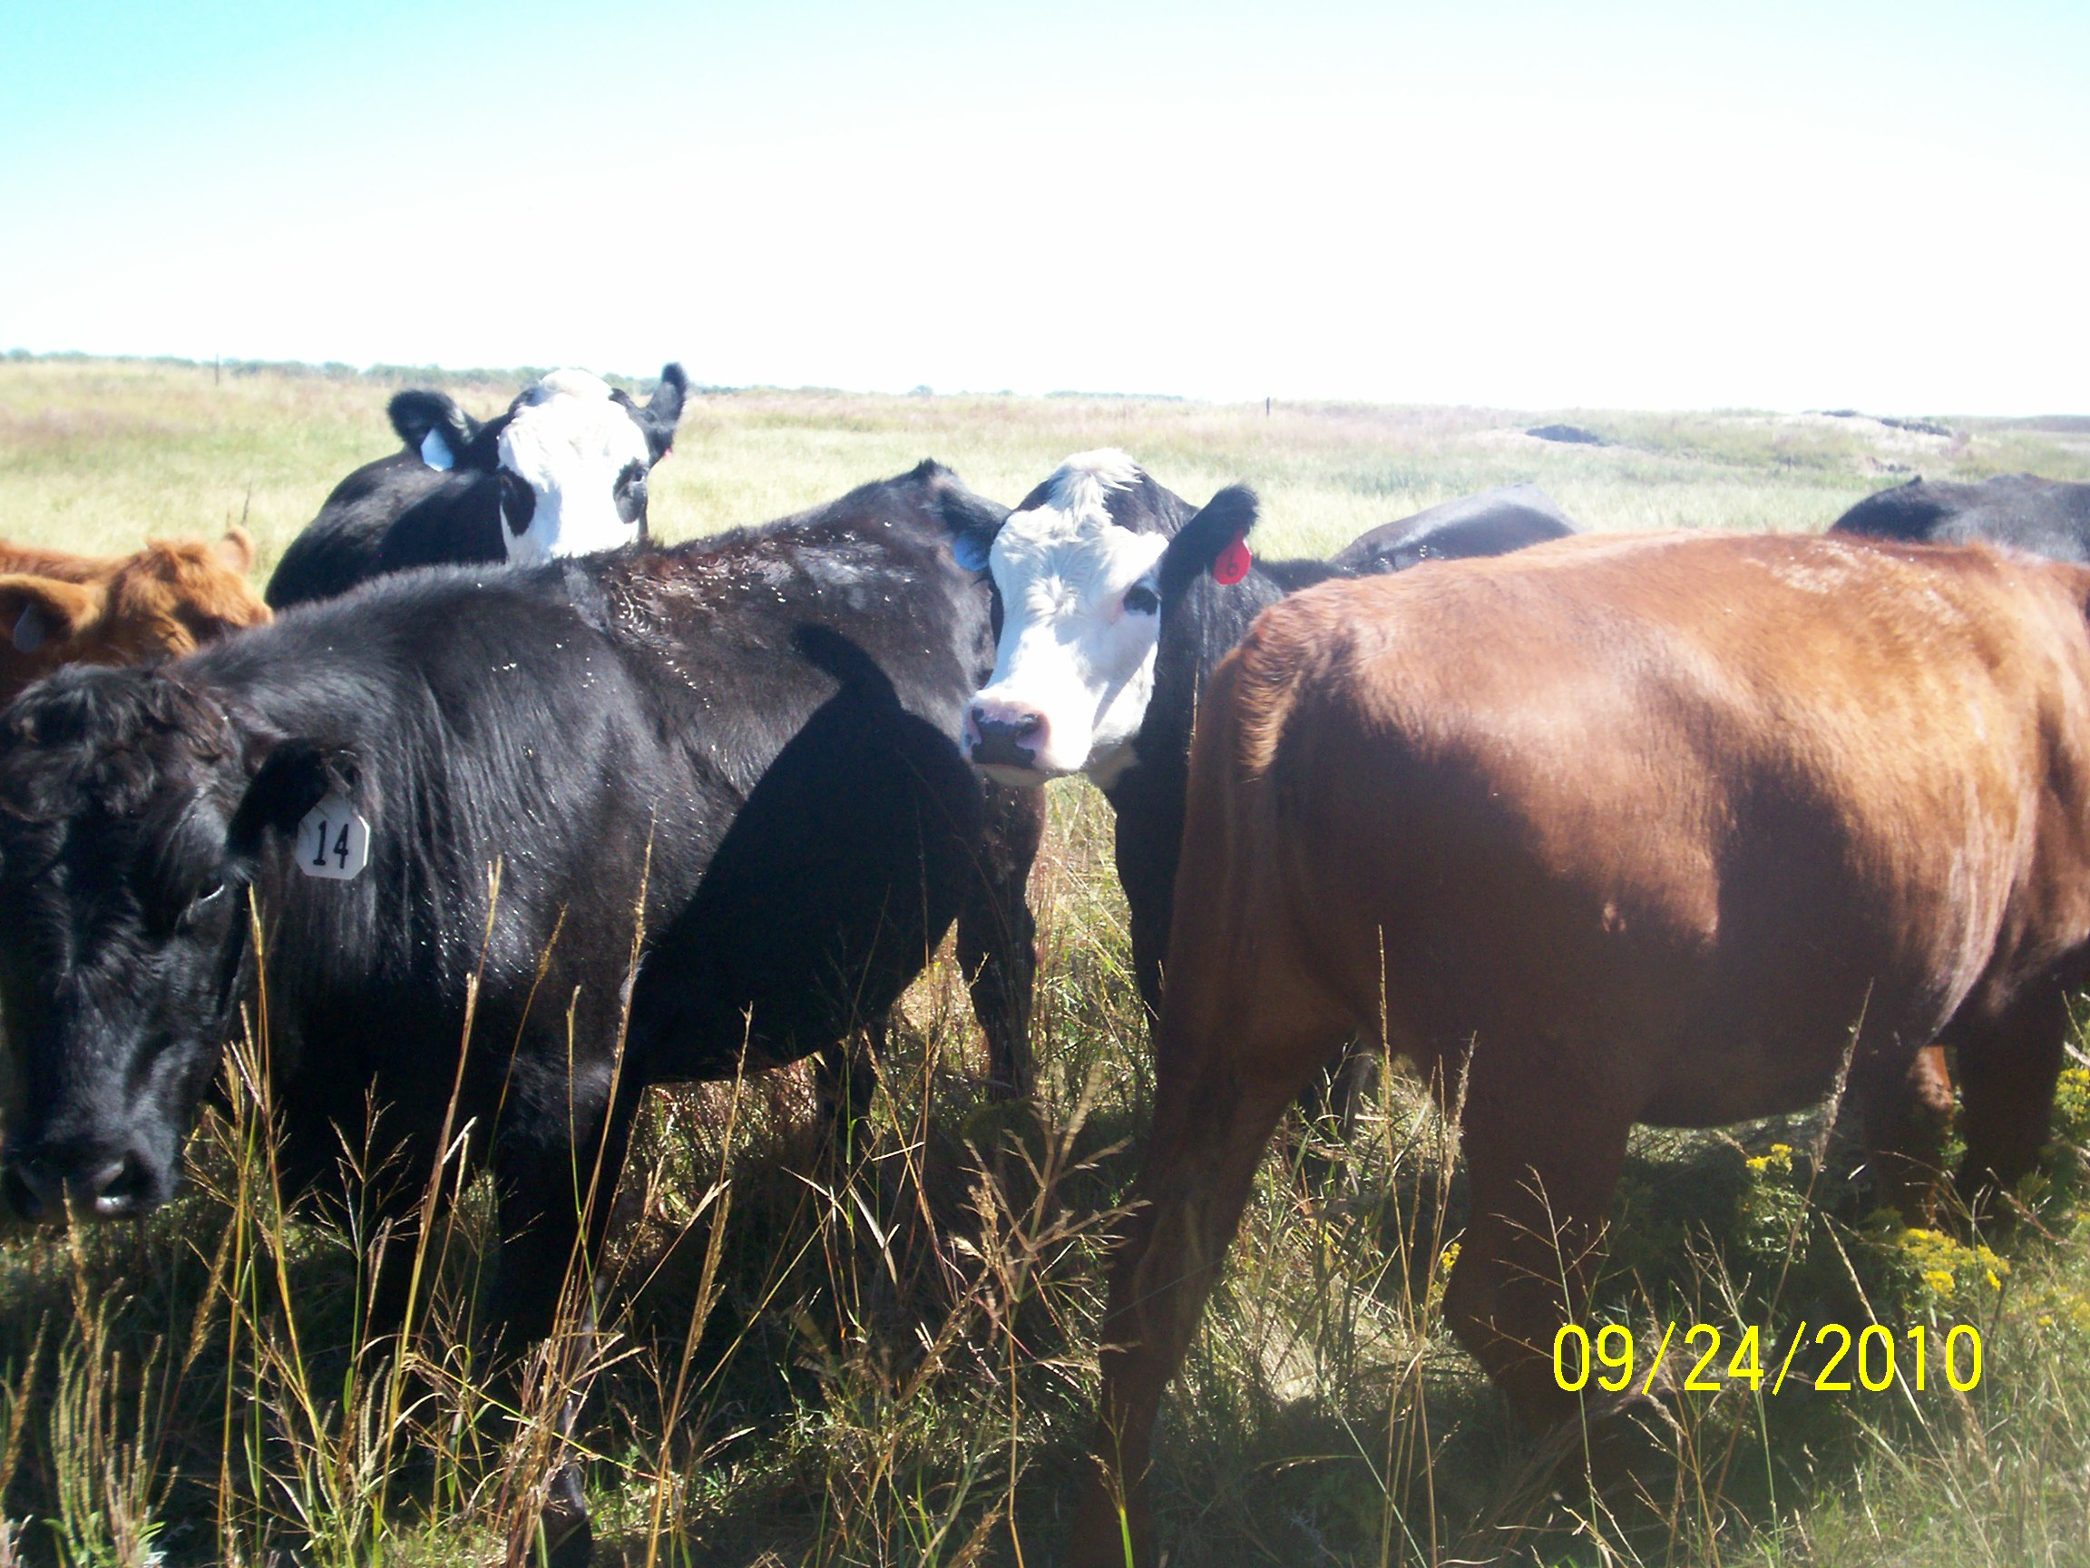Finishing Cattle
The finishing cattle will first graze high quality hay meadows with cool season grasses and legumes until the middle of May. Hay meadow regrowth will be harvested in large round bales the first half of July. The finishers will rotationally graze low ground pastures containing cool season grasses, legumes, and warm season grasses. A three to four day grazing period will be followed by four to five weeks of rest, with paddocks grazed four times during the growing season.

By the end of September, the hay meadow regrowth is ready for the finishing cattle to return for the final finishing period. All of the animals will be marketed during October and November.

Winter Feeding
The key to their winter feeding program begins in July with the production of high quality grass/legume hay from the ranch's hay meadows. The early May grazing of the early growing cool season forages prevents them from becoming to mature by haying time. Winter feeding on the hay meadows and biennial frost seeding of 1 pound of red clover improve soil fertility to increase yields and nutrient content of the hay. Gordon has found that when comparing two adjacent pastures, recycling nutrients through winter hay feeding has increased yields by 33%.

Although they would like to utilize custom hay operations, it is difficult to get the hay cut and baled at the right time to provide the high quality hay required for growing the calves during the winter. Tannon is very particular about cutting and baling the hay at the optimum time to produce highly nutritious hay. Extensive hay testing is done to provide an inventory of hay quality and quantity.

After weaning the dry cow herd will graze corn stalk residue from November through December. Typically around the first of the year the cows will be moved to a dormant hay meadow to be fed prairie grass hay. Feed rations are calculated according to hay tests and adjusted for weather and cow condition. Gordon does not like the cows to lose body condition in late gestation because he feels it will negatively impact breeding rates, milk production, and calf growth. The cattle will be moved to the calving pastures the end of February since the heifers will begin calving February 25th and the cows on March 7th.

The newly weaned calves will be wintered on hay meadows from November until they are moved to spring pasture. Gordon likes to feed the calves on the meadows because the manure is returned to the hayfield and animal health is improved because there is no dust or mud, as in a feedlot. A base hay ration is formulated by a feed nutritionist. In the past, the rations were adjusted biweekly based upon weather and calf condition. Calves are fed to full consumption with up to 20 pounds per day of grass/legume hay, and up to one pound of cane or black-strap molasses may be fed with the hay as allowed by Thousand Hills’ protocol.

Two years ago Tannon observed their nutritionist using a stick to tear apart manure patties and he began to make daily observations of the calf manure. When the manure became too firm he fed more hay testing higher in protein. Colder weather periods required feeding higher energy testing hay. This fine tuning of the energy/protein ratio appears to have had a positive impact upon calf performance during the 180 day winter feeding period. After the winter of 2008-2009 the calves weighed approximately 100 pounds heavier than historical ranch averages. The very cold and snowy winter of 2009-2010 produced calf weights similar to ranch averages, however many area ranches experienced much lighter weight calves than usual at the end of the winter.

Beef Herd Management
The Dvorak cow herd consists of 357 Red Angus cows which Gordon has bred with emphasis on easy fleshing, heavy muscled, moderate framed, good growth, milking ability and good back fat. He would like the 1,400 pound cows with frame scores of 5 to 5.5 to be down sized to 1,250 to 1,300 pounds with an average frame score of 5. Red Angus bulls are purchased, with emphasis placed upon carcass ultrasound data and reducing frame score and mature weight.

Carcass tenderness traits have been improved through an ultra-sound evaluation of all calves. Cows whose calves did not meet grassfed standards were culled and sold as bred cows at the local livestock auction barn. Beginning in 2010, only potential replacement heifers will be evaluated with ultra-sound, and their selection based upon tenderness, rib eye area, high marbling traits, disposition, growth, and potential milk production.
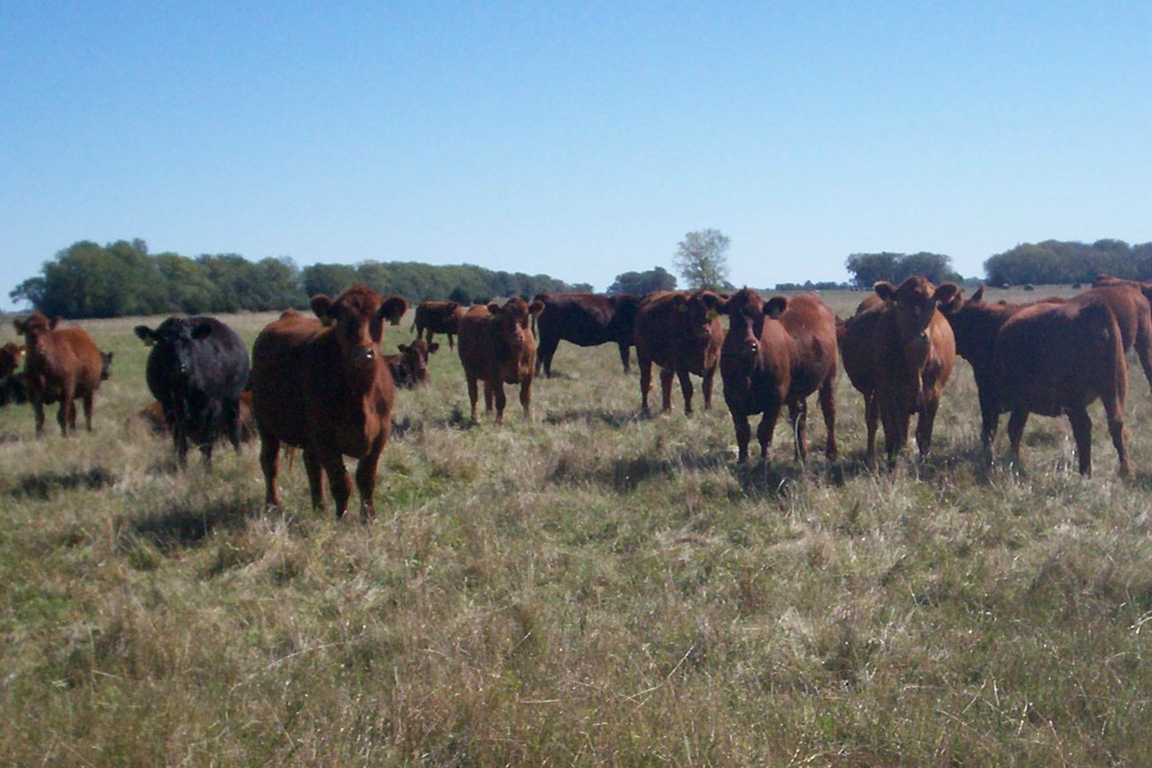Bred Heifers

The 60-day cow calving season runs from March 7th to April 30th because it matches the ranch's climate, labor and feed resources. The bred heifers begin calving earlier on February 25th. These dates allow the staff to focus on calving before they begin fixing fences for pasture turnout. Gordon has found that when calving later, the cows produced too much milk for the small calves, causing scours.

Weaning occurs the first week of November when the calves are 7 to 8 months old and typically weigh 700 to 750 pounds. The cow herd is moved from the upland pasture to a meadow near the working corrals in order to prepare the calves for weaning. They graze together one day to acquaint the calves the pasture area, then the cows are removed and placed into the corral. After 4 or 5 days of separation, the cows are moved away and the newly weaned calves remain in the meadow. From November till the first week of May, they are fed a ration of grass/legume hay. When turned out to graze the hay meadows, they will weigh 900 to 1,000 pounds. At 20 to 21 months of age and weighing 1,250 to 1,300 pounds, the finished cattle will be marketed during October and November.

Herd Health
The ranch's vaccination program is typical for Sandhills ranches. At 4 to 6 weeks of age the calves are branded and vaccinated for respiratory diseases and BVD. In late September or early October the calves are given the 2nd vaccination and weighed. At weaning the calves are given another booster shot and weighed. In the spring, prior to turning out to pasture, the calves are given a pink eye and foot rot vaccine. This vaccination program has reduced death loss from 4% to less than ½%. In 2010 no finishing cattle were treated for pink eye or foot rot. If an animal needs to be treated for pink eye or foot rot, they will be treated with iodine and zinc therapy under the consultation of a feed nutritionist or veterinarian. If an animal is treated with an antibiotic, it is sold at the conventional livestock market at weaning or in the spring.

The cows will be given a breeding vaccination shot at the November pregnancy check. The bred heifers are pregnancy checked and vaccinated the end of September.

Marketing
The finished cattle will weigh 1,150 to 1,300 pounds by October to November. Historically, approximately 92% of the calves are marketed as grass-fed natural beef through Thousand Hills Cattle Company. The only animals that do not meet standards have been treated with antibiotics, but are very marketable through the local sale barn. Tannon thinks that is very important for their grassfed program cattle to also have “commercial relevance”; the ability to deliver a truckload of calves of a similar weight which are highly desired by cattle feeders.
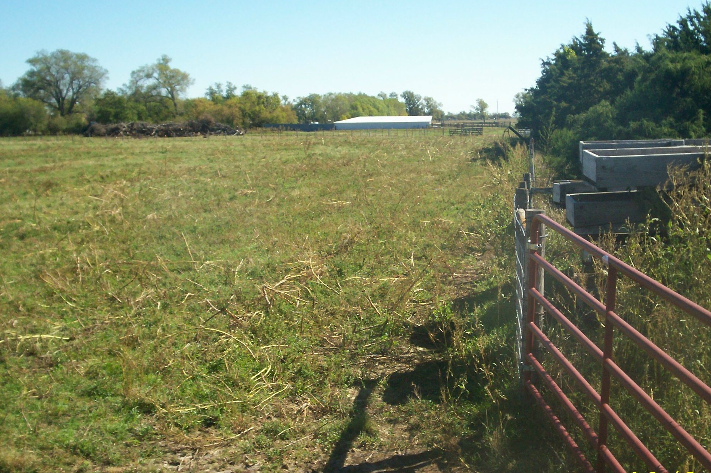
Weaning and Calving Area

The Thousand Hills cattle are shipped 400 miles to Lorentz Processing in Cannon Falls Minnesota, with the buyer paying part of transportation costs. For 2010, a base price of $1.75 per pound hot carcass weight is contracted with price adjustments according to the carcass quality and expected yield.

Summary-Challenges
Gordon has developed a successful grass finished beef production system in the last 10 years. Although he makes it appear easy, he will admit that it is an ongoing challenge to combine the right cattle genetics with a year around supply of high quality forages.

He has worked to improve the herd genetics for the last 15 years and will place emphasis on reducing frame score from 5.5 to a herd average of 5, while maintaining growth traits. Tannon's return to the ranch will bring new challenges with herd expansion, implementation of new ideas, more detailed economic analysis, and lots of new energy.

Keys to the Operation
Cattle genetics which will reproduce, milk, grow, be easy fleshing, heavily muscled, finish on grass, and produce a high quality carcass.

Cattle that have “commercial relevance”, give the Dvoraks the ability to deliver a truckload of calves of a similar weight, which is highly desired by cattle feeders.

High quality hay for winter feeding.

Use of forage testing, manure consistency monitoring, and feed consultants for ration formulation.

An animal health program utilizing vaccinations and non-antibiotic treatments to minimize animals pulled from the program.

Rotational grazing practices which harvest and grow high quality forages.

A grazing plan with flexibility to provide forages during times of slow grass growth or drought.

