Grassfed Beef Case Study
Mike and Deb Hansen
Good Earth Farm
Milladore, Wisconsin

Who?
When Deb and Mike Hansen started Good Earth Farm in 1991, they probably never imagined that they’d end up selling beef directly to some 1300 customers across the country. In fact, during their first years, they experimented with everything from beef to pastured chickens, turkeys, sheep and vegetables. Through trial and error, they learned which enterprises held the most promise for them in terms of their skill sets and goals.

Production Model
Mike is philosophical about his production system. They started into the business with the goal of being organic and grass-based, so there weren’t traditional mindset problems to overcome. They’ve focused on educating themselves on the best methods and always making incremental improvements in their system.

Why?
Their farm is organic because of their commitment to environmental stewardship. Their herd of belted and black Galloway cows are cared for with the goal of providing their animals with a good life. Pasture is the main source of forage for the cattle because “That’s the way the Lord intended them to eat,” says Mike.
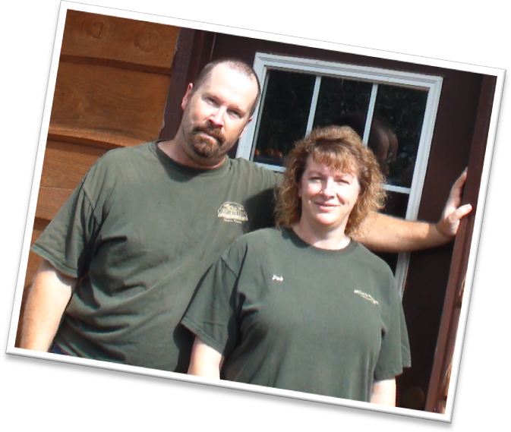
Farm, Soil, and Climate
Good Earth Farm is near Milladore in central Wisconsin. Their land is flat and gently rolling silt loams and their grazing season is approximately 180 days.

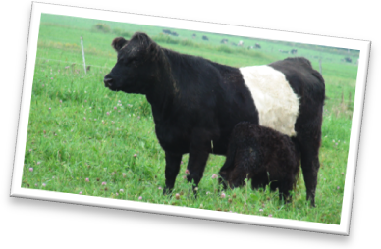
The Hansens operate 200 acres of which they own 80. One hundred fifty acres is managed as pasture, with 50 acres in hay production. Mike keeps up with current research on pasture management and uses practices typical of management intensive grazing systems.

Pastures/Grazing Management
Mike’s pasture management is based on the principle of managing for the grass, not for the cows. By managing for a healthy pasture, he ensures that there will always be plentiful, high quality pasture for his herd. His cow herd and finishing animals are managed similarly, but on separate pasture systems. Both groups are moved to fresh pasture daily.

Winter Feeding
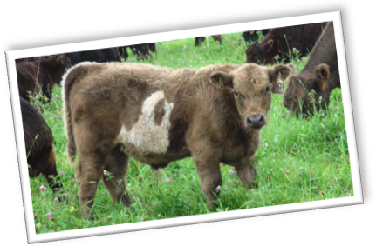
Wisconsin’s long winters are a challenge for pasture-based beef producers. Mike’s philosophy is to produce the highest quality hay and baleage he can to maintain good weight gains during winter. He feeds on pasture as much as possible and provides open sided housing, which he finds is seldom occupied. The cattle choose to stay outdoors except under extreme conditions.

Beef Herd Management
The herd of 45 cows grazes two 30 acre pastures that are subdivided with polywire. Mike gives them approximately an acre of fresh pasture every day, giving the grasses a rest period varying from 14 to 30 days, depending on climate conditions.
Market animals, steers and heifers, are raised on a separate 27-acre pasture, with once-a-day moves as well. These animals usually finish in approximately 20 months at about 975 pounds. Mike is working on increasing the growth rate and carcass weight of his finished animals by breeding to black Galloway bulls that have these characteristics. He and Deb share an interest in maintaining the belted Galloway phenotype for its marketing value.

Herd Health
Most of the calves are born in May and June on pasture. Mike finds that this promotes a healthy calf and plenty of milk during the first months of life. He believes that maintaining a healthy pasture is necessary to maintain a healthy herd.

Marketing
The Hansens’ marketing efforts have focused on finding customers who value the practices they use, people who are willing to pay a premium for the high value product they produce. Targeting a demographic that values and can afford their meat has meant selling their product via the Internet primarily. They ship out orders to customers all over the country every week.

Good Earth Farm and Gifts from the Good Earth are examples of the new trend toward values-based marketing, but not at all in the superficial way that ‘green’ and ‘sustainable’ marketing has been used in recent years. The brand identity that the Hansens created was developed from the heart. Their production system reflects and supports their values. They farm “as if everything matters.”

Mike has found that his strengths are in his marketing and organizational skills. He’s built a diversified customer base of restaurants, coops and markets, and individuals. And to serve them better, he’s created a network of like-minded farmers to supply pork, lamb, and poultry.

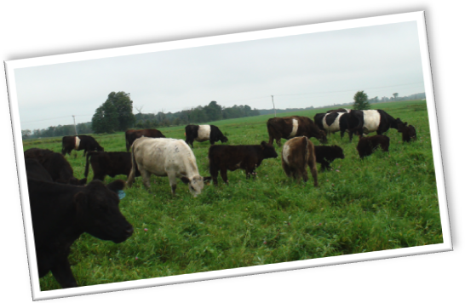
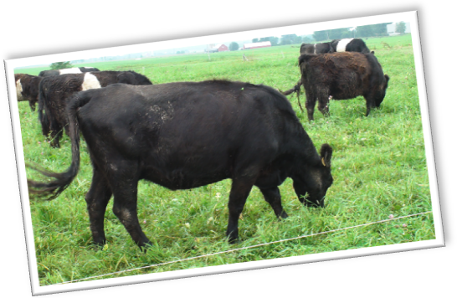
Early on, Mike and Deb realized that they were challenged by trying to provide a variety of meats to their customers. As their business grew, they decided to focus on their beef operation and work with other like-minded farmers to supply their customers with poultry, lamb, and pork.

Summary – Challenges
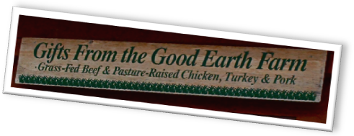
No particular production challenges stood out in Mike’s mind at the time of this interview. Their biggest problem is keeping up with demand for their product. Expanding their herd and increasing pasture production are their focus going forward.

Keys to the Operation
One key reason for their success is their ability to focus both on the big picture and on the details. Mike can easily articulate their guiding principles for what they do, whether it’s pasture management or marketing. Their overarching principle is the triple bottom line—balancing financial security with quality of life and environmental stewardship. At the same time, they take care of the details, with Mike practicing management intensive grazing on the pastures and Deb, with her accounting degree, taking care of the bookkeeping.

The Hansens know their customers well. In addition to the production principles they follow, they know that part of the allure is in knowing the farmer, knowing where the food comes from and how it’s raised. To be good in this business, Mike realizes that you have to be good at telling your story, because, in large part, “that’s what people are buying”.

Looking forward into the future, Mike sees an opportunity to bring his son into the business if he’s interested. “There is the potential here to make this business into an Omaha Beef-type company,” he said, referring to the well-established national mail order beef company. He also sees a potential opportunity in franchising “Good Earth Farms” and providing other groups of producers a framework around which to build a marketing business, with a centrally organized marketing program. He feels he’s found a successful approach to niche marketing meat. He says, “As long as a farmer answers the phone, we’re in good shape.”

Written by Kelliann Blazek and Laura Paine, WI DATCP. Photos by Kelliann Blazek. September 2010.

