Grassfed Beef Case Study

Wayne Rasmussen
Wayne Rasmussen
Plainview, Nebraska


Wayne’s grassfed cattle at the first Grassfed Exchange in Yankton, SD

Who
As a conventional crop and livestock producer in Pierce County Nebraska, Wayne Rasmussen developed a farming operation which utilized the best management and production practices. However, in the 1990s he began to look at the impact which modern agriculture was causing upon the environment and community. His interest and adoption of management intensive grazing has led to the development of a grassfed beef operation.

As owner and manager, Wayne has assembled a team to provide input and accomplish daily tasks. His wife Judy provides assistance as the “go for this” and paying the bills. Their son Tim manages the crop farming operation. Myron Hitz provides general farm assistance with the crops and livestock, animal health, feeding, hay production, and maintains equipment. Brothers Cully and D.M. Forker work with the cattle operation. Cully manages the Verdigre ranch and cow herd. D.M. manages the cattle at the Plainview operation which includes the grass finishing cattle. Debbie White keeps the financial records for the operation.

Production Model
The grassfed beef production model which Wayne has developed was built upon the strengths of his diversified crop and livestock farm. These strengths include family, employees, land base, cow herd, forage harvesting equipment, livestock facilities, feeding equipment, management experiences, and marketing expertise. Wayne utilizes many different marketing opportunities to make the best use of cattle type and feed resources.

The grazing system has evolved from simple rotations to management intensive grazing and mob grazing. The beef cow herd was linear measured to identify cows best adapted to producing grassfed beef. Irrigated cropland was converted to pasture by planting cool season grasses and legumes. A watering and fencing system was installed utilizing EQIP cost share programs. The crop rotation now includes a small grain crop followed by forages for stockpiled grazing or silage.

Why
Wayne has become very dedicated to adopting sustainable farming practices to become a better steward of the land and livestock. As he began to learn and utilize Holistic Management a new vision for his farming operation has created the beginning of this grassfed beef production system. Wayne wants to strive to learn all he can about grassfed beef production. He wants to “try to build a model by which others can look at to obtain information as to what has worked for us and what has not.” It is very important to share what he learns with others through The Grassfed Beef Exchange activities.

Farm, Soil, and Climate
The pasture and crop land in the Plainview area is a mix of wet meadow pasture, silt loan, and sandy loam soils. The Verdigre ranch pasture has clay rolling hills. Rainfall ranges from 20 to 25 inches with approximately 24 to 36 inches of total snow accumulation. The growing season for forages runs from April 1st to October 15th.

Pasture/Grazing Management
Detailed grazing charts are kept to assist staff in decisions concerning grazing and rest periods. The grazing system utilizes simple rotation, management intensive grazing, and mob grazing to accomplish goals for improved pasture management, soil quality, and animal performance.

The pasture forages are a diverse mixture of warm and cool season grasses and legumes. A management intensive grazing system is utilized for the cow herds. Each pasture is divided into 11 to 15 paddocks with the beef cows grazing each paddock for 2 to 5 days and allowing for 35 to 50 days of rest.

The finishing cattle will utilize a mob grazing system from April 1st to December 1st with daily or multiple day moves. The cattle are moved in the afternoon to take advantage of higher sugar levels in the grass. Supplemental feed may be provided on pasture after September 1st.
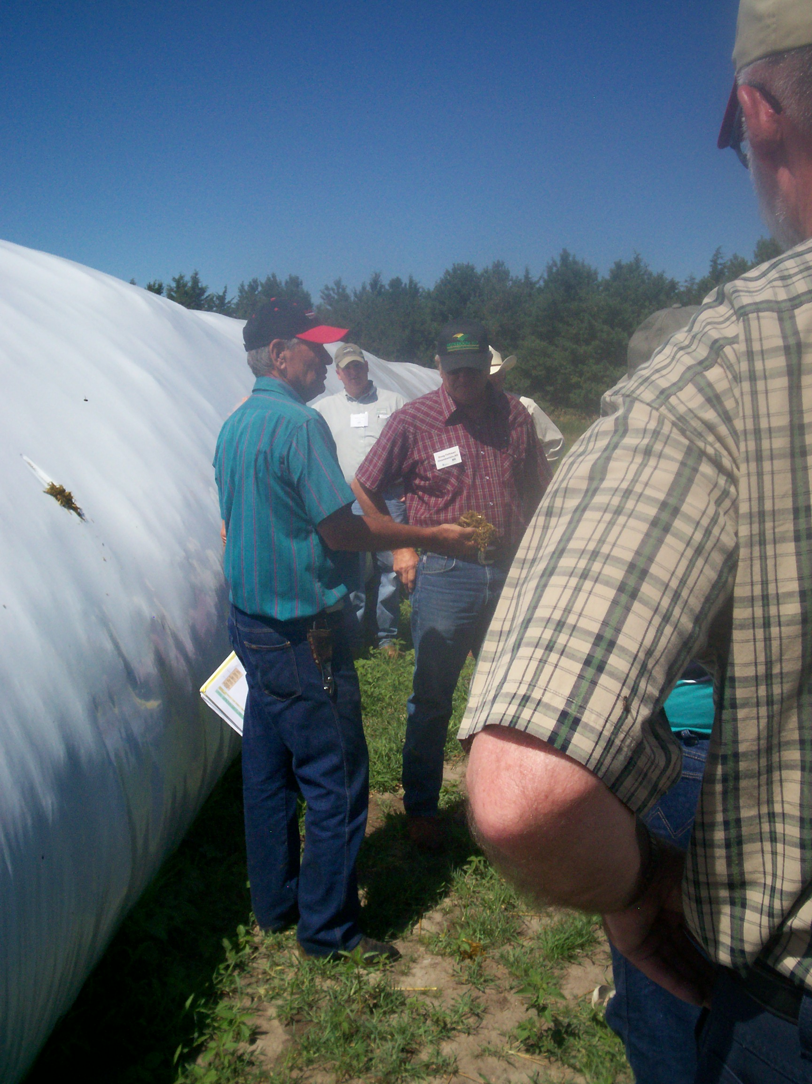
Bale of Silage

Winter Feeding
Finishing grassfed beef and backgrounding calves during the winter requires high quality stockpiled forages and stored feeds. Wayne is very interested in identifying forages to be used to provide a balanced ration to improve the performance and quality of grass finished beef. Forage testing and a feed nutritionist are utilized to provide feed rations for growing and finishing cattle. From September 1st to May 1st the cattle are fed rations on pastures, stockpiled forages, or minimal pen enclosures with a bale processor or feed wagon.
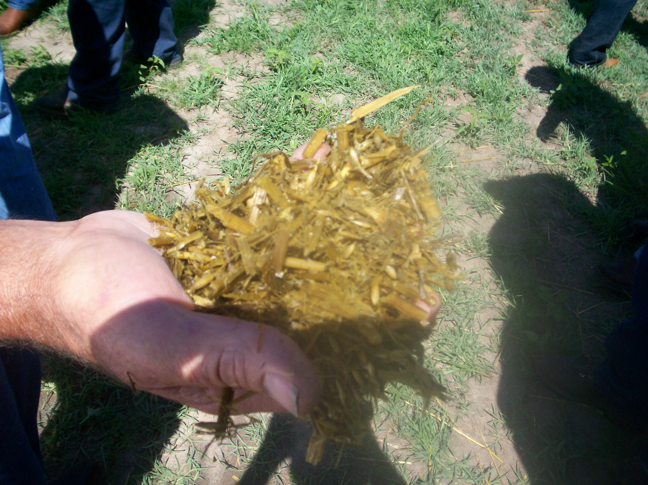
Alfalfa Silage

The cropping system provides the foundation for the winter feeding program with hay and balage of alfalfa, small grains, and double cropped forages. After summer harvest of winter wheat grain and small grain/pea forage the fields are quickly prepared and planted to crops for stockpiling or harvesting as silage. Brown midrib sorghum, male sterile corn, and late planted (earless) corn may be grazed or harvested for silage and stored in big plastic bags. A winter brassica mix will be stockpiled to be strip grazed with supplemental forages fed to balance the ration.

The cow herd will utilize corn and soybean crop residues from October to April. Supplemental feeds used include alfalfa, grass hay, and wet distillers are fed with a bale processor or feed wagon during periods of heavy snow cover or to provide additional protein and energy to balance the ration. Corn silage and hay will be used once the April 1st calving season begins. Rye and wheat winter annuals provide early spring grazing.

Beef Herd Management
The cow herd consists of an Angus based herd with some Red Angus and Hereford. When Wayne began the transition to grassfed beef the original cow herd was linear measured to identify the cows best suited to producing calves acceptable for grassfed beef. The larger framed cows were sold through a local livestock auction barn for a very good price. The remaining cows were more moderate frame scores of 4 to 5. Bull selection and retaining grassfed quality replacement heifers will improve herd genetics and grass finishing traits. One half of the bulls are purchased, 20% are home raised, and artificial insemination is used on 30% of the cows to bring in new genetics.

The 60 day calving season runs from April 1st through June 1st because it best matches the farm’s labor, climate, and high quality stored feed resources. Crop residues can be utilized until April 1st with supplemental feeding on the fields which improve soil fertility is through nutrient recycling.
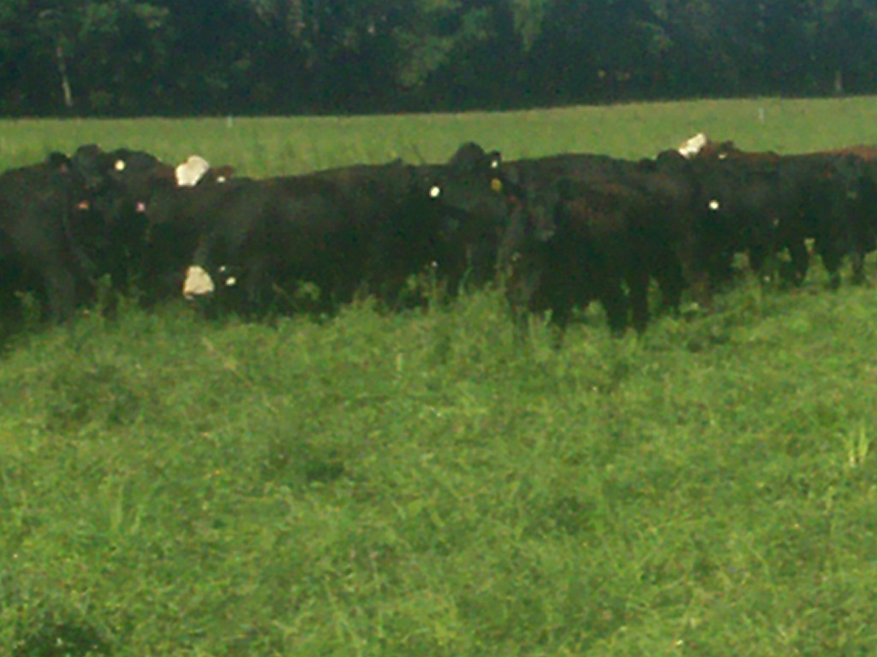
Finished Cattle in 2009

Herd Health
The animal health program is based upon guidelines provided by grassfed beef marketing companies. Calves receive preconditioning vaccinations and cows receive standard breeding vaccinations. Fecal samples are collected to monitor internal parasites. Apple cider vinegar has been used for external parasites. Ivomec type products are allowed by protocol guidelines and are used for lice on calves and cows.

In the past calves have been weaned the end of October before cows are moved to cornstalks. Wayne is considering moving weaning back to the end of November based upon discussions with a grassfed beef consultant.

Marketing
The finished cattle will be marketed from November to May weighing 1,250 to 1,400 pounds. Approximately 75% of the finished cattle are sold to niche markets as grassfed, natural beef, age/source verified and/or direct marketed. Approximately 300 grassfed cattle are marketed each year to Tallgrass Beef Co., US Wellness Meats, Thousand Hills Cattle Co., and local direct markets. Wayne would like to market more cattle to local direct markets. Scheduling cattle slaughter at local locker plants is difficult especially during fall deer season.

Conventionally finished cattle are hedged and sold direct to the packer or a local sale barn. Cull animals are sold through a local sale barn.

Summary-Challenges
The process that Wayne has followed to transform a traditional crop and livestock farm to a crop farm with a grassfed beef operation has been successful and can help to provide a model for other producers. Wayne utilized the assets of family and staff to provide labor and management. A key starting point was a crop operation to produce grain crops, high quality stored forages, stockpiled forages, and crop residues to serve as the foundation for a winter feeding program. He identified cows which could produce grassfed quality calves and marketed the cull cows into the conventional market for a very good price. Several niche markets are utilized for marketing the different types of cattle and feed resources of the farm.

Challenges for Wayne include improving the production system by identifying grasses and feeds which can be utilized in balanced feed or grazed rations to improve performance, economic return, and carcass quality. The difficulty in accessing information about methods to produce grassfed beef provided Wayne with the idea to start The Grassfed Exchange to assist producers in acquiring and sharing information.

The Grassfed Exchange Purpose Statement
To promote grass-fed beef for the social good of our land, our consumers, and our communities.
To educate both consumers and producers by promoting the exchange of ideas and developing strategies to increase the value of the grass-fed industry.
To improve genetics for the grass-fed industry through the exchange of proven genetics and to improve the skills of the grass-fed producers through education and the sharing of knowledge by means of sales and seminars.

