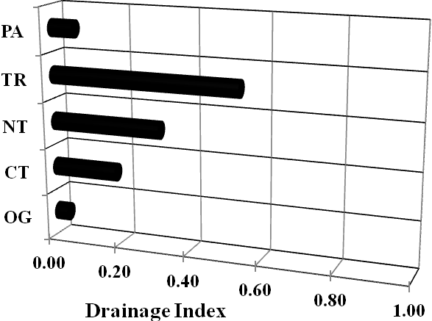
Figure 1. Drainage index values for pasture (PA), tree (TR), no tillage (NT), conventional tillage (CT), and organic production (OP) systems. Drainage Index = fraction of sample volume relative to the largest sample volume collected.

Figure 2. Average nitrate concentration in drainage water of pasture (PA), tree (TR), no tillage (NT), conventional tillage (CT), and organic production (OP) systems.

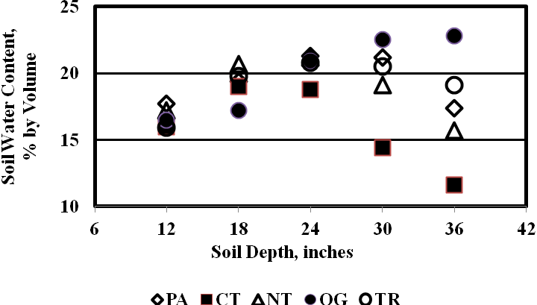
Figure 3. Average soil water content pasture (PA), tree (TR), no tillage (NT), conventional tillage (CT), and organic production (OP) systems.

