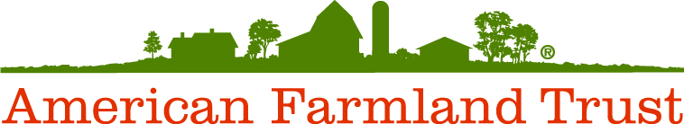

Steering Committee for
Farmland Advisors: A Training Program about
Farmland Access and Farm Transfers

Jerry Cosgrove, New World Foundation

Julia Freedgood, American Farmland Trust

Erica Frenay, Northeast Beginning Farmer Project, Cornell Small Farms Program

Jennifer Hashley, New Entry Sustainable Farming Project

Michael Hurwitz, GrowNYC

Jiff Martin, University of Connecticut Extension

John Piotti, Maine Farmland Trust

Kathy Ruhf, Land for Good

Stephen Searl, Peconic Land Trust

Ed Staehr, New York FarmNet/FarmLink

Ben Waterman, University of Vermont Center for Sustainable Agriculture

