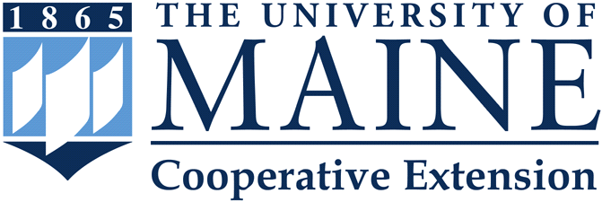
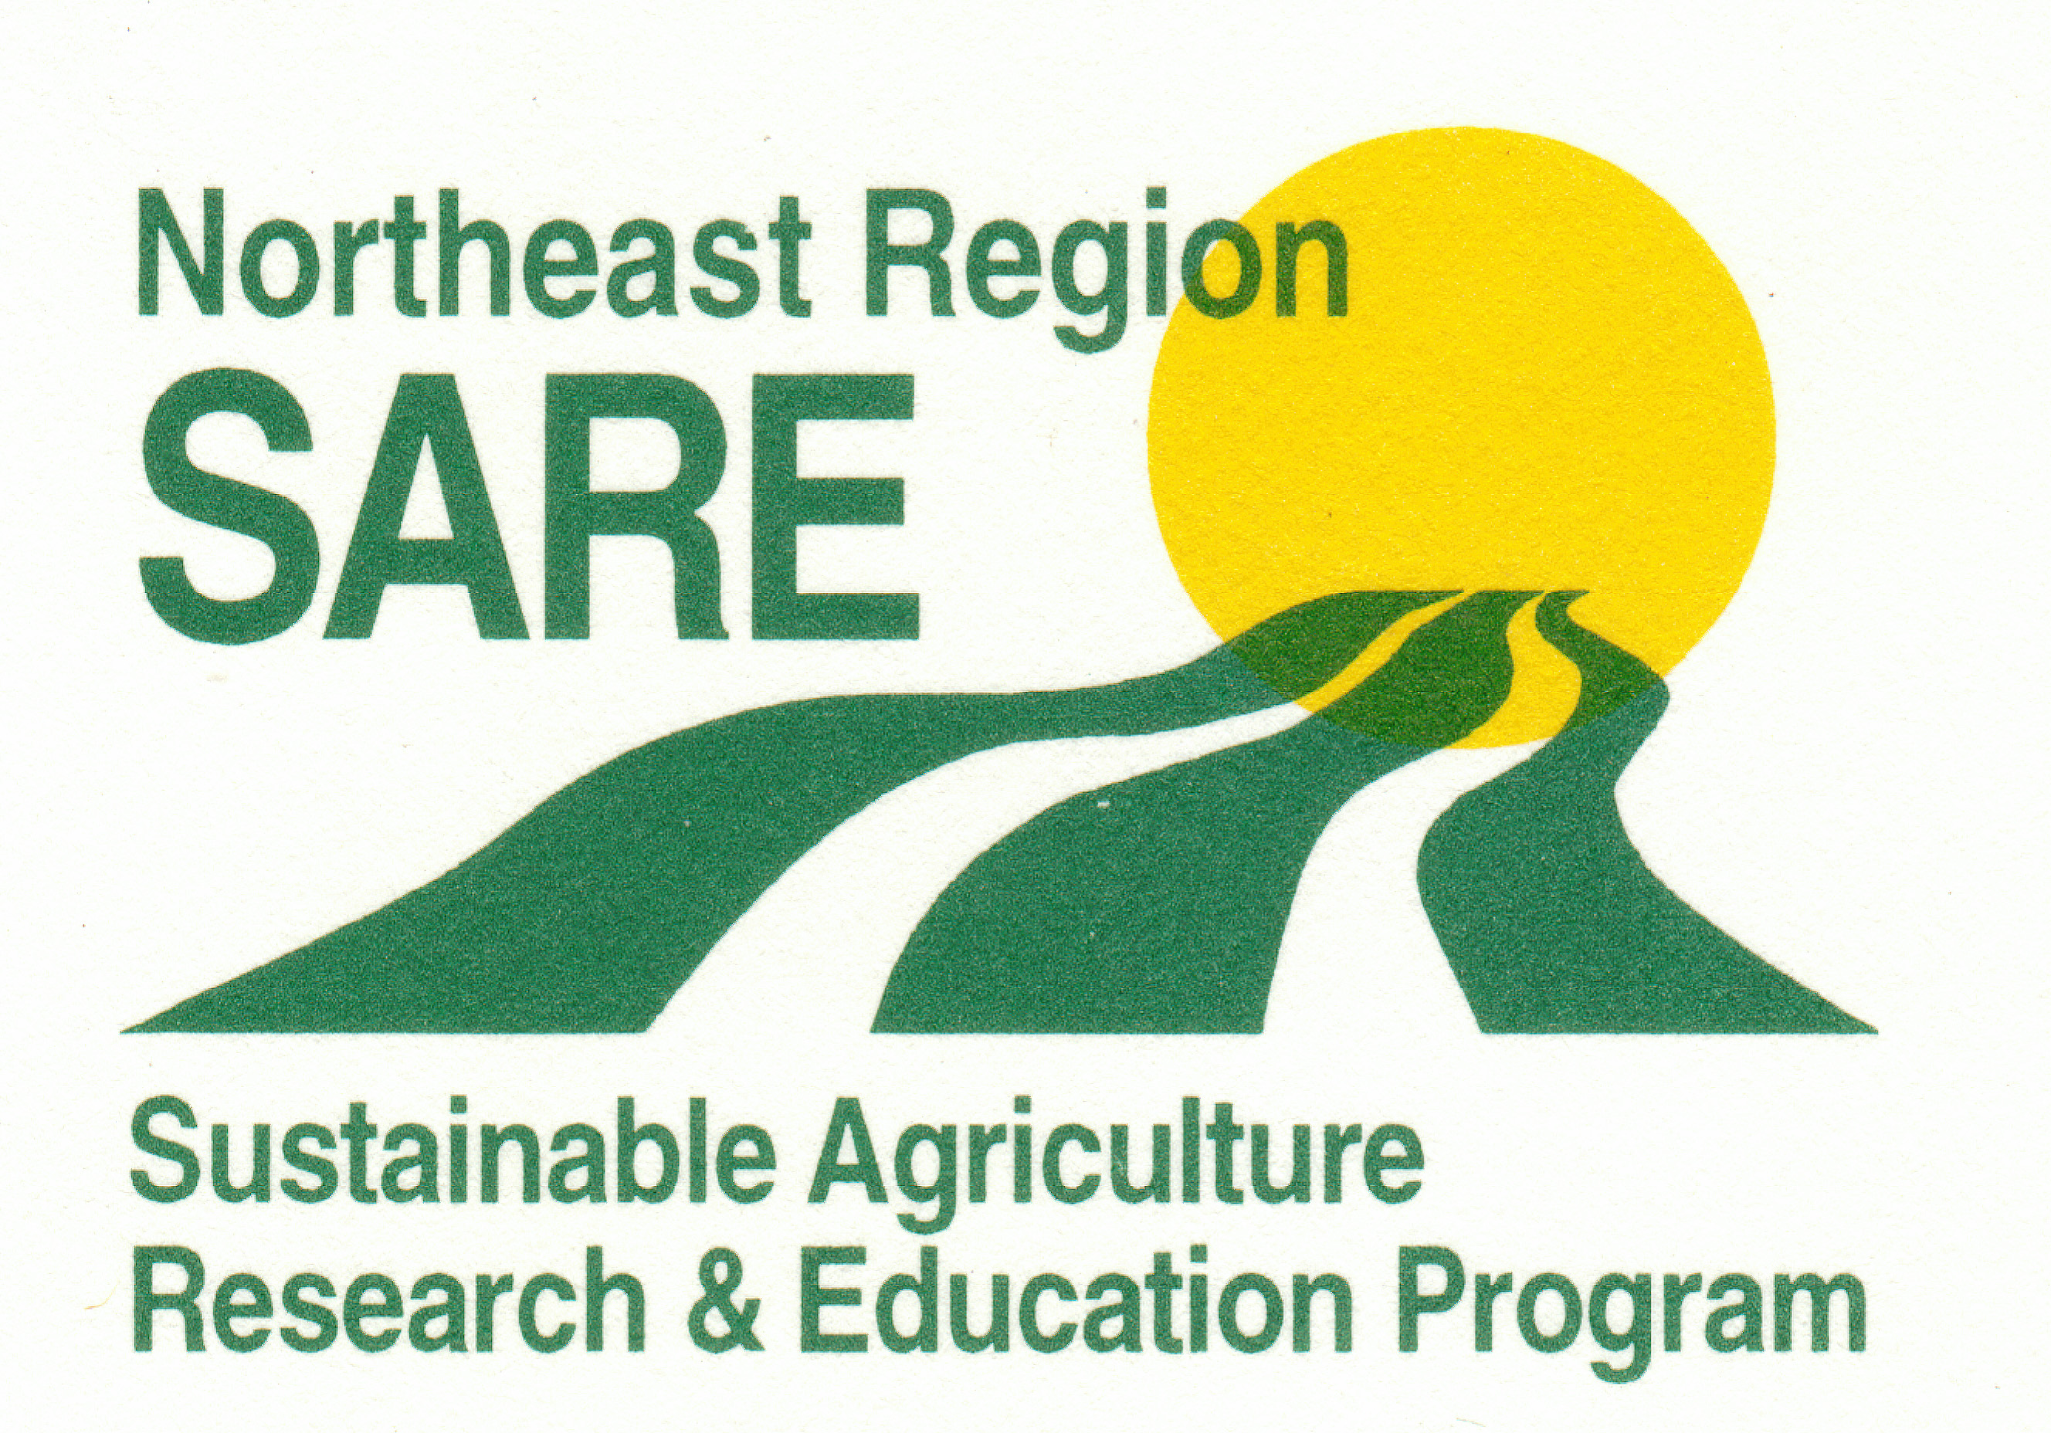
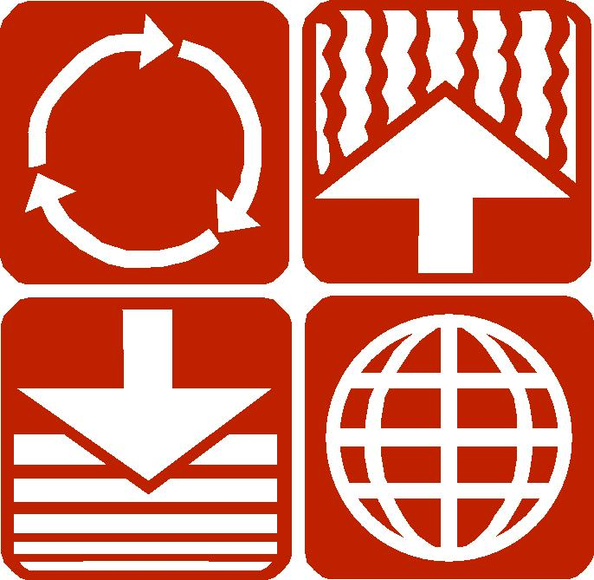

Cornell
Waste Management
Institute

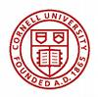
Announcement: 2008 Carcass Management Training Workshop:

Concepts and Practices

For Agricultural Service Providers: State and USDA Agency, Extension, Non-Profit and Private Crop Advisors from throughout the Northeast

- Do you want to give good advice to your clientele about carcass management?
- Do you want to improve your understanding of carcass management?
- Do you want to get hands-on experience in carcass management?
- Do you want to know what carcass management resources are available to help you work with your clientele?

Then this workshop is for you!

The 2-day workshop will cover a wide range of carcass management topics for agricultural professionals. The workshop will be repeated three times in the northeast region to reduce travel cost. The workshops will be held September 16th -17 2008 (Livestock Evaluation Center, State College PA), October 15-16th 2008 (Miner Institute Chazy NY) and April 28-29th 2009 (Highmoor Farm Monmouth ME). Lodging expenses, resource materials and some meals will be covered and travel will be subsidized through a NESARE grant. There is a $50.00 non refundable fee for resource material, including a 3’ compost thermometer.

If interested, please fill out an application form. You will be notified if accepted into the Train-the-Trainer Program. There are 20 spaces available at each site. Applicants must commit to attending all workshop sessions, which will be taught by researchers and Extension educators. Classroom and in-field activities will be complemented by extensive printed and electronic resource materials.

Overall Learning Outcome:

Participants have a clear understanding of the principles of carcass management and can articulate these to clients and colleagues. They are able to plan and deliver programs, services, and/or projects (appropriate to their professional responsibilities) that meet the needs of farmers and/or agricultural service providers who may work with these farmers.

Planning team:

Mark Hutchinson: Associate Extension Professor, University Of Maine
Craig Williams: Extension Educator, Penn State University
Jean Bonhotal: Senior Extension Associate, Cornell Waste Management Institute:
Dept. of Crop and Soil Sciences

TENTATIVE Curriculum

Day 1:

9:30 – 10:00 Registration
10:00-10:30 Introductions/ Expectations
10:30- 11:30 Biology of Compost

11:30- 12:30 Lunch

12:30- 1:30 Site Selection
1:30 - 2:30 Feedstocks
2:30- 2:45 Break
2:45- 4:15 Technology/ team formation
5:00- 6:00 Dinner (group dinner)
6:00-7:00 Carcass management regulations
Day 2:

8:00-9:00 How to’s of Carcass Management
9:00-10:30 Pile Construction & dig
10:30-10:45 Break
10:45- 11:45 Troubleshooting

11:45- 12:30 Lunch

12:30- 1:30 Environmental Impact of Carcass Composting
1:30 -2:30 Carcass Compost Utilization
2:30- 2:45 Break
2:45- 3:30 Bio-security/ Health safety



