Carcass Management Train-the-Trainer Workshop
State College, PA
September 16-17, 2008

Day 1 Schedule
9:30 – 10:00 Registration
10:00-10:30 Introductions/ Expectations
10:30- 11:30 Biology of Compost Mark Hutchinson
11:30-12:30 Lunch
12:30- 1:30 Site Selection Craig Williams
1:30 -2:30 Feedstocks Mark Hutchinson
2:30-2:45 Break
2:45- 4:15 Technology/ team formation Craig Williams

5:00- 6:00 Dinner (group dinner: Dutch treat)
6:00-7:00 Carcass management regulations Team
Day 2 Schedule
8:00-9:00 The “how to” of Carcass Management Jean Bonhotal
9:00-10:30 Pile Construction Jean Bonhotal
Team
10:30-10:45 Break
10:45- 11:45 Troubleshooting Jean Bonhotal
11:45- 12:30 Lunch
12:30- 2:00 Environmental Impact & Bio-security Jean Bonhotal
Craig Williams
2:00-3:00 Carcass Compost Utilization Mark Hutchinson
3:00- 3:30 Next Steps
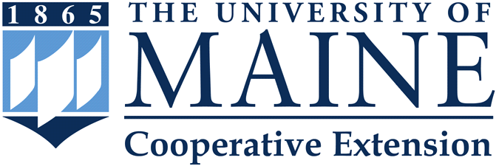
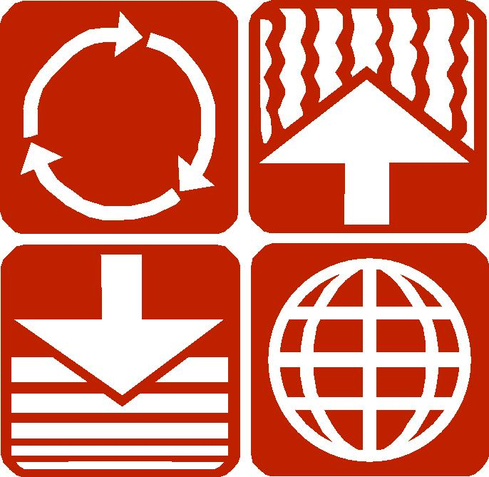


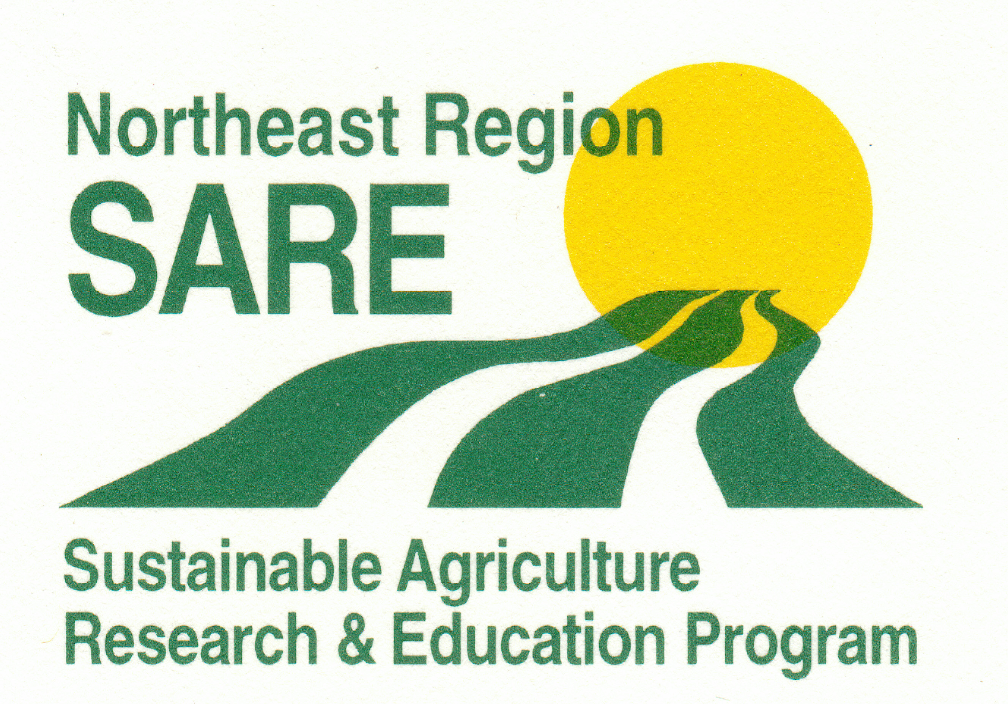
Cornell
Waste Management
Institute

