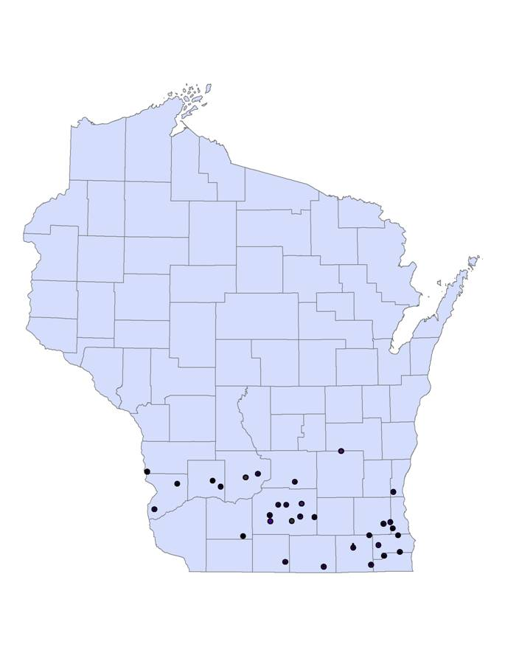

Figure 1. Distribution of study sites in southern Wisconsin

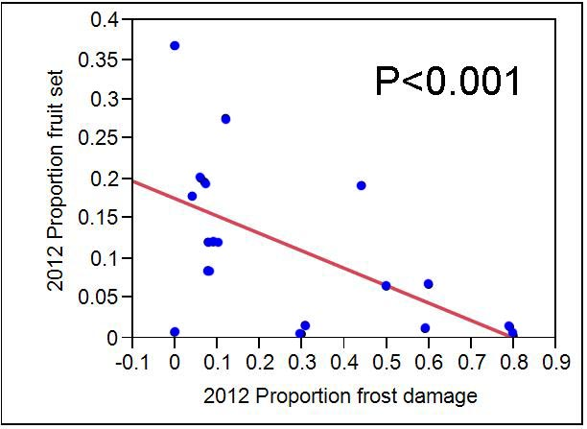

Figure 2. Relationship between frost damage and fruit set in the 2012 growing season

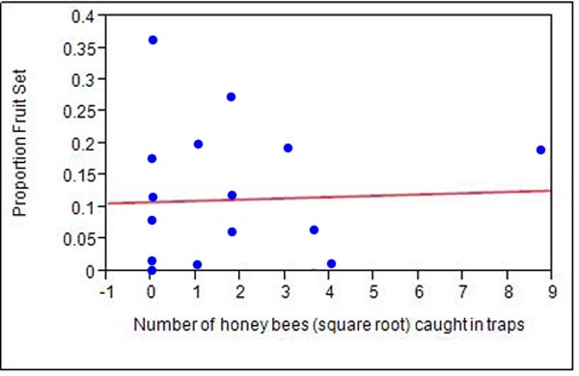

Figure 3. Relationship between the abundance of honey bees captured at an orchard and fruit set during the 2012 growing season.
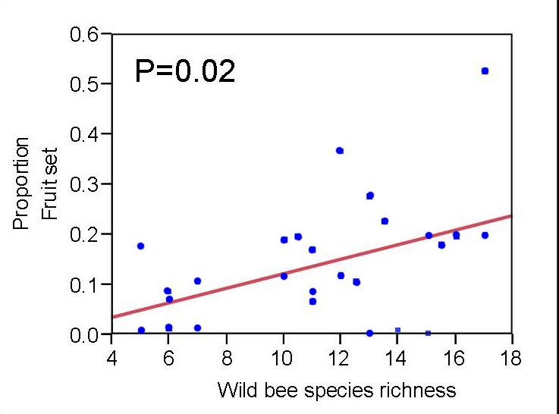

Figure 4. Relationship between the species richness of wild bees found within an orchard and fruit set during the 2012 growing season.

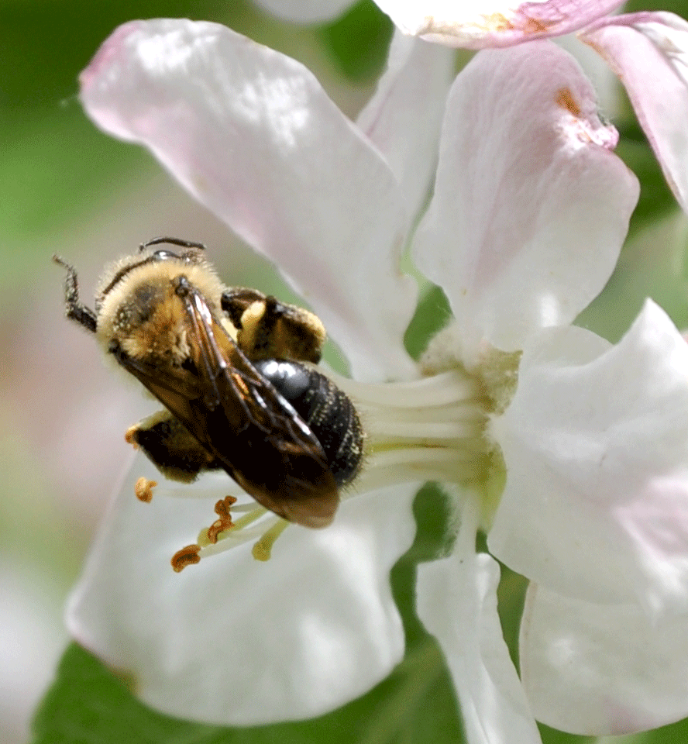
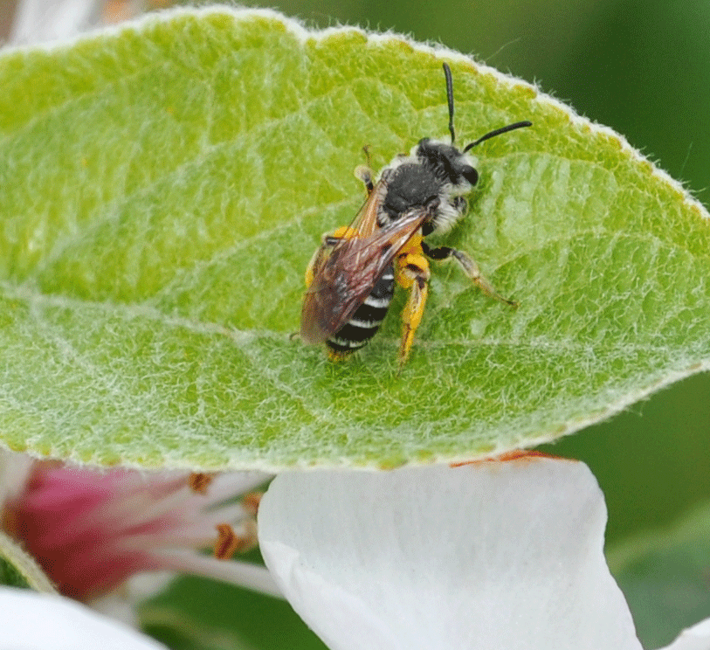
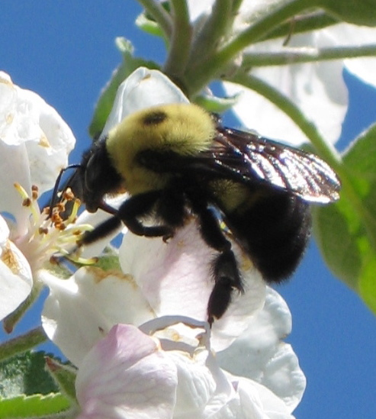

Figures 5, 6, 7. Pictures of wild bees found visiting apple blossoms.

