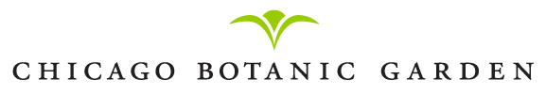

Farmers Market Demonstrations
2012 Schedule
Demos at 11:30 a.m. and 1 p.m. (15 minutes in length with time for Q&A)

June 3: Raising Backyard Chickens
Kim Snyder, Faith’s Farm

June 17: Beekeeping Basics
Dan Ewing, Xanadu Apiary

July 1: Backyard Composting Basics
Lynn Bement, The Organic Garden Coach

July 15: Companion Planting with Herbs and Vegetables – a Sustainable Gardening Technique
Liz Fiorenza, Wind Ridge Herb Farm

August 5: Insect and Disease Pests and How to Handle Them
David Woodruff, W&M Land Corp.

August 19: An Introduction to Cover Crops
Blayne Grenier, CBG, Windy City Harvest

September 2: Seed Saving for Beginners
Sacha Burns, H&H Flowers/Sunkissed Organics

September 16: Solar Power Basics
Tom DeBates, Habi-Tek

October 7: An Introduction to Farmstead Cider
Pete Klein, Seedling Fruit

October 21: Aquaponics: Growing Fish and Plants Symbiotically
Paul Hardej, Farmedhere, LLC

