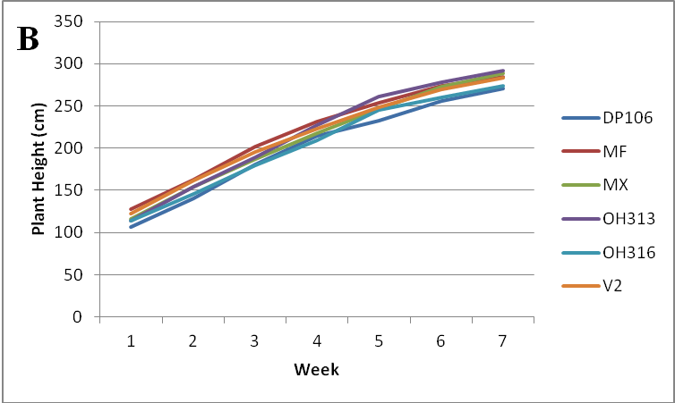
Figure 1. Tomato plant height as impacted by rootstock treatment at Haywood County site (A) and the Mountain Horticulture Crop Research site (B) in 2012. Rootstock treatments include “RST-DP106” (DP106), Mountain Fresh (MF), Maxifort (MX), OH313, OH316 and V2. All lines were not significantly different based on the F-value of repeated measures analysis.

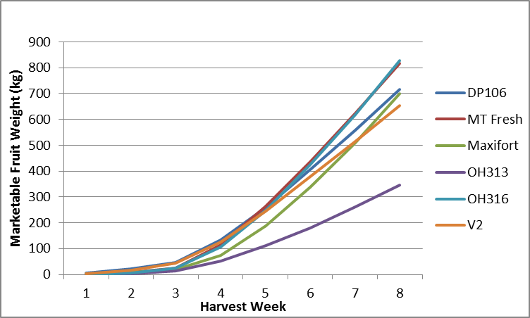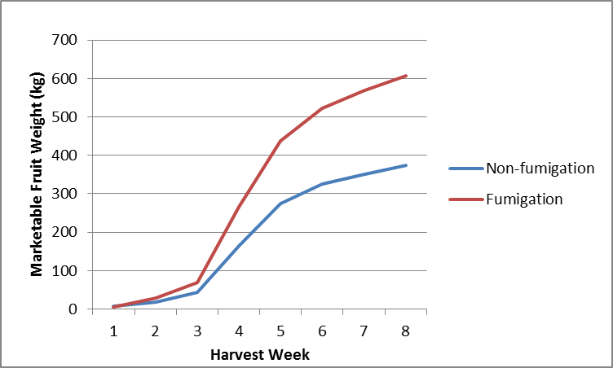
Figure 2. Tomato plant marketable fruit weight as impacted by rootstock (A) and fumigation (B) treatments at the Haywood Country site in 2012. Rootstock treatments include “RST-DP106” (DP106), Mountain Fresh (MF), Maxifort (MX), OH313, OH316, V2. Lines highlighted with vertical bars are not significantly different based on repeated measures analysis and means separation using Tukey LSD (ρ= 0.05)
B
A

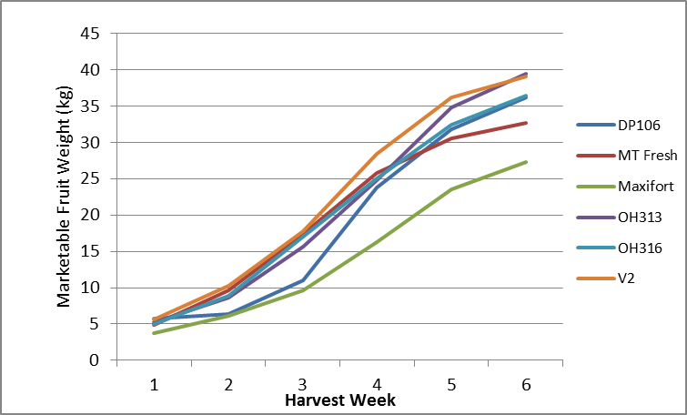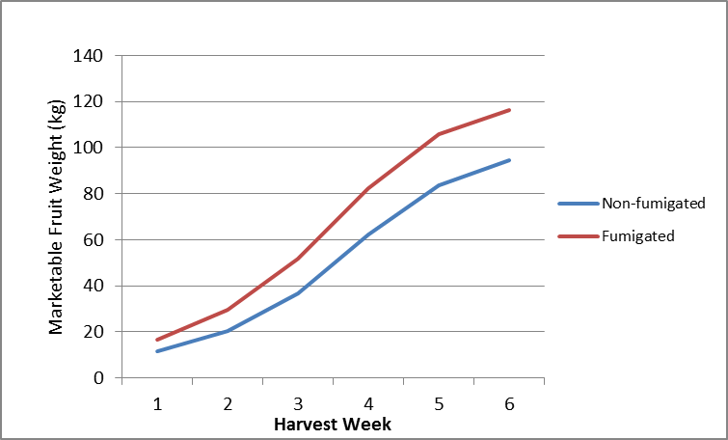
Figure 3. Tomato plant marketable fruit weight as impacted by rootstock (A) and fumigation (B) treatments at the Mountain Horticulture Crop Research and Extension site in 2012. Rootstock treatments include “RST-DP106” (DP106), Mountain Fresh (MF), Maxifort (MX), OH313, OH316, V2. Lines highlighted with vertical bars are not significantly different based on repeated measures analysis and means separation using Tukey LSD (ρ= 0.05)

B
A

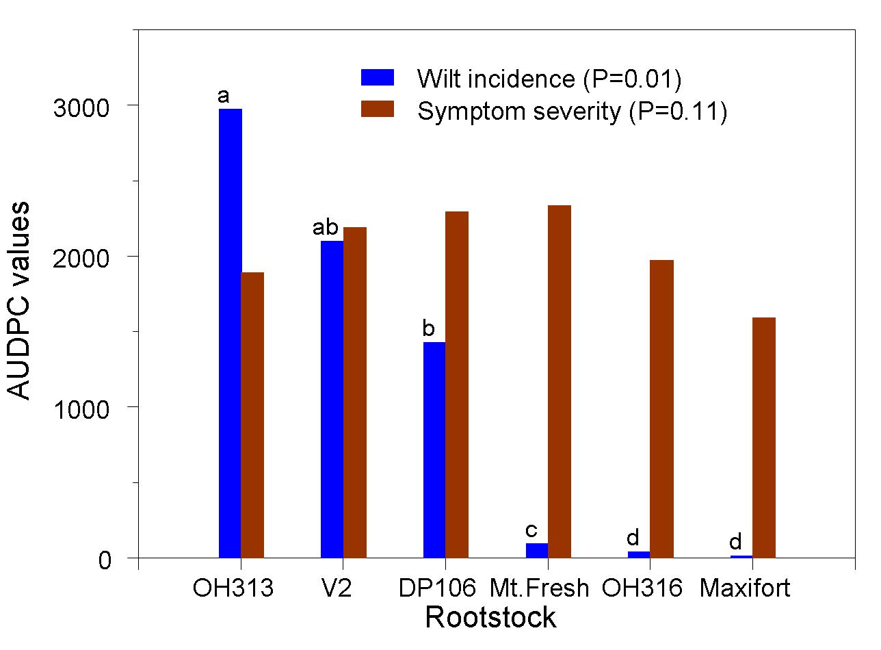
Figure 4. Verticillium Wilt incidence and severity on tomato plants as impacted by rootstock treatment at Haywood County in 2012. . Rootstock treatments include “RST-DP106” (DP106), Mountain Fresh (Mt Fresh), Maxifort, OH313, OH316 and V2. Lines of the same color and highlighted with different letters are significantly different based on repeated measures analysis and means separation using Tukey LSD (ρ= 0.05).

Table 1. Rootstock varieties used for each field site and seed source in 2012.
Figure 5. Verticillium Wilt incidence (A) and severity (B) on tomato plants as impacted by rootstock treatment at Mountain Horticulture Crop Research and Extension site in 2012. Rootstock treatments include “RST-DP106” (DP106), Mountain Fresh (MF), Maxifort (MX), OH313, OH316 and V2. All bars were not significantly different based on repeated measures analysis and means separation using Tukey LSD (ρ= 0.05)

Rootstock Variety | Seed Source
RST-DP106 | New England Seed Co.
Maxifort | Johnny Select Seed Co.
OH313 | David Francis , The Ohio State University
OH316 | David Francis , The Ohio State University
V2 | Asahi numbered line, Japan
Mountain Fresh (scion and non-grafted control) | Johnny Select Seed Co.

Table 2. Rootstock and fumigation treatment interaction effect on average plant vigor over the growing season at Haywood County field site in 2012. Vigor was based on a subjective rating scale from 1 to 10 with 1 being all plants dead or dying and 10 representing lush, green, and healthy plants.
Rootstock | Non-fumigated Average Vigor^{z} | Fumigated Average Vigor^{z} | Main Effects
MX | 8.6 AB | 8.6 AB | 8.6
OH316 | 7.5 BC | 8.9 A | 8.2
MF | 6.1 DE | 7.9 ABC | 7.0
DP106 | 4.4 FG | 6.7 CD | 5.6
V2 | 3.7 G | 5.3 EF | 4.5
OH313 | 3.5 G | 4.1 FG | 3.8
Main Effects | 5.6 | 6.9
Means followed by different letters are significantly different based on Tukey’s test (P < 0.05)
^{Z} Interaction between rootstock and fumigation treatments was significant therefore mean separation was performed on subplot values

