Request for Symposia, Forums and Workshops
Society for Range Management
2013 Annual Meeting
Oklahoma City, Oklahoma

Check one:
x | 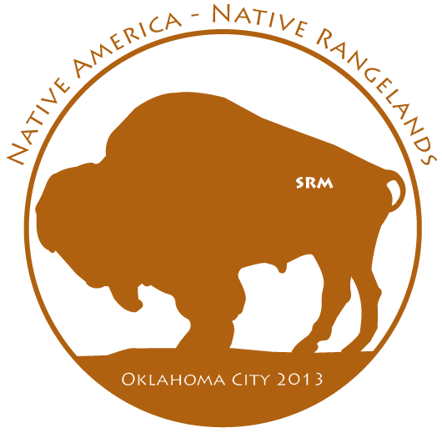  Symposium
 | Forum
 | Workshop

Time requested:
 | 3 hours and 40 minutes (morning only)
 | 3 hours (afternoon only)
x | 6 hours and 40 minutes (full day)
 | Other:

Note: All papers for sessions, symposia and forums must be in multiples of 20 minutes (e.g., 20 minutes, 40 minutes, etc.). A morning event is allowed a maximum of 10 presentations of 20 minutes each with one required break at 10:00 am. Similarly, an afternoon event is allowed a maximum of 8 presentations of 20 minutes each with one required break at 2:20 pm. Full day events are allowed a maximum of 18 presentations of 20 minutes each, a required break at 10:00 am, a required lunch break from 11:40 am – 1:00 pm and 2 breaks of 20 minutes, and a required break at 2:20 pm.
Title of event: | Targeted grazing: Management of livestock distribution

Brief description of event:

Targeted grazing is a tool that is receiving increased attention as a means to provide ecosystems services such as 1) improving habitat for wildlife, 2) controlling noxious weeds, and 3) reducing fuel loads that contribute to unwanted wildfires. Typically, discussions of targeted grazing have focused on management of finer spatial scale behaviors in order to get livestock to select specific plant species such as noxious weeds. However, grazing can also be targeted by managing where livestock graze on the landscape. This symposium will describe tools used to manage livestock grazing distribution and focus on recent research results. The morning session will address management of cattle movements to utilize steep rugged terrain or areas far from water or to prevent localized overgrazing. The afternoon session will focus on targeting grazing to improve wildlife habitat, reduce fine fuel loads and assist in the management of wildfires. Ecologic, economic, and social/political implications of using targeted grazing to achieve multiple resource objectives will be presented.

Tentative Presentation Titles and Speakers:

- 8:40-9:00: Introduction – Why worry about grazing distribution? Derek Bailey* and Larry Howery*
- 9:00-9:20 Ecological value of managing livestock grazing distribution – Ken Tate*, Leslie Roche and Mel George
- 8:40-9:20: Advances in grazing distribution practices – Pat Clark*
- 9:20-10:00: Nature vs. Nurture: How can we create adapted animals? - Karen Launchbaugh* and Fred Provenza
- 10-10:20: Break
- 10:20-11:00: Selection for cattle adapted for sustainable use of extensive rugged rangeland: Part 1 - Understanding important phenotypes – Derek Bailey*, Milt Thomas, Steven Lunt, and Adrienne Lipka
- 11:00-11:20: Selection of cattle adapted for sustainable use of extensive rugged rangelands: Part 2 – What can we learn from the genotype – Milt Thomas*, Gonzalo Rincon, Juan Medrano, and Derek Bailey
- 11:20-1140: All animals used in targeted grazing have been selected: now it is time to target selection to enhance their efficacy as targeted grazers– John Walker*
- 11:40-1:00: Lunch
- 1:00-1:20: Integration of targeted grazing with other vegetation management techniques – Rachel Frost*
- 1:20-1:40: Why use cattle for targeted grazing? Larry Howery* and Derek Bailey
- 1:40-2:00: How effective is targeted cattle grazing – Retta Bruegger*, Larry Howery and Derek Bailey
- 2:00-2:20: Keys to making targeted cattle grazing more effective – Mitch Stephenson*, Derek Bailey, Retta Bruegger, and Larry Howery
- 2:20-2:40: Break
- 2:40-3:00: Potential effect of fine fuel management by targeted cattle grazing on wildfire behavior - Leticia Varelas*, Allen Torell, Mitch Stephenson, Retta Bruegger, Larry Howery, and Derek Bailey
- 3:00-3:20: Economic evaluation of targeted cattle grazing to reduce fire hazard and keys to making it a viable option – Allen Torell*, Leticia Varelas, and Derek Bailey
- 3:20-4:00: Social factors influence the implementation of targeted cattle grazing and other rangeland innovations – Maria Fernandez-Gimenez*

Organizer:
Name: | Larry Howery* and Derek Bailey**
Title: | *Professor/Extension Specialist  **Professor
Organization/employer: | *U of A  **NMSU
Contact information (email address, phone, mailing address): | lhowery@ag.arizona.edu; 520-621-7277; BSE 325 ~ SNRE ~ The University of Arizona ~ Tucson, AZ 85721  dwbailey@nmsu.edu/505-646-2554; Animal & Range Sciences Dept. ~ New Mexico State University ~ Box 30003, MSC 3-I ~ Las Cruces, NM 88003-8003

Partners/co-sponsors (name of organization and contact information if applicable):
SRM Targeted Grazing Committee and SRM Watershed and Riparian Committee

Anticipated attendance of session: ______50_____________

Deadlines:
Submitting request: May 7, 2012
Notification of acceptance: June 1, 2012
Abstracts submitted online: August 20, 2012

Note: Organizer is responsible for getting all event presenters to submit abstracts on time.

Attach this form to an email message and mail to:
Eric Thacker at eric.thacker@okstate.edu

You will receive notice of receipt within 3 days. If you do not receive a notice, contact Eric Thacker at the above email.

General Questions can be directed to Dwayne Elmore (dwayne.elmore @okstate.edu) or Dave Engle (david.engle@okstate.edu).

