ENE10-114
Reading the Farm: Discovering Whole-Farm Interactions

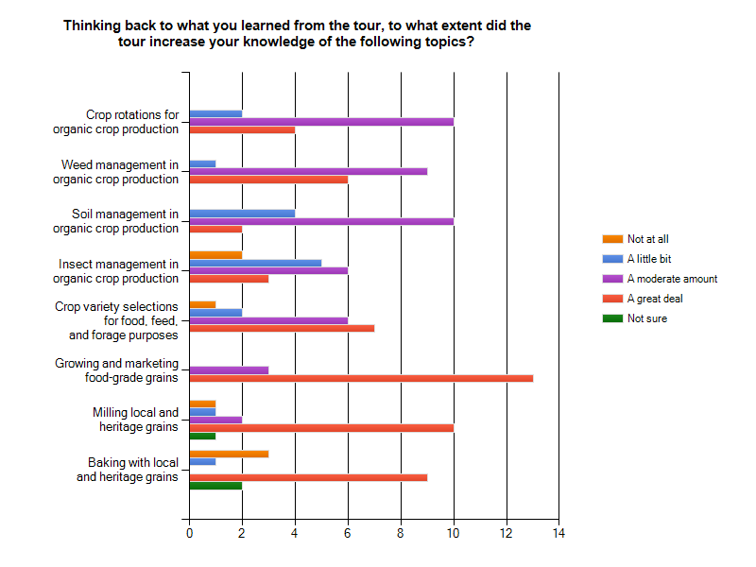
Figure 1. Knowledge gained in each topic area of the Finger Lakes Organic Crop Production Tour. Number on the x-axis indicates number of people responding in each category. N=16

