Farmer Rancher Grant Program

Final Report Form

- Project Title: Breeding Strategies for Improving Resistance to Gastrointestinal Nematodes in Wool Breeds of Sheep
- Project Number: FNC10-794

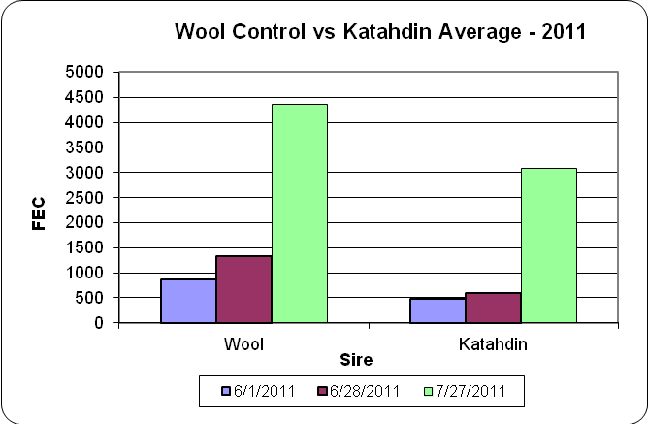
Chart 1 – Rickard

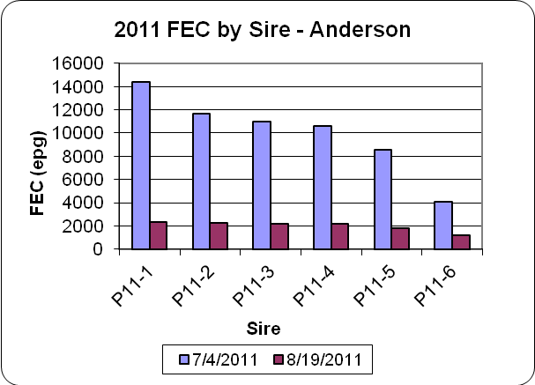
Chart 2 - Anderson
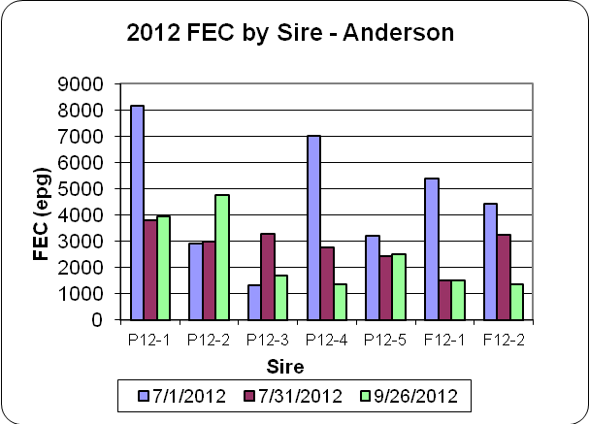
Chart 3 - Anderson

