This photo shows the 2 by 6 frame cross braced with 2 by 4’s. It is 20 foot long and 12 foot wide. Note the small skids on the ends.

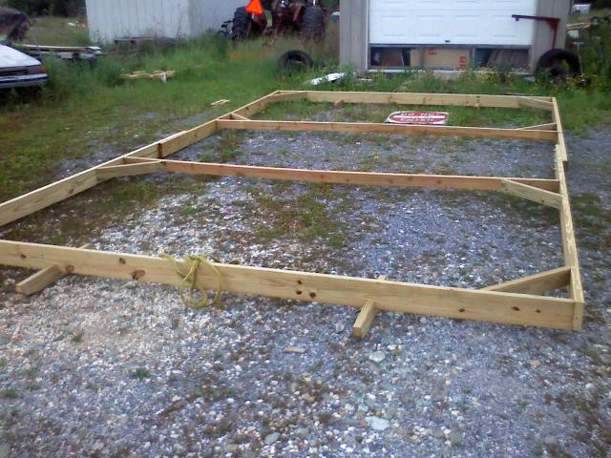

This picture shows 20 foot long by 1 3/16” chain link fence top rail posts. That are bent into twelve (12) foot wide hoops and bolted to the base. This creates the frame work for the cover. There is tool available from Johnny’s Select Seeds that makes bending the hoops very easy.

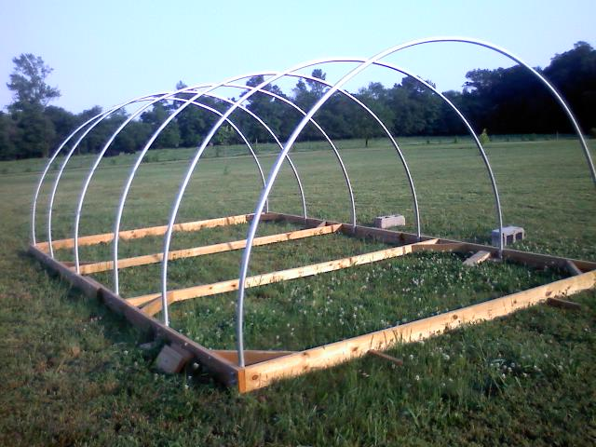
Here we are showing the top purlin rail and the door frames. These are made from 2” by 4”s that ripped lengthwise and screwed together with deck screws and reinforced top and bottom with metal L brackets.

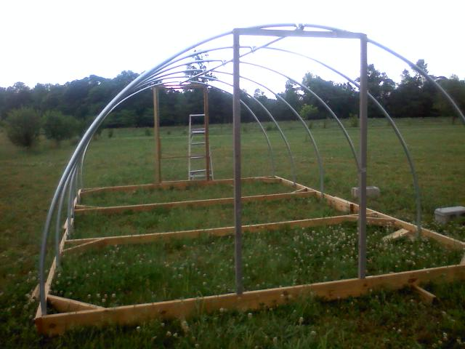

This is a close up of the top of the door frame attached to the center purlin and the end arch.

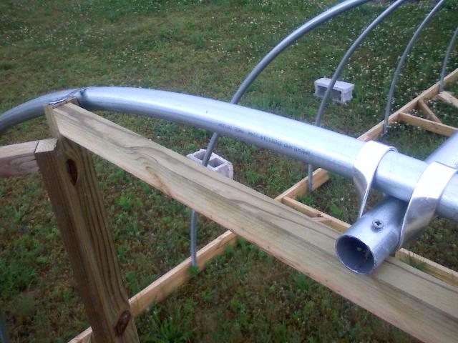
Here we have the finished product. It is covered with an eight (8) mil 20ft by 30ft tarp secured around the edges with batten boards. The door is finished with a diagonal brace, handle and latch. The top is covered in chicken wire and a small door is constructed to close the bottom where the birds enter and exit the coop. Note that the entry door allows many birds to enter or exit at the same time. This allowed the birds to flee in a panic whenever they saw a hawk, possibly eliminating airborne predator losses. The chicken wire over the top of the door allowed to birds to stand inside the door and look out. We would watch the whole flock cluster just inside the door to watch a hawk watching them and none would leave until the hawk left. This coop is light enough to be moved with a small tractor or a large lawnmower and needs to be anchored at the corners to prevent high winds from moving it. Before we anchored it a thunderstorm came in, picked it up, spun it 180 degrees and moved it 80 foot sideways.

