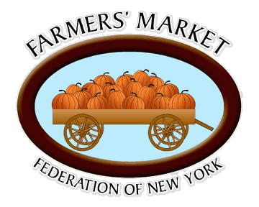
Farmers’ Market Federation of New York
117 Highbridge St, Suite U-3
Fayetteville, NY 13066
315-637-4690
315-637-4691 (fax)
www.nyfarmersmarket.com

ENE11-118 Marketing for Profit: Tools for Success
2013 Annual Report

Table A
Workshop | Webinar Participants | On-line Viewing
Assessing Your Identity | 45 | 721
Exploring Marketing Channels | 26 | 721
Where Are We and Where do We Want to Be | 24 | 721
Learning to Look Around, or, Getting Your Head in the Game! | 102 | 341
How smart ARE you, Really? | 107 | 257
Building the Marketing Plan | 120 | 264
People Sure Are STRANGE! Coming to understand the consumer | 106 | 166
BOGOs, Bounce Backs and the cost of freebies! Promoting the Product | 83 | 148
Every Silver Lining has a Cloud! - Market assessment & Analysis | 76 | 98
How to Say what we mean and mean something! Communication Assessment | 80 | 98
You are what you Look Like! Preparing the Product | 50 | 51
You are what they THINK you are! Selling the Product | 44 | 13
Total attendance | 863 | 2157

Table B
Referral Source: | Referral Numbers: | Percent:
Extension Educators | 59 | 51%
Press Release | 23 | 20%
Ag-Based Non-Profit | 18 | 16%
Visiting the Federation Website | 14 | 12%
Google Search | 2 | 1%

