APPENDIX A

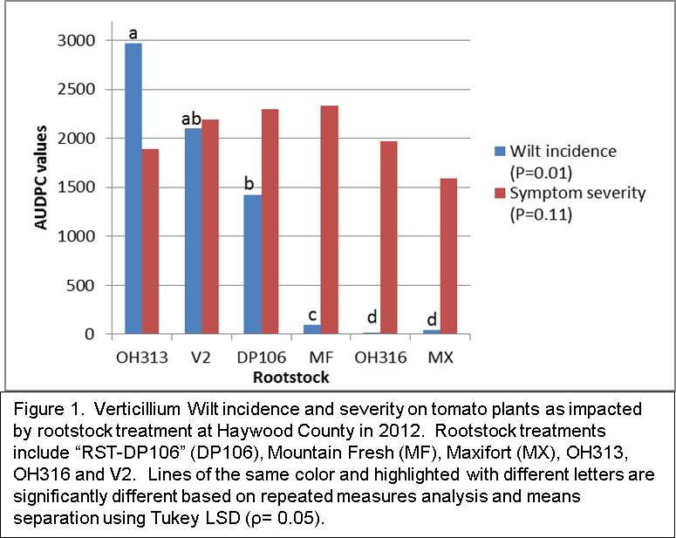

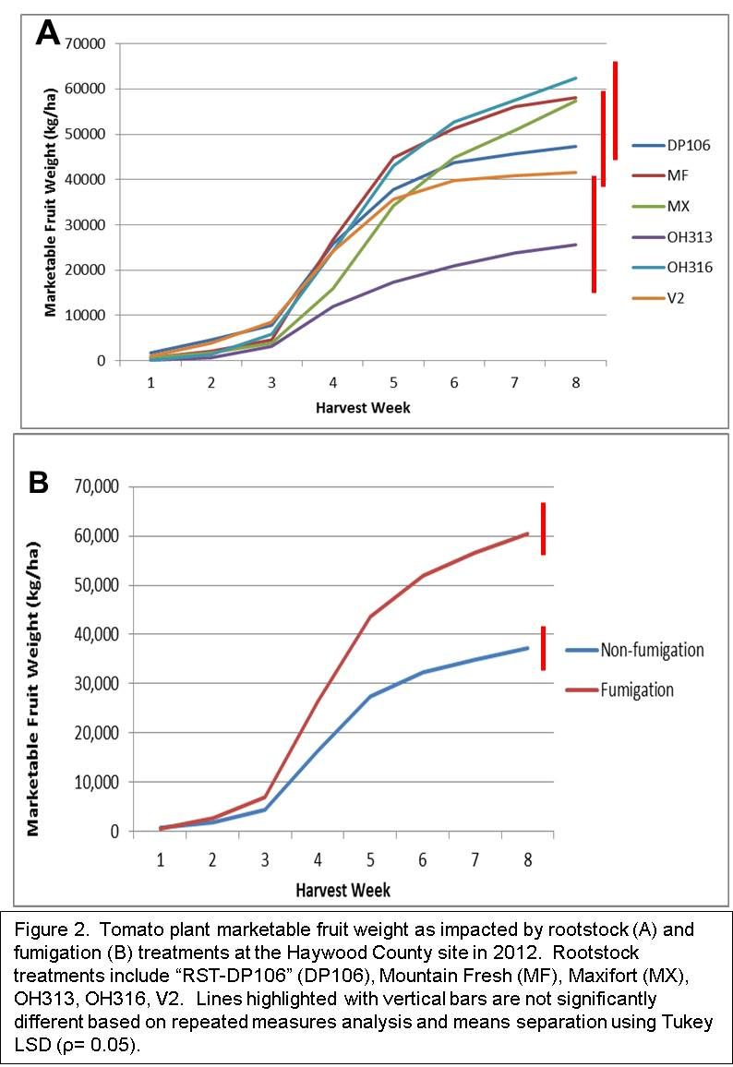

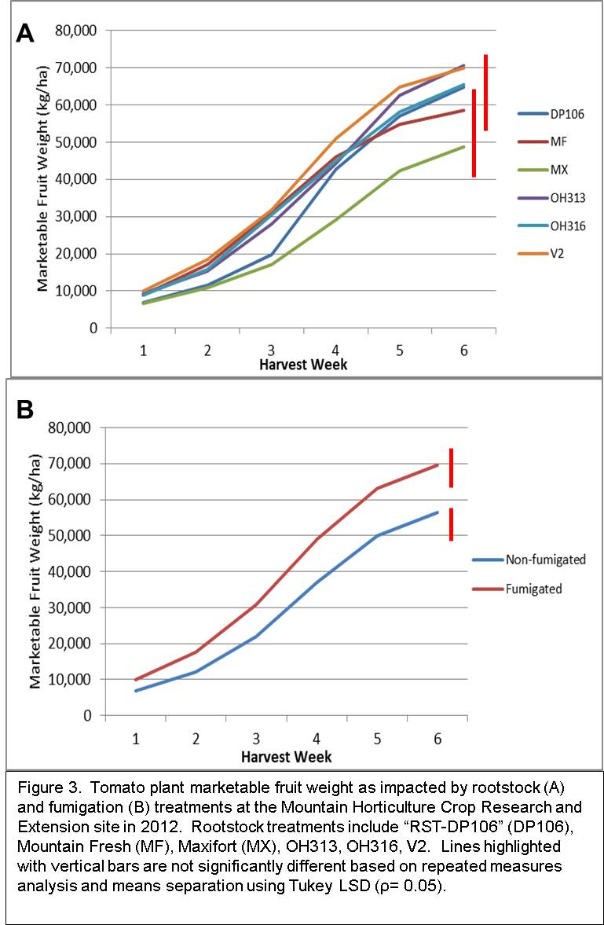
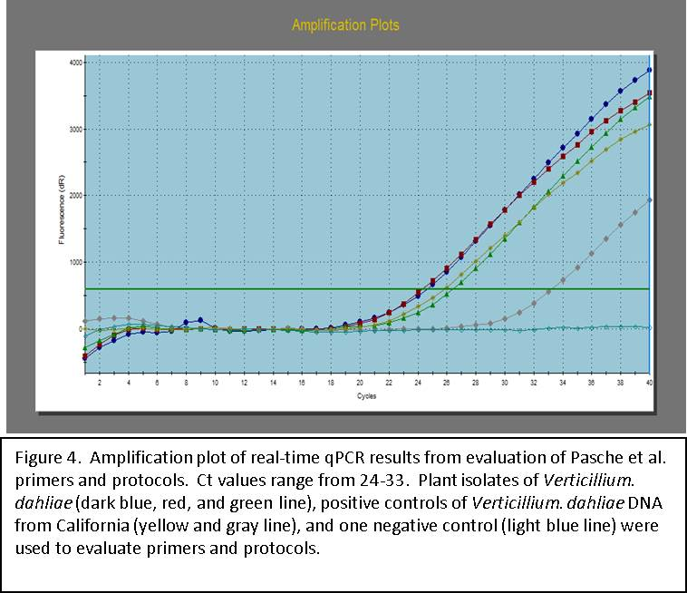

Table 2. Rootstock treatments effect on average dry plant weight in grams Haywood County (HC) and Mountain Horticulture Crop Research and Extension (MHCRE) field sites in 2010 and 2012.
Rootstock genotype | MHCRE Average Dry  Weight (g) per plant 2010z | HC Average Dry Weight (g) per plant 2012 x | MHCRE Average Dry  Weight (g) per plant 2012
DP106 | 108.8 A Y | 392.0 Y | 178.5 Y
MF | 118.9 AB | 299.3 | 158.1
MX | 199.5 C | 444.7 | 206.8
OH313 | 163.0 C | 286.1 | 177.4
OH316 | 158.3 BC | 367.0 | 175.8
V2 | --- | 278.1 | 161.1
P-value | 0.01 | 0.12 | 0.39

Z 2010 dry weight represents back-transformed data after analysis of log transformed data.
Y Means followed by different letters in columns are significantly different based on Tukey’s test (P < 0.05) if Fisher’s P-value was significant
X Means in 2012 are based on repeated measures analysis over 5 sampling dates.

Table 3. Fumigation treatments effect on average dry plant weights in grams at Haywood County (HC) and Mountain Horticulture Crop Research and Extension (MHCRE) field sites in 2012.
 | HC Average Dry Weight (g) | MHCRE Average Dry Weight (g)
Fumigation | 429.9 | 194.0
Non-Fumigation | 259.2 | 158.5
P-value | 0.002 | 0.013
Means are based on repeated measures analysis over 5 sampling dates.
Table 4. Rootstock and fumigation treatment interaction effect on average plant vigor over the growing season at Haywood County field site in 2012.
Rootstock | Non-fumigated Average Vigor^{z} | Fumigated Average Vigor^{z} | Main Effects
MX | 8.6 AB | 8.6 AB | 8.6
OH316 | 7.5 BC | 8.9 A | 8.2
MF | 6.1 DE | 7.9 ABC | 7.0
DP106 | 4.4 FG | 6.7 CD | 5.6
V2 | 3.7 G | 5.3 EF | 4.5
OH313 | 3.5 G | 4.1 FG | 3.8
Main Effects | 5.6 | 6.9
Means followed by different letters are significantly different based on Tukey’s test (P < 0.05)
Vigor was based on a subjective rating scale from 1 to 10 with 1 being all plants dead or dying and 10 representing lush, green, and healthy plants
^{Z} Interaction between rootstock and fumigation treatments was significant therefore mean separation was performed on subplot values.

