Worms are our Friends!

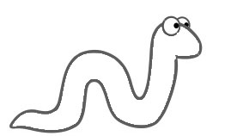
Anterior End (head)

Clitelum (middle)
Posterior End (tail)

Need reasons to Worm Compost?
- Approximately 1/3 of all waste in landfills is from food waste;
by worm composting you can greatly reduce your waste output.
- Food waste in landfills has no access to oxygen and creates methane
which is a green house gas so composting or worm composting cuts
down on the methane as well as landfill space.

For more info visit:
www.one20farm.com

