SARE Farmer /Grower Grant Report
“Perimeter and Internal Trap Cropping in Organic Winter Squash”
FNE09-659
Nancy Hanson
Manager
Community Supported Agriculture Program
Hampshire College Farm Center
893 West Street Amherst, MA 01002
413-559-5599
nhanson@hampshire.edu

Goals:
Our objective for this project was to continue research in the development of an effective trap cropping system in winter squash using organic methods. We proposed using Buttercup squash as a perimeter and internal trap crop for the control of cucumber beetles in a Butternut squash main crop using plots larger than in previous experiments. Our goal was to determine if the addition of internal trap crop rows to fields with perimeter trap crops would have one of the following effects:
- act as additional sinks for cucumber beetles and further reduce their numbers in main crops
- act as a source and increase cucumber beetles in the main crop
- have no net effect.

Farm Profile:
As the manager of the Hampshire College Community Supported Agriculture Program, I grow 15 acres of mixed vegetables using organic methods. The CSA is located at Hampshire College in Amherst MA. Crops are distributed to 210 shareholder households from September through November. The majority of shares are sold to students, staff and faculty of the Five colleges (Hampshire, Smith, Mt Holyoke, Amherst Colleges and the University of Massachusetts).

Participants:
Grower:
Nancy Hanson
Manager
Hampshire College CSA

Technical Advisor
Brian Schultz
Professor of Entomology
Hampshire College
Role: Assistance with sampling, experimental design and plot layout. Conducted statistical analysis

Cooperator:
Ruth Hazzard
Umass Extension
Role: Assistance with experimental development and design. Supplied information about previous experiments. Visited experiment several times to help with sampling techniques and results interpretation.

Project Activities:
On 5/21/09 Buttercup(Johnney’s Burgess strain) and Butternut (Johnney’s Waltham) squash seeds were started in the greenhouse in plastic flats.
On 6/16/09 transplants were set out into the field in one large plot of squash containing 12 rows of plants with each row 41 plants long. Rows were spaced at 80 inches with 36 inch in-row spacing. Buttercup plants were planted as a trap crop around the entire field perimeter one plant deep. Buttercup plants were also planted as 4 interior trap crop plots randomly spaced within the field. Interior trap crop plots were two rows wide and 4 plants long. All other plants in the field were Butternut. (See figure 1) All internal (non-trap) Butternut squash transplants were treated with Surround only before planting (in trays) and not subsequently. This main crop was never treated with Entrust.

We examined every plant in the experiment (visually to note first arrival of pest) and counted any live cucumber beetles on each plant , starting the day after transplanting (6/17/09) and then on 17 subsequent dates: June 19, 22, 23, 24, 25, 26, 29, 30, and July 1, 2, 6, 7, 8, 10, 13, 14, 15. Interior trap plants were sprayed with Entrust on 6/24 (after insect sampling on that day), when trap crops generally exceeded economic thresholds for cucumber beetle (1 beetle per plant). Threshold levels were reached in both the perimeter and interior trap crops on 7/2 and on 7/14. All trap crop plants were sprayed on those days after insect sampling. Entrust was applied to Buttercup plants with a backpack sprayer at the rate of 2.5 oz/ acre.

Results:
Because we were able to count cucumber beetles on each plant in the experiment, we were able to track the movement of beetles across the field. During the critical period prior to the first Entrust spray, beetles would first colonize the perimeter trap crop but move rather quickly to the interior trap crop without building up in the main squash crop. During that period, the beetle numbers decrease or stay constant the main crop, decrease in the perimeter trap crop, and increase in the interior trap crop. (See figures 2 and 3) This could mean that the inner traps may be helpful in the sense that they "sweep" up cucumber beetles that leave the edges and enter the field. The beetles keep going on to the interior traps, rather than building up in the main crop. Interior trap crops can act as a sink for cucumber beetles if the perimeter trap crop is breeched.

Conditions:
The summer of 2009 was extremely wet and cool. Possibly because of this, total cucumber beetle numbers were low and did not reach threshold numbers until nearly one week after transplanting. Threshold levels were reached only two times subsequently. In previous years with warmer, drier weather, cucumber beetle pressure was much higher. While I believe that the results of our experiment would have been the same, higher numbers of cucumber beetles may alter the patterns of cucumber beetle movement in the field.

Economics, Assessment and Adoption:

While it is difficult to directly connect these activities to overall CSA profitability, winter squash is an important part of the fall CSA crop mix. The reduction of CB damage, especially while transplants are young, is imperative to good yields of winter squash. At $600/lb, Entrust is a relatively expensive material. Any reduction in the amount of Entrust applied helps with farm profitability. Based on the results of this experiment it seems that the addition of interior trap crops does improve control of cucumber beetles. The use of both perimeter and interior trap crops, however, does increase the number of plants requiring treatment and thus increases the cost of that control. Further work to determine alternative and possibly less expensive materials for beetle control in the trap crops would be useful.

As far as use and cost of using Entrust: We sprayed the trap borders twice and the interior traps 3 times.
I estimate that we used .5 oz each time we sprayed the borders and .17 oz when we sprayed the interior traps for a total of 1.5 oz for the season. Entrust costs about $600 per pound so our total cost of materials was $56.25. Unfortunately the smallest quantity of entrust that you can buy is 1 lb.

Outreach:
The results of our experiment were presented during a workshop on fall vegetable production at the August 2009 Northeast Organic Growers conference. Fifty attendees were shown slides of the experimental field and given information on the field layout, spraying techniques and sampling results.
Results of this experiment will be published in Vegetable Notes (Umass extension) this spring.

Report Summary:
This experiment was conducted to determine if the addition of interior trap crops to a perimeter trap crop system would be an improved technique for control of cucumber beetle in organic winter squash. We planted experimental plots with Buttercup squash as both perimeter and internal trap crops in a main crop of Butternut squash. We found that the internal trap crops did act as a sink for cucumber beetle and decreased numbers in the main crop when perimeter trap crops were breeched. Based on these results, we can say that the use of internal trap crops improves control of cucumber beetles in winter squash. Because of the increased expense of spraying both perimeter trap crops and interior trap crops we recommend further work to look for control materials less expensive that Entrust.

Figure 1. The experimental design for 2009. Dark green squares represent Buttercup squash plants both as perimeter trap crops and as interior trap crops. Lighter yellow squares represent the main Butternut squash plants.
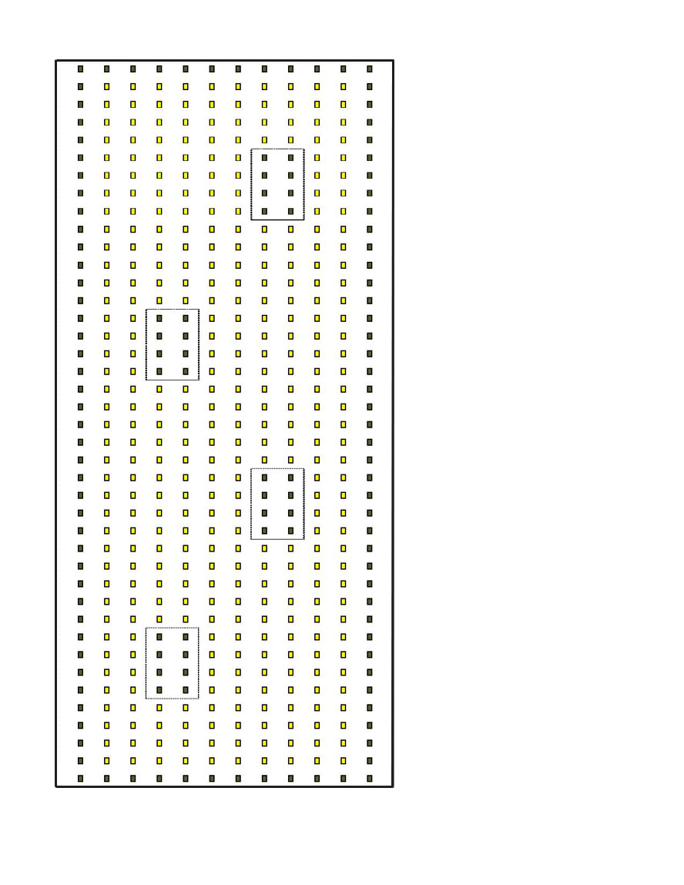

Figure 2. Results for counts during the season of cucumber beetles (CB) on every plant in the experiment, showing both total numbers overall and for each type of planting, the perimeter trap crop plants, the main winter squash crop plants, and the internal trap crop plants, and then mean numbers per plant for each treatment. Note how before the first spray (dotted line under bottom graph) winter squash CB numbers become more or less constant while edge perimeter crop CB numbers decrease but internal or inner trap crop CB numbers increase.

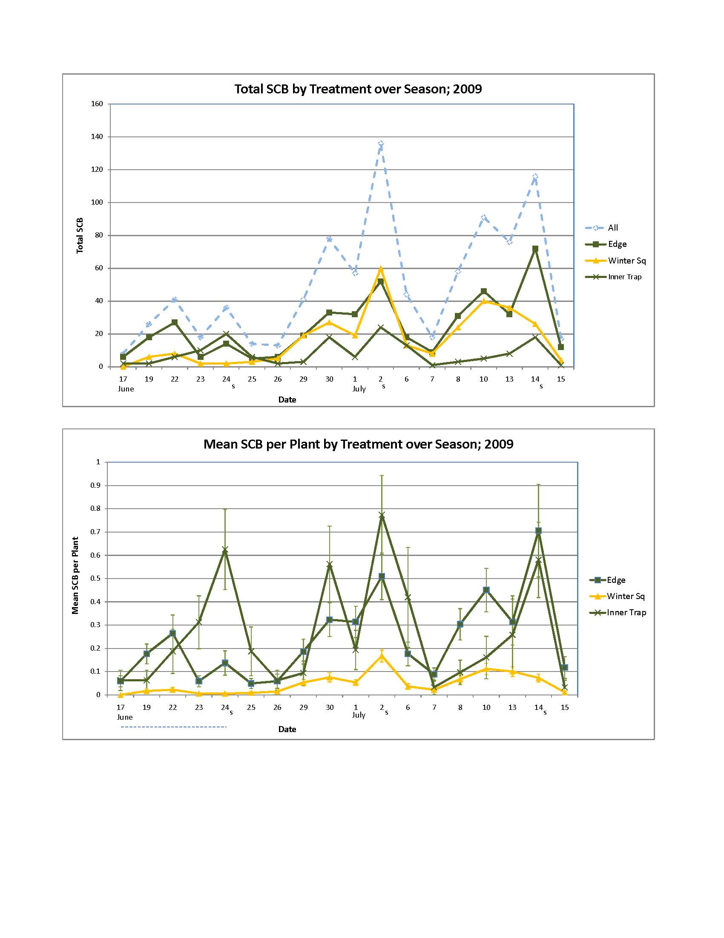

Figure 3. Mean CB numbers in transects across the field and by row locations, for the first five sampling dates before the first spray (showing how CB accumulates in the internal traps).
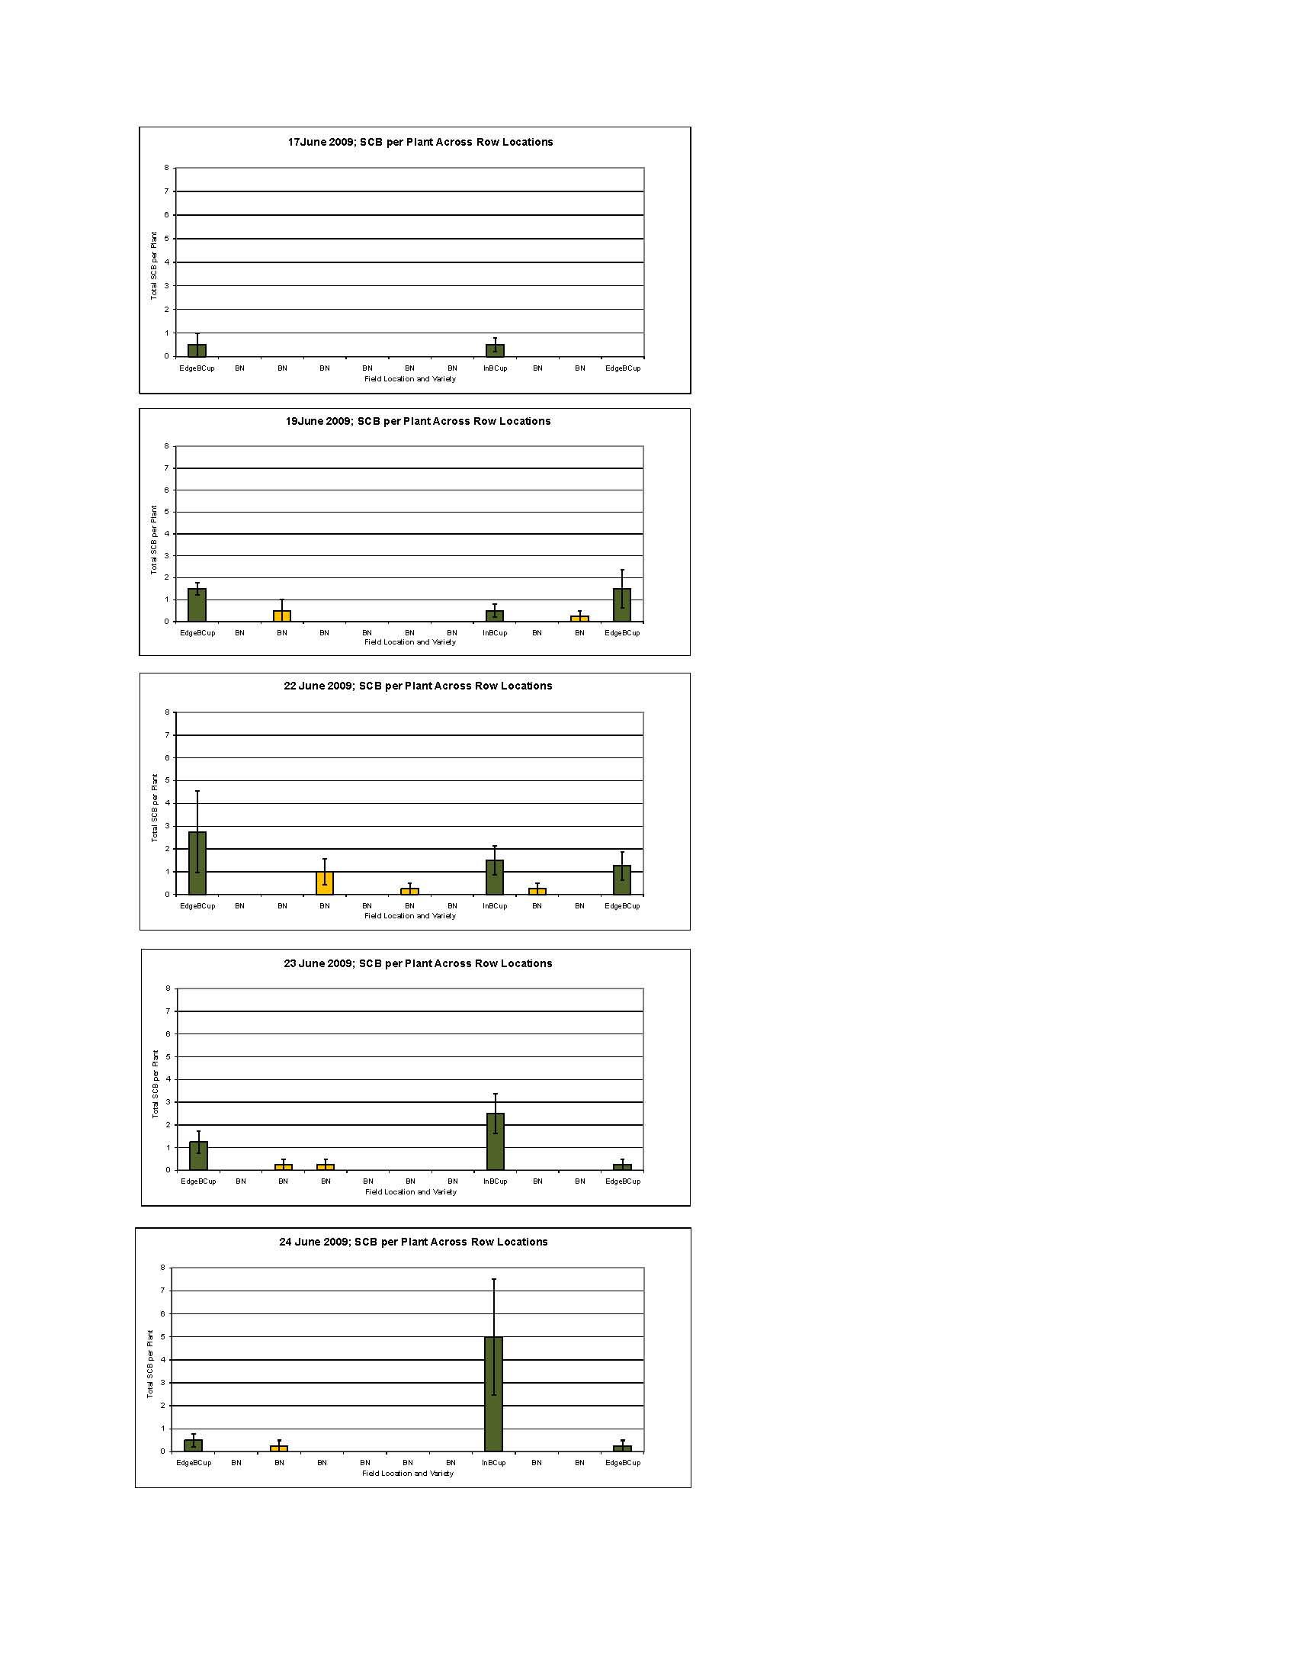
Nancy Hanson 2/28/10

