Farmer Rancher Grant Program

Final Report

I. PROJECT IDENTIFICATION
David Brandt
6100 Basil Western Road
Carroll, Ohio 43112
Phone: 740-756-4436
Email: brandtsfarm@yahoo.com

Jim Hoorman
22133 TR 60,
Jenera, Ohio 45841
(419) 326-5100

Utilizing Homegrown Nitrogen from Legume Cover Crops for Corn Production
Project Number: FNC12-848
Project Duration: 2012 - 2013
Date of Report: April 16, 2014

II. PROJECT BACKGROUND

David Brandt operates a family farm in Fairfield County, Ohio. The farm includes 1200 acres of cropland and is all no-till in a Corn, Beans, and Wheat rotation.

David has been using Cover Crops following wheat for the last 30 years, and in the last 13 years has changed his cover cropping practice to include aerial application into standing soybeans and corn for the limited acres that do not get wheat in the rotation. Dave’s cover crop practice has also expanded from using single species such as Cereal Rye and Hairy Vetch to include precision planted Winter Peas and Radishes to complex mixes planted with a seed drill after wheat harvest.

Jim Hoorman operates a 60 acre farm in Putnam County, Ohio. Jim farms a Corn, Beans, and Wheat rotation. Jim began operating this farm three years ago and has been using no-till practice the entire time. Prior to Jim operating the farm, it was leased to various tenants with various cropping practice.

III. PROJECT DESCRIPTION
Two hundred acres were evaluated with three different cover crop mixes for the cover crop ability to reduce the need for added nitrogen in the production of a corn cash crop. In addition to the three cover crop treatments, the fields received three different nitrogen applications; full rate of side dress nitrogen, half rate of side dress nitrogen, and no additional nitrogen. The resulting corn yields show that the cover crop treatments without side dress nitrogen yielded above state average and that the addition of side dress nitrogen did not provide enough yield benefit to offset the additional cost.

Study Descriptions:
Cover Crop Treatment #1 is precision planted Austrian Winter Peas and Daikon Oilseed Radish. Peas and radish were planted after wheat harvest in alternating 15 inch rows using a White 8415 planter equipped with soybean and sugar beet seed plates. The following spring field corn was planted into the pea and radish residue, applying 8 gal/A of starter nutrient (9-24-3) in the furrow. Portions of the field were side dressed with the equivalent of 200lbs nitrogen, 100lbs nitrogen, or no additional nitrogen using liquid at 28%. Corn yields for the respective treatments were 192Bu, 197Bu and 185Bu per acre respectively.

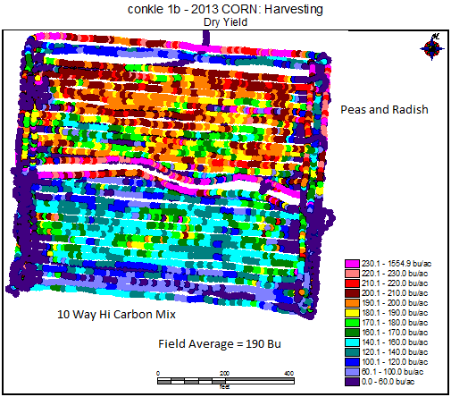

Cover Crop Treatment #2 is an 8 way mix of four legume, two brassica and two warm season grass cover crop varieties Planted after wheat harvest in 7 ½ in rows using a Krause 13ft seed drill. The following spring field corn was planted into the pea and radish residue, applying 8 gal/A of starter nutrient (9-24-3) in the furrow. Portions of the field were side dressed with the equivalent of 200lbs nitrogen, 100lbs nitrogen, or no additional nitrogen using liquid at 28%. Corn yields for the respective treatments were 158Bu, 160Bu and 174Bu per acre respectively.

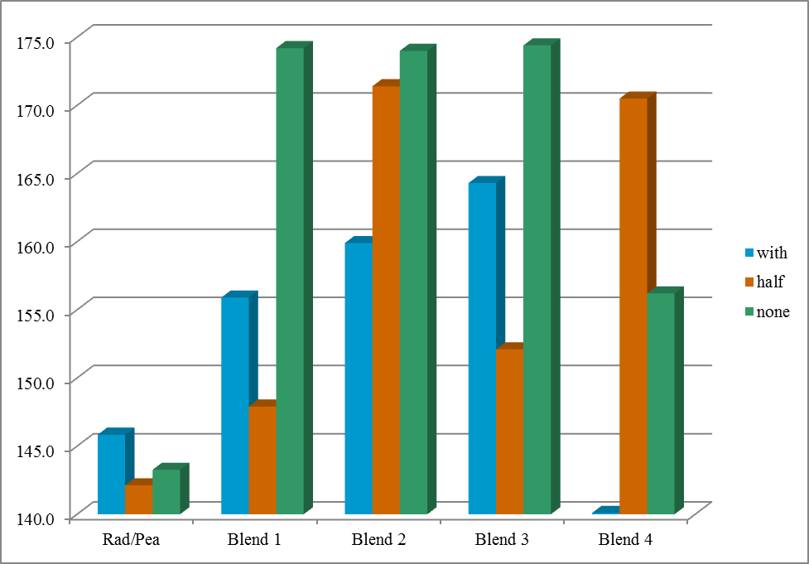

Cover Crop Treatment #3 is Soybean or Sunn Hemp inter planted between corn rows at planting time. Starter nutrient (9-24-3) was applied in the furrow at planting. Portions of the field were side dressed with the equivalent of 200lbs nitrogen, 100lbs nitrogen, or no additional nitrogen using liquid at 28%. Corn yields for the respective treatments were 191Bu, 184Bu and 189Bu per acre respectively for the Soybean inter plant treatment. While digging up roots in this plot it was noticed that the corn roots were growing into the nodules of the soybean plants. In 2012 there was reduced rainfall, and the corn canopy did not shade out the soybeans and they developed pods and seed. Repetition of this trial in 2013, when there was an abundance of rain, the corn canopy was dense enough to shade out the soybeans and no seed was produced.

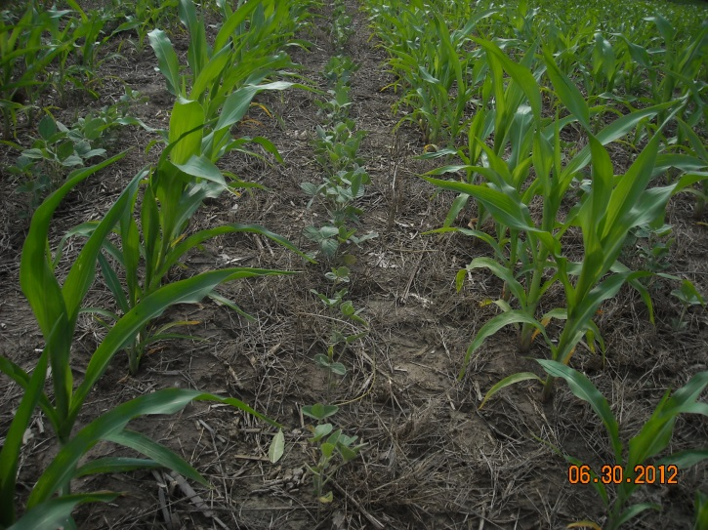

Grain samples of these different cover crop treatments and a sample of corn from a conventionally tilled farm were sent for protein and nutrition analysis. Test results show that on average the conventional corn contained a protein value of 6.9% and the cover crop treatments contained a value of 9.2%.

During the 2012 – 2013 growing season four different meetings were held at the Brandt Farm to demonstrate the benefits of cover crops before corn and inter planting with corn. The combined attendance at these meetings was 500 people.

In the fall of 2013 a Self-Propelled Sprayer was purchased and converted to an air seeder for the application of cover crops. It is our intention to continue this study using the high clearance seeder to apply cover crop mixes to standing corn and soybean fields and to evaluate subsequent crop yields and soil improvements.

Sunn Hemp Study 2012-2013
A Sunn Hemp study as supplemental Nitrogen to corn was initiated in 2012 on the Hoorman farm in a 10 acre corn field on a Pewamo soil type. Corn was planted at a population of 32,000 seeds per acre on May 10th into a dry soil, 2 inches deep with 20 gallons 28%N as starter. Sun Hemp was seeded at 20#/A between the rows 0, 7, and 12 days after planting the corn at 1.0 inch depth to reach moisture. The Sunn hemp was inoculated and seeded with a modified White splitter planter unit designed to sow in between the corn rows. The corn started to germinate immediately, however there was very little evidence of Sun Hemp growing for almost 3 weeks.
Sunn Hemp started to grow after we received a 1.25 inch rain the first week of June. However, by that time the corn was already 16 inches tall and the corn outgrew the Sun Hemp. The Sun Hemp stand was excellent at the beginning, but 2-3 weeks after emergence, the corn was really tall and had shaded the Sun Hemp so much that the stand was very weak and almost nonexistent. Stands were reduced from Sun Hemp every 2-4 inches apart down to 1 weak plant every 2-3 feet at best and in most cases no Sunn Hemp could be found. Continued dry weather due to the drought of 2012 and shading reduced the Sunn Hemp stand. The early planted Sunn hemp faired and grew the most. The later planted Sunn Hemp started to sprout and grow, but due to a lack of moisture and shading, withered away. In 2012, we searched for nodules on the Sunn hemp, but either due to poor growth, dryness, or shading, we did not find many nodules. The corn was fertilized at the full rate of N nitrogen (150# N/Acre) late (June 14th) since there was little Sunn Hemp growth and the corn appeared to be lacking nitrogen. Corn Yields were 183 bushel/Acre (no Sunn Hemp), Sunn Hemp planted at day 0, 179 bushel/Acre, at day 7, 181 bushel/Acre, and at day 12, 180 bushel per acre. Small strips of corn were tested with zero nitrogen side-dressed N fertilizer and only Sunn Hemp yielded 125 bushel/A (Sunn Hemp planted day 0), 127 bushels/A (day 7), and 119 bushel/A (day 12) compared to 123 bushel/A with no Sunn Hemp and zero side-dressed N. There did not appear to be any difference in corn yield due to Sunn hemp growing with the corn, however, the Sunn hemp growth was extremely spotty and inconsistent during the drought year of 2012 as might be expected.

In 2013, we started the year dry again but ended up with an extremely wet year. Corn was planted at 32,000 seeds per acre with 20 gallons 28% N as a starter on May 14th on a Blount soil however due to some equipment problems the Sunn Hemp was not planted until day 7 and 14. While the soil was dry at planting, the weather quickly turned wet. Almost 7 inches of rainfall was received in June and 12 inches in July. Temperatures were a little cooler in early June and the corn really grew fast and the Sunn hemp, being a tropical plant seemed to stagnate once it was 2-3 inches tall. Unfortunately, the Sun Hemp again struggled to keep up with the corn growth and the heavy rains in late June and early July flooded the fields and the Sun Hemp died out. In 2012, at least a few plants survived the drought, but in 2013, no plants survived the wet summer weather. For our soils and climate, Sunn Hemp may not be a good fit.
We tried two different varieties of Sun hemp in 2013, one from Georgia called “Sunny” and one from South Africa. The Georgia variety was developed in the USA and is an early maturing variety but fared no better than the later maturing variety. Due to all the wet weather and standing water, nitrogen was deficient in the corn. On June 10th, side-dressed nitrogen was applied on all the plots at 150# N/Acre due to poor Sunn Hemp growth. Corn yields were 155 bushel/Acre (no Sunn Hemp), Georgia “Sunny” Sunn Hemp planted at day 7, 153 bushel/Acre, and at day 14, 137 bushel per acre. Small strips of corn were tested with zero nitrogen side-dressed fertilizer and only Georgia “Sunny” Sunn Hemp yielded 92 bushel/A (Sunn Hemp planted day 7), 105 bushels/A (day 14) compared to 102 bushel/Acre (zero nitrogen added, zero Sunn Hemp). The South Africa variety of Sunn hemp yielded 75 bushel (planted day 7), and 103 bushel (planted day 14) all with no additional N fertilizer except at planting. Again, the Sunn hemp did not appear to add any nitrogen, however; Sunn Hemp stands were zero at harvest. Due to all the wet weather and high winds, the corn appeared to be nitrogen deficient at harvest and some corn was lodged and overall did not yield as well as expected.

On our next experiment we will try growing late maturing soybeans (group 7) with corn to see if the corn and soybeans can grow together and have the soybeans supply nitrogen to the corn.

V. OUTREACH
Both David and Jim are active speakers at Farm Field Days and in regional conservation conferences. In 2012 and 2013 David and Jim have given over 100 talks in 10 states and Canada, reaching over 5000 farmers and USDA employees to explain conservation practices focused on the use of no-till and cover crops. David and Jim have been in several publications, including The Ohio Farmer, and the Ohio Country Journal, and have articles and video available on the internet covering the topics of no till and cover crops. Both David and Jim are working with The Ohio State University Extension with various in field research projects to add academic and peer review to the benefits they have experienced.

