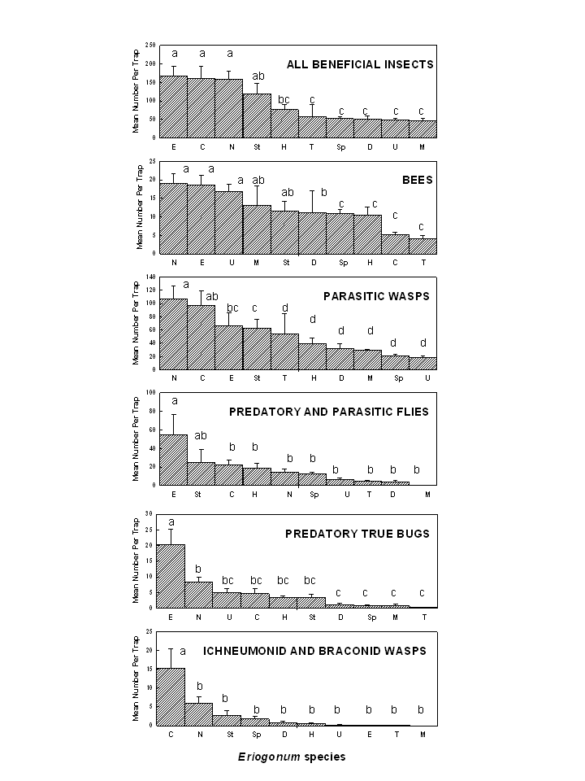
Figure 1. Mean (±SE) of all beneficial insects, bees, parasitic wasps (excluding ichneumonids, braconids, mymarids, aphelinids), predatory and parasitic flies, predatory true bugs and ichneumonid/braconid wasps attracted to 10 flowering Eriogonum species in central Washington. Key: C = E. compositum, D = E. douglasii, E = E. elatum, H = E. heracleoides, M = E. microthecum, N = E. niveum, Sp = E. sphaerocephalum, St = E. strictum, T = E .thymoides, U = E. umbellatum. Columns labeled with different letters are significantly different (P < 0.001) (repeated measures ANOVA with means separated using the Holm-Sidak method).

