Alcorn State University Extension Program
2013 Annie’s Project Evaluation

Demographic Information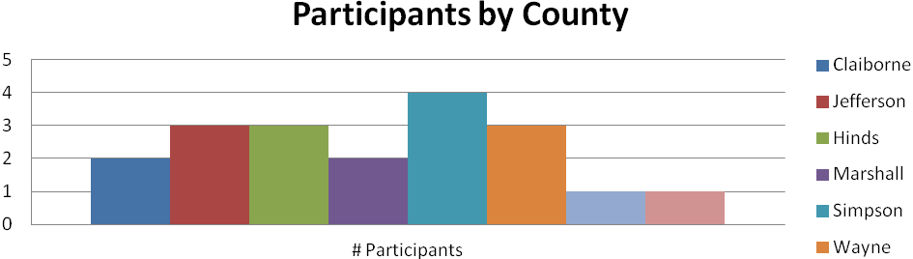
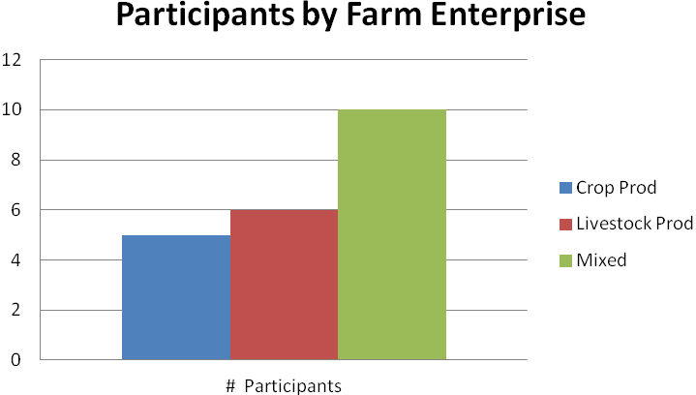
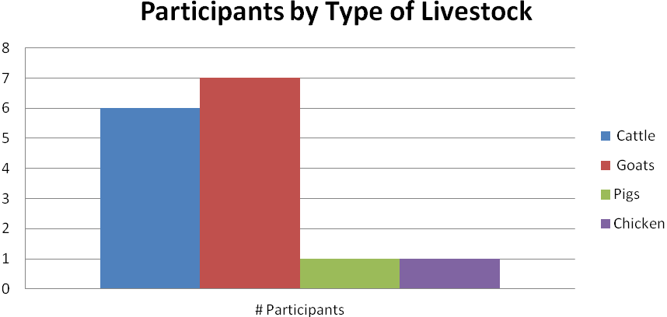
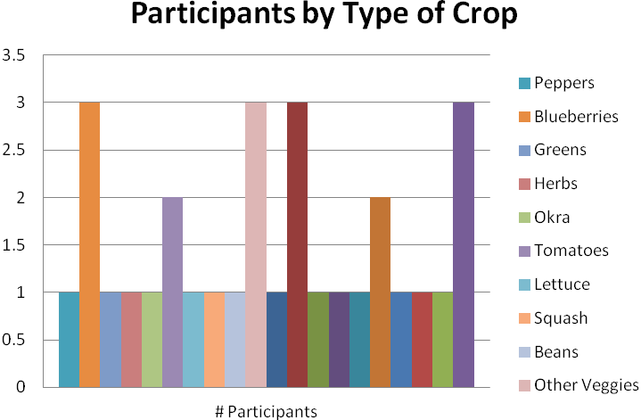
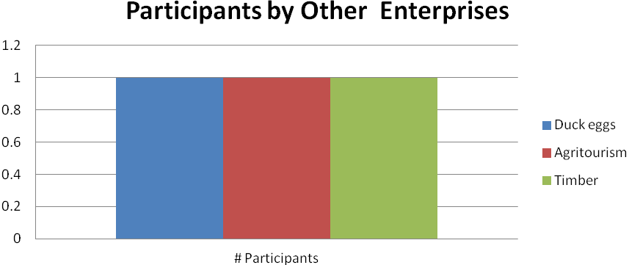

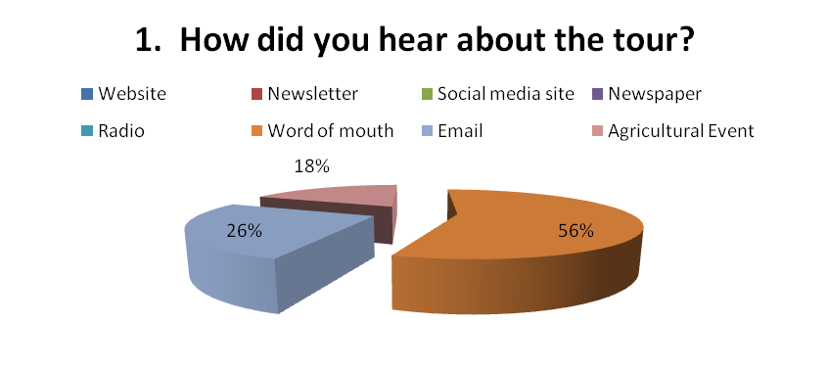
Most participants heard about the tour through an agricultural event.
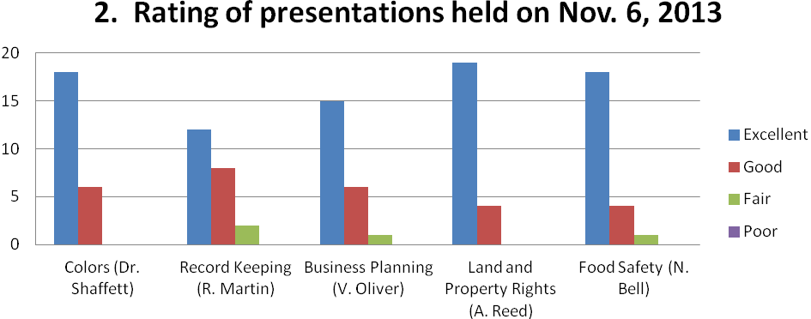
Mean score on 4.0 scale:
Colors 3.75
Record keeping 3.45
Business Planning 3.64
Land and Property Rights 3.83
Food Safety 3.74

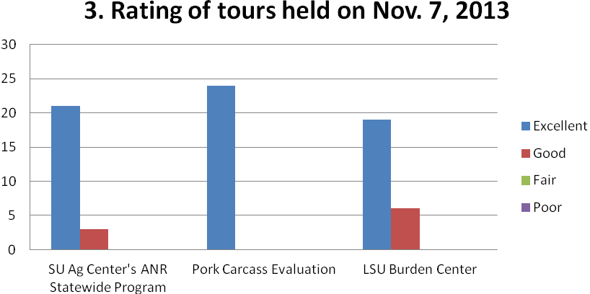

Mean score on 4.0 scale:
SU Ag Center’s ANR Statewide Program 3.88
Pork Carcass Evaluation 4.00
LSU Burden Center 3.76

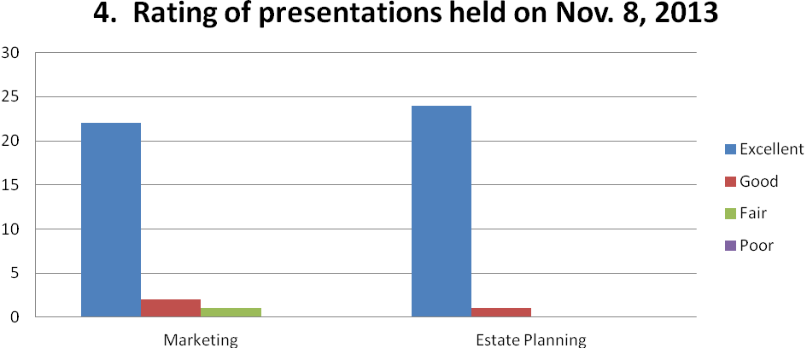

Mean score on 4.0 scale:
Marketing 3.84
Estate Planning 3.96

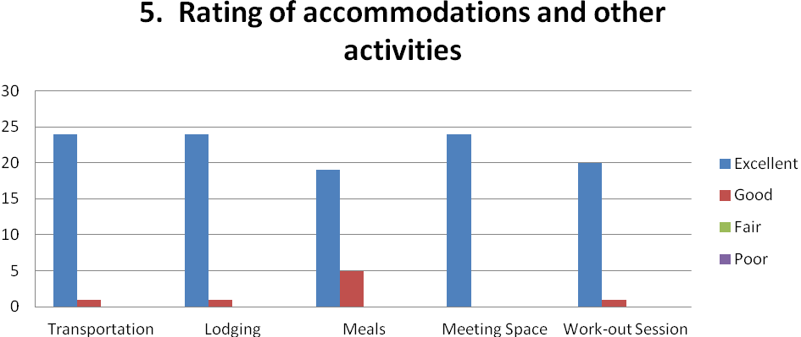

Mean score on 4.0 scale:
Transportatio 3.96
Lodging 3.96
Meals 3.79
Meeting Space 4.00
Workout Session 3.95

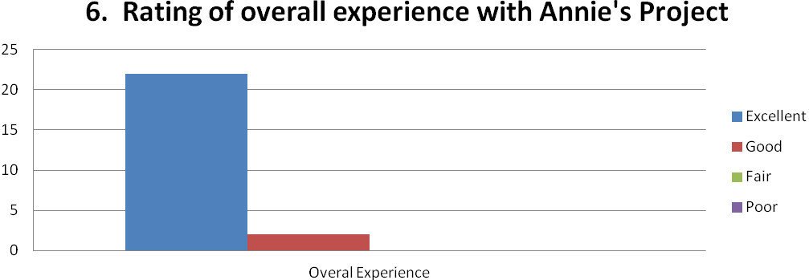

Mean score on 4.0 scale:
Overall Experience 3.92

