Survey of High Tunnel Practices in Northern New England
B Sideman, H Bryant, M Skinner, C Frank Sullivan, M Hutton, B Hoskins and E Sideman
UNH Cooperative Extension, UVM Extension, UMaine Extension
and the Maine Organic Farmers’ and Gardeners Association (MOFGA)

High tunnels are a useful tool for Northeastern diversified farmers, offering opportunities for extending the growing season and generating greater revenues by producing cold-tolerant crops (e.g., spinach, lettuce and brassica greens) and protecting high value warm-season crops (e.g., tomatoes and cucumbers). High tunnels are rudimentary hoop houses covered with one-two layers of plastic, and vented with roll-up sides for cooling. Limited data are available on the number of high tunnels in operation or the acreage they cover, and the practices used within these tunnels. A survey of Northern New England high tunnel growers was conducted in 2016 to generate baseline date on use of pest, nutrient, and crop management practices. We were particularly interested in identifying areas where growers were experiencing crop losses AND where educational or research activities could help reduce these losses. Two other surveys were recently done: A 2013-14 survey conducted by UVM Extension, with a focus on IPM tactics; and a 2011-12 survey by UMaine Extension, which focused on nutrient management in high tunnels. We hoped to broaden the information obtained from these surveys, and reach the entire Northern New England audience of our current SARE project.

Survey results are described below, using the following organization/layout.
- General information/cropping practices
- Pest and disease problems in high tunnels (p.2)
- High tunnel tomato crop quality and yields (p.4)
- High tunnel tomato fertilization, nutrient and irrigation management (p.5)
- Resources/information Needed (p.7)

1. General Information/Cropping Practices. Out of the 110 survey respondents, 95 reported that they currently grow crops in high tunnels. Forty-two percent (42%) of respondents’ tunnels were entirely certified organic, and 51% were entirely conventional. The remaining 7% had split operations.

The number of tunnels per respondent ranged from 0 to 22, with an average of 3.4 tunnels each. The total number of tunnels of all respondents was 311. Participants provided ranges of area covered by their high tunnel space; the total area covered by all respondents’ tunnels was estimated to be 682,906 square feet, or 15.7 acres.

Distribution of respondents, and tunnels represented.
State | % of respondents | Total number of tunnels reported
ME | 20 % | 46
NH | 55 % | 188
VT | 13 % | 55
MA | 8 % | 15
CT, RI, NY | 4 % | 7

Responses showed that warm-season crops tomato, pepper, and cucurbits (cucumber, summer squash, etc.) and herbs feature prominently in spring, summer and fall high tunnels. Greens are most commonly grown in fall, winter and spring high tunnels. Many growers use high tunnels for early season transplant production in the spring, before transitioning to other crops in summer. Growers also listed over 20 minor crops that are produced in high tunnels, including (in order of decreasing number of mentions): eggplant, alliums, carrot, brassicas, ornamentals, raspberry, strawberry, beet, beans, radish, ginger, cut flower, blackberries, and others.

Responses to: “What crops do you grow during each season in your high tunnel?” Most popular entries are presented in rank order, with most popular listed first, number of responses in parentheses.
Spring | Summer | Fall | Winter
Greens (48) | Tomato (64) | Greens (45) | Greens (45)
Transplants (46) | Pepper (54) | Tomato (42) | Herbs (8)
Tomato (36) | Cucurbits (53) | Pepper (27) | Alliums (6)
Cucurbits (26) | Herbs (30) | Herbs (20)
Herbs (21) | Transplants (25) | Cucurbits (20)
Pepper (19) | Eggplant (13)
 | Greens (17)

2. Pest and Disease Problems in High Tunnels.

Among pests, aphids, hornworm and striped cucumber beetle were most frequently cited as causing mild, moderate or severe problems. Whiteflies and thrips were the next most frequently cited as causing mild or moderate problems. Mites (two-spotted spide, broad, and russet) and thrips were most frequently mentioned as “don’t know”, suggesting that growers may not know how to identify these pests or the damage they cause.

Among diseases, tomato leaf mold, powdery mildew and gray mold were most frequently cited as causing mild, moderate or severe problems. Tomato or cucurbit viruses were the next most frequently cited as causing mild problems, or as “don’t know”, suggesting that growers may not know how to identify plant viruses.

Voles were described as causing mild (35%), moderate (35%) or severe (15%) problems, with only 15% of respondents reporting that voles did not cause any problems.

Common insect pests in high tunnels
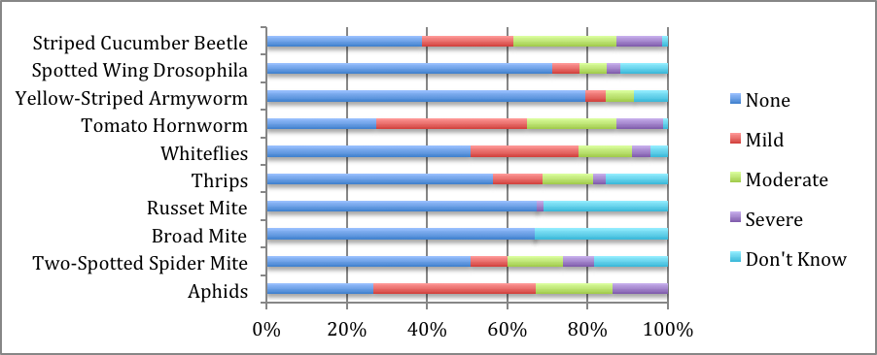

Common diseases in high tunnels
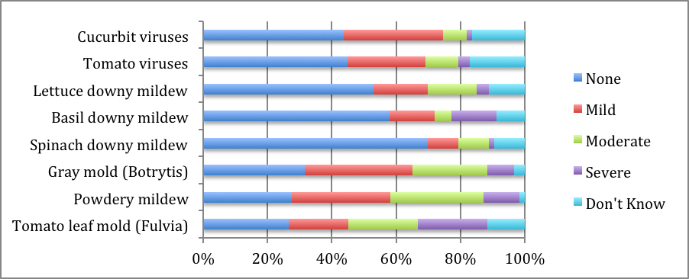

Most respondents (49-100%, depending on the category of material) did not use pesticides in their high tunnels in the year prior to the survey. Among those that used pesticides, most used general-use insecticides or fungicides, 1-3 times during the year. Based on the numbers of respondents and number of applications reported, we estimated 117 and 101 applications of general use insecticides and fungicides, respectively, and only 29 and 33 applications of restricted use insecticides and fungicides, respectively, were made among all respondents. Herbicides were very rarely used in high tunnels.

Pesticide use in high tunnels
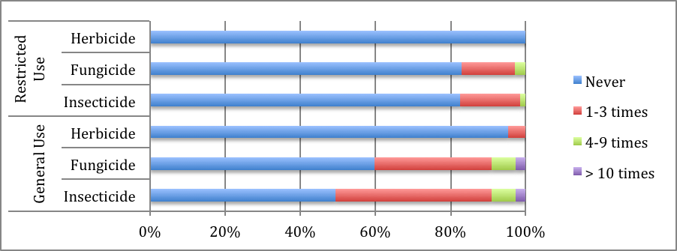

Growers reported using a wide variety of IPM tactics in high tunnels. Plant-mediated systems such as banker plants, indicator or trap plants, and habitat plants were among the least frequently used. Other uncommon strategies included pesticide treatments (either spot or preventative), beneficial nematodes, screening to exclude pests, soil sanitization, and the use of diagnostic pathogen test kits. Nearly all growers reported using routine scouting and good airflow management to reduce pest and disease problems.

Insect and disease management practices used in high tunnels
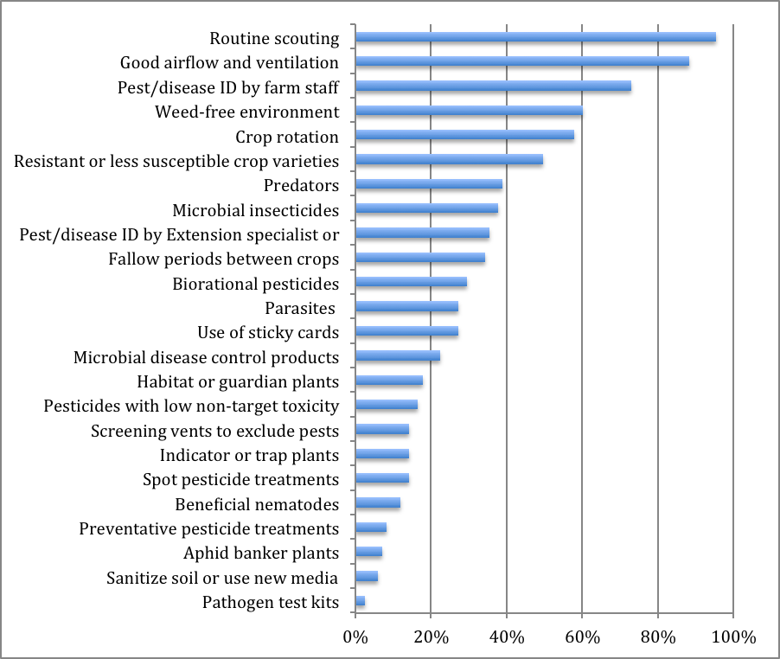
3. High Tunnel Tomato Crop Quality & Yields

Nearly 40% of respondents grow exclusively indeterminate varieties in high tunnels. However, over 70% of respondents reported growing at least SOME of each of the following categories in their high tunnels: cherry tomatoes, modern greenhouse varieties, modern field varieties, and heirloom varieties. This suggests that there is a large amount of variation in varieties and types being grown. Over 60% of growers do not grow ANY grafted tomatoes, whereas only 40% grow some grafted plants, and around 10% grow exclusively grafted plants.

Respondents were asked to estimate average total high tunnel yield in lbs of marketable fruit per plant during the prior year. 19% reported yields of 6-10 lbs per plant, 28% reported 11-15 lbs per plant, 19% reported 16-20 lbs per plant, and 7% reported yields of over 20 lbs per plant. 25% of respondents did not know their yields during the previous year. It is important to note that this question was flawed because yield for cherry tomatoes would be different (and much less) than yields of indeterminate greenhouse tomatoes, for example.

Types of tomato varieties used in high tunnels
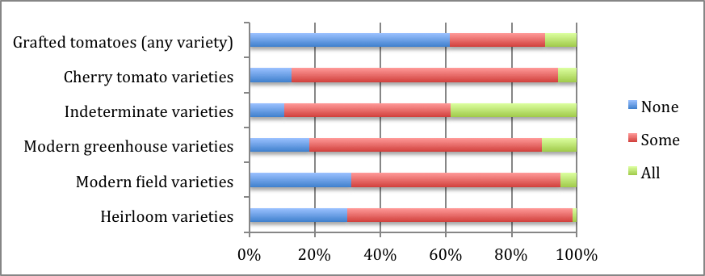

Over 60% of respondents observed foliar diseases, off-color leaves, fruit cracking, insect damage on fruit, blossom end rot, and yellow shoulder in some, most, or all years in their high tunnel tomatoes. Other production issues were less commonly observed, but over 60% of respondents felt that all of these issues except fruit drop, off-color leaves, and too much vigor resulted in a loss of marketable yields when they did occur.

Fruit and plant quality issues
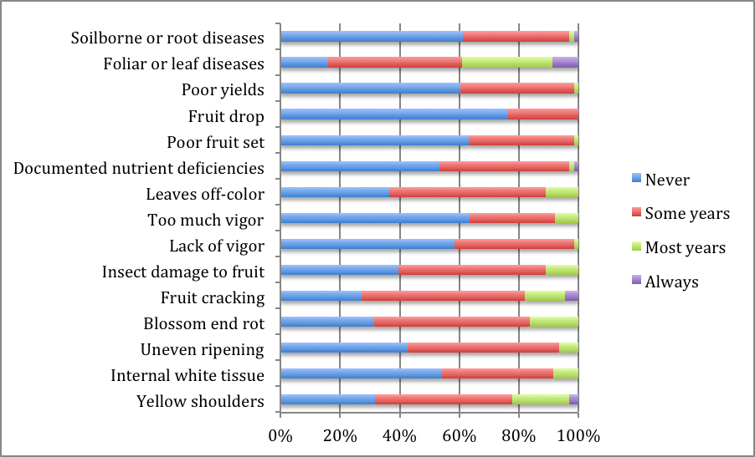
4. Fertilization, Nutrient and Irrigation Management

Nearly all respondents (99%) reported that they were growing tomatoes in-ground. However, almost 20% reported that they were growing tomatoes in containers or bags, which suggests that some producers are growing both in soil and in media. Nearly 80% of growers apply some or all fertilizers pre-plant, and 50% of growers applied fertilizers through the irrigation/drip system (e.g. fertigated). Over 75% of respondents reported using organic solid and liquid fertilizers, whereas 25% reported that they used synthetic soluble or granular fertilizers. Most reported that they used a mixture of sources; with only a few growers using only a single source (14% used only organic solid fertilizers, 11% used only compost made on-farm, for example).

All in all, most growers were happy with their fertilization plan. Over 75% of respondents agreed somewhat or highly with the statements that their fertilization plan resulted in high yields, high quality fruit, met plant nutrient needs, and was easy to do. Over 60% of respondents felt confident in calculating fertilizer rates, and felt that they were applying only the amount of nutrients needed. There was greater uncertainty about the accumulation of soluble salts over time; 35% agreed with this statement, but 42% did not know.

Over 75% of growers reported that they re-mix beds at least once per year. Very few growers tested crop plants to monitor nutrient status: only 4% of growers reported that they use petiole sap testing, and 24% used plant leaf tissue analysis. Soil testing was much more commonly used. Most growers used field soil tests (47% yearly, 23% every other year, and 22% every 3-4 years). Fewer growers used soluble salts tests (26%, 16%, and 13%, respectively); and fewer still used the SME tests (19%, 8%, and 6%, respectively – with 3% testing more than once per year). Approximately half of growers reported removing the plastic at some point to leach soluble salts from the soil, a similar percentage reported that they used irrigation for the same purpose.

Most respondents (92%) use drip irrigation. 55% of the respondents determine the timing of irrigation by feel of the soil, wheras another 36% use a timer. Only 5% of respondents use a tensiometer to schedule irrigation events. Nearly all respondents felt their irrigation methods were easy to use, but 25-29% of respondents said that they disagreed with or did not know whether their irrigation strategy resulted in high yields or high quality fruit.

General growing practices
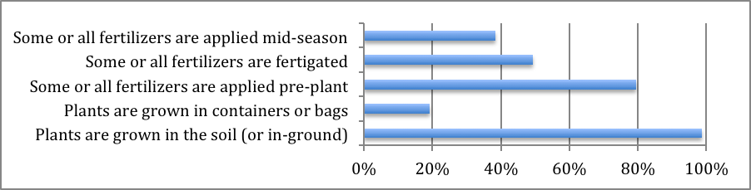

Fertilizers used
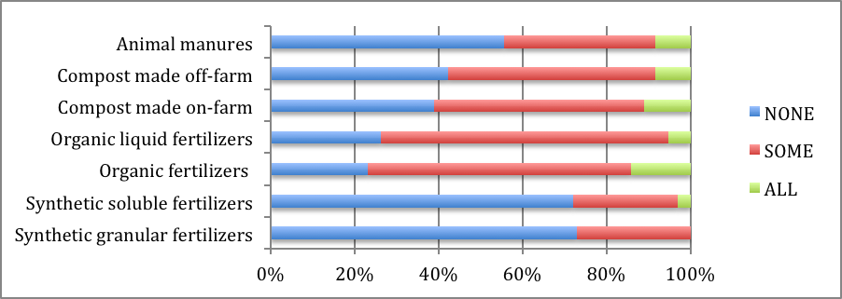

Perceptions about nutrient management/fertilization

Nutrient management practices used in high tunnels
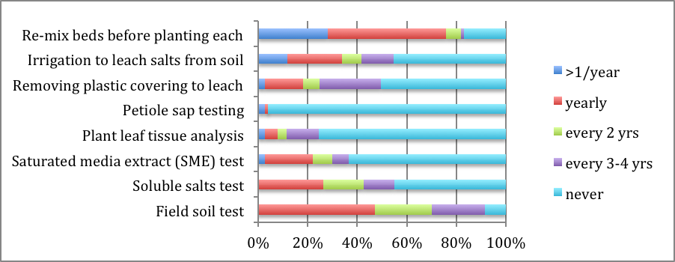

Irrigation strategies
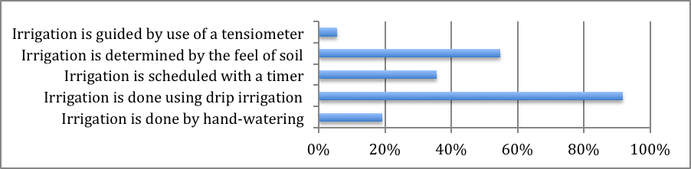

Perceptions about irrigation strategies

5. Resources/Information Needed

When asked what resources or information would help them manage insect and disease pests in high tunnels, respondents were most interested in identification tools for diseases and pests, regional biocontrol guidelines for high tunnels, web-based pest management information, lists of pest-resistant plant varieties, and action thresholds for specific pests/diseases.

What resources or information would help you manage insect and disease pests in high tunnels?
When asked what resources or information would help them manage crop fertility in high tunnels, respondents were most interested in information on how to identify nutrient deficiencies, guidelines for use of specific sources of fertility (e.g. composts), and local guidelines for high tunnel fertility management.

What information or resources would help you improve your crop fertility management in your high tunnels?

We also asked participants specifically how they would like to receive information that would help them manage pests, diseases and crop and soil fertility. The most popular responses to this question were written fact sheets (accessible online, 81%), workshops and conferences (77%), twilight meetings (58%), and short (5-10 minute) instructional videos or “webinettes” (57%). 39% were interested in full-length (30m-1hr) webinars, and others wrote in suggestions, including: online video library, written fact sheets, farm visits by extension specialists, website with easily accessed info, and good online photos with decision trees for diagnosing issues.

