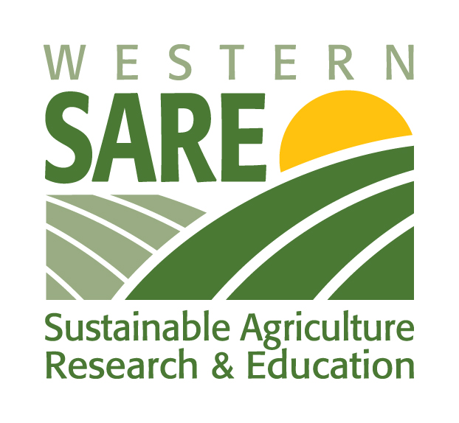
WSARE Idaho State Enhancement Program
Application for Hosting Local Food Systems Workshop

Request for Proposal
PROPOSAL DUE DATE: December 15, 2017

Program Goals and Objectives:
- Host a tailored food system workshop in your community based on the local food system needs (see examples highlighted below).
- Increase the capacity in your community to prioritize and achieve food system goals.

Intended Outcomes:
- Increase local and regional collaborations in local food system efforts.
- Increase understanding of methods to help communities start or continue the conversation of enhancing local food system efforts.
- Increase capacity of Extension Educators, nonprofit groups, cities, volunteers, and community leaders to work together to prioritize and achieve community food system goals.
- Increase communication to political officials, community members, and consumers regarding the impact of local food for economic and community development.
Those invited to apply:
The Idaho Western Sustainable Agriculture Research and Education team invites communities and individuals in Idaho that would like technical assistance to host a food systems workshop or other similar professional development activity to enhance local food systems efforts and goals. Each community may have different goals and may be in a different phase of building a more resilient food system. We encourage applications from anyone who would like to work toward development of a food systems project for their community or would like to increase the capacity of a project that is already taking place (projects must include UI Extension as a core partner).

Examples of food system workshops for new or on-going projects:
- Enhance activities of a Food Council, Food Coalition or other food systems organization
- Learn how to organize and convene a successful Food Coalition
- Enhance efforts to further develop a local food hub
- Get help implementing healthy school food or other farm-to-institution initiatives
- Learn how to conduct a community food assessment to identify gaps in your local food system
- Learn to develop policies to create a more resilient local food system
- Learn how to use data to evaluate and communicate the economic impacts of local foods to your community
- And much more

Research in food system reform identifies local efforts as the source of change in our national food system. Around the country, farmers, entrepreneurs, community organizers, and activists are creating novel ways to rebuild food systems that are economically, environmentally, and socially sustainable. Use this opportunity to help your community do something transformative. Let your imagination be your guide!

Please email Lauren Golden (lgolden@uidaho.edu) with any questions regarding the application.

Requirements:
- Awards restricted to UI Extension faculty and staff or groups that plan to partner with a UI Extension Educator/Specialist.
- The workshop or event must be completed by one year from approval of proposal. Approvals can be expected by January 15, 2018.
- Funding will be available upon approval.
- Those receiving funding will need to complete a SARE evaluation survey and a final report.

BUDGET RANGE: $1,000 - $5,000; Project spending is flexible and can be spent a variety of ways for further enhancing your community’s food system. The WSARE State Enhancement Grant team can help you create your workshop/event. The team can work with you to identify pertinent topics and find both local and regional speakers with relevant expertise. Funds can be used for speaker fees, travel, room rental, lunch, supplies, publications or purchase of books for participants, postage, photocopies, and equipment rental.

APPLICATION:

Contact Name: County or Community:

Organization name (if applicable):

Email: Phone:

Project Title:

List Partners and/or Collaborators:

Local Food Systems Enhancement Grant funds requested: $

1) Project Description
- Provide a brief situation statement or justification of the food system needs in your community/area.
- Describe what you plan to do (host a workshop for your community, focus of the workshop, etc.).
- Identify the groups/individuals that will be targeted for participation in your project.
- What changes in the local food system do you hope to accomplish with this grant?
- Evaluation plan – How will you evaluate to determine if your workshop has been successful? (All workshops need to use a SARE Evaluation Form, or create your own survey that includes similar questions).

2) Self-identify (circle) the stage of your community’s local food system work:
Beginning: Little work has been done so far in our community.
Medium: There is interest in food system work in our community and we have some accomplishments but would like to accomplish much more.
Advanced: We have a core group of organizations/individuals regularly working on food system issues in our community/area. We would like to expand our programming and increase our impact.
3) Budget Narrative: Please provide an itemized list of expenses.

Email proposals to: Lauren Golden lgolden@uidaho.edu

