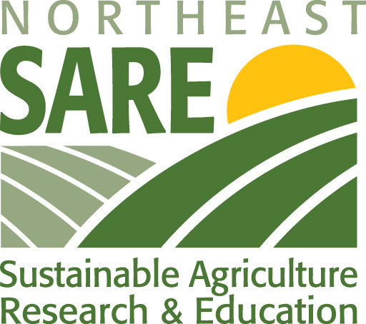
AN INTRODUCTION AND WELCOME TO

Cover Crops for Soil Health: A Northeast SARE
Professional Development Workshop
March 29-31, 2016
Baltimore, Maryland

Doubletree Hotel at BWI Airport
Baltimore, Maryland

The seeds of this workshop were sown in early 2014, when the Northeast SARE Administrative Council expressed a strong interest in continuing the momentum generated by the national cover crops conference in 2014, sponsored by North Central SARE and the Howard Buffet Foundation. The Administrative Council wanted to increase knowledge about and adoption of cover crops in the Northeast Region. From these seeds grew the plans for this train-the-trainer workshop. The objectives of the workshop are to equip teams of agricultural service providers and farmers from Northeast states with knowledge and skills they can use to educate and advise farmers about cover cropping choices, practices and technologies.

There have been many steps along the way from 2014 to now in planning this workshop, and we thank the numerous individuals who contributed much time to the planning process. They offered organizational advice, shared their expertise about cover crops and their ideas about which concepts, research, innovations and technologies agricultural service providers would benefit from learning more about. Without their contributions we would all not be here today.

Workshop Planning Committee

Katie Campbell-Nelson, University of Massachusetts
John Clendaniel, Delaware State University
Nevin Dawson, University of Maryland
Masoud Hashemi, University of Massachusetts
Dean Hively, USGS
Sally Kepfer, USDA NRCS Delaware
Ellen Mallory, University of Maine
Janet McAllister, University of Connecticut, Northeast SARE
Steven Mirsky, USDA ARS Beltsville
Tom Morris, University of Connecticut, Northeast SARE
Sonia Schloemann, University of Massachusetts
Lauchlin Titus, Ag Matters, LLC, Maine
Ray Weil, University of Maryland
Charlie White, The Pennsylvania State University

We welcome you and hope you find this workshop to be a rewarding professional development experience – one that prepares you well, and that motivates you to share your knowledge with farmers to help them make wise and appropriate decisions about cover crops. Northeast SARE is looking forward to supporting your cover crop outreach efforts when you return home.

Jamie Timson
Delaware State University
Program Assistant
Jason Challandes
Regional SARE Educator
Delaware State University
Workshop Coordinator

