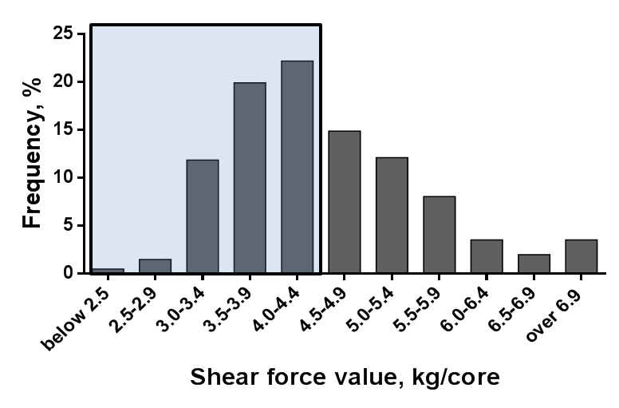
Fig. 1. Shear force value distribution of ribeye steaks from grass-fed cattle of Hawai‘i. The rectangular region indicates the area below the minimum tenderness threshold value (MTTV) required to claim “USDA Certified Tender.”

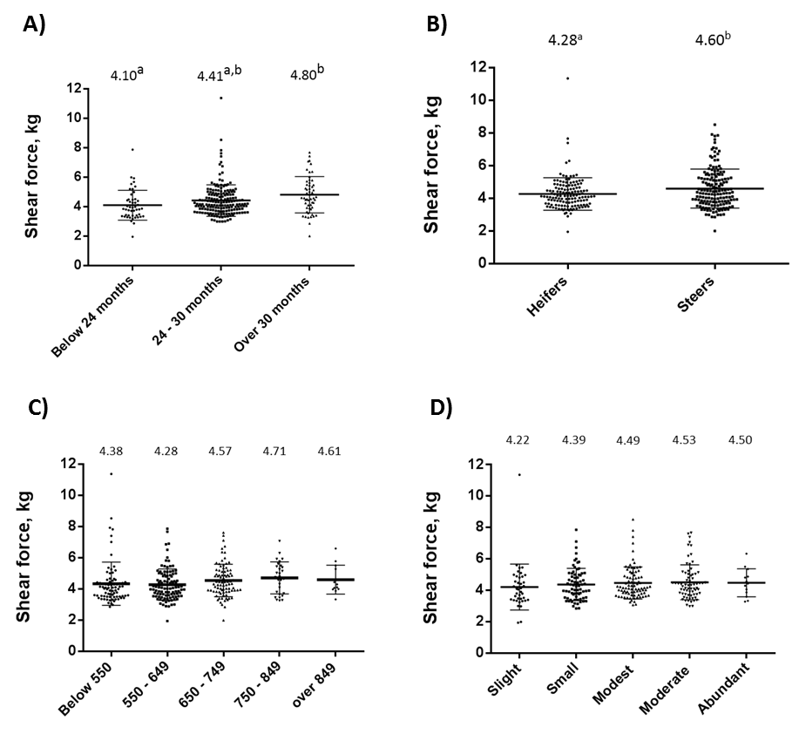

Fig. 2. Shear force value by age group (A), sex (B), carcass size (C) and marbling (D). Means not sharing the same superscript differ at P<0.05.

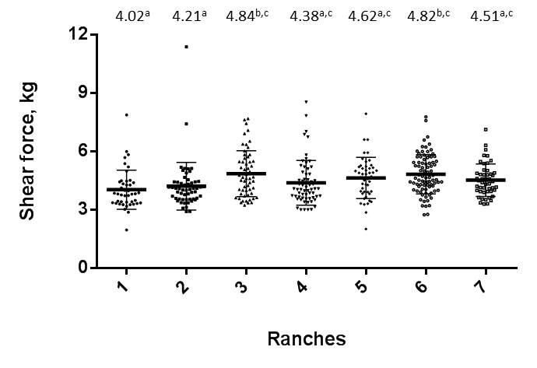
Fig. 3. Shear force value by ranches. Means not sharing the same superscript differ at P<0.05.

