High Tunnel Conference
Manchester, NH - 14 December, 2016
B Sideman, H Bryant, M Skinner, C Frank Sullivan, M Hutton, B Hoskins and E Sideman
UNH Cooperative Extension, UVM Extension, UMaine Extension
and the Maine Organic Farmers’ and Gardeners Association (MOFGA)
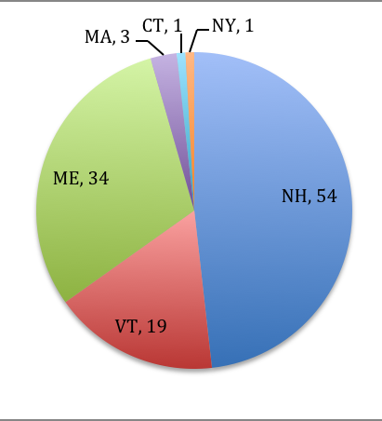
Participants

112 participants attended the High Tunnel Conference. Attendees included primarily growers, but also agricultural service providers/extension, and researchers. Attendees came primarily from NH, ME, and VT (see right).

Evaluation

Of the 55% of participants that filled out a conference evaluation, the geographical representation was similar to that of attendees.

Participants were asked to evaluate the quality of the program, location/facilities, speaker presentations, and Farmer-to-Farmer sessions, using a 1-5 scale. Results are presented below, with mean values ± one standard deviation. In general, participants were very satisfied with the conference.

Overall quality of the program.
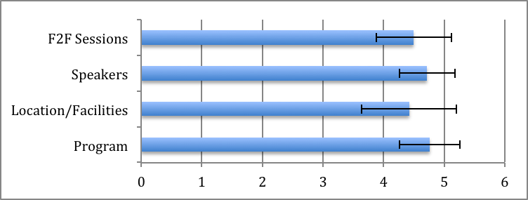

For each specific topic covered, participants were asked to estimate their knowledge of the subject before and after the presentation, using a 1-5 scale. The mean ± SD for PRE and POST ratings, and the mean difference between them, are provided on the following page.

Participants were also asked, for each topic, whether they intended to make any changes on their farm based on what they learned. A free-form box was provided, where participants could write in intended changes. These changes were summarized and grouped into similar themes. The most frequently mentioned changes included changes in plant spacing and/or pruning (25 comments), changes in irrigation methods (including using tools like tensiometers to monitor soil water status, 24 comments), add/change varieties grown (16 comments), scout more frequently for insect/disease pests (16 comments), experiment with trap crops such as marigold and bean (13 comments), experiment with habitat plants such as alyssum (12 comments), increase soil testing (9 comments), and improve ventilation (9 comments). Many more individual comments were submitted, and are listed below. These will be used to guide post-conference followup surveys during the next growing season.

Reported gains in knowledge on specific topics.
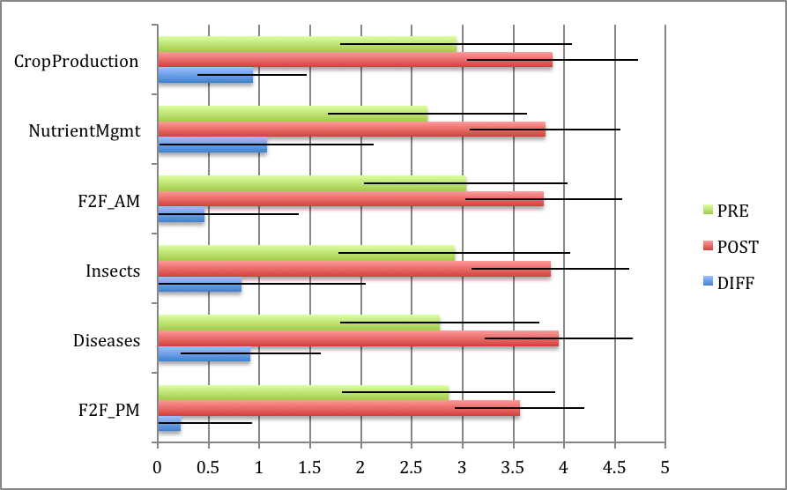

Intended specific changes in practices by participants, followed by number of participants mentioning each.

Crop management change spacing or pruning strategies (cluster thinning, etc.) (25)
change irrigation management (24)
add/change varieties (16)
improve ventilation (9)
increase sanitation (8)
add or change cover crops (5)
improve temperature management (4)
try grafting (4)
change shade cloth practices (either stop or start!) (3)
use better crop rotation (2)
invest in structures (1)
talk to other farmers more (1)
manage crop stresses (1)
Soil/Nutrient management more soil testing (11)
change soil nutrient management (bring in new soil, change fertilizers, etc.) (9)
increase potassium (7)
test pH of irrigation water (4)
monitor soil salinity (3)
scout more (16)
experiment with trap crops (e.g. marigold, bean) (13)
experiment with habitat plants (e.g. alyssum) (12)
improve humidity management (7)
Pest/Disease management improve pest and disease id (especially aphids) (6)
consider hot water treating seeds (4)
use biological controls SOONER (4)
vole trapping (3)
try aphid predators (3)
use banker plants (2)
use Bt for armyworm in winter tunnels (1)

Participants were also asked the following question about future outreach events like this one:

Question. We are contemplating holding a high tunnel conference like this one every other year. Please indicate your preference for such a conference:
☐ one-day conference in central location, like this one
☐ two-day conference in central location, like this one
☐ one-day conference repeated in three different sites across New England.
Responses were overwhelmingly in favor of a one-day conference in a central location (50), with conferences repeated in different sites as a distant second (20), and a two-day conference third (12). Of course, our respondents were potentially biased, since they were all people that did in fact travel to a one-day conference in a central location.

Question. Would you prefer that a high tunnel conference be focused on:
☐ high tunnel tomatoes, specifically
☐ high tunnels generally, including other crops
Here, 60 respondents indicated a preference for a focus on high tunnels generally, including other crops. Only 11 respondents wanted a focus on high tunnel tomato (and a few of these selected both options).

Train-the-trainer

In addition to growers, the primary audience for the conference, 7 agricultural service providers from 4 states attended the workshop. In written comments on evaluations, we learned that the conference provided them critical information that will help their programming related to high tunnels. For example, participants said that “[The session] improved my overall understanding of high tunnel systems and challenges which will help in my programming with growers”, and “I will promote annual soil testing in high tunnels.”

